LINK

The magazine of the Barnsley Group Pastorate



**SPRING 2013**  

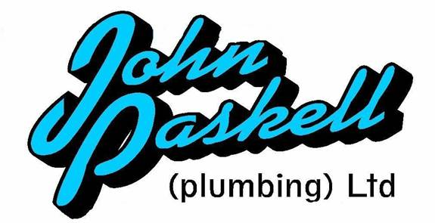Plumbing and

heating engineers

Tel: 01709 873518

[info@paskellplumbing.co.uk](mailto:info@paskellplumbing.co.uk)



**Druids Sheffield**

**Friendly Society**

Plans for Healthcare – Tax Exempt Savings

Sickness and Death Benefits

Endowments – Insurance I.S.A.

Leaflets on all plans available from:-

Dove House, Brampton Road,

Wath-Upon-Dearne, S63 6BE

Tel: 01709 876409

Fax: 01709 878045

Email: deuidssheffield.friendly@virgin.net

www.druidsfriendly.co.uk

Established 1858. Authorised in the United Kingdom under the Friendly Societies Act 1992. Reg. No. 795f

Druids Sheffield Friendly Society is regulated by the

13307

_________________________

**Simon T. Anderson**

Funeral Director

23 Dodworth Road, Barnsley.

**(01226) 733119**

*24 HOUR SERVICE*

AN INDEPENDENT FUNERAL SERVICE

*Professional and friendly advice on all aspects of the funeral service*

Financial Services Authority

___________________________________________________



Andrew P. Lockwood

**MinstChP. CCM(Sheffield)**

**CHIROPODIST**

**All Foot Ailments Treated**

CORNS – CALLOUSES (Hard Skin) – VERRUCAE – ATHLETE’S FOOT etc.

**Home Visits – Prompt Attention**

**Tel: 01484 687632**

**Mobile: 07971355078**

Dear friends

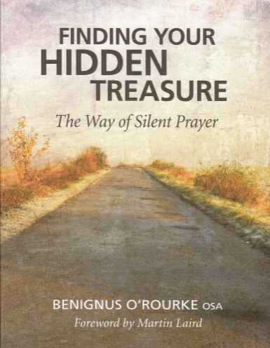I don’t know about you, but for me Lent is a time of quiet for prayer, reflection and meditation. Iv’e never ‘given anything up’ for Lent and am not really sure where that concept came from. If we were to follow Jesus’ example we would fast for forty days and nights. I’m not sure how that would work unless we did as Muslims do during Ramadan and fast between dawn and sunset. I think I would find that difficult but it would probably do my waistline the power of geed!

Back to the times of quiet. I have a gem of a book in my study. It is called ‘Finding Your Hidden Treasure’. I intend to re-read it during Lent this year (I first read it during Lent last year). Below is the first chapter of this book. My hope is that you will find it useful in your own prayer life during Lent and beyond.

**Sitting There All Peaceful and Quiet**

by Benignus O’Rourke

Some time ago an elderly lady complained to me that she could no longer pray. 'Father,' she said, 'I can't pray like I used to. I come here to church after my shopping and sit here all peaceful and quiet. But,' she sighed, 'I can't pray like I used to.'

I tried to suggest that perhaps sitting there all peaceful and quiet *was* prayer. Maybe it was a gift God was offering her at this stage of her life. But she was not convinced. Prayer for her meant keeping her mind on the words, battling with distractions, concentrating. Sitting there all peaceful and quiet would have seemed to her like laziness and failure.

What my parishioner was discovering, in fact, was one of God's loveliest gifts, the purest form of prayer. She rejected it because it was not what she had been taught. And she is not alone. Many people who come to the retreat house where I live, to attend Sunday or daily Mass, or in search of peace and quiet or guidance, share her anxiety about praying.

Many of us will remember being taught that prayer is a lifting of our minds and hearts to God. This teaching can lay a heavy burden on us. We feel that we must make an effort to speak to God, to praise

him, to give thanks, to ask for help. We normally use words, thoughts and images, and feel we have to keep our minds fixed on what we are saying.

But there are times when *we* cannot find the words, or when the well-known prayers which usually inspire and comfort us strike no chord in our hearts. Or we may be singing God's praises while our hearts are heavy, or empty. And our hearts become heavier because our feelings do not match the words.

We are perhaps tired of words, anyway. Tired of asking God in words that have no life in them. Tired of thinking about God. Tired of being talked to about God. Tired of saying prayers that may be beautiful in themselves but are not bringing God closer to us.

Then, perhaps it is best to simplify our prayers and follow the age-old advice, to go from many words to few words, from few words to one word, and from one word into silence. Sometimes when we pray, our words, any words, can be barriers. They come between us and God. The deepest communion with God comes through silence.

There is a form of prayer where we do nothing, where we sit in stillness and silence, not straining or striving. We abandon all words and reflection and we rest. We put ourselves in God's hands and wait in silence, to let God's Spirit pray in us. Sitting there all peaceful and

quiet, like the elderly lady in church, is what this kind of prayer is all about.

Have a peaceful and blessed Lent and may the joy of the resurrection fill you anew.

Items for the Summer 2013 LINK need to be with me by Sunday 12 May. Thanks

Your friend and minister

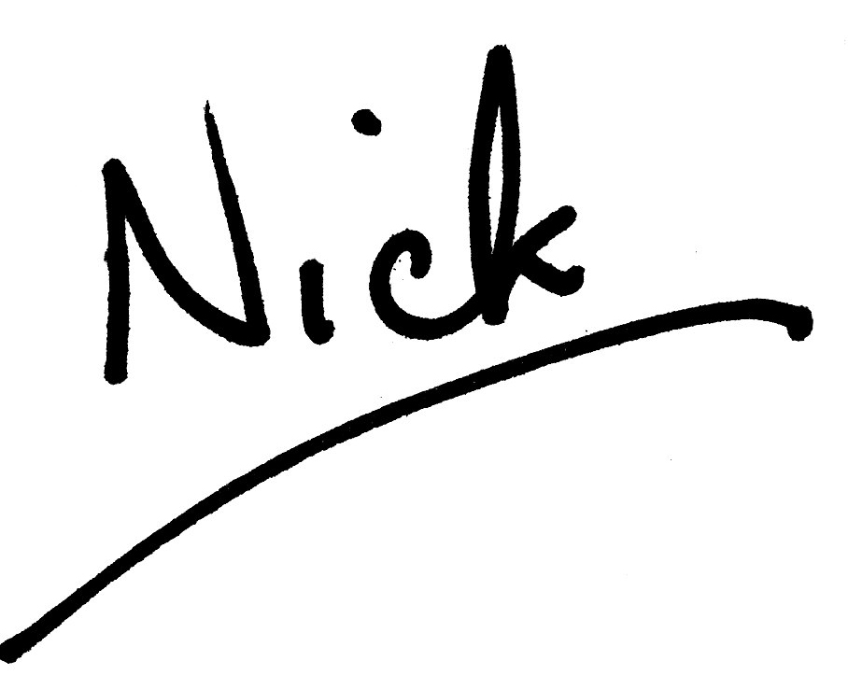

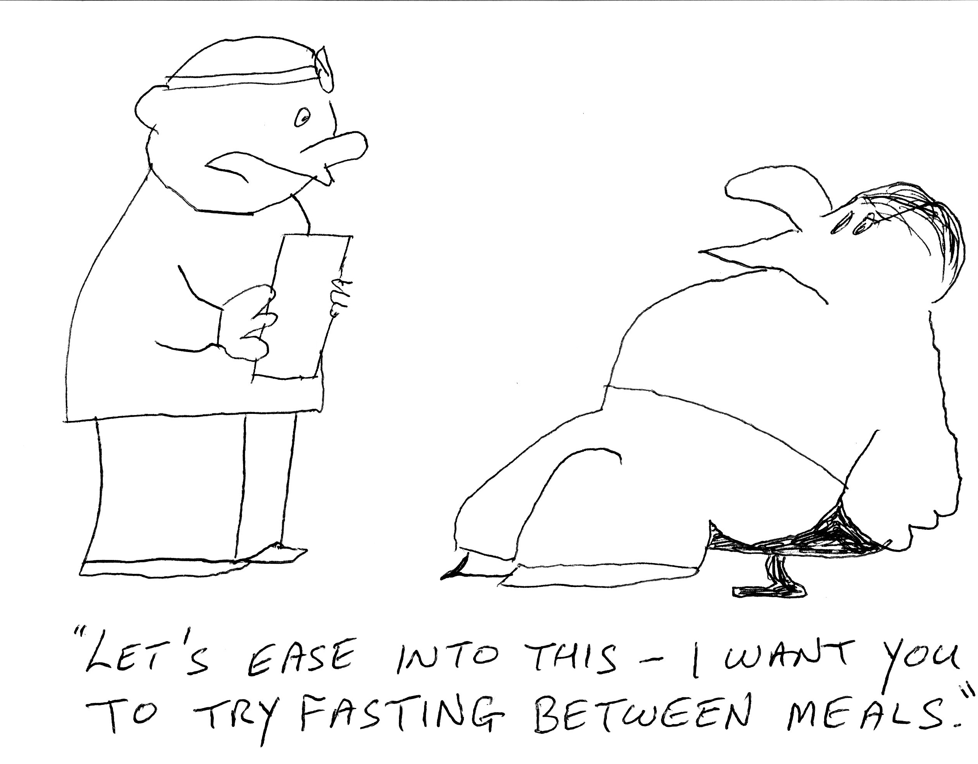

**WEST MELTON’S GREEN TIPS CORNER**

by Helen Owen

**Number 12 – Sit – Boiling**

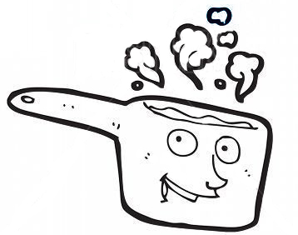

Try "sit-boiling"- a great way to save energy in the kitchen.

Just boil your vegetables, pasta or rice for a few minutes on full power then remove from the hob but keep covered and leave to finish cooking in the hot water.

You may have to experiment a bit to get the timings right but once you've done that you'll wonder why you didn't try it before.   
  
PS I've done this often with rice and it works a treat and needs much less water.

**TRINITY PLAYERS - DICK WITTINGTON and HIS CAT**

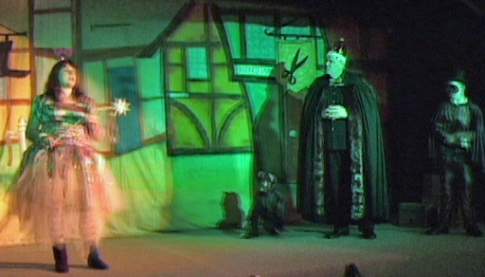 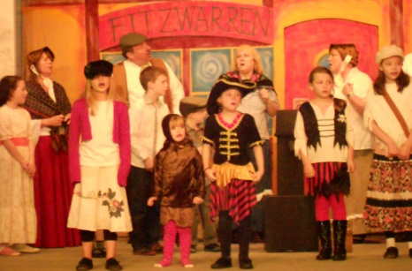

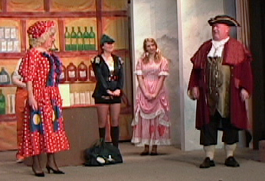 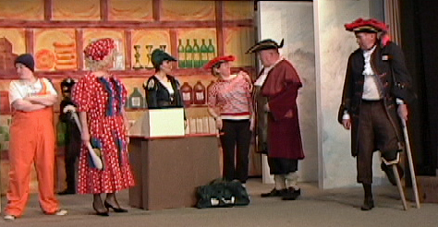

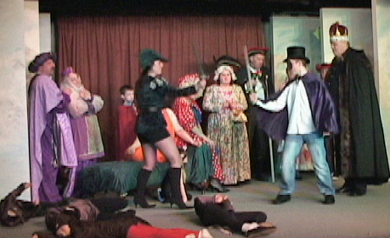

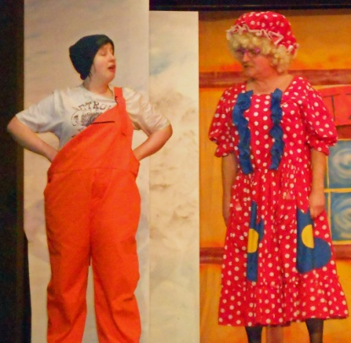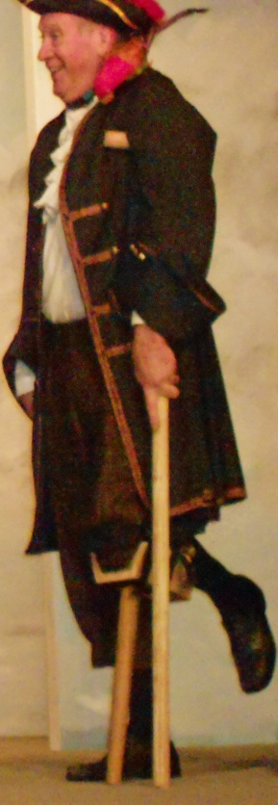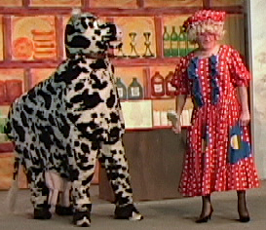What a joy it was for me (*Rev. Nick*) to be offered the role of King Rat. I have always wanted to play the baddy! Dick Whittington and his Cat was another rip-roaring pantomime success by the Trinity Players. The comedy was as it should be, cringe-making, the songs were all sung well, even, I am told, mine! Of course, good triumphed over evil yet again. (doesn’t it always in a panto- oh yes it does) The only downside for me, personally, was that I got killed in the last scene and never got to Rule the World – not for want of trying. If you were lucky enough to see the show you will, I hope, remember it for a long time. There will always be something which sticks in your mind. For me one of the highlights was on the first night when there was a clatter on the stage. The Captain’s (Phil Johnson) wooden leg fell off! Another panto next year – I do hope so, it may be hard work but the fun more than compensates. Look out for the Players’ next production, "Side Effects" This will be staged in the church hall from 15th to 18 May.

