Recipe page: Easter fruit cupcakes

Ingredients

100g/3½oz unsalted butter
2 tsp ground ginger
2 tsp mixed spice
250g/9oz caster sugar
100ml/3½fl oz sunflower oil
4 medium free-range eggs
1-2 small dessert apples, (about 100g/3½oz)
100g/3½oz crystallised ginger
100g/3½oz currants
100g/3½oz mixed dried fruit
300g/10½oz plain flour
2 tsp baking powder
Icing sugar

For the sugar syrup

25g/1oz caster sugar
25ml/1fl oz water

Preparation method

Line the pockets of a muffin tray with muffin cases or paper wraps, and preheat the oven to 180C/350F/Gas 4.
Melt the butter with the spices in a small pan over a low heat, then pour this into a mixing bowl with the sugar and oil and stir well. Beat in the eggs until smooth.
Peel the apples and grate them, discarding the core, and stir the apples into the other ingredients, followed by the crystallised ginger, currants and mixed dried fruit. Stir in the flour and baking powder evenly.
Three-quarter fill each muffin paper with spoonfuls of the mixture and bake for about 25 minutes, or until a skewer poked in comes out almost clean.
Make the syrup by boiling the sugar with the water in a small pan until dissolved, then leave to liquid to cool. Brush it over the warm cupcakes.
When cold, pipe crosses on the cupcakes with the icing sugar before serving.

A Palm Sunday picture for you to colour

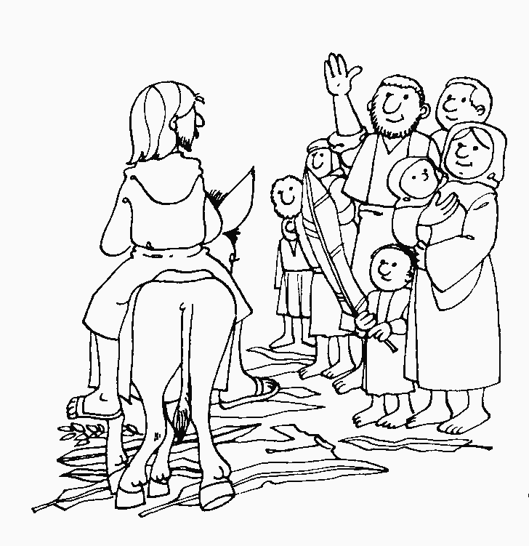

"Hosanna to the Son of David!" "Blessed is he who comes in the name of the Lord!" "Hosanna in the highest!" (Matthew 21:9)
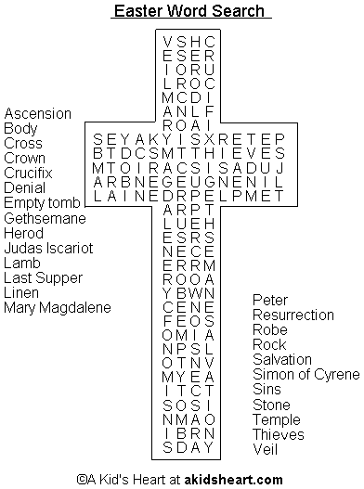
A Florida Court Sets Atheist Holy Day!
In Florida, an atheist created a case against Easter and Passover Holy days. He hired an attorney to bring a discrimination case against Christians and Jews and observances of their holy days. The argument was that it was unfair that atheists had no such recognized days.

The case was brought before a judge. After listening to the passionate presentation by the lawyer, the judge banged his gavel declaring, "Case dismissed!"

The lawyer immediately stood and objecting to the ruling saying,
"Your honour, How can you possibly dismiss this case? The Christians have Christmas, Easter and others.
The Jews have Passover, Yom Kippur and Hanukkah, yet my client and all other atheists have no such holidays..."
The judge leaned forward in his chair saying, "But you do. Your client, counsellor, is woefully ignorant."
The lawyer said," Your Honour, we are unaware of any special observance or holiday for atheists."
The judge said, "The calendar says April 1st is April Fools Day. Psalm 14:1 states, 'The fool says in his heart, there is no God.' Thus, it is the opinion of this Court, that, if your client says there is no God, then he is a fool. Therefore, April 1st is his day.
Court is adjourned..."
I’m sure God is giggling!
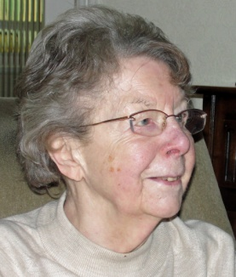
Getting to know you – Mary Thompson
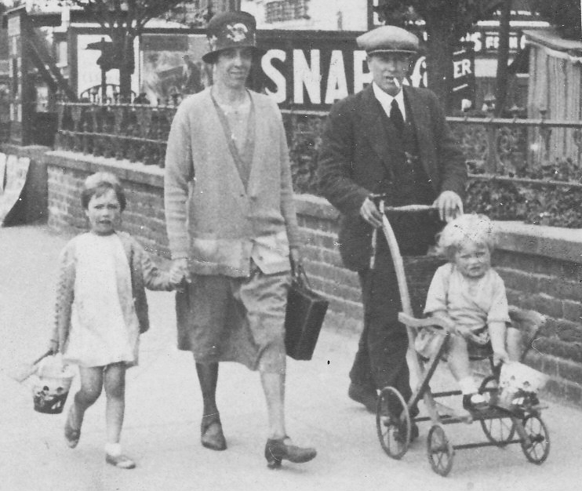
Mary writes: I was born on 16th January 1923 at Talbot Road, Swinton (Dan Pottery was at the bottom of the road) to John Wilfred Thompson and Annie Elizabeth Thompson (nee Cass). My father was born in Bishop Wearmouth in the north east. His father died when he was a boy so his mother came to Swinton to be near her sister, Ruth Elizabeth Drakeford who was marrie dot Thomas Drakeford. My father grew up near his cousins Earnest, Stanley, Sydney and Sylvia. Ernest played the violin and Stanley the piano. Ernest became a musician in Lusitania’s orchestra and survived its sinking in May 1915. My mother was born in the village of Everton near Balby but, sadly, her mother died and her father, George Cass, came back to his parent’s home in Church Street, Mexborough, with his baby. Later she was told she made ‘the dozen up’! Later they moved to Talbot Road in Swinton.
Mother and father married after the Great War and had a son, John, in 1921 but he only lived for six days. I arrived in 1923 and my sister, Hilda, in September 1926. When I was five I started at Swinton Bridge Infants School. When my grandfather died we moved to Wortley Avenue near to grandma Thompson.
Mary, Mother, Father and Hilda on holiday in Skegness c.1929
I still went to the same school, taken by Margaret Allen, age 7, who became a life-long friend. We had a good ‘gang’ of children in the Avenue, with plenty of room to play – having only one car in the street.
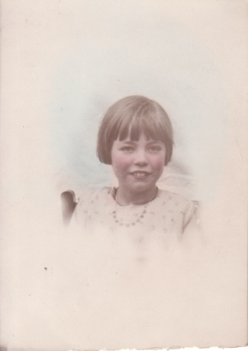
At eleven years old I got a County Minor Scholorship to Mexborough Secondary School and stayed there until I was eighteen. Other famous pupils at the school were, Keith Barron, Brian Blessed and Ted Hughes (later to become Poet Laureate). War broke out when I was sixteen and I went into the sixth form and got the Higher School Certificate which you had to have to apply to go to college. My friend, Margaret, went to college in September 1939 and her mother remarked to me, “Never mind it (the war) will all be over when you go!” The boys in the sixth form could not apply to go to college as they were ‘called up’ at eighteen.
I went to Derby C of E Training College but the college building had been taken over by the army. The college was evacuated to Elvaston Castle outside of Derby in the country, a ‘minor Wentworth’ with lovely grounds and a lake. We had lectures morning and afternoon and sometimes at night. Everyone had a Religious Education lecture, given by the Principal, Miss Hawkins, ‘The Hawk’ on Saturday mornings from 11.00 to 12.00. Saturday afternoon and Sunday was our only free time and we had to sign in every night at ‘blackout time’. Those of us who had a bike rode down the lanes on a Saturday to a garage who let us leave our bikes there so we could catch the bus into Derby. Elvaston Castle was alright in summer but a bit grim in winter. We did have a couple of bombs dropped on us but fortunately they fell in the grounds and hit two statues in the Italian Garden.
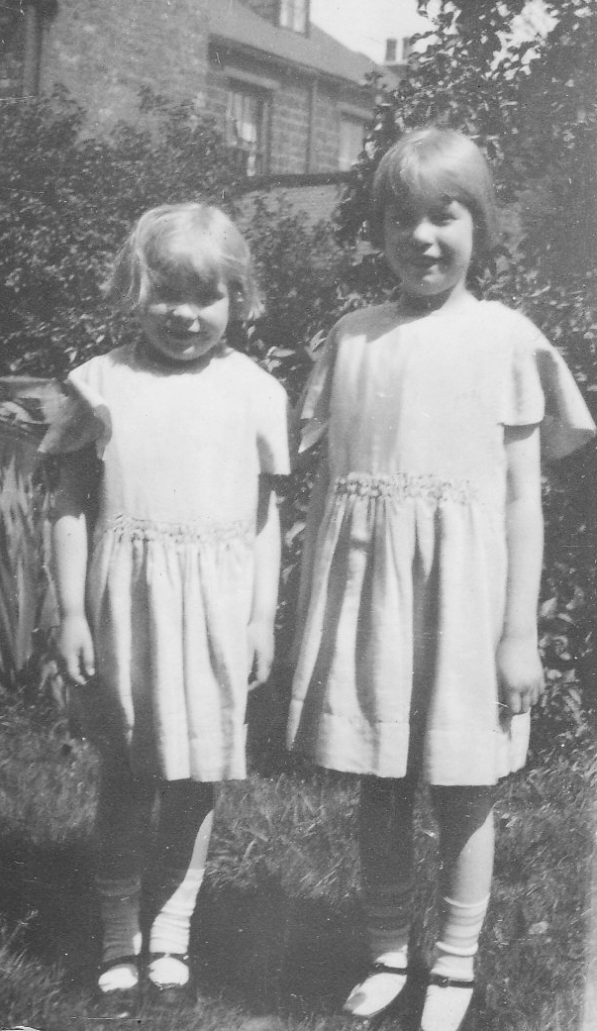
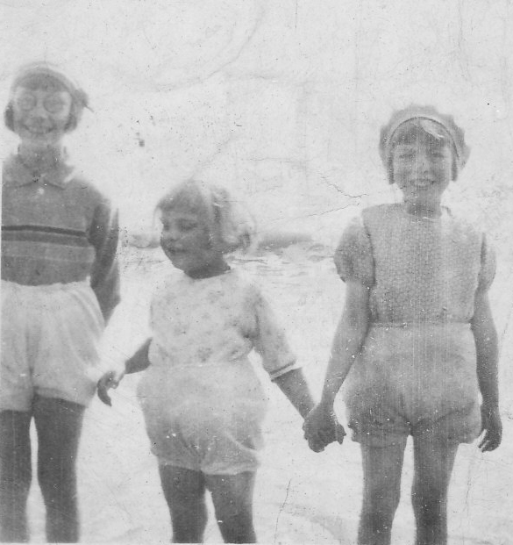
After college getting a post was not very easy because married women came back into teaching because of the shortage of male teachers. I got a post at Batley C of E Primary School. It was a typical church school building with five classes – two infant and three junior. We had ages 3 – 7 in the infants. Class 1 nursery to 5 yrs. Class 2, 5–7 yrs. The infant classrooms were divided by the ‘old type’ glass partition. Classes 3, 4 and 5 were in the juniors. Mr Thurman, the headmaster, taught class 5 including the scholarship needed to get to Batley Grammar School. He and the boys worked on an allotment across the road from the school in the dinner time break. We infant teachers were always on playtime duty, dinner duty and during the afternoon we had to put the beds out for the 3-4 year olds, not to mention teaching! Our children mainly came from the poorer families and some mothers went back to work in the mills starting at 6.30am so a lot of the children had to get themselves ready for school. The contrast between the back-to-back houses near the school for the mill workers and the mill owner’s properties in Upper Batley as well as the owner of Fox’s Biscuits house, had to be seen to be believed. It was an advantage to have the biscuit factory, though, as we were able to queue at a little shop where we could buy cheap, misshapen, biscuits – quite a luxury for us.
Hilda and Mary in anniversary dresses
Margaret, Hilda and Mary

Then, one Monday in 1944, we were inundated with evacuees, mainly from London and Hull. By 10.30 am I had 60 children in my class, all with different accents – it was hard and I enquired about signing up for the army, just to get away! This situation lasted until a teacher came from London two weeks later and another class was set up. This was a very unhappy time for the evacuees in a strange land and being so young and away from their families. Eventually the situation eased and many went back home.
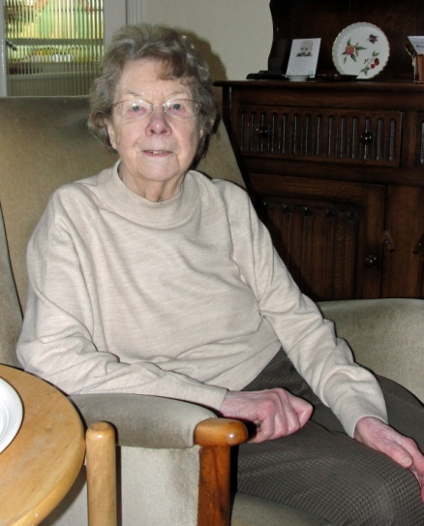
In September 1945 I had a letter from the West Riding Education Council saying that there was a vacancy at Park Road Infants School in Mexborough if I wanted it. I applied and got it and started there in the December. A great contrast to Batley. A bungalow type building with eight classrooms, central hall, kitchen, canteen, a large playground at the front and grass at the back. I was the youngest teacher there. I lived in Swinton and everyone else lived in Mexborough so I was an unknown quantity. Eventually things settled down and altered and I enjoyed my job and made good friends and learned more about Mexborough than I knew about Swinton!
Then one day a West Riding Inspector came and asked if I would be interested in taking a job at Mexborough Roman Terrace Primary School, overseeing the two infant classes. After much thought and consideration I decided on the move (this school had a reputation for being a ‘bit rough’). He school building was like an updated version of the school at batley. I was now in my middle thirties and the oldest female teacher there. With staff changes over the years I then became deputy head and when Highwood’s Infants School headship became vacant I was given the job, much to my surprise, and stayed there until I retired in 1982 after forty years in teaching.
I started going to the Sunday School at Swinton Congs when I was 5 tears old. I taught a primary group from 14 – 16 yrs old and at 16 became Primary leader which I did until I left for college when I was 18. On return from college I continued going to church and, in my 30s, became a Deacon. I played badminton and ran coffee mornings with Gwen Flinton. We had a church band which played for dances during the war to raise money for charity. When Swinton United Reformed Church shut I began worshipping at West Melton URC where I remain to this day.
Kids for Christ Jesus
Is a project run by a contact of mine in India. David Karunakar and his wife Lavanya have a ministry working with street children in India. Their desire is to provide a school in which to educate poor and street kids. As you can imagine doing this costs money. To provide free education and food for each child will cost about £20 per month. To build a School with all educational facilities they need a building with 3,000 square feet, which would cost just over £35,000.
If you have internet access and would like to read more about this fantastic project you might like to visit www.kidsforchristjesus.com

News from around the world

Christian man killed in Pakistan after refusing to convert to Islam
A Christian man in Pakistan suffered fatal gun-shot wounds in an attack believed to have been carried out because he resisted pressure from Muslim colleagues to convert to Islam.
Younas Masih (55) died last Tuesday (5 February) following the shooting five days before. He was attacked in Baluchistan as he made his way home by a gunman who shot him five times. Younas was rushed to hospital in a critical condition; the bullets were removed, and he received treatment in intensive care before succumbing to his injuries. Younas’ Muslim colleagues had been pressuring him to convert to Islam. Repeated threats and blackmail attempts had been made against him but he had remained firm in his faith.
On the day of the shooting, Younas’ co-workers made another attempt to persuade him to convert. A heated discussion ensued, with insults and threats issued. Younas’ son tried to register the attack on his father with the police, but they refused to file a First Information Report, which launches a criminal investigation in Pakistan. The family has made repeated appeals for justice, which have been ignored. They feel abandoned by the authorities.
Christians are an extremely vulnerable minority in Pakistan, which is 95% Muslim. They suffer discrimination and persecution because of their faith, and rarely experience help from the authorities. Speaking about the tragic death of Younas Masih, one church leader said that “the behaviour of the concerned authorities was even more devastating”, adding: We demand protection for the lives and property of minorities in Pakistan. The authorities must ensure and safeguard the basic rights of minorities and protect them from hatred and violence. (http://barnabasfund.org/Christian-man-killed-in-Pakistan-after-refusing-to-convert-to-Islam.html)
Over 500 Christian girls kidnapped by Muslims in Egypt since revolution
Over 500 Christian girls have been abducted in Egypt since the revolution of January 2011; they are taken by Salafists who forcibly convert them to Islam and marry them to Muslim men against their will. The number of cases has been documented by the non-governmental Christian organisation Association of Victims of Abduction and Enforced Disappearance (AVAED), which says that Salafist sheiks are behind nearly all of the abductions and the interior ministry colludes with them.
Founder Ebram Louis said: In every Egyptian province there is a Salafist association which handles the kidnapping of Christian girls. They have homes everywhere where they keep them. If we inform the police where the kidnapped girl is being kept, they inform the Salafists, who then move her away to another home and then we lose all trace of her.
AVAED lawyer Said Fayez said that the age of the abducted girls is becoming younger at typically 13-14 years old. One case involves 14-year-old Sarah Ishaq Abdelmalek from el-Dabaa. She disappeared on her way to school on 30 September 2012, having stopped at a bookshop; Sarah’s father subsequently accused the Salafist bookshop keeper of abducting his daughter and marrying her against her will. Mr Louis said that Sarah was smuggled across the border to Libya with the help of the interior ministry. The kidnappers claim that the teenager left home, embraced Islam and married a Muslim man of her own free will. A spokesman for the Salafist Front said that they would not hand over Sarah under any circumstances, claiming that they were acting in the interests of her human rights. Under Egyptian law, a person may not marry or change their religion until the age of 18. The prosecutor in Alexandria has ordered the arrest of Sarah’s kidnapper, but the police have failed to take any action. Another recent case has had a happier ending. Agape Essam Girgis (13) from el-Ameriya, near Alexandria, went missing on 23 December 2012; she had gone in a taxi with her school’s Muslim social worker and two male teachers. Agape was drugged and woke up in a secluded place with an elderly woman and two sheikhs, who tried to convert her to Islam. The schoolgirl was forced to wear full Islamic dress and was beaten two or three times when she refused to say the Islamic confessions of faith. Following demonstrations by Agape’s family and their supporters, she was returned on 31 December. Her family has decided that she will not return to school. Many Christian parents are no longer sending their daughters to school, fearing that they may be kidnapped.
http://barnabasfund.org/Over-500-Christian-girls-kidnapped-by-Muslims-in-Egypt-since-revolution.html
REGULAR ACTIVITIES IN OUR CHURCHES
Clayton West

Sunday Worship every week at 3.00 pm. Communion is included
in the service on the 1st first Sunday of each month
Friday Baby and Toddler Group 1.15pm – 3.15pm (in term time)
Saturday Coffee Morning on the 4th Saturday each month 10.00am

Trinity (Barnsley)

Sunday Worship every week at 10.30 am. Communion is included in the service on the 3rd third Sunday of each month
Tuesday Bible Study at 7.30 pm
Wednesday Age-Well (over 50s club) every week 10.30am-1.00pm
Trinity Players every week at 7.30pm
Thursday Trinity Tots (carers & toddlers) 10.00am – 12.00noon

West Melton

Sunday Worship on the 1st (inc. WHIZZ KIDS) and 4th Sundays at 10.30am and on the 2nd & 3rd Sundays at 3.00pm. Communion is included in the service on the 3rd Sunday of each month
Wednesday Little Stars 9.30am every week (in term time)
Praying Hands (prayer group) 7.30pm – 8.30pm on the 2nd Wednesday of each month
Fellowship evening (varied programme) 7.30pm on the 4th Wednesday of each month
Saturday Men’s Breakfast at 8.00am on the 3rd Saturday each month

Group Minister: Group Treasurer:
Rev. Nick Percival BA Mr. John Paskell
19 Longdale Croft 1 Giles Avenue
Barnsley, S71 2QT Wath on Dearne
Tel: 01226 771277 Rotherham, S63 6SG
Mobile: 07986668032 Tel: 01709 879224
Email: revnickp@yahoo.co.uk Email: john@paskellplumbing.co.uk

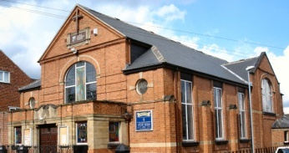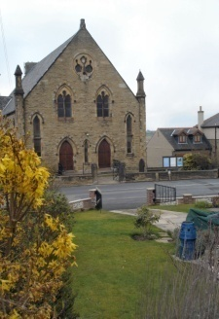
Trinity Clayton West West Melton,
Farrar Street Church Lane Melton High Street
Barnsley Clayton West Wath on Dearne
S70 6BS Huddersfield HD8 9LY Rotherham S63 6RG

Church Secretaries:

TRINITY: Mrs. Fiona Weighton-Smith, 18 Normans Way, Sandal, Wakefield, WF2 6SS Tel: 01924 253010
Email: isabelsmith655@talktalk.net

CLAYTON WEST: Mrs. Betty James, Winter Hill Farm, Bank End
Lane, High Hoyland, Barnsley, S75 4BB
Tel: 01226 382820

WEST MELTON: Mr. John Paskell. (As above)

www.urcbarnsleygroup.co.uk

