LINK

The magazine of the Barnsley Group Pastorate



**SUMMER 2012**  

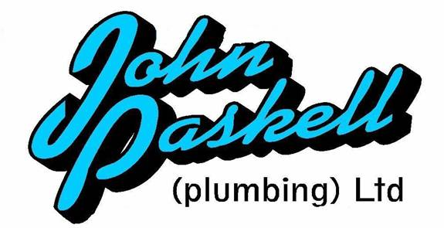Plumbing and

heating engineers

Tel: 01709 873518

[info@paskellplumbing.co.uk](mailto:info@paskellplumbing.co.uk)

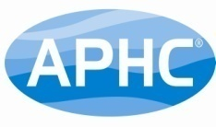

**Druids Sheffield**

**Friendly Society**

Plans for Healthcare – Tax Exempt Savings

Sickness and Death Benefits

Endowments – Insurance I.S.A.

Leaflets on all plans available from:-

Dove House, Brampton Road,

Wath-Upon-Dearne, S63 6BE

Tel: 01709 876409

Fax: 01709 878045

Email: deuidssheffield.friendly@virgin.net

www.druidsfriendly.co.uk

Established 1858. Authorised in the United Kingdom under the Friendly Societies Act 1992. Reg. No. 795f

Druids Sheffield Friendly Society is regulated by the

13307

_________________________

**Simon T. Anderson**

Funeral Director

23 Dodworth Road, Barnsley.

**(01226) 733119**

*24 HOUR SERVICE*

AN INDEPENDENT FUNERAL SERVICE

*Professional and friendly advice on all aspects of the funeral service*

Financial Services Authority

___________________________________________________



Andrew P. Lockwood

**MinstChP. CCM(Sheffield)**

**CHIROPODIST**

**All Foot Ailments Treated**

CORNS – CALLOUSES (Hard Skin) – VERRUCAE – ATHLETE’S FOOT etc.

**Home Visits – Prompt Attention**

**Tel: 01484 687632**

**Mobile: 07971355078**

Dear friends

As I write this the sun has decided to shine and the temperature is steadily rising. I am hoping that summer has now started. Probably a vain hope knowing the vagaries of our English weather.

But I can still hope, can’t I? And what about our hope for the ‘bigger’ things in life? What about our Christian hope?

[1 John 5:4-5](http://biblegateway.com/bible?version=51&passage=1+John+5%3A4-5) says: *‘For every child of God defeats this evil world, and we achieve this victory through our faith. And who can win this battle against the world? Only those who believe that Jesus is the Son of God.’*

Sometimes it seems like there are no limits to the evil that humankind can do; a headline in the newspaper, a scandal laid bare, a heartbreaking story. This world is evil and no matter how much progress we make with technology, communication and global business, it will remain an evil place, because deep down we are all capable of more than we can imagine.

That sounds pretty bleak.

What is the Christian’s hope?

Jesus.

Our faith in Him, that He is who He says He is, changes everything! This faith allows God to work through us to change us, and to help us make an impact on a world that is in desperate need. This faith gives us hope, not in ourselves but in God, who sent His Son to rescue us from our destructive selves, so that we can have life, life in all its fullness.

But we’re swimming upstream. It’s not enough to have faith. So many people have faith. (We can have faith in anything!) The only faith that gives us the victory, that helps us to be different from the core of our hearts, to the depth of our being, is faith in the Saviour of the world. His name is Jesus.

Where’s your hope?

Have a good summer and may our God of hope continue to bless you.

Your friend and minister



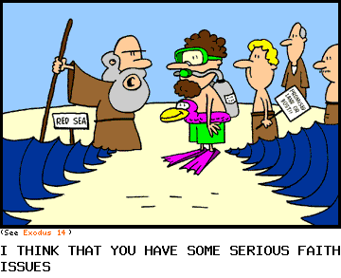

WEST MELTON’S GREEN TIPS CORNER

**Numbers 8 & 9– Cleaning Smelly Trainers and Chopping Boards** by Helen Owen

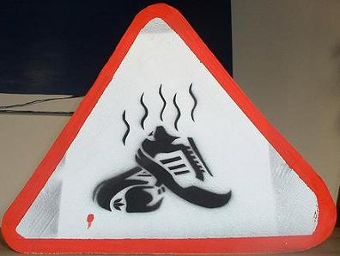

**Cleaning your smelly trainers**

Poor a little bicarbonate of soda inside and leave overnight. Shake out next morning. The bicarb will absorb odours overnight.

**Cleaning your chopping boards**

*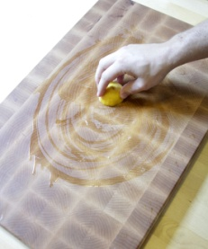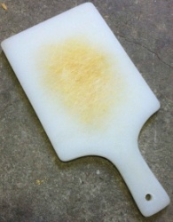Step One:* Cut a lemon in half. Take one half of it in your hand and squeeze the juice all around your cutting board, using the lemon to spread it all around. The lemon juice naturally deodorizes those lingering onion and garlic smells that may be lurking on your board. Discard the used half of lemon.

*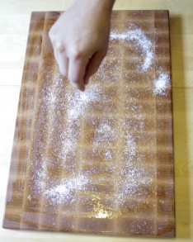Step Two:* Sprinkle course salt all over your board and squeeze the juice of the second lemon half on top of that. Repeat the process of step one by using the lemon to clean the board. The course salt scrapes all of the crumbs and dried bits off your board, as well as absorbing the lemon juice so your board doesn't get too wet.

*Step Three:* Using paper towels (or a tea towel, if you don't mind), wipe the lemon and salt off. This may take a little while, depending on how much salt you used. Dampening your paper towel will help. When the board is salt free, stand it up on its side and allow it to dry completely.

Christian African Relief Trust by Ann Peace

by Ann Peace

In March this year a group of ladies from West Melton URC and a church in Great Houghton decided we could use our spare wool to knit jumpers for children to support the work of the Christian African Relief trust (C.A.R.T.)

The trust was started in 1982 by Mr. G. Tomkins and his wife who sent one box of items to poor Ghananian students. Mr. Tomkins, a committed Christian, asked other like-minded people to assist him. Over the years he established a network of supporters throughout West Yorkshire and other areas nationwide.

The group outgrew its original ‘shed’ in Huddersfield and moved into its present warehouse in Lockwood, Huddrersfield im 2000. The purchase price of £120,000 being raised through voluntary donations.

C.A.R.T. now works with other small agencies and representatives of the people in over 17 African countries.

In April we sent 46 jumpers and have received a letter from their representative in Zimbabwe, Byrony Pichanik. The following is an extract from the letter:

*It is the beginning of winter here so the jumpers and blankets have been distributed immediately. Thank you for making it possible for them to receive one. These were distributed in our urban* *groups in Harare. These people have a daily struggle just to feed themselves, so the jumpers and blankets are a great gift.*

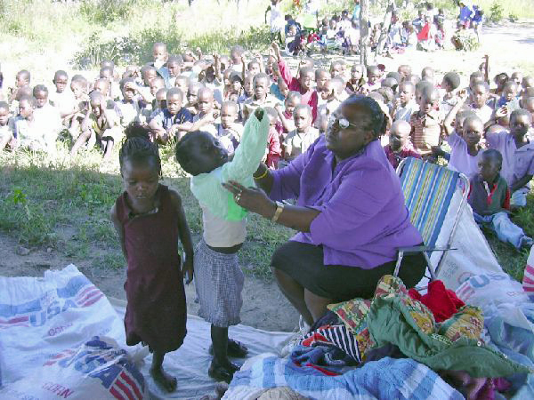

Children receiving jumpers from a lady in Zimbabwe

*The gifts we are able to distribute from you are a reminder to the*

*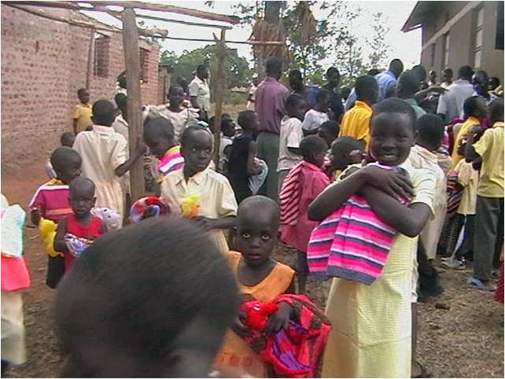people that there is a God who cares for their physical needs and also fellow Christians in a far country who want to help them. It is a form of love in action and the evidence is there for all to see for a long time to come.*

Children hugging jumpers at a displaced peoples' camp near Lira in the north of Uganda

Our work for C.A.R.T. will carry on. If anyone wishes to join us patterns are available from me, (*Ann Peace - 01709 875691*).

If you can’t knit your donations of Double Knitting wool will be most welcome. Thank you. Ann.

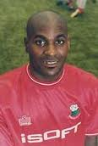**Love Life Festival** by Bruce Dyer

MANCHESTER United defender Rio Ferdinand was the special guest at the LoveLife UK festival in Barnsley on Bank Holiday Monday in May.

Ferdinand signed autographs and met with fans at the festival, which was attended by about 2,000 people on Kendray Playing Fields near to the town.

The event, organised by retired footballer Bruce Dyer, included fun rides, food stalls and live gospel music by artists LZ7, Philippa Hanna, Isaiah Raymond Dyer, Israel Allen and Bruce's wife, Janine Dyer.

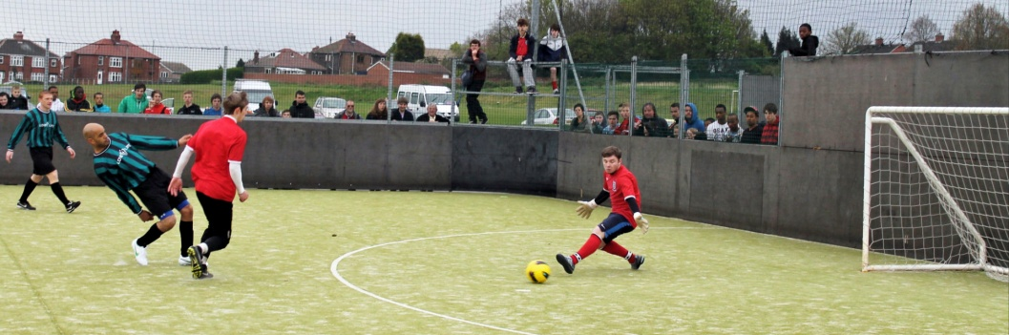

There was also a five-a-side tournament with winners Barnsley Academy facing an all-star team in an exhibition match that included professional footballers Bobby Hassell, John Bostock, Danny Webber, Leon McKenzie, James Chambers and Mustapha Dumbuya. Dyer, the nation's first £1million teenager who enjoyed a glitzy career with Crystal Palace, Barnsley and Sheffield United, said: "It was a terrific day which was enjoyed by many people. We are thankful to God for holding off the rain and 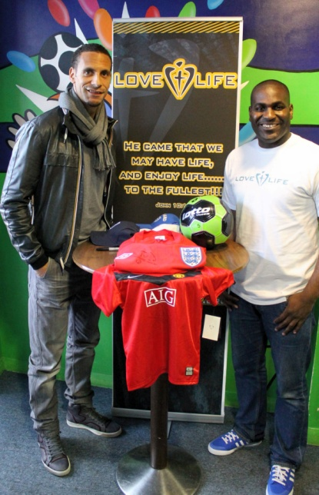giving us a blessed day."

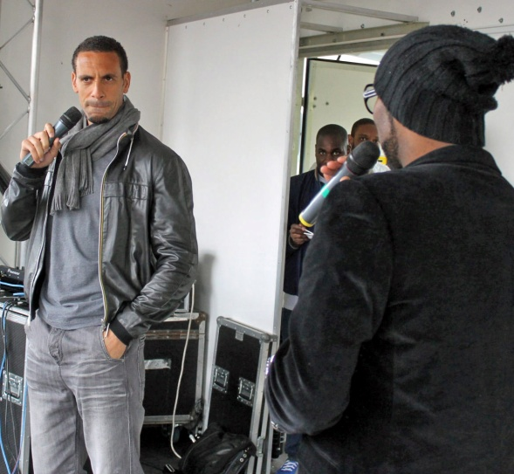

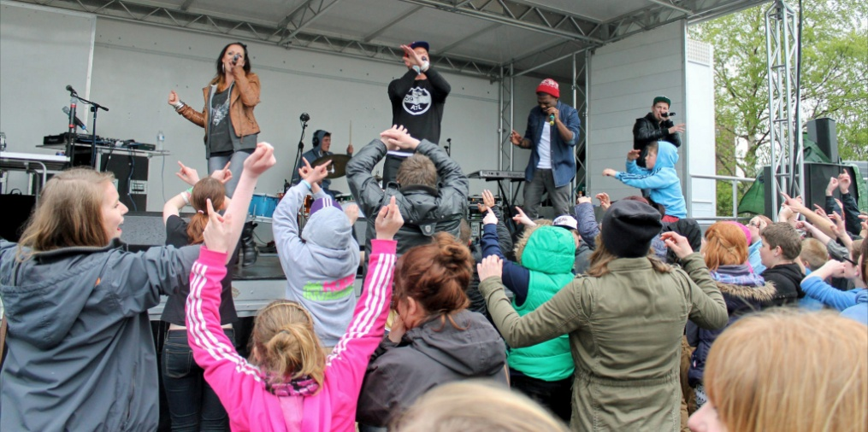

Check out www.[www.lovelifeuk.org](http://www.lovelifeuk.org/)

for more information on Dyer's organisation.

How the internet started... (by ANON)

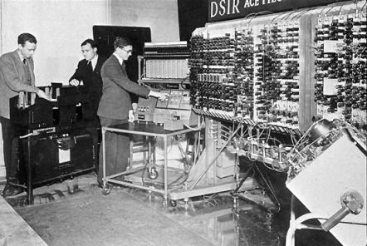In ancient Israel , it came to pass that a trader by the name of Abraham Com did take unto himself a young wife by the name of Dot. And Dot Com was a comely woman, broad of shoulder and long of leg. Indeed, she was often called Amazon Dot Com.

And she said unto Abraham, her husband, "Why dost thou travel so far from town to town with thy goods when thou canst trade without ever leaving thy tent?"

And Abraham did look at her as though she were several saddle bags short of a camel load, but simply said, "How, dear?"

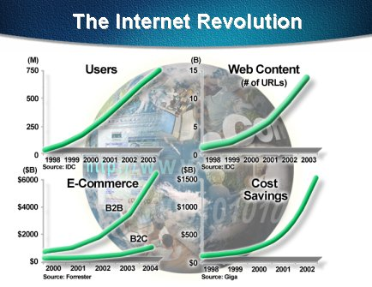And Dot replied, "I will place drums in all the towns and drums in between to send messages saying what you have for sale, and they will reply telling you who hath the best price. And the sale can be made on the drums and delivery made by Uriah's Pony Stable (UPS)."

Abraham thought long and decided he would let Dot have her way with the drums. And the drums rang out and were an immediate success. Abraham sold all the goods he had at the top price, without ever having to move from his tent.

To prevent neighbouring countries from overhearing what the drums were saying, Dot devised a system that only she and the drummers knew. It was known as Must Send Drum Over Sound (MSDOS), and she also developed a language to transmit ideas and pictures - Hebrew To The People (HTTP).

And the young men did take to Dot Com's trading as doth the greedy horsefly take to camel dung. They were called Nomadic Ecclesiastical Rich Dominican Sybarites, or NERDS.

And lo, the land was so feverish with joy at the new riches and the deafening sound of drums that no one noticed that the real riches were going to that enterprising drum dealer, Brother William of Gates, who bought off every drum maker in the land. And indeed did insist on drums to be made that would work only with Brother Gates' drumheads and drumsticks.

And Dot did say, "Oh, Abraham, what we have started is being taken over by others." And Abraham looked out over the Bay of Ezekiel , or eBay as it came to be known. He said, "We need a name that reflects what we are."

And Dot replied, "Young Ambitious Hebrew Owner Operators." "YAHOO," said Abraham. And because it was Dot's idea, they named it YAHOO Dot Com.

Abraham's cousin, Joshua, being the young Gregarious Energetic Educated Kid (GEEK) that he was, soon started using Dot's drums to locate things around the countryside. It soon became known as God's Own Official Guide to Locating Everything (GOOGLE).

That is how it all began. And that's the truth.

