LINK

The magazine of the Barnsley Group Pastorate

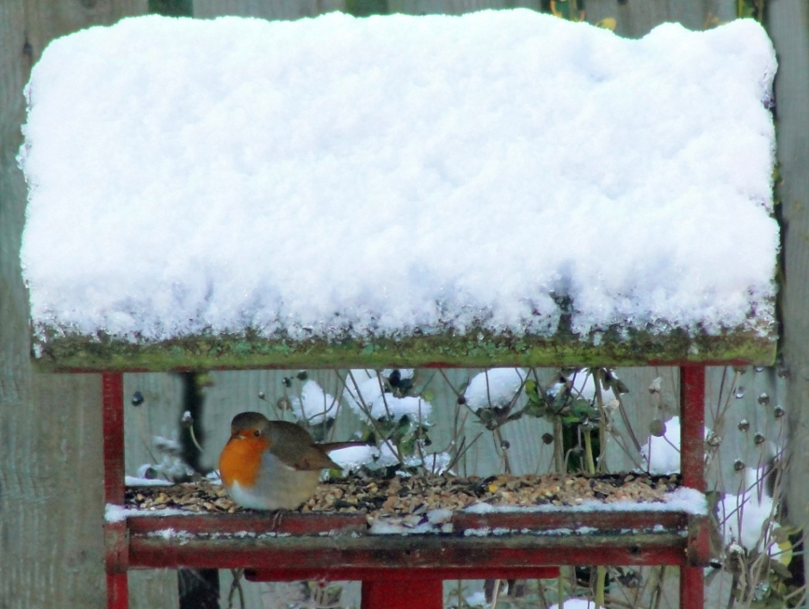

**WINTER 2012**  

Plumbing and

heating engineers

Tel: 01709 873518

[info@paskellplumbing.co.uk](mailto:info@paskellplumbing.co.uk)



**Druids Sheffield**

**Friendly Society**

Plans for Healthcare – Tax Exempt Savings

Sickness and Death Benefits

Endowments – Insurance I.S.A.

Leaflets on all plans available from:-

Dove House, Brampton Road,

Wath-Upon-Dearne, S63 6BE

Tel: 01709 876409

Fax: 01709 878045

Email: deuidssheffield.friendly@virgin.net

www.druidsfriendly.co.uk

Established 1858. Authorised in the United Kingdom under the Friendly Societies Act 1992. Reg. No. 795f

Druids Sheffield Friendly Society is regulated by the

13307

_________________________

**Simon T. Anderson**

Funeral Director

23 Dodworth Road, Barnsley.

**(01226) 733119**

*24 HOUR SERVICE*

AN INDEPENDENT FUNERAL SERVICE

*Professional and friendly advice on all aspects of the funeral service*

Financial Services Authority

___________________________________________________



Andrew P. Lockwood

**MinstChP. CCM(Sheffield)**

**CHIROPODIST**

**All Foot Ailments Treated**

CORNS – CALLOUSES (Hard Skin) – VERRUCAE – ATHLETE’S FOOT etc.

**Home Visits – Prompt Attention**

**Tel: 01484 687632**

**Mobile: 07971355078**

Dear friends



Since the coming of the Internet we hear a lot about viruses. Some are simply hoaxes whilst others can render a computer unusable and delete precious files. I read recently of a new virus which can affect many, if not all, of us. It is called **THE ADVENT VIRUS**.

**WARNING……WARNING: ADVENT VIRUS**

Be on the alert for symptoms of inner **Hope, Peace, Joy and Love**. The hearts of a great many have already been exposed to this virus and it is possible that people everywhere could come down with it in epidemic proportions. This could pose a serious threat to what has, up to now, been a fairly stable condition of conflict in the world.

Some signs and symptoms of **The Advent Virus:**

* A tendency to think and act spontaneously rather than on fears based on past experiences.
* An unmistakable ability to enjoy each moment.
* A loss of interest in judging other people.
* A loss of interest in interpreting the actions of others.
* A loss of interest in conflict.
* A loss of the ability to worry. (This is a very serious symptom.)
* Frequent, overwhelming episodes of appreciation.
* Contented feelings of connectedness with others and nature.
* Frequent attacks of smiling.
* An increasing tendency to let things happen rather than make them happen.
* An increased susceptibility to the love extended by others as well as the uncontrollable urge to extend it.

Please pass this warning on to all your friends. This virus can and has affected many systems. Some systems have been completely cleaned out because of it.

Have a happy and peaceful and virus-free Christmas and New Year and may God continue to bless you.

Your friend and minister

*Cartoon by Ira Coffin*



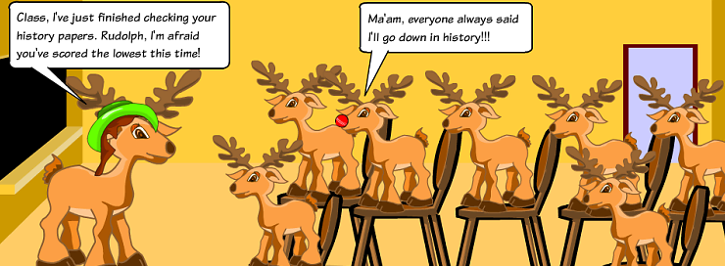

*Rudolph's History Class by Meerasapra*

**WEST MELTON’S GREEN TIPS CORNER**

By Helen Owen

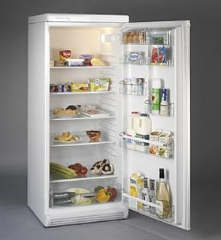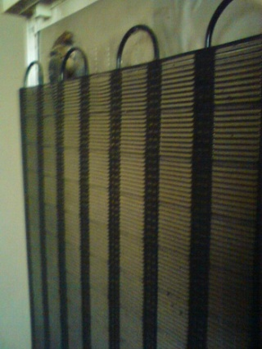**Number 11 – Dusty Fridge**

Help your fridge use less electricity-and save you money- by dusting down the coils at the back. A fridge is a heat exchanger; it transfers heat from the inside of the fridge out into the room. The part that sends the heat out into the room is a radiator type attachment on the back. If this is coated with an insulating layer of dust, it's going to have to work harder to get the heat out there, so the fridge is less efficient, overall. Dusty coils can waste up to 30% extra electricity.

**Number 12 –** **Oil Stains**

Get rid of oil stains on clothes by rubbing chalk on to affected area before washing. This should avoid the use of chemical stain removers.

**My experiences working in Childrens’ Homes**

by Margaret Swallow

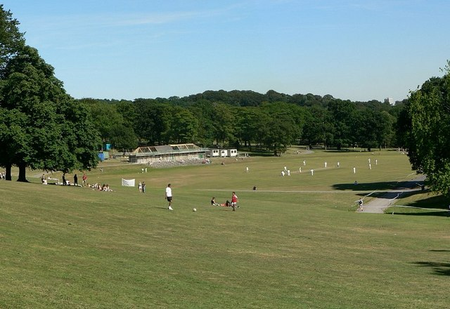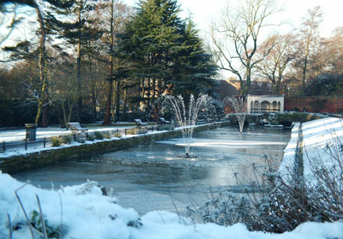I was 20 back in 1959 when I started working with Leeds City Council. It was a large complex consisting of a nursery, reception centre , boys home and a short stay home. I was to work in the short stay home which was situated not far from Roundhay Park. Roundhay Park was ideal for taking the children (24 of them) sledging during the winter . There were lots of events organised in the park, including Jimmy Saville in his early days, riding in his now famous car with his dyed locks!!

My very first day I was asked to cook dinner for the children coming home from school! “Can you cook Liver” I was asked! Thinking of neatly sliced lamb’s liver I did not think there would be a problem. That is until I saw 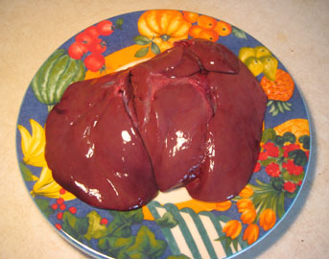the huge monstrosity complete with tubes which had to be dissected before I even started cooking! Then there were potatoes to rumble, peel, cook, and veg to prepare--some 2 hours later the kids had their meal--not a very successful one!!!!

The children stayed with us for only a short time usually whilst their mum’s had their other babies.

We had holidays at the sea side--usually in Bridlington . All the children were kitted out in brand new clothing and Clarks shoes. They were well cared for but the one thing missing in their young lives was time to love them and treat them as individuals! Two housemothers (as we were called) looking after24 children, cooking for, playing with, washing, cleaning and a myriad of other tasks all part of the daily routine. I remember on one occasion putting a pan of eggs on to boil, and sneaking off to put rollers in my friend Maureen`s hair, before the children got home from school.

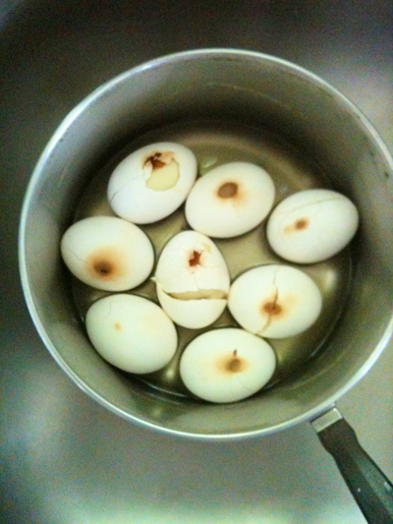Some time later, we returned to our duties to find that 1dozen hard boiled eggs had fallen through the pan and stuck to the gas burner!! A bit like my experience with my charcoaled beetroot last week!! *(But that’s another story.)*

My annual salary was £390 minus £120 board and lodge. My first pay packet contained £2.8 shillings and I had ½ day off per week! Happy Days!

It was hard work, but I enjoyed every minute. I often wonder what happened to the youngsters we cared for. I am still in contact with two from my days at Lymm, and have been privileged to see their children and grand children growing up and leading happy and successful lives!

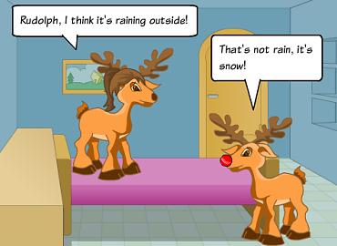

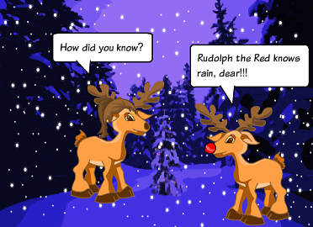

*Rudolph the Red by Meerasapra*

Five Have Fun in Whitby!

By Trinity Age-Well

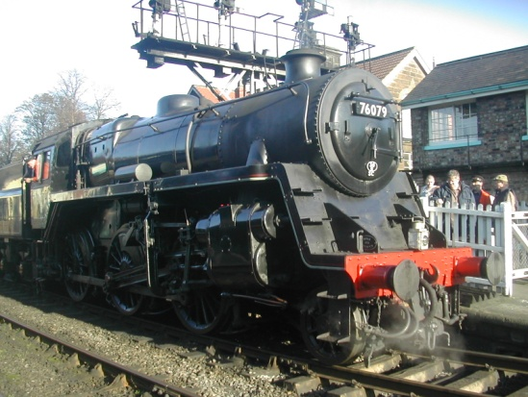The intrepid-five set off on an outing to Whitby. The morning started with some excitement for Fiona and Joyce. Fiona was supposed to be calling at Joyce’s to leave her car there and pick up a taxi which would take them both to the bus-station. 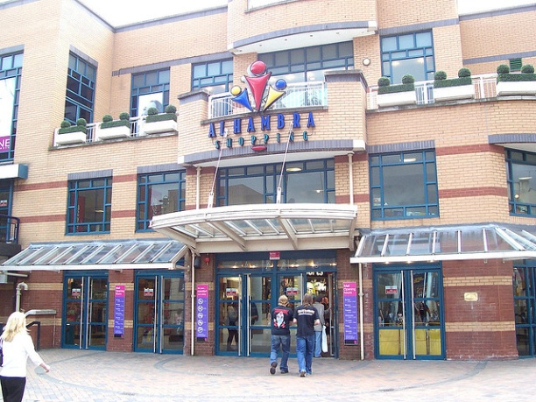Unfortunately Fiona was late and so missed the taxi. Driving quickly but not breaking the speed limit she managed to park in the Alhambra Centre and walked quickly to the bus station where the others were waiting for her. Luckily Joyce had got the taxi, which had arrived at her house on time. There were 50 others on the coach that was to take us to Whitby. We had decided to use the Yorkshire Rose Coach company; rather than booking and filling one ourselves.

We left the bus station on time at 9.00a.m. with a pick-up in Dewsbury then on to Pickering where we boarded the steam train at 12 mid-day. We had a very pleasant journey passing through beautiful countryside. Lovely trees, heather and bracken with cattle, sheep and colourful pheasants running under the trees. The sun shone on everything. 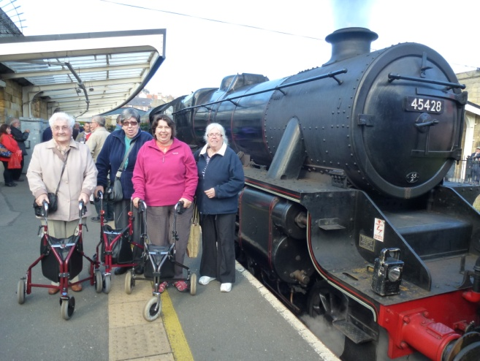The trip took two hours. Stewards came round with a trolley selling drinks, eatables and memorabilia. Tracey bought a guide book from which she proceeded to regale us as to the sizes and capacities of the various engines. That is until Val said in a no-nonsense voice “OK that’s enough teacher”.

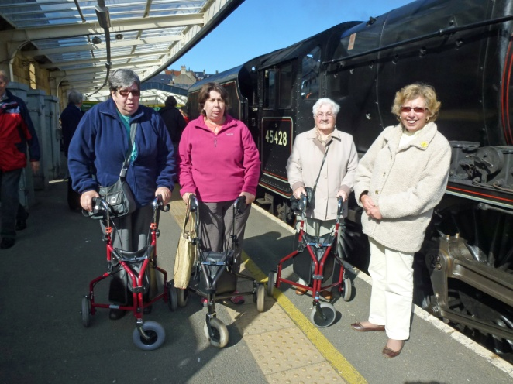Arriving in Whitby at 2p.m. there was a mad dash to the toilets after which we split into two groups. Alice’s first call to a shop where she hoped to get an Aspidistra, but no success. The next stop was a shoe shop where Tracey bought a pair of boots. The assistant was very nice and we managed to get 4 empty shoe boxes from her, a strange request maybe, but we were thinking about the shoe boxes we would soon be filling with goodies to send to the Operation Christmas Child charity. Then it was off to the famous fudge shop to treat ourselves.

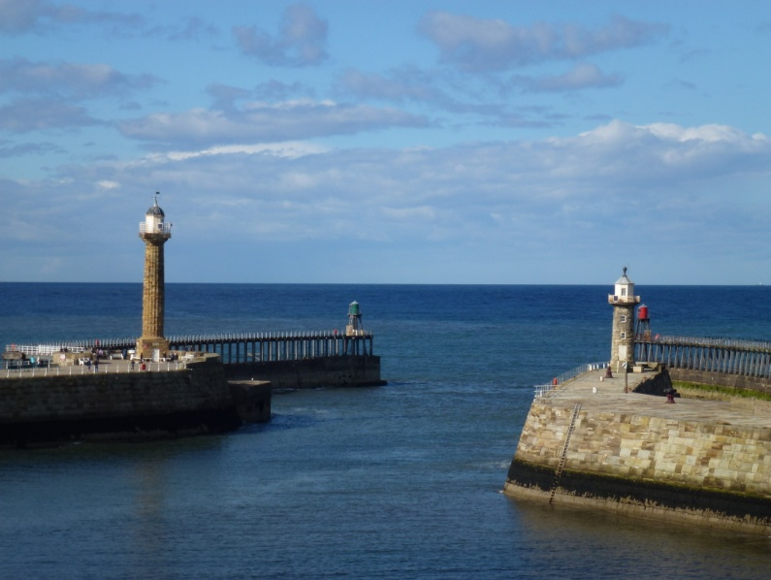Joyce and Fiona decided to walk along the quayside towards the pier. The weather stayed sunny and the sea was blue. As it had been some time since breakfast Fiona needed some nourishment and treated herself to a waffle. Joyce had brought a sandwich and had a cup of tea. Leaving Joyce sitting on a seat Fiona went for a walk in the Old Town. For a Wednesday Whitby was busy with day trippers like us and young families.

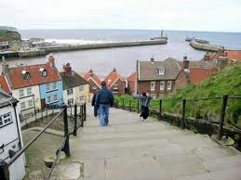Calling at the rock shop where the display was tempting so Joyce and Fiona bought a sample to take home as pressies for friends. In the old town many were climbing the 199 steps to the Abbey; but a good enough excuse for Fiona not to climb them was there was not enough time!

Poor Joyce had become rather cold sitting so had walked to the bridge to meet up with the 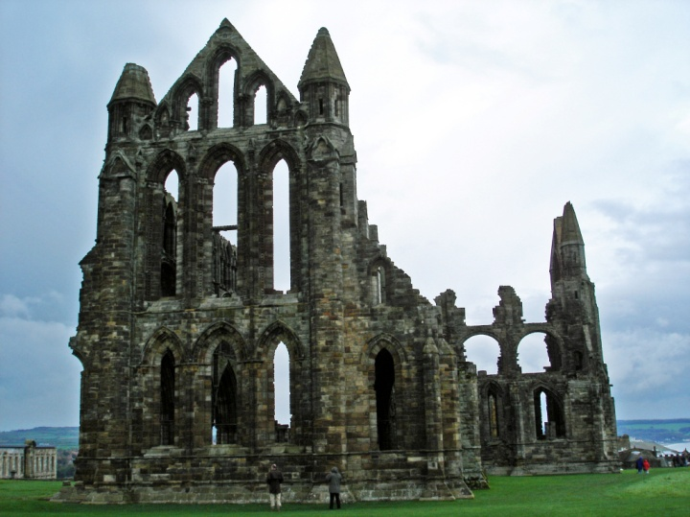others. We all walked back to the pick up point for 4.00p.m. as the coach was to leave for the Fish and Chip restaurant near York where we due to arrive at 5p.m.

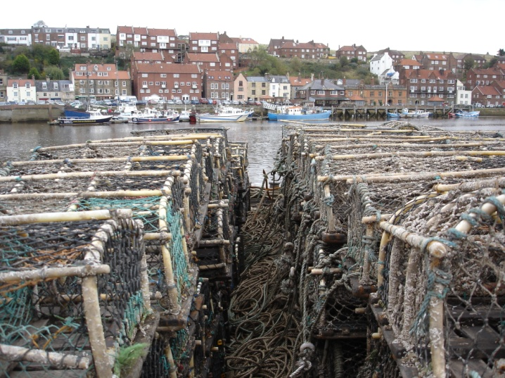Arriving back in Barnsley at 7.30p.m. Fiona went to get her car to find that the car park at the Alhambra centre closes at 6.30p.m. Hiring a taxi to take us home Joyce to Caister Avenue and Fiona to Wakefield. Next morning another taxi ride to the car-park to retrieve her car Fiona made it back to Barnsley ; an experience not to be repeated.

A very enjoyable day, even with the evening’s problem, was had by all.