LINK

The magazine of the Barnsley Group Pastorate



**AUTUMN 2012**  

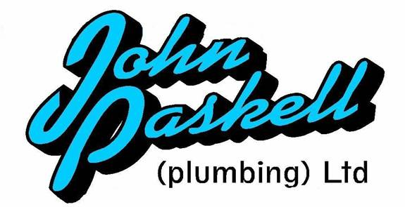Plumbing and

heating engineers

Tel: 01709 873518

[info@paskellplumbing.co.uk](mailto:info@paskellplumbing.co.uk)



**Druids Sheffield**

**Friendly Society**

Plans for Healthcare – Tax Exempt Savings

Sickness and Death Benefits

Endowments – Insurance I.S.A.

Leaflets on all plans available from:-

Dove House, Brampton Road,

Wath-Upon-Dearne, S63 6BE

Tel: 01709 876409

Fax: 01709 878045

Email: deuidssheffield.friendly@virgin.net

www.druidsfriendly.co.uk

Established 1858. Authorised in the United Kingdom under the Friendly Societies Act 1992. Reg. No. 795f

Druids Sheffield Friendly Society is regulated by the

13307

_________________________

**Simon T. Anderson**

Funeral Director

23 Dodworth Road, Barnsley.

**(01226) 733119**

*24 HOUR SERVICE*

AN INDEPENDENT FUNERAL SERVICE

*Professional and friendly advice on all aspects of the funeral service*

Financial Services Authority

___________________________________________________



Andrew P. Lockwood

**MinstChP. CCM(Sheffield)**

**CHIROPODIST**

**All Foot Ailments Treated**

CORNS – CALLOUSES (Hard Skin) – VERRUCAE – ATHLETE’S FOOT etc.

**Home Visits – Prompt Attention**

**Tel: 01484 687632**

**Mobile: 07971355078**

Dear friends

What a summer of sport! What fantastic Olympic Games. What fantastic weather (for a change!) Who’d have thought the Great Britain team would have won so many medals. How interesting that so many Olympians dedicated their success to God. Either by kneeling and kissing the ground, genuflecting (crossing themselves) or by simply looking heavenward and raising their arms up in praise.

Special mention must be made of the participants from Yorkshire who finished up with seven gold medals, two silver and three bronzes, placing Yorkshire twelfth in the medal table if it were regarded as an independent country! A truly magnificent achievement for one county.

If I were to ask you “what is the mission of “the summer Olympians?... What would you say?  
*(Answer)* To Win.  
How do you know if they are accomplishing their mission?   
*(Answer)* Whether or not they are winning their games.  
How do you know if they are winning their games?  
*(Answer)* They keep the score.

I mean can you imagine what a game would be like if the teams just lined up and played each other going up and down the field but didn’t bother to keep the score? What would be the point?

How about our Christian life? What’s our mission? What’s our goal?

If our goal is to win the prize and if we’re to “run to get the prize”, then wouldn’t it be nice to know what “the prize” is?

What is the prize in the Christian Life? What is the reward? I dare say that most of us would say heaven. And we would be partially correct because heaven is part of the prize, but it’s not the prize whilst we are on earth. Do you want to know what the prize is? The prize is a Changed Life. That is surely a prize worth aiming for!

Be a winner by giving God your best in everything!

Your friend and minister



*(Cover picture - ‘It’s a Hoot’ winner of an ‘apple painting’*

*competition at RHS Wisley****)***

WEST MELTON’S GREEN TIPS CORNER



**Number 10– Bathing Beauty** by Helen Owen

A home-made treat to leave your skin feeling silky smooth.  
Put a handful of oats in the foot of a stockng or one tight and tie a knot. Add it to your bath either under running water or just dropped in. It will make the water slightly milky which will make your skin lovely and soft. Don't forget to compost the oats afterwards.   
Don't know if it would work in a shower but maybe you could experiment!

**General Assembly 2012 News round-up**

(Held in Scarborough – 6 – 9 July)

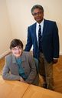**FRIDAY 6 JULY**

New moderator inducted to URC General Assembly

In the opening session of Assembly, the Revd Dr Michael Jagessar was inducted as moderator of General Assembly 2012-14.

During his two-year moderatorship, Dr Jagessar will continue in his permanent role as URC secretary for racial justice and multicultural ministry. Mrs Val Morrison was reaffirmed in her lay moderator’s role. She is expected to hand over to the newly-elected lay moderator, Mr John Ellis next summer.

**Moderator addresses General Assembly**

The Revd Dr Michael Jagessar gave a passionate and lively address, appealing to Assembly members to embrace a habit of trusting in a generous God instead of allowing our lives to been determined by scarcity.

He said: “The re-authoring of our conversations along positive stories of generosity and abundance is not about avoiding tough questions or not dealing with pain or grief: it is about facing them squarely but through a different set of optics — God’s expansive generosity through Jesus Christ’. Full version of address is available online. http:/bit.ly/LErmTQ

**SATURDAY 7 JULY**

**Assembly enables civil partnerships to be registered in local churches**

Assembly agreed a resolution allowing local churches to decide on whether to allow civil partnerships to be registered in their buildings. In taking this decision, the URC has become the first mainstream Christian denomination to allow same-sex partners to register their civil partnership in church.

This resolution takes effect immediately and enables local United Reformed churches in England and Wales to consider whether they wish to allow civil partnerships to be registered on their premises (i.e. for the legal formalities, as well as the religious ceremony, to take place in church). Once a church has decided to take this step, it will need to ask its trustees to apply to the superintendent registrar of the relevant local authority to become registered as an approved venue.

**Awards highlight community action**

Four diverse projects were honoured as part of the 2012 Community Project Awards sponsored by the URC and insurer, Congregational & General.

**Winning a first-place prize of £3,000, The Edge Project was named the overall winner** — *a youth centre whose varied support programme has helped transform the lives of underprivileged young people in the Holmewood area of Bradford.*

Three other projects were awarded joint second place and received £2,000. Our Tribe — an Edinburgh-based project whose work supports greater integration between the lesbian, bisexual, gay and transgender (LBGT) community and the local church**; The Terminus Initiative — an ecumenical project in Sheffield, offering a variety of community services;** and The Avenue Centre — a project that works with families in the community surrounding Southampton.

**In Brief**

‘The Revd David Grosch-Miller was announced as the ministerial moderator of General Assembly for 20 14-16. Mr John Ellis was announced as lay moderator for 2013-16.

Assembly has voted to change the normal retirement age of full-time stipendiary ministers from 65 to 68. No minister will be forced to work beyond 65, but 68 would be the full pensionable age. Ruth Whitehead, convenor of the ministries committee, which brought the resolution. said: ”Ministries will receive any requests to work beyond 68 with acclaim and amazement.”

Report shows youth and children’s work growing

Presenting the first part of the Youth and Children’s report. Rob Weston, convenor of the youth and children’s work committee, detailed growth in areas of the committee’s work. He said ‘We have seen nine new Pilots companies begin in the last 12 months; the change of title from FURY Assembly to Youth Assembly has enabled the participation of more young people at January’s Youth Assembly.

Assembly agreed to”affiirm the Youth and Children’s work offered by Pilots and commend it to local churches” and to celebrate Pilots through a dedicated Sunday service each year.

Mr Weston also expressed his thanks to “talented staff”, including Jo Williams, who will be leaving the role of children’s secretary in July, and John Brown. who leaves his role as URC youth work development officer in October.

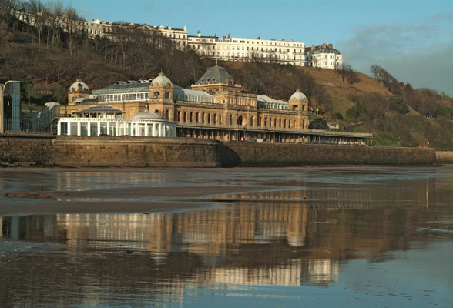

**SUNDAY 9 JULY**

**Major budget cuts agreed**

Accepting the recommendation of Mission Council which met in March 2012, General Assembly asked six of its committee to achieve expenditure reductions amounting to £600,000 in 2013relative to their 2012 budgets.

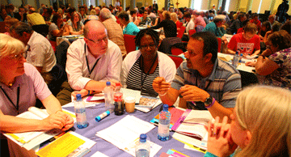The decision came after an emotionally-charged debate which reflected the particular consternation of many members in specific fields affecting children and young people. It continues a process that began in November 2011 when Mission Council agreed the deficit in the budget for 2012 was not sustainable.

While Mission Council chose to identify £600,000 of savings in net expenditure in March 2012 the Moderators Think Tank, on the advice of Finance Committee and the URC Trust had recommended that £1m savings be found at that time. Treasurer John Ellis warned that committees would need to review their longer-term costs to produce further savings.

**Changes to ministers’ pension benefits**

URC Ministers wishing to receive full retirement benefit will need to work until age 68 in the future Following changes to the Rules of the Ministers’ Pension Fund agreed at GA , younger ministers in the United Reformed Church will need to work until age 68 to receive as good a pension as that which has hitherto been available to retiring ministers. This will make little difference to older ministers approaching retirement, since the benefits they have earned through service up to 2012 will still be calculated on the old basis assuming a retirement age of 65.

The changes make dear that it will still be possible for any minister to retire at age 65 if they so wish, with reduced benefits where applicable. Separate decisions were taken allowing the church to pay higher ill health pensions to stipendiary ministers with longer service, and to simplify the church’s pension arrangements in the light of new government regulations.

**MONDAY 9 IULY**

**Final airing for ZI**

Roberta Rominger speaking as co-convener of the ZI steering group took a variety of questions on the end of the campaign.

She confirmed that Mission Committee would be taking the lead on moving forward the URC’s work on radical welcome and that the copyright for posters created for the campaign belongs to the URC; decisions as to their availability have not yet been taken.

As to funding, she informed Assembly that ZI has been funded by a grant from CWM. The accounts to the end of 2011 showed a total expenditure of £325,000 (funded by a CWM grant); final accounts are now being prepared.

In brief continued...

Hundreds of members of Assembly and Children’s Assembly marched with members of the congregation of St Andrew’s URC, from the church to Scarborough Town Hall on Sunday. Their “walk of witness” gave expression to the concerns of many about the disproportionate impact of spending cuts and welfare reforms on the most vulnerable in our society.

At the Town Hall, the walkers, led by the moderators of GA, The Revd Dr Michael Jagessar and Mrs Val Morrison, met Scarborough’s MP, Robert Goodwill, and presented him with a copy of the Scarborough Statement and the URC’s Report on Poverty and Inequality. (Both documents are available from http://bit.ly/MPaOaK).

**West Melton Eco Garden – Latest pictures**

Photos by Georgia Paskell

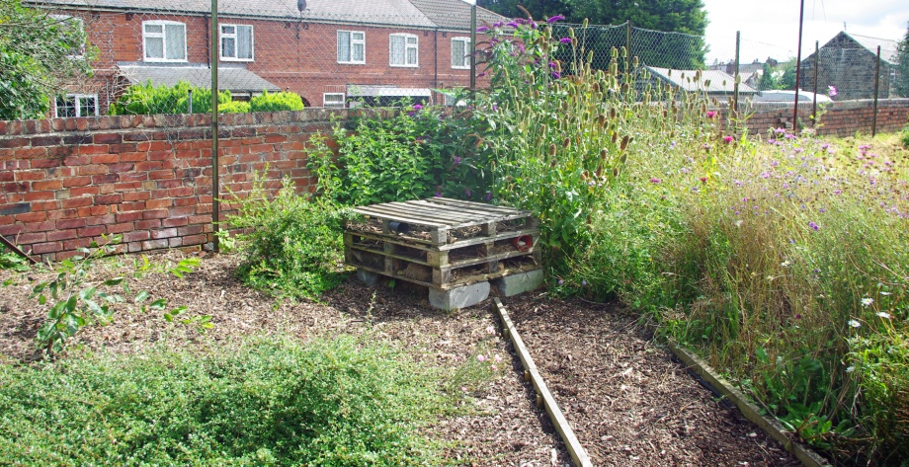

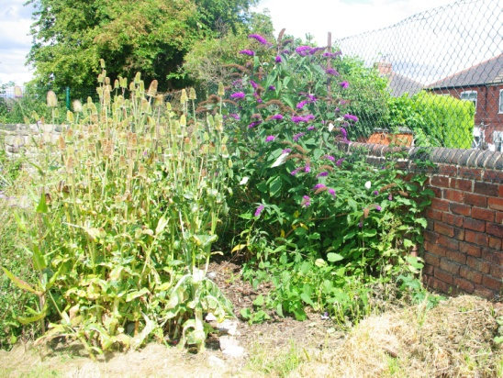 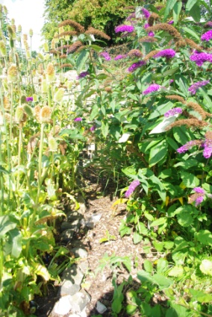

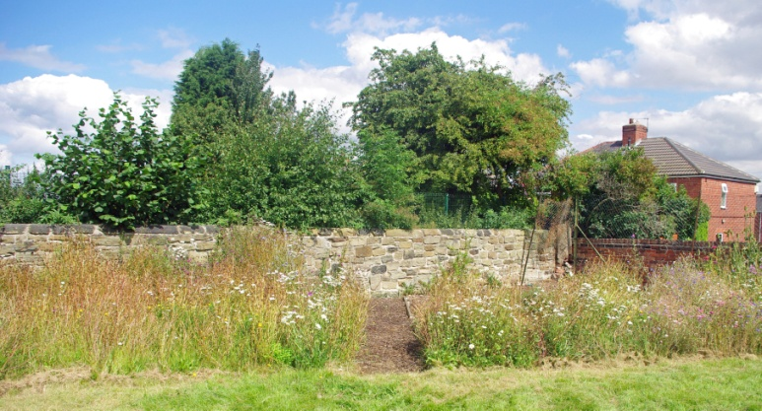

**Getting to know you – Eve Wensley**

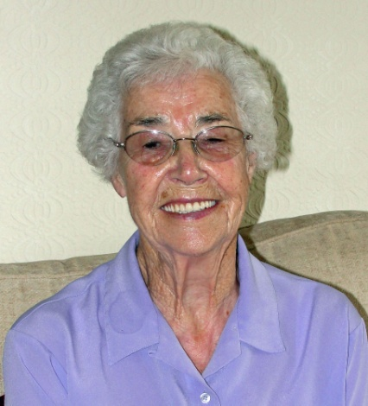Eve celebrated her 90th birthday in July. She writes:

I was born on 21st July 1922, a big disappointment to my parents as they already had two girls and badly wanted a son! However, their wish was granted two and a half years later.

Six of us lived in a two up two down terrace house with one cold tap and the water closet at the bottom of the yard. My first memory is of the 1926 miners’ strike when I went coal picking with my mother. Our father was very strict and believed in children being seen and not heard, but we were well fed and looked after and I spent a very carefree childhood.

We were lucky enough to have a field at the side of our house and I loved nothing better than to be outdoors playing with no fear of being molested (as seems to happen so often today). We were also very involved with Sunday School and went in the morning and afternoon every week.

I had a passion for dolls and as I grew a bit older spent many happy hours sewing dolls clothes. I also loved reading and joined the library as soon as I was old enough and I am still a member.

When I was ten or eleven our fortunes changed and we moved into a brand new three bed-roomed semi-detached house with all mod cons. What a joy to have an indoor loo and bathroom! My brother was able to have his own room, my eldest sister left home to go into service and my other sister and I shared the other bedroom. I also had dancing lessons and learned to play the piano and we also had an annual holiday, usually in Scarborough.

In 1933 a brand new school was built in Barnsley, called Raley School, and I was one of the lucky ones to be in the very first intake. Imagine my joy when I saw what it had to offer. Set in extensive grounds with playing fields, its own swimming pool and a gymnasium with all the modern equipment. There was a domestic science room with electric ovens and even a pottery room where we could dabble with clay. The school also had a cottage where girls, as they grew older, could learn midwifery. I was in the top form and although I struggled with maths I was good at English and enjoyed both history and geography. I excelled at all sports and swimming-all this, then after one short year I was upgraded to Mark Street Central school. What a contrast! From the very new to the very old with a high wall all the way round. However, the high wall did stop the balls going over when we played netball and I was soon chosen for the team. We also went to Race Street baths and I was soon entering the swimming galas. We also had a sports day at Shaw Lane.

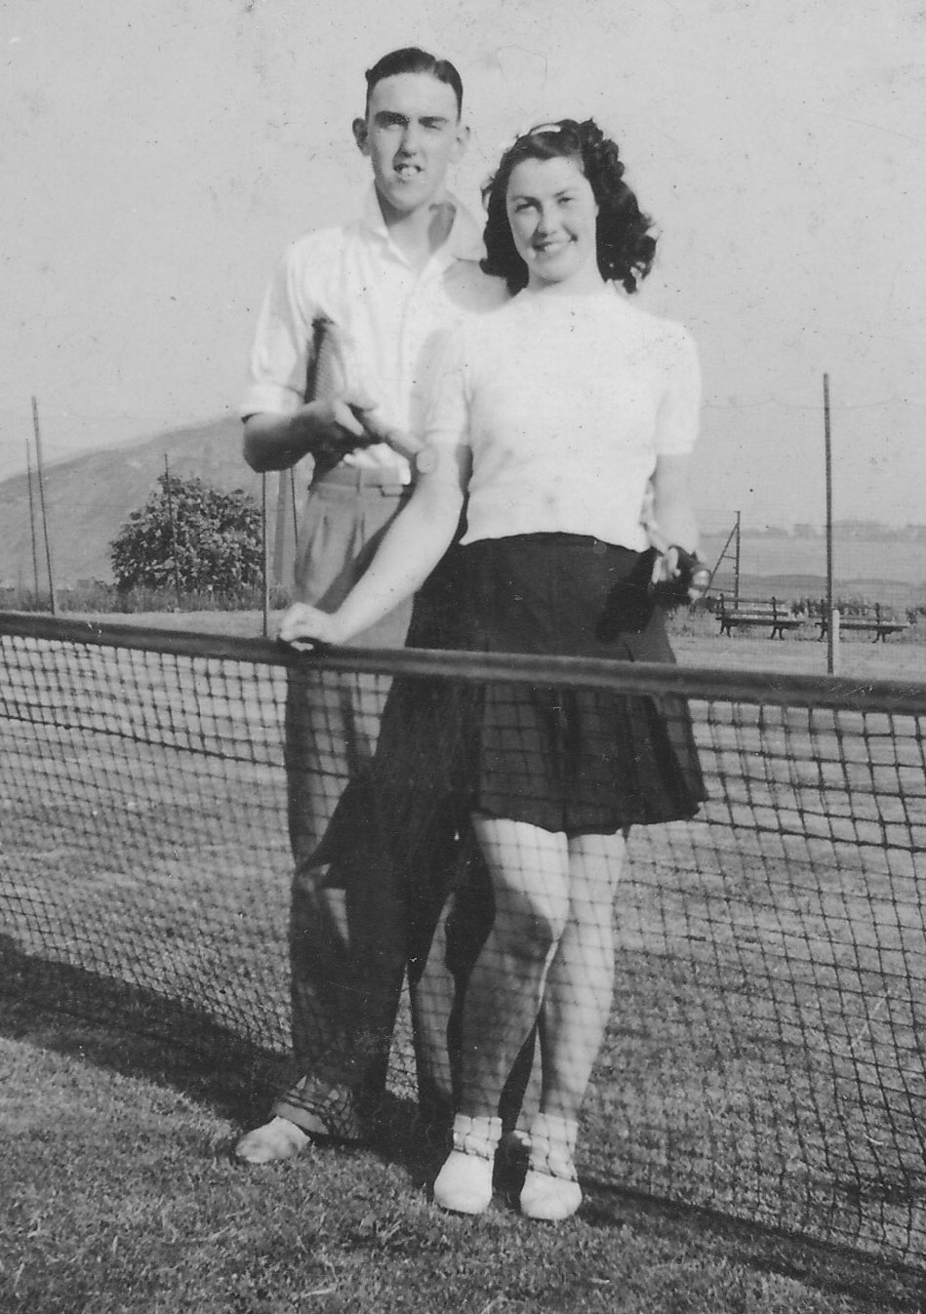Being adaptable I made the best of it but the only benefit I got was that I learned French as I left at fourteen and went to work at the Co-op tailoring and as I did like sewing soon settled down to the tedious work – and it was *The Coop!* They had a sports field next to Barnsley football ground which I quickly joined. We worked long hours but every opportunity I had I was down at the sports field joining in with everything that was on offer. Running in the sports events, playing hockey and it was while learning to play tennis that I met my future husband, Frank.

Then, in 1939, war was declared and life changed dramatically. Being young we looked on it as a big adventure. In due course Frank joined the Air Force, we got married and I joined the national fire service and became firewoman Wensley. It was like Raley school all over again, everything was so much better than I had been used to. I learnt to drive and I was out on the road delivering meals to the firemen at various substations in Barnsley and surrounding districts. Most of my spare time was spent writing letters to Frank and oh the excitement when his leaves came round which was not very frequent as he was soon sent abroad – and so the years went by.

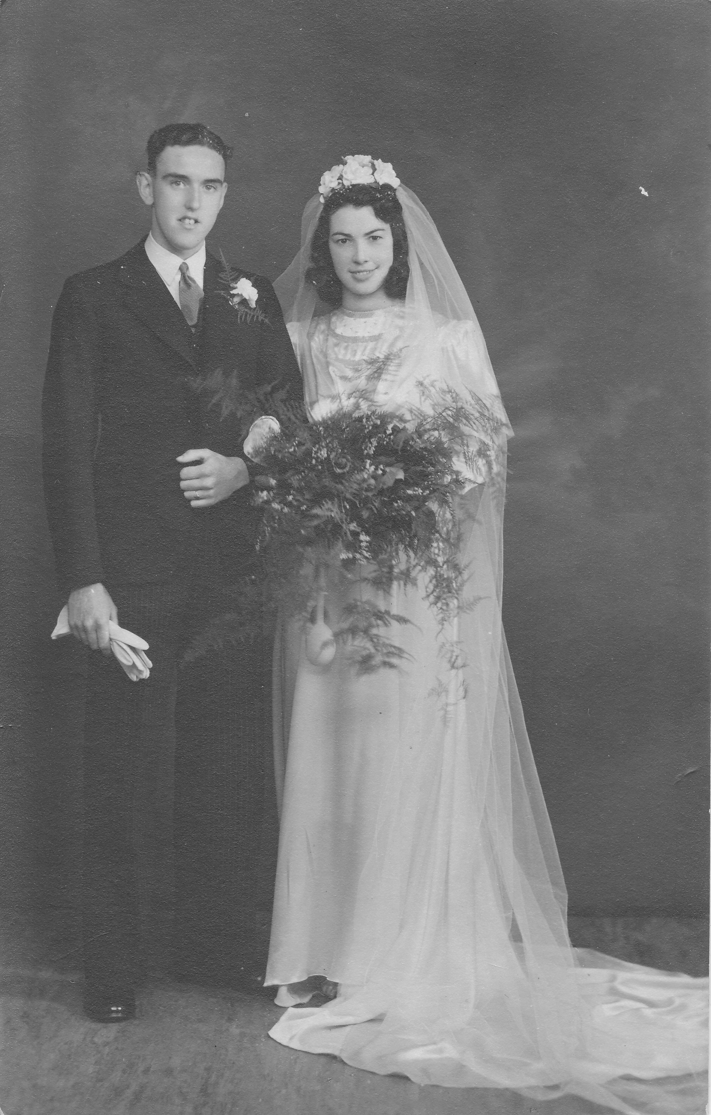And at last the war was over, what rejoicing and excitement as we waited for our loved ones to come home from the war for good. Of course the main thing we wanted was our own home. I had saved enough to put a deposit down on a house and guess what? I’m was back living in a two up two down with a DUCKET toilet at the bottom of the yard and a tin bath hung on a nail outside.

Money was very tight as by 1948 we had two children, a boy and a girl. Frank had gone back to his old job as an assistant in the Co-op tailoring shop but he had always fancied following in his father’s footsteps and joining the police force. He was accepted and we not only got an increase in salary but also a free uniform, boot allowance and a brand new home with indoor facilities. The downside was that it was in Athersley North which meant our children had to travel to school by bus. Paul, our son, developed asthma and had a difficult childhood but our daughter, Diane, sailed through her childhood.

Then misfortune struck. After serving in the police for eight years Frank developed arthritis and was advised by specialists that he must have a more sedentary job or risk being in a wheelchair for the rest of his life. So he lost the career he loved and we lost our home as we were given notice to quit the police house. At forty years old Frank had to start looking for another job. First he went to the NCB as a security officer and then to Wades – The furniture shop in the accounts department, dealing mainly with bad debts. Eventually moving to Wakefield to work for Clegg and Huntington as accounts manager where he controlled the outdoor collecting agents of which I became one until the miners strike in 1984 which knocked it on the head as most of my customers were in the mining industry.

We were given a council house in Athersley South in a rough area so as soon as we could, and with the help of parents, we saved enough to put a deposit down on a house back in Barnsley.

And so our children grew up, got married and left home. Then there was the joy of grandchildren. Both our children moved away from Barnsley and we didn’t see as much of them as we should have liked. We moved to Higham in 1975 into another brand new four bedroomed house so we would have more room to accommodate them. I loved nothing better than to have them come and stay and we would enjoy holidays with Diane at Stafford with their three children and with Paul, first at Stamford Bridge, York, then, after divorce, to Cockermouth, Cumbria, with a new daughter-in-law and another granddaughter who came later into our lives and brought great joy.

Frank never really got over having to leave the police force but became comparatively content working in Wakefield. I became involved with the Women’s Gas Federation on the committee. I was also a member of Trinity URC in Farrar Street joining in with all the activities one of which was working as a volunteer for Age Concern serving meals to the elderly in the church hall which was used as their dining room.

Retirement came and we moved into our small semi-detatched bungalow and both became involved with the White Rose Organ Society. Frank, having a natural ability for playing the organ, soon bought his own electronic organ and even gave the odd concert. He was also a DIY enthusiast so was never bored. I joined the local history group and gained a new set of friends.

Our grandchildren grew up and we now have four great grandchildren. In 2002 we celebrated our diamond wedding.

We are now both in our nineties and have both had hip replacements as we like to share everything. We treasure each day we are still together.

