LINK

The magazine of the Barnsley Group Pastorate



**SPRING 2010** 

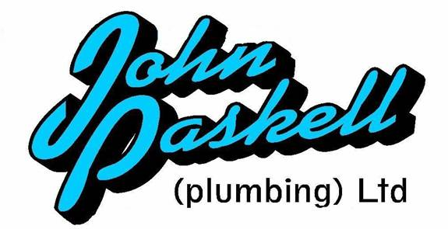Plumbing and

heating engineers

Tel: 017090873518

[info@paskellplumbing.co.uk](mailto:info@paskellplumbing.co.uk)



**Druids Sheffield**

**Friendly Society**

Plans for Healthcare – Tax Exempt Savings

Sickness and Death Benefits

Endowments – Insurance I.S.A.

Leaflets on all plans available from:-

Dove House, Brampton Road,

Wath-Upon-Dearne, S63 6BE

Tel: 01709 876409

Fax: 01709 878045

Email: deuidssheffield.friendly@virgin.net

www.druidsfriendly.co.uk

Established 1858. Authorised in the United Kingdom under the Friendly Societies Act 1992. Reg. No. 795f

Druids Sheffield Friendly Society is regulated by the

13307

_________________________

**Simon T. Anderson**

Funeral Director

23 Dodworth Road, Barnsley.

**(01226) 733119**

*24 HOUR SERVICE*

AN INDEPENDENT FUNERAL SERVICE

*Professional and friendly advice on all aspects of the funeral service*

Financial Services Authority

___________________________________________________



Andrew P. Lockwood

**MinstChP. CCM(Sheffield)**

**CHIROPODIST**

**All Foot Ailments Treated**

CORNS – CALLOUSES (Hard Skin) – VERRUCAE – ATHLETE’S FOOT etc.

**Home Visits – Prompt Attention**

**Tel: 01484 687632**

**Mobile: 07971355078**

Dear friends

Whilst searching the internet for new ideas for Easter Worship I happened across this site: *http://socyberty.com/holidays/easter-thoughts* and thought I would share the article with you.

Easter Thoughts by [Carol M Creasey](http://www.triond.com/users/Carol+M+Creasey)

As the bible tells us, Easter was the time that our Lord died on the cross and rose again. This is what I believe, but there may be other people who don’t believe in God, so why do they celebrate Easter? Why do they buy Easter Eggs? Is it just another excuse to eat a lot, drink a lot too, and have a holiday, as most people get Good Friday and Easter Monday off [work](http://socyberty.com/holidays/easter-thoughts/)?

Easter means lots of things to me. It’s the beginning of a new spring, closely followed by summer, it’s baby chicks, daffodils, bulbs bursting into flowers, longer evenings, and more mellow weather. The sun decides it’s about time he showed himself again, the trees turn green and thicken up, and everything looks so fresh and clean.

All this makes me want to spring clean the house. It’s so lovely to open the [windows](http://socyberty.com/holidays/easter-thoughts/) again, and smell the fresh air. My washing can go out on the line, and not adorn the [radiators](http://socyberty.com/holidays/easter-thoughts/) in an effort to get it dry. My dog benefits too, his walks get longer, as I don’t have to plough through mud, and turn my collar up against the wind and rain, it is a real pleasure to be out in the beautiful world.

As I walk past the farm, I see baby lambs gambolling in the fields. They look so soft, how lovely it would be to pick one up and cuddle it. Lots of animals come to life, including my cat, who decides that she will find a patch of sun to lie in out in the [garden](http://socyberty.com/holidays/easter-thoughts/), instead of sleeping on the sofa in the conservatory all day.

Easter and spring bring a feeling of relief to me; the winter has been cold and long. Off come my gloves and scarf, on come lighter clothes, and jackets, and I start looking forward to summer. It can’t be that far away now, and then it will be nice to wear a tee shirt, and let the sun get to my skin again. At Easter I have something else to look forward to. [My family](http://socyberty.com/holidays/easter-thoughts/) will come to visit and for me that is the best thing of all. Roll on Easter!

A RIDDLE to get those little grey cells working!

I am a letter.  
  
I am in talk, and in stop,  
I am in tickle, and in tackle,  
I am in bullet, and kite,  
I am in poster, and in tear,  
I am in torn, and in fear,  
I am in tick, and in stock,  
I am in tulip, but I'm also in by.  
  
What am I?

Answer in the next edition of LINK.

I hope you have a blessed and peaceful Easter.





# *Press Release from the United Reformed Church. Date: 3 February 2010*

**United Reformed Church encourages its congregations to take firm stand on racist parties**

The United Reformed Church has contacted its leaders and congregations, reminding them of its long standing opposition to extreme right-wing and racist political parties, and urging them to act in accordance with the URC resolution that “The United Reformed Church believes support for extremist parties to be incompatible with Christian discipleship.”

The anti-racist resolution was passed in January 2004 and, as the country prepares for a general election, the URC believes it timely to remember and re-emphasise that voting can be seen as both a civic and moral duty – and that support of parties that discriminate on racial grounds has no place amongst Christians.

John Marsh, Moderator of the General Assembly of the United Reformed Church, adds, “As the election approaches I urge all Christians to consider carefully where they place their cross on the ballot paper. Let us focus clearly on the truth that we are all members of one race - the human race. Within God’s Kingdom there is no place for racial hatred and I call upon us all to remain firm in our commitment to practise and promote racial justice and inclusion.”

The guidelines advise against allowing an extremist party to use church premises and recommends that political parties with racist policies are not invited to participate in election hustings meetings held on church premises.

THE YORKSHIRE GOSPELS

This was the contribution of West Melton

to our Synod’s Yorkshire Gospels.

(If you need a translation may I suggest

you look the passage up in your bible.)

Matthew Ch 28

Sitha

It we’r after t’sabbath just as Sunday wa’r a baht, Mary Magdalene an’t t’other Mary wa’r of’t for a pike at t’tomb, reet, flipping eck tha sez, t’ wa’r this gret lound bang reet an summat appened, odd on Mary sez, an t’angel o’t lord fluttered darn, and does tha know, t’angel pushed this gret lump o solid stone t’ side as if it wa’r a yorkshar pudding, angel wa’r like litening, an looked as tho he’d just bin fettled and wa’rsnow white. The guards wa’r gob smacked, shekin en cudn’t shift. Angel sez t’ two Mary’s wa’r du y’ want, if ye looking for Jesus ee wa’r killed on’t cross an deed. Well sitha e’s no’r ere, e’s gone an brought is sen back t’life, just as e sed e would, cum, ger a gander a’t t’place were e wa’r laid.

Nah gerron wi ye sens, of’t t’diciples and tell em Jesus is alive and bahn t’go t’Galilee, ther you’ll be able to see im. So dunt forget wa’r a told ye. So two Mary’s left tomb, chuffed f’r joy, and set off t’ let t’diciples know w’er ad appened. T’he wa’r capt when they met this bloke “Peace Be With You” e sez t’em, tha wa’r gobsmacked it wa’r Jesus. They knelt darn at is feet and worshipped im an wer reet suited. Jesus sed to em, get ye sen up, gee or blubbering, ger of’t t’other’s, an all on us el meet we’m in Galilee.

Now whilst Mary’s wa’r on’t journey, soldiers who wa’r supposed to be guarding t’tomb wa’r now wekken an mardy. Tha went into city to tell gaffer wa’r appened. So gaffer met wi elders an cum up wi a grand plan. E gid soldiers umteem bags o brass and told em t’ say that t’other folk ad cum during neet an pinched Jesus ‘s body, cos this way the guv’nar wud ear this an cotton on like that t’soldiers wa’r innocent. So’s they’d have nowt t’worry abart, the guards tuc brass an spread this porky pie all t’over.

Now’t t’disiples went t’place were Jesus sez e would see em, when tha saw im tha wa’r reet glad an worshipped im, a reckon one or two of em um were doubtful an flummox. Jesus sed t’em nah lads frame ye sens, think on I ave all t’authority in heaven an on’t t’earth. So get ye sens of’t t’fowk an mek em my disciples, an ger em dumped in watter t’baptize em, in’t name o’r father, son an t’oly spirit and tell em t’obey all I ave let on t’ye, cos I’ll allus b wi ye t’end o t’time.

So now tha nows.

Transposed by John Paskell.

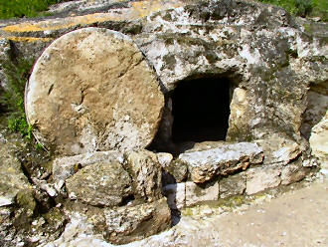

SERVICES at ADEN LODGE and ADEN HOUSE in CLAYTON WEST.

By Rev David Priestnall (Methodist Minister)

Month by month our Churches Together group visit Aden Lodge and Aden House on Long Lane to lead a short service for the residents. Each church takes the lead in arranging the service for the month, and the worship takes different forms, including celebrations of Holy Communion. The most recent was December's carol service when this photo was taken - all the churches combine for this event.

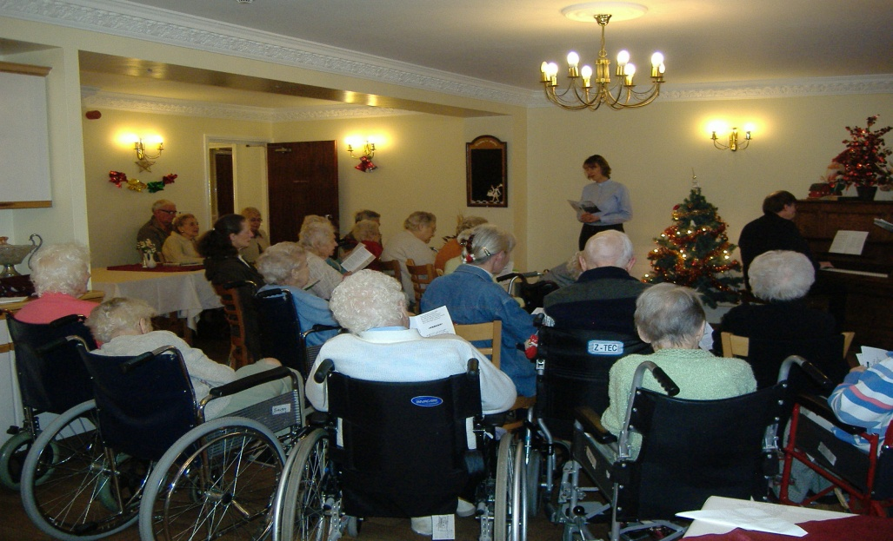

The residents will not usually be able to get out to worship in a church, and are glad that the services come to them instead. They also appreciate the fact that visitors come in to meet them in their home. Watch out for the date of the next visit and come along - you are welcome to join in. The services are usually planned for the fourth Thursday afternoon in the month, at Aden Lodge at 1:30p.m. and then at Aden House at 2:15p.m.

Sensory Sensation at Clayton West Baby and Toddler Group

by Joanna Rhodes

CW Baby Group has been going from strength to strength since moving back to the newly refurbished schoolroom at the United Reformed Church. We can all remember the day that Rachael gave us a guided tour of the new facilities and we were instantly unanimous that this was the perfect location for the group to grow and flourish.

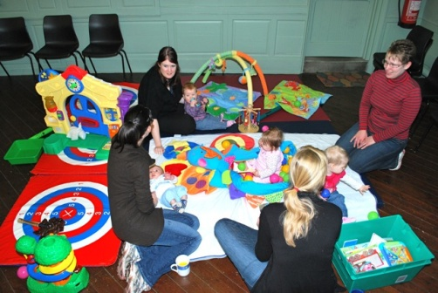

I am delighted to say that we are definitely progressing along that road with a wonderful atmosphere and numbers steadily increasing.

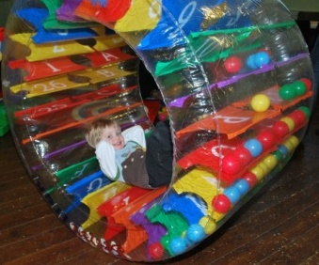Clayton West is a wonderful village for families, we benefit from the countryside as well as convenience for parents who need to work. However the facilities for pre-school children in the village are fairly sparse and it was with this in mind that we applied earlier this year for a grant from Denby Dale Parish Council for new equipment that was better suited to providing an educational and entertaining environment for our babies and toddlers. The Parish Council very kindly awarded us £500 and we have purchased an amazing selection of sensory toys and other accessories.

We are also proud to be able to be able to make the group available to all children regardless of whether they, or their carers are disabled. It is due, in no small part, to the new toilet and changing facilities along with ramp access to the side of the building that has made this possible and was key to the success of our proposal for funding to the Parish Council. The equipment is designed to be accessible to both able and disabled children and is stimulating and fun.

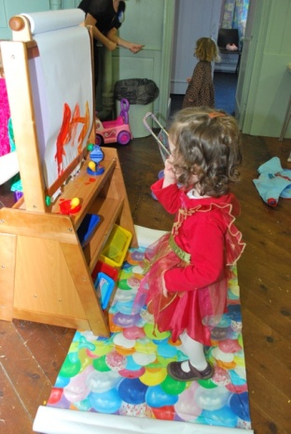We have the large Sensa Trak which the children can roll and lie in watching the balls tumbling around them, a portable baby ball pool, a dark den with fibre optic lighting, a wooden painting easel, boomwhackers (musical pipes) and other new ethnic instruments a mirror chimeabout which is perfect for a gentle sound for little babies.

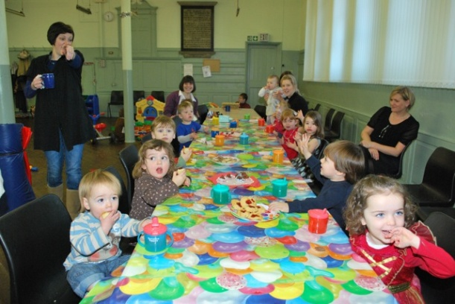We meet in the schoolroom on Fridays from 9.30am to 11.30am during term time and charge £2.50 (snacks and teas and coffees are included). Each session has a variety of activities available as well as all the new equipments. We also have fun singing nursery rhymes under the parachute. Anyone is welcome to drop in for a visit, regardless of whether they are accompanied by a toddler. We have a whole age range of carers including plenty of grandparents as well as parents! Feel free to chat to us at the Men’s Society table top sale on 13 March (10.00am - 12 noon) when we will be selling a selection of garden plants grown by the children as well as some other arts and crafts.



I love the expression on the face of the dog, obviously deep in prayer.

*Submitted by Margaret Swallow.*

[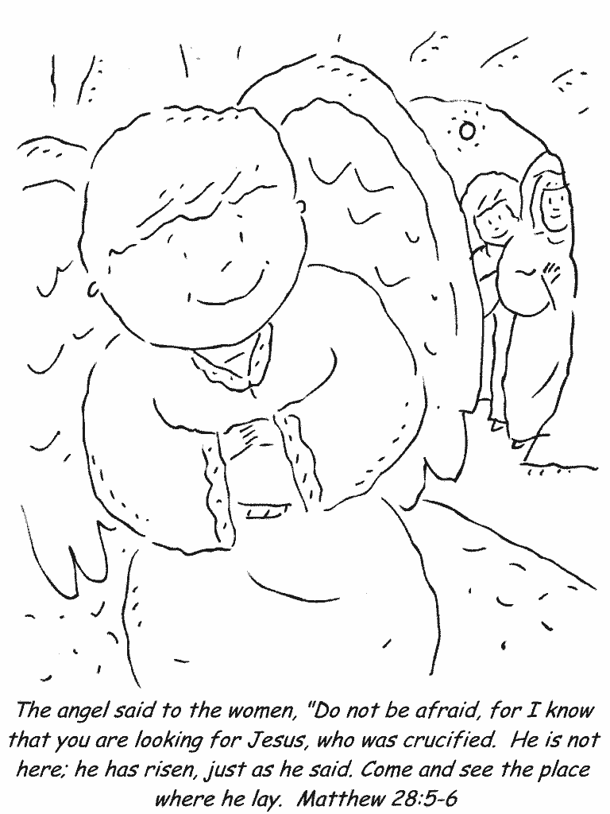](http://www.first-school.ws/t/cpresurrection.html)

Word Search Puzzle *from www.geocities.com/lectionarypuzzles*

***Words in a straight line in all directions*** (John 20:15-16)

W V W O M A N D S T W M

E J E S U S W U W E I E

R O S F L M P A H A L A

B H I L O P I W Y C L N

E N L E O R N H G H C S

H E K S K D U E N E A W

T A I L I A O R I R R H

T N A A N R B E P N R O

G I S V G E B V E R I M

D E N R U T A A E S E A

T H C I H W R H W V D R

U O Y G A R D E N E R Y

Jesus said to her, "Woman, why are you weeping? Whom are you looking for?" Supposing him to be the gardener, she said to him, "Sir, if you have carried him away, tell me where you have laid him, and I will take him away." (16) Jesus said to her, "Mary!" She turned and said to him in Hebrew, "Rabbouni!" (which means Teacher). NRSV

SUPPOSING RABBOUNI GARDENER WEEPING TEACHER LOOKING CARRIED TURNED HEBREW WOMAN WHICH WHERE MEANS JESUS WILL WHOM TELL TAKE SAID NRSV MARY LAID JOHN HAVE AWAY YOU WHY THE SIR SHE HIM FOR ARE AND TO IF

Help the family

to find the egg!





*www.ActivityVillage.co.uk*

**MY EARLY YEARS** by Helen Owen

Long before I was born, so I understand, my Dad fell in love with the back of my mother’s neck!............... he used to sit in the pew behind her in Welholme Congregational Church in Grimsby.

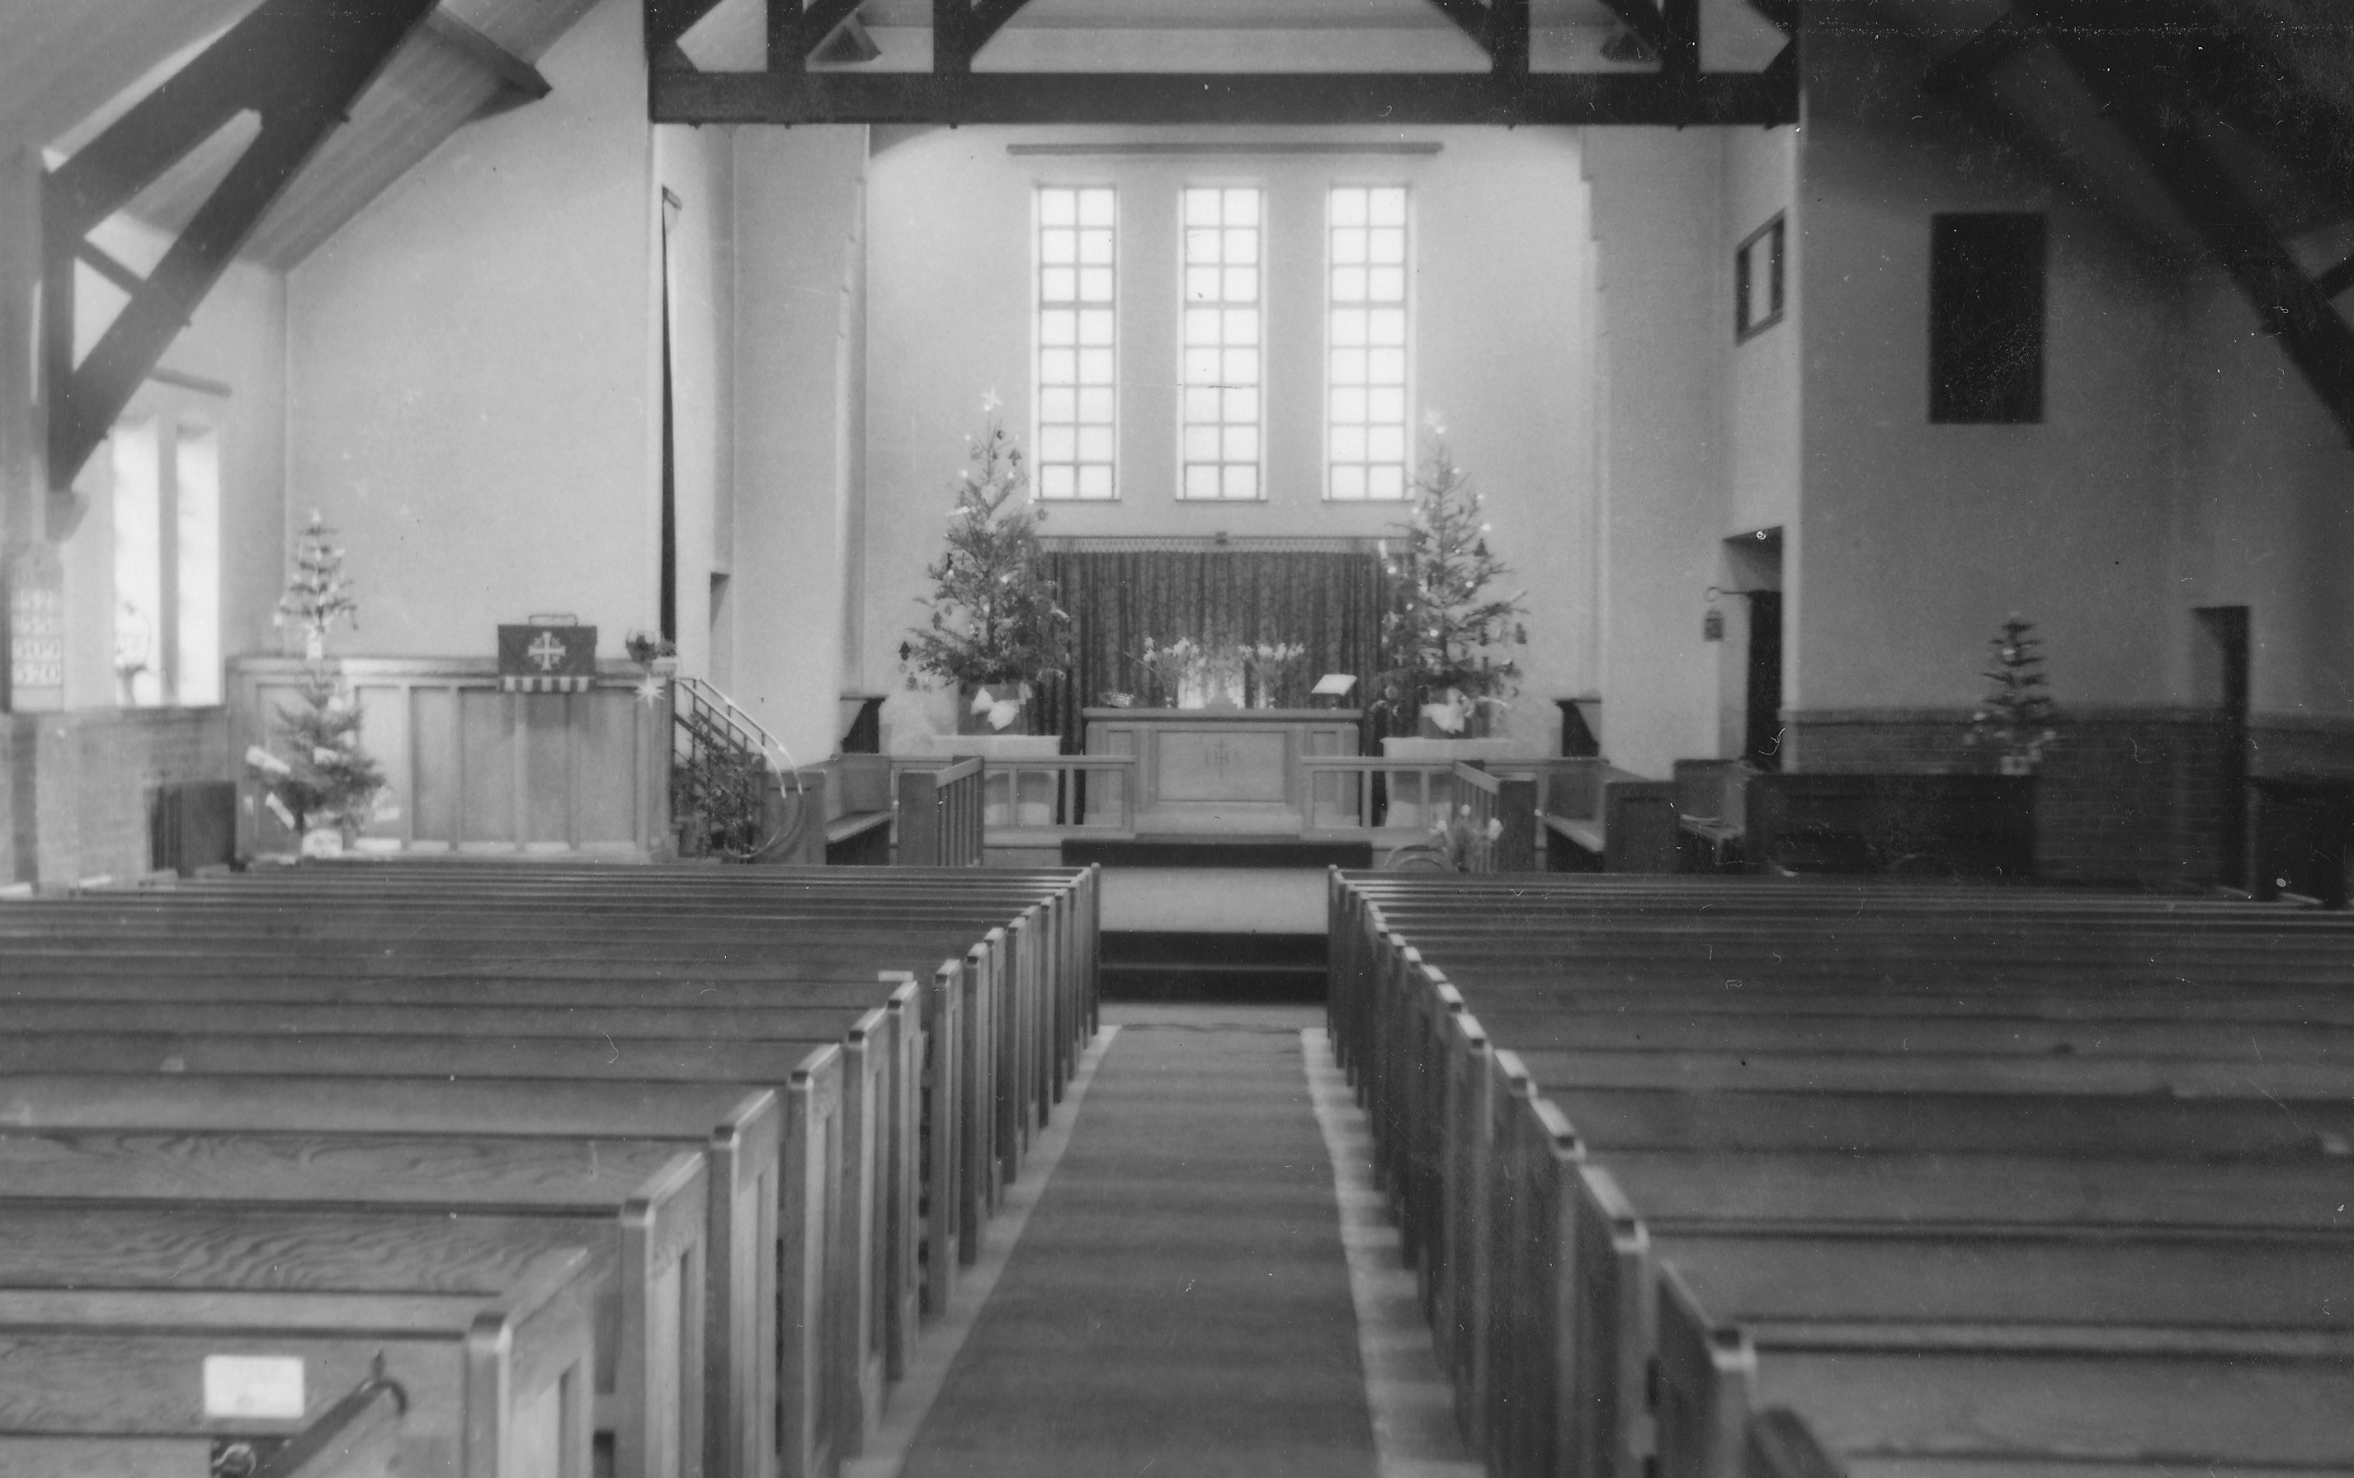That was the Church in which, much later, I was baptised and later still, first became an Elder. It is now the Grimsby museum.

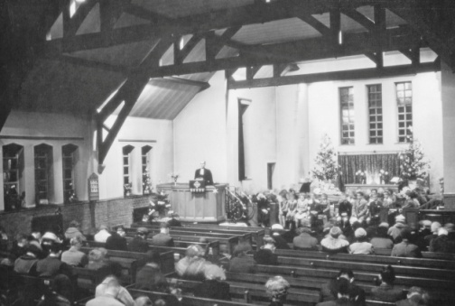When I was three, we moved to Leeds and my parents became members of West Park Congregational Church. My Dad was Church Secretary there for several years and as a kid I used to help him with various Secretary - type jobs such as stoking the boiler and opening and locking up the Church. My Mum was the British and Foreign Bible Society person and a Women’s Guild member. I have vivid memories of helping to butter hundreds of bridge rolls on trestle tables at hundreds of Women's meetings and rallies in Church halls and kitchens all around Leeds!

I remember too being a very enthusiastic Brownie in the Church pack where I became a Sixer of the Sprites.

While my Dad was Secretary, we had a number of visiting preachers from abroad who were always invited to have dinner at our house after the service. One I particularly remember was from India and before his visit Dad warned me that it was the Indian custom to burp after a meal as a way of showing appreciation and I was not to laugh or look surprised. Lo and behold, after dinner on the Sunday, Mr. Sahiadas, a very large man, showed his appreciation very loudly. It was a real test of my ability to behave!

Regular attenders at our Sunday morning service were the children of a nearby small Council Children’s Home with their housemother, Miss Williams. One morning they did not arrive as usual, but in they all trooped just as the service was ending. It was the beginning of BST and Miss Williams had forgotten to put the clocks forward! She never lived it down.

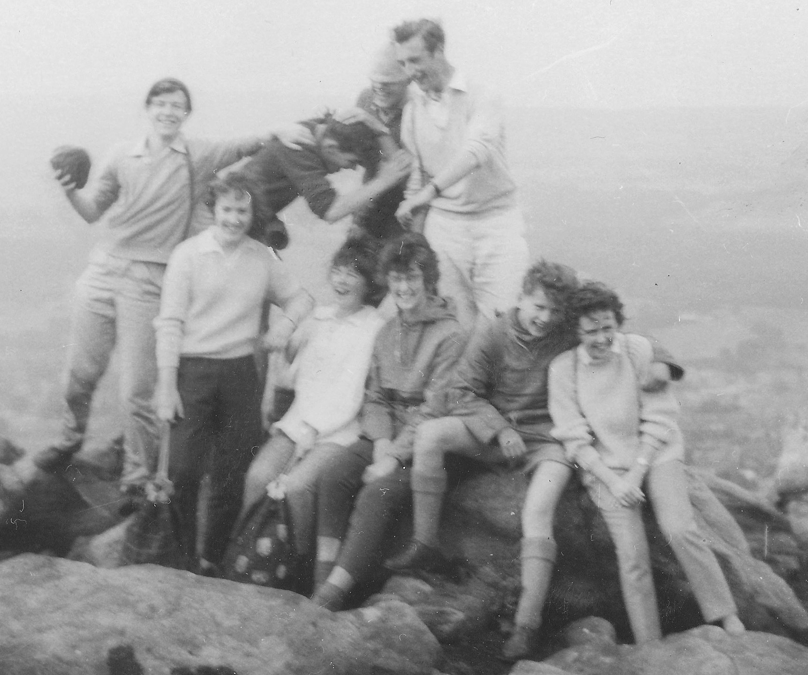With my friends, most of whom went to the same school as myself, I progressed through Junior Church and at 12, after a series of preparation sessions, we were welcomed as Junior Church members and were able to share in the “mystery” of Holy Communion. At 16, I became a full member.

My teenage years were involved with Church Youth Fellowship (devotional) and Youth Club (my Dad ran both!). A few of us also joined a local Crusaders group and on Summer Sunday evenings we sang choruses and heard testimonies in the open air on Adel crags (on the NW outskirts of Leeds). It was also during this time, that we 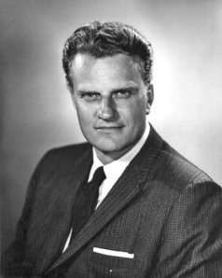went to Manchester to hear Billy Graham in Maine Road Stadium; an experience I shall always remember.

After a brief spell in the Church Guide group I finished school and left Leeds to go to College, never to live in Leeds again.

But those early years are where my faith was born and nurtured to be developed in subsequent years.

*******

**The Wizard of Oz** – by Bob Willerton (the director)

*Photographs by Alan Percival*

We have just done the first Trinity pantomime for over 20 years. We've made the decision to put one on following our recent successes with dramas and comedies both here and at the Lamproom.

Our choice is also a little different - the Wizard of OZ with Elvis. I'm sure that the audience recognised all of the usual family panto elements (oh yes you will !) - costumes, bright sets, songs and audience involvement. What was a little different is that this show tried to follow the story, so there was a little more focus on words and jokes for all ages.

The cast included many Trinity regulars and of course the Rev Nick in – the title role (see the next page). We managed to live with his ad-libbing and scurrilous promotion of URC.

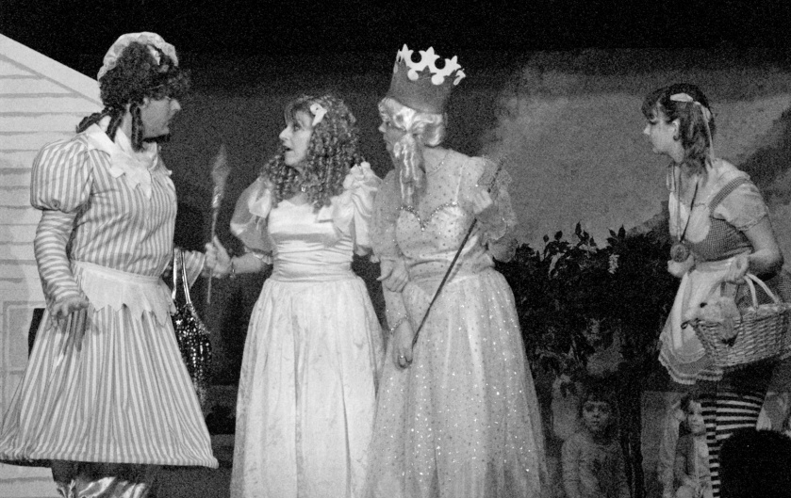

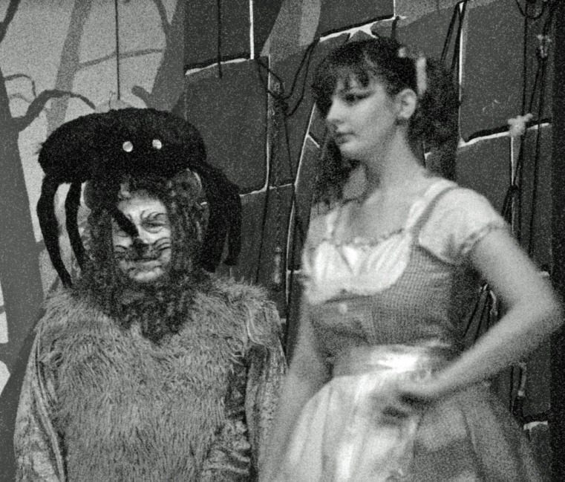Staging a panto at Trinity Church Hall has been a challenge and we have all learnt during this production. Thanks are needed for a magnificent effort by the back room team of stage designers and developers who braved the conditions to get to the hall through hail and blizzard (Blizzard of OZ was an alternative title at one point).

Anyway, over 350 people enjoyed the show and I hope they all went away with fond memories of us. Something to make us all smile in these freezing conditions.

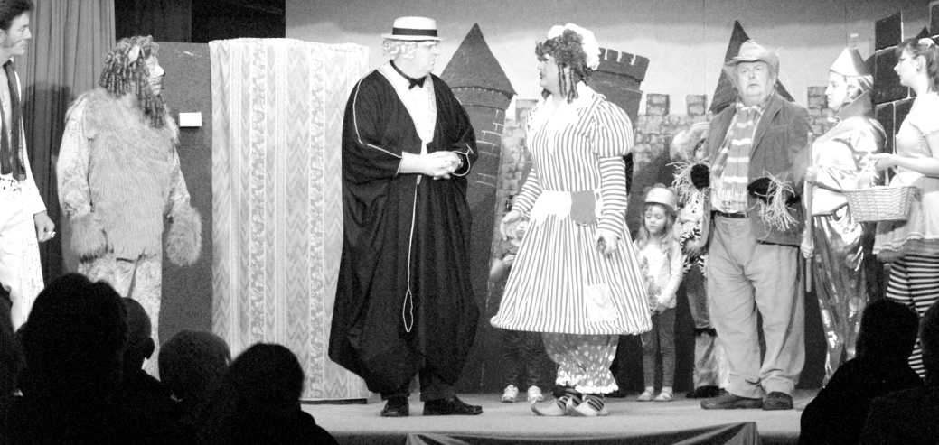

From the programme notes:

*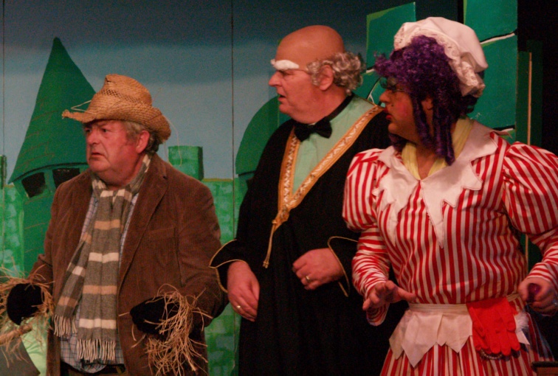Nick is the minister of Trinity URC and also of Clayton West and West Melton churches. Nick is returning to the stage after an absence of over 30 years. He has appeared in plays ranging from Shakespeare to Robert Bolt with a bit of Moliere thrown in for good luck. This is his debut with the Trinity Players and his first foray into Pantomime. He says he was delighted to be offered the title role in "The Wizard of Oz" Oh yes he was!*

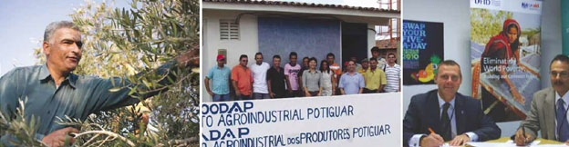



**POOR HARVEST BLOW FOR FAIRTRADE**

**OLIVE FARMERS –**

**FAIRTRADE IN PALESTINE**

In November 2009 Veronica Pasteur, Head of Campaigns at the Fairtrade Foundation, joined the Zaytoun Olive Tour in Palestine, visiting olive farmers and their communities to experience living and farming in the West Bank. As well as meeting the farmers and the co-operatives, the purpose of the trip was also to help the farmers collect the olives, though this year has seen the farmers’ worst harvest in 20 years, so the work had already been done. As well as a bad year of harvest, the olive farmers face continued struggles due to the Israel/Palestine conflict. The cooperative in the village of Anin, in particular, is directly affected by the position of their land right next to the separation wall.  
A year ago Anin Co-operative launched their Fairtrade certified olive oil in the UK. The certification has enabled the farmers to access markets previously out of their reach.

Support the olive farmers in Palestine through their poor harvest by buying their olive oil – available in Sainsbury’s and Co-op stores – visit ww.equalexchange.co.uk for your nearest stockist, or catch up with the latest news from the farmers at [www.zaytoun.org](http://www.zaytoun.org)

Article from: [*www.fairtrade.org.uk/resources/fair_comment/spring_2010/top_news.aspx*](http://www.fairtrade.org.uk/resources/fair_comment/spring_2010/top_news.aspx)

For the latest on Fairtrade producers in Haiti, visit [*www.fairtrade.net/press_releases.html*](http://www.fairtrade.net/press_releases.html)

**Fairtrade fortnight is 22February – 7 March 2010**

*****

*Some gems contributed by Eve Wensley:*

Life is not measured by the breath you take, but the moments that take your breath away!

Remember – You don’t stop laughing because you grow old. You grow old because you stop laughing!

Thought for today – Always keep your words sweet, just in case you have to eat them!

Never put both your feet in your mouth at the same time – because you will not have a leg to stand on!

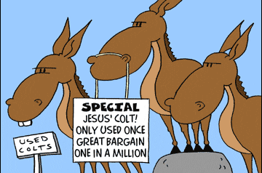

NEW GROUP WEBSITE

Following the demise of our original website host, Geocities, I am pleased to tell you that we now have a new website. You can find it at: [**http://urcbarnsleygroup.weebly.com**](http://urcbarnsleygroup.weebly.com)

If you have any suitable, and up to date, photographs of our church life please let me borrow them and I will put them on the site. Thanks. Nick

Thanks to all the contributors to this edition of LINK.

Contributions are always welcome and for the Summer 2010 edition of this magazine need to be with Rev. Nick by

Sunday 16th May, please.

**REGULAR ACTIVITIES IN OUR CHURCHES**

**Clayton West**

Sunday Worship every week at 3.00 pm. Communion is included in the service on the 1st first Sunday of each month

Friday Men’s Society (*September-April*) Every fortnight 7.30pm

Saturday Coffee Morning on the 4th Saturday each month 10.00am

**Trinity (Barnsley)**

Sunday Worship every week at 10.30 am. Communion is included in the service on the 3rd third Sunday of each month

Tuesday Bible Study at 7.30 pm

Wednesday Age-Well (*over 50s club*) every week 10.30am-1.00pm

Trinity Players every week at 7.30pm

Thursday Trinity Tots (*carers & toddlers*) 10.00am – 12.00noon

**West Melton**

Sunday Worship on the 1st (*inc. WHIZZ KIDS*) and 4th Sundays at 10.30am and on the 2nd & 3rd Sundays at 3.00pm. Communion is included in the service on the 3rd Sunday of each month

Monday Sisterhood every week at 2.30pm

Wednesday Parents and Tots 9.30am every week *(in term time)*

Praying Hands (*prayer group*) 7.30pm – 8.30pm on the 2nd Wednesday of each month

Fellowship evening (*varied programme*) 7.30pm on the 4th Wednesday of each month

Friday Children’s Fun Night 6.30pm – 8.00pm (1st & 3rd Fridays *in term time*)

Saturday Men’s Breakfast at 8.00am on the 3rd Saturday each month

**Group Minister: Group Treasurer:**

Rev. Nick Percival BA Mr. John Paskell

19 Longdale Croft 1 Giles Avenue

Barnsley, S71 2QT Wath on Dearne

Tel: 01226 771277 Rotherham, S63 6SG

Mobile: 07986668032 Tel: 01709 879224

Email: [revnickp@yahoo.co.uk](mailto:revnickp@yahoo.co.uk) Email: [john@paskellplumbing.co.uk](mailto:john@paskellplumbing.co.uk)

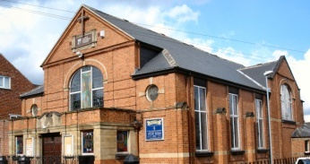 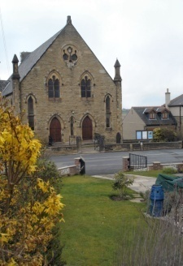 

Trinity Clayton West West Melton,

Farrar Street Church Lane Melton High Street

Barnsley Clayton West Wath on Dearne

S70 6BS Huddersfield HD8 9LY Rotherham S63 6RG

**Church Secretaries:**

TRINITY: Mrs. Fiona Weighton-Smith, 18 Normans Way, Sandal, Wakefield, WF2 6SS Tel: 01924 253010

Email: [isabelsmith655@btinternet.com](mailto:isabelsmith655@btinternet.com)

CLAYTON WEST: Mrs. Betty James, Winter Hill Farm, Bank End

& group secretary. Lane, High Hoyland, Barnsley, S75 4BB

Tel: 01226 382820

WEST MELTON: Mr. John Paskell. *(As above)*

**http://urcbarnsleygroup.weebly.com**