LINK

The magazine of the Barnsley Group Pastorate



**SPRING 2011** 

Plumbing and

heating engineers

Tel: 017090873518

[info@paskellplumbing.co.uk](mailto:info@paskellplumbing.co.uk)



**Druids Sheffield**

**Friendly Society**

Plans for Healthcare – Tax Exempt Savings

Sickness and Death Benefits

Endowments – Insurance I.S.A.

Leaflets on all plans available from:-

Dove House, Brampton Road,

Wath-Upon-Dearne, S63 6BE

Tel: 01709 876409

Fax: 01709 878045

Email: deuidssheffield.friendly@virgin.net

www.druidsfriendly.co.uk

Established 1858. Authorised in the United Kingdom under the Friendly Societies Act 1992. Reg. No. 795f

Druids Sheffield Friendly Society is regulated by the

13307

_________________________

**Simon T. Anderson**

Funeral Director

23 Dodworth Road, Barnsley.

**(01226) 733119**

*24 HOUR SERVICE*

AN INDEPENDENT FUNERAL SERVICE

*Professional and friendly advice on all aspects of the funeral service*

Financial Services Authority

___________________________________________________



Andrew P. Lockwood

**MinstChP. CCM(Sheffield)**

**CHIROPODIST**

**All Foot Ailments Treated**

CORNS – CALLOUSES (Hard Skin) – VERRUCAE – ATHLETE’S FOOT etc.

**Home Visits – Prompt Attention**

**Tel: 01484 687632**

**Mobile: 07971355078**

Dear friends

Daily devotional thoughts, *Our Daily Bread*, have been published by RCB Ministries since 1956. If you have access to the internet you can read them on their website: http://odb.org

*The following is by* [*M.R. De Haan*](http://odb.org/author/mrdehaan) *and was the devotional reading for April 23rd 2000.*

“Surprise! Jesus is alive!” The two travelers from Emmaus, who had just entertained the risen Saviour in their home, were greeted by the disciples with the news that the Lord was no longer in the tomb ([Lk. 24:29-34](http://biblia.com/bible/nkjv/Lk.%2024.29-34)).

How strange that the news of Jesus’ resurrection should be a surprise. He had told them repeatedly that He would rise after 3 days ([Mt. 26:61](http://biblia.com/bible/nkjv/Mt.%2026.61); [Mk. 8:31](http://biblia.com/bible/nkjv/Mk.%208.31); [Jn. 2:19](http://biblia.com/bible/nkjv/Jn.%202.19)). Yet when Jesus was crucified, His disciples were filled with gloom and despair, though they should have been joyously and expectantly waiting for Him to rise.

Resurrection day is a day of joy and victory! But on that first resurrection day there was gloom and sadness before the disciples realized Jesus was alive. Mark’s Gospel tells us that they “mourned and wept” ([Mk. 16:10](http://biblia.com/bible/nkjv/Mk.%2016.10)), but they should have been rejoicing.

It is the resurrection that gives meaning to the cross. The death of Christ alone is bad news, but followed by His rising from the dead it is good news. Why? Jesus took our sins to Calvary. Had He atoned for all but one, He would still be in the tomb. His resurrection is the assurance that the work is finished. God was satisfied, and He demonstrated it by raising Jesus from the grave ([Acts 13:32-33](http://biblia.com/bible/nkjv/Acts%2013.32-33)).

Hallelujah! The Lord is risen indeed!

Christ the Lord is risen today, Alleluia!  
Sons of men and angels say, Alleluia!  
Raise your joys and triumphs high, Alleluia!  
Sing, ye heavens, and earth reply, Alleluia!

**Live as if Christ died yesterday, arose this morning**

**and is coming back tomorrow!**

I hope you have a blessed and peaceful Easter.

Jesus told his disciples to “**watch and pray”…**

And the time honoured tradition of sleeping in church was born!

(Mt. 26: 36-46).

**Sunday School Days** by Joyce Jones



I remember my Sunday school days first in the primary department which was held in what is now part of the community hall, We could start their at the age of three and we progresses through until the age of about seven as we did at day school.

Then into a different world - Junior's held in the big room at the back of the church.

There we left behind Mr and Mrs Paskell, and the staff of teachers the playmates we received each week which I made into books sewn together. With wool, any colour mum had to spare.

We had Mrs Stanger, Mrs Humphries, Mr Smith, Mr Ferns and later Mr Neil as Sunday school superintendents. And George Kay played the piano for our singing. We made progress then into seniors, when George left I played, then I became a Sunday school teacher until I got married and had my family.

Our happiest days were the Sunday school anniversary held every first Sunday in May when we had a visiting speaker to take the service, all words were learned as we sang without a hymn sheet until in about 1950 we had the moderator Rev John Smith a very large man with white hair who insisted on not following the set programme and picked the hymns in his order and we never sang without a sheet again.

We also had a primary anniversary later in about June with allthe little ones on the platform built on either side of the organ. Then we had the best thing each March the Prize giving, if we had the right number of stars on our star card we received a first prize, or a second, always a book suitable for our age. These came from Harpers in Rotherham, now long gone. The children sang or said a poem. The church as full of proud mums and dads. The photo with this story dates from about 1959 or 1960, it shows some of the teachers Mrs Paskell, Margaret Copeland now Marchant, Mr Paskell, Pat Smith now King and myself with Margaret Kirkham now Smith. Seated with the children the organist was Mr Eric Stanger. Some of the children are still in our area others are far away but fondly missed. Oh happy days.

West Melton’s Green Tips Corner



**Number 3 – Grass cuttings**

If you are putting your grass cuttings on a compost heap the addition of crumpled pages of old newspaper will stop the grass going slimy and will help dry out any extra unwanted moisture in the heap.

Grass cutting are also useful as a mulch around your garden plants.

**TRINITY PLAYERS – CINDERELLA**

textby Nick Percival

photos by Philip Johnson

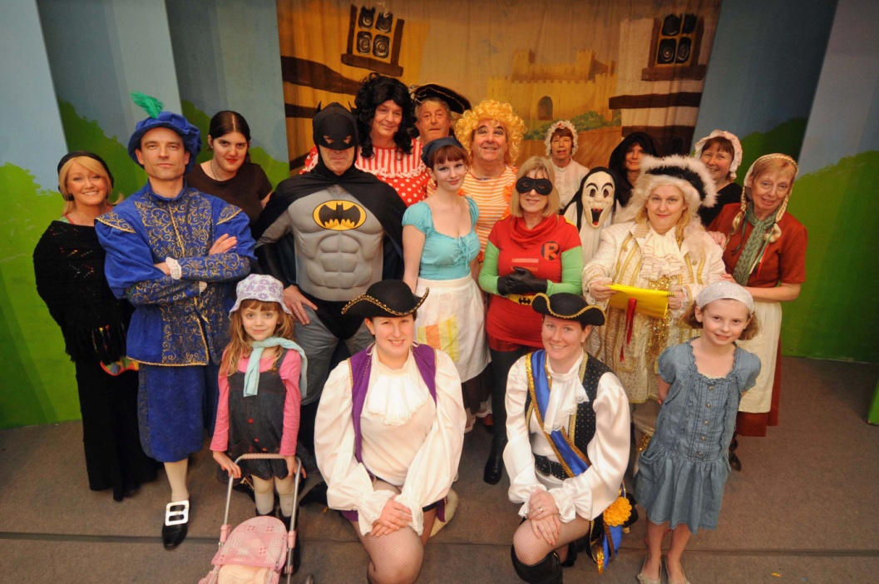

Why on earth did I want to play an Ugly Sister in a panto? Perhaps I wanted my ‘feminine side’ to be seen! The panto was a huge success and great fun too, even if it was rather tiring!



The show ran for seven performances and attracted large numbers for every performance.

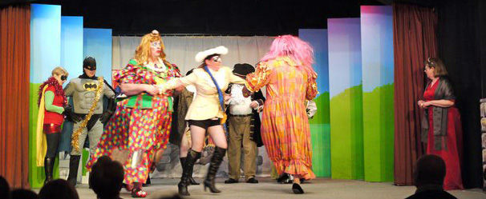

Even though I was the glamorous sister – Oh yes I was!! – I was still perceived as a bit of a villain. Perhaps that was because fairly early on when we were singing about the bags of shopping that Buttons had bought for us I had to produce five squirty lemons, and boy did they squirt a long way. Many of the audience got ‘hit’ by jets of water, some more than once. No surprise then that the audience cheered when I got a face full of ‘mashed potatoes’ later in the show! My grandchildren still laugh if I say ‘mashed potatoes’ to them! More photos on the next page.

 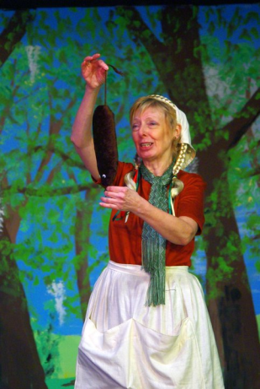

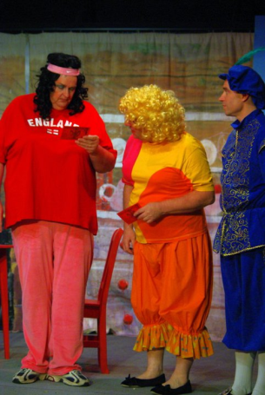 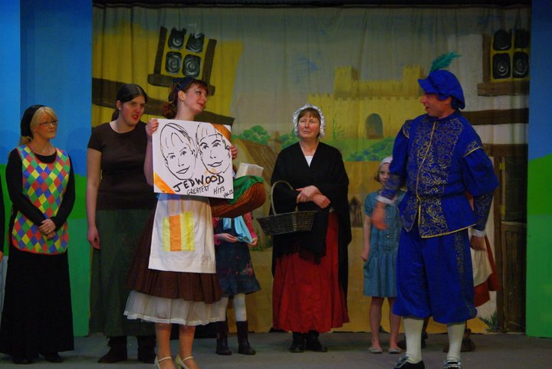

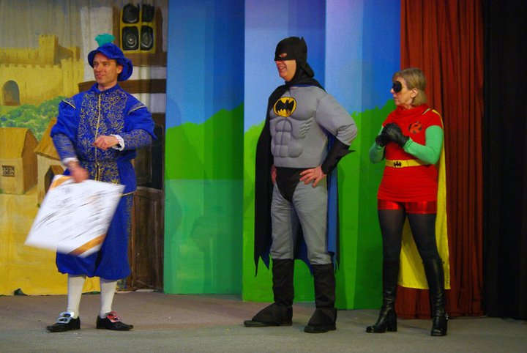 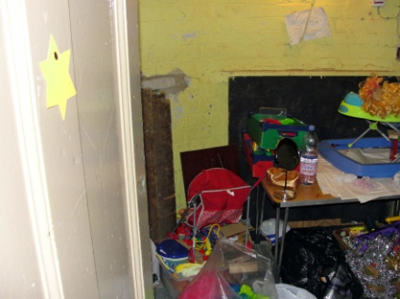

**As you can see, the Ugly Sisters’ dressing room was first class!**