LINK

The magazine of the Barnsley Group Pastorate



**SUMMER 2010**  

Plumbing and

heating engineers

Tel: 017090873518

[info@paskellplumbing.co.uk](mailto:info@paskellplumbing.co.uk)



**Druids Sheffield**

**Friendly Society**

Plans for Healthcare – Tax Exempt Savings

Sickness and Death Benefits

Endowments – Insurance I.S.A.

Leaflets on all plans available from:-

Dove House, Brampton Road,

Wath-Upon-Dearne, S63 6BE

Tel: 01709 876409

Fax: 01709 878045

Email: deuidssheffield.friendly@virgin.net

www.druidsfriendly.co.uk

Established 1858. Authorised in the United Kingdom under the Friendly Societies Act 1992. Reg. No. 795f

Druids Sheffield Friendly Society is regulated by the

13307

_________________________

**Simon T. Anderson**

Funeral Director

23 Dodworth Road, Barnsley.

**(01226) 733119**

*24 HOUR SERVICE*

AN INDEPENDENT FUNERAL SERVICE

*Professional and friendly advice on all aspects of the funeral service*

Financial Services Authority

___________________________________________________



Andrew P. Lockwood

**MinstChP. CCM(Sheffield)**

**CHIROPODIST**

**All Foot Ailments Treated**

CORNS – CALLOUSES (Hard Skin) – VERRUCAE – ATHLETE’S FOOT etc.

**Home Visits – Prompt Attention**

**Tel: 01484 687632**

**Mobile: 07971355078**

Dear friends

First the answer to the riddle in the Spring LINK.

*I am a letter. I am in talk, and in stop, I am in tickle, and in tackle, I am in bullet, and kite, I am in poster, and in tear,  
I am in torn, and in fear, I am in tick, and in stock,  
I am in tulip, but I'm also in by.  
  
What am I?*

Answer: I am a letter, I didn't ask which one!

# Something to think about.

[GOD’S NOT A SPOILSPORT](http://feedproxy.google.com/~r/EatTheWord/~3/BDDzrs_OHr0/)

And because we are his children, God has sent the Spirit of his Son into our hearts, prompting us to call out, “Abba, Father.” ([*Galatians 4:6*](http://biblegateway.com/bible?version=51&passage=Galatians+4%3A6)*)*

God is the ultimate Father; He has created us, gives us great gifts, knows us intimately, loves us unconditionally, has the best plans for our lives… the list could go on! He cares for us so much that He put His own Son’s life on the line so that He could adopt us as His own and so that we could have a close relationship with Him. The question is: will we accept him?

Admittedly, whilst growing up there are times when we choose not to obey our earthly fathers/mothers and ignore their advice because we want to figure it out on our own. We do this with God too, not just as a young person, but throughout our lives until we understand the value of what He is saying and understand that “in all things God works for [us]” *(*[*Romans 6:28*](http://biblegateway.com/bible?version=51&passage=Romans+6%3A28)*)*.

This is why He gave us the Holy Spirit, because He wanted us to know Him, to guide us through this world etc. It’s because He loves us and wants the best for us, just as our parents do, that He tells us stuff through His Holy Spirit. We need to get a grasp on the fact that He’s not trying to spoil our fun; it’s just that He can see absolutely everything, through time and space, and He has the wisdom that goes with all that.

As Paul says, when we submit to God, acknowledging Him as Father, we cannot help but cry out to Him when we need Him and to praise Him: “Abba, Father”.

✞

# A Riddle

# Where will you find roads without cars, forests without trees and cities without houses?

Answer in the next edition of LINK.

I hope you have a great summer.



MY LIFE IN SUNDAY SCHOOL by Margaret Marchant

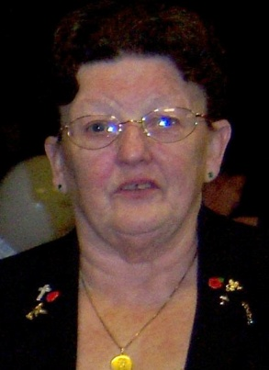

One of my earliest memories of Sunday school is of one very wet and miserable Sunday afternoon walking to where Sunday school was held and standing waiting for someone to come for what seemed to me then like a life time, only to be disappointed, needless to say I did not go back. After this I tried various other Sunday schools, but-never really settled in them, I just did not feel happy going. However when I reached the age of ten years I went to the then congregational Sunday school and this is where I felt I belonged.

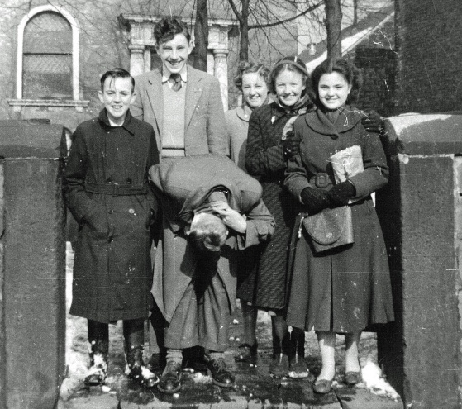Here I felt happy and part of a church family. In Sunday school you started by sitting on the front row and as you got older then you moved towards the back row this had a feel good air about it.

Sunday school started at 10-15am. After half an hour here we all went into church for the morning service, boys sitting on one side girls on the other, and the same seating applied youngest at the front older ones towards the back.

When we had been home and had dinner we would be back at 2pm for the afternoon Sunday school when we would have hymns prayers, then go into various classes for I suppose what you would call scripture lessons, taken by the adult members of the church.

Some of my most vivid memories are of the anniversaries we had and prize givings, the anniversaries were joyous occasions. we would have weekly practices to learn the hymns and be asked to sing a solo or even a duet, maybe even be given a little verse to recite on the big day, we even had platforms one each side of the organ, you've guessed it one for boys one for girls we also had members from other church's come to make a choir to help fill our church with music. If I sit quietly I can still hear them singing especially the men with their tenor and bass voices and I can see Uncle George (Mr. Paskell) standing on the front row seat waiting for hush so we could begin. The church would be packed and the sun would be shining. Oh what memories!

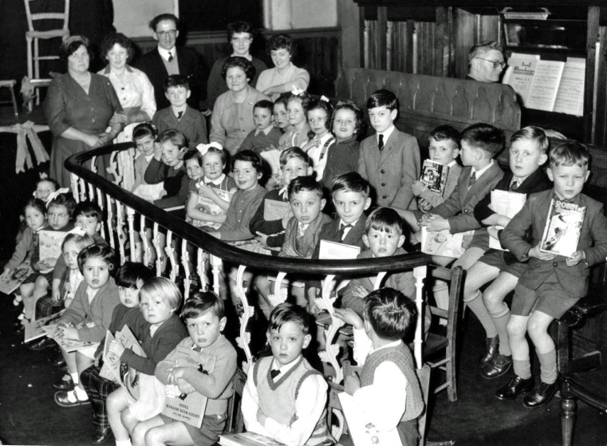Then we had the prize givings, these would be awarded according to the number of attendances you had during the year calculated on the number of stars on your star card which you brought with you each time you came to Sunday school.

This event was usually held one night during the week, the prizes were books of various types according to the age of the child receiving it.

As I reached my teens I started going to church on Sunday evenings. There were quite a few of us teenagers going, we must have enjoyed going because there was never any grumbles about it. Then after church we would all go for a Sunday night walk usually round the three sisters, rounding the evening off at some one's house having a cup of tea and biscuits. From here I went into primary Sunday school helping Mr. and Mrs. Paskell with the younger children in Sunday school. Here we would sing hymns tell them bible stories and draw pictures.

I remember on Sunday mornings and afternoons collecting children from round where I lived and walking them to Sunday school sometimes as many as 8 boys and girls felt like the pied piper, but I enjoyed every minute of it and I would do it all over again.

After a spell of travelling with my husband whilst he was in the army I am still attending the same church and still feel part of one big happy church family.

🕈

West Melton’s Green Tips Corner

**Number 1 – Salt**

Use salt instead of chemical weed killer for removing weeds – especially dandelions!

Simply pour some salt into the centre of the plant. If it doesn’t rain for a couple of days water the plant to dissolve the salt. The salt will be absorbed by the plant killing its entire root system. Success!

Bicarbonate of soda can be used for the same purpose.

**🕈**

**END OF AN ERA IN CLAYTON WEST by Eddie Smith**

Friday the 26th of March 2010 marked the end of an era when it was decided to end the life of the Clayton West Men's Society after being active for sixty years. There were only six members at the annual general meeting when the decision was made to finally end activity due to a drastic decline in numbers.

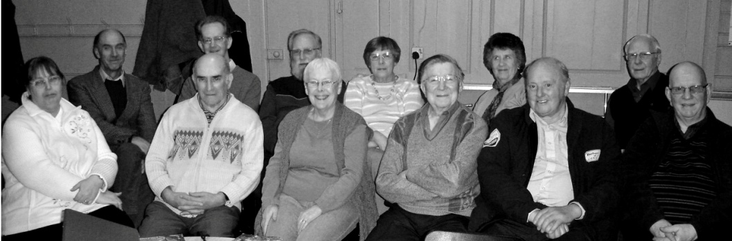

The society was founded in 1950 by the Rev. Frank W. Hewis who was resident minister at the Congregational Church at the time. Frank was a young minister and came to Clayton West straight from serving in the Army Chaplains Department. He spent time in India and on the European Western Front and had an easy affinity with people of all ages. The idea behind the Men's Society was to have a gathering where speakers would talk on a wide range of subjects, where visits could be made to factories and places of interest. In the course of sixty years much was accomplished.

At the time of formation the war had been over for four years, there was plenty of local employment. There was a strong and active branch of the Royal British Legion in the village and the Rev. Frank Hewis was an honorary Padre to the branch. Looking down the list of founder members of the Men's Society I noticed that a lot of them were also members of the British Legion and I can only assume that Frank did quite a bit of canvassing on the Society's behalf.

Talks covered areas as diverse as wild life and transport. We had a speaker from the British Interplanetary Society long before NASA put a man on the moon. Hundreds of slides were shown and in later years we saw electronic digital projection via a laptop computer. Visits to places of interest varied from a stately home like Bretton Hall to a glass bottle factory. In later years things like health and safety and security made visits to industrial premises much more difficult to arrange.

We need to give a big thank you to a succession of secretaries, treasurers, presidents and speakers who have kept the organisation going for all these years. To mention names would be a mistake as an omission might cause offence. The final meeting closed with handshakes all round and a blessing from the Rev. Nick Percival. It was all rather emotional.

✞

**TIME TO COOK some YORKSHIRE PUDDING**

*By William (Bill) Swallow formerly of 56 High Street, West Melton, emigrated to New Zealand in 1924 with wife Annie of Lundhill. Bill Swallow started work with pit ponies in Manvers Main Colliery, worked as a volunteer with the MM Mine Rescue team and served in the Royal Army Medical Corps. 22nd Casualty Clearing Station France 1914-18. This recipe went with him from Yorkshire to Auckland.*

Recipe sent by Bill’s son Fred, Auckland.

1 cup plain flour

[](http://www.recipes4us.co.uk/images/Yorkshire%20Pudding%20All%2010%20x%205%20500dpi.JPG)pinch salt

250 ml milk

1 egg

1 to 2 tbls dripping from roast beef

Sift flour and salt into basin, make well in centre, add egg and beat into flour, Gradually add half milk, beating constantly and mixing all flour together. When batter is thick beat well about 5 minutes. Stir in remaining milk. Cover and refrigerate for 30 minutes. Now place dripping into baking dish or smaller dishes and heat in oven. When very smoking hot, add batter and bake in very hot oven 475 degrees Fahrenheit (240c – gas mark 9)

until browned and cooked. Turn heat down when pudding is well risen. Serve with roast beef and rich gravy.

Yorkshire pudding topped with mincemeat makes a hearty meal.

Topped with raspberry jam and whipped cream a desert. Enjoy!!!

✞

***Didn’t we have a lovely time the day we went to…. Scarborough*** by Fiona Weighton-Smith and Mary Gibson

*Fiona writes:* Wednesday dawned bright as the elderly and young joined together at the end of Farrar Street to wait for the coach to take us to Scarborough. We folded the buggies to go in the hold and helped each other onto the coach. As it was a 25 seater and there were only 15 adults and two children who needed seats there was plenty of space for everyone.

The journey to Scarborough was smooth and uneventful. We arrived at 11.45am to glorious blue sky and sunshine. We could then do our own thing as long as everyone met at 5.00pm for the journey home. Mums and tots went to the beach and the older members to cafés and for gentle strolls along the South Bay.

At 5.00pm our driver was waiting as many tired people walked up to the Valley Road to board the coach back home. Another smooth journey and with only one sleeping on the way home (an 11 month old) the group arrived back on Dodworth Road at 6.45pm. A good day was had by all.

*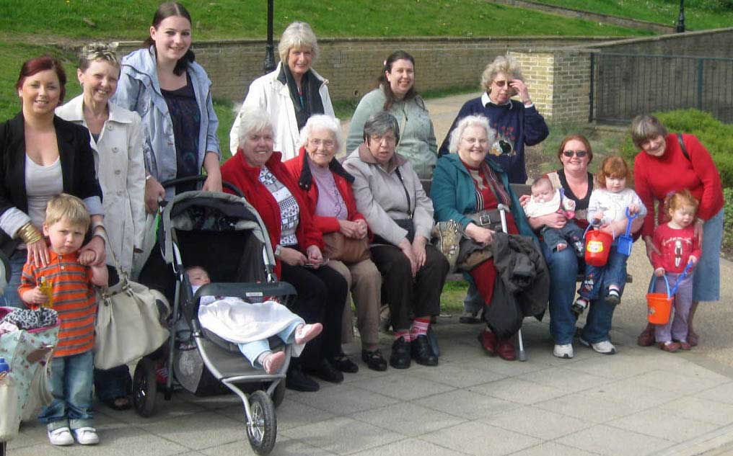Mary writes:* Yes it was a perfect day, however, Una, one of our members, who was there for the week, said after our perfect Wednesday that every other day was freezing cold, wet and windy.

It was a lovely ride both ways. All we needed to do was find a nice seat on the front with a calm sea and lovely sunshine so that we could watch the crowds of people walking up and down enjoying every minute of our glorious day out. Fiona did us proud.

🕭

**GOLDEN WEDDING**

We would like to say thank you to all our church family for all the gifts, cards and good wishes as we celebrated our golden wedding on March 19th and a great surprise party. An occasion we will always remember. Freda and Doug Wroe.

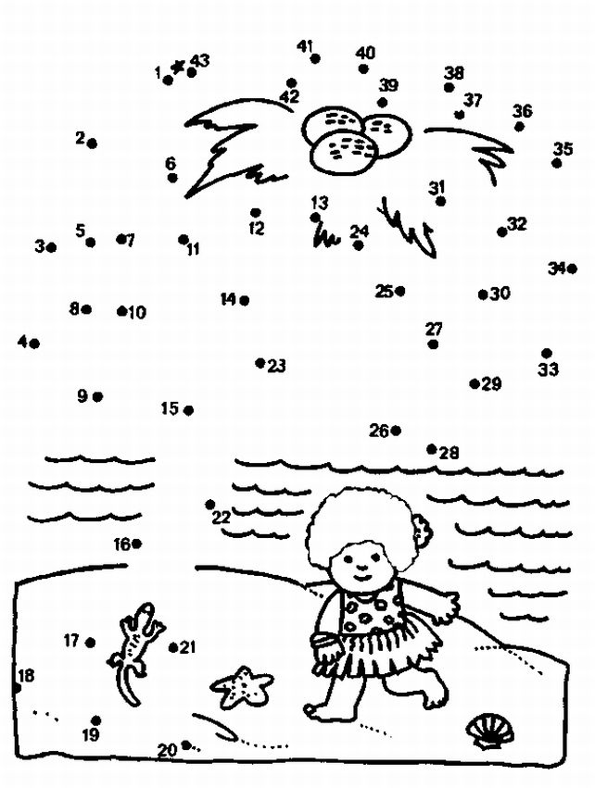

**Word Search Puzzle**

from www.geocities.com/lectionarypuzzles/

words in a straight line in all directions

S S E N L U F H T I A F

S N A I T A L A G N R S

F K I N D N E S S U C H

J L O V E C N E I T A P

O B E T S A R T N O C E

Y T I S O R E N E G E A

W A L O R T N O C R N C

N T S N I A G A E D Y E

S P I R I T T H I N G S

S S E N E L T N E G O F

(Galatians 5:22-23) By contrast, the fruit of the Spirit is love, joy, peace, patience, kindness, generosity, faithfulness, gentleness, and self-control. There is no law against such things. (NRSV)

**Word List**

FAITHFULNESS GENTLENESS GENEROSITY GALATIANS PATIENCE KINDNESS CONTRAST CONTROL AGAINST THINGS SPIRIT THERE PEACE FRUIT SUCH SELF NRSV LOVE LAW JOY AND OF BY

**Amy Louise Houghton 22 March 1992 – 28 March 2010**



Amy died suddenly just a few hours after celebrating her eighteenth birthday with family and friends. Her funeral at West Melton URC on 8 April was attended by over 300 people.

Her family would like to thank you all for your cards of sympathy, love and prayers at this difficult time. Also a big thank you to Ann, Les, John, Nora, Doug and Freda for all the work they did cleaning and getting the church ready for Amy’s funeral service, it was very much appreciated. Thanks also to Rev. Nick for all his kind words and understanding. Thank you.

Amy’s son, Josh, was baptised at West Melton URC

on 14 February 2010.

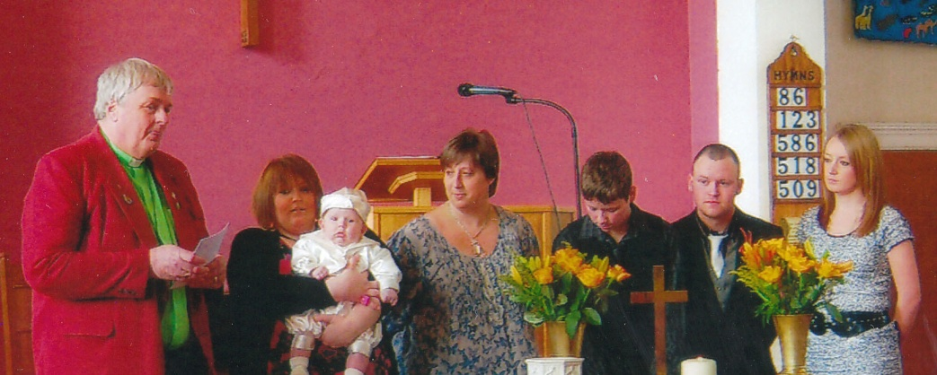

**It could only happen to Margaret!!**

**The Taming of the shrew and its demise!**

(A true story by Margaret Swallow)

Everyone knows how prone I am to things happening to me which could happen to no one else. Apart from getting myself locked in the Church Gallery, here’s another story to add to my growing repertoire!!

It had been one of those days when everything went wrong! There I was, minding my own business, attempting to make myself tea when in through the cat flap burst Daisy!! (For all those who do not know, Daisy is my furry feline friend!!) In she came carrying a little shrew—ah!!! I shouted at my feline friend to drop it, and to my surprise she did as she was told—a very unusual thing for her to do!! The little shrew was in the corner of the kitchen. Grabbing Daisy by the scruff of the neck and throwing her out of the kitchen I went to pick up the shrew to find it was still alive!! Well can those creatures move!! Hence the phrase *taming of the shrew!!*

I was intent on rescuing the little creaturefor which it should have been grateful*,* but instead it shot around the kitchen behind the fridge freezer. Dragging the fridge freezer out it then took refuge under the cooker!! Well I could not leave it there, so once again I dragged out the cooker, but in the process I had dropped the cooker on to the shrew, and killed it!! I then had to remove it and conduct an internment in the back garden—ah!!

So there ends the story. I was exhausted, the cat was in disgrace, and the shrew was dead—so much for trying to help Gods little creatures!! Before anyone asks –no I don’t have a video of me chasing the shrew!

**Sequel to The Taming of the Shrew**

**Happy Endings--or thereby hangs a tail!!!**

Another day, another shrew, brought in by my feline fiend!!

In she came diving through the cat flap, making for the stairs!!

“Bad girl “says I-drop it! Deciding not to challenge my authoritarian voice, she promptly dropped the poor little shrew on the stairs, and made for her hidey hole in the airing cupboard!

Thinking the shrew must be dead I went to pick it up. Yes you’ve guessed it--it was alive! After much chasing around with paper towels to try to rescue it, I finally cornered it on the stairs and moved to take it outside.

It escaped in the back porch and refused to go out of the open door! Yanking all the rubbish out of the porch I finally rescued it and took it out into the garden!

It survived against all the odds!!

Ahh!!!

🕈

**Pondering** by Norma Pugh (March 2010)

Sailing the Atlantic with nothing in sight,

Not even a sea bird swooping in flight

I watched the ocean shining and glimmering

And in a clear blue sky, the sun was beaming.

I had nothing to do but ponder on what, where and why.

All around were people like me, soaking up the sun or

Playing deck quoits or shuffle board;

Laughing and cheering when somebody won.

Others were walking incessantly round the ship on the promenade.

And I watched them as they passed me by.

Some walked with a determination

To get there quickly — wherever "there" is.

One mile equals three times around the ship and a bit,

And I pondered why all this activity, were they hurrying

from or to something or was it just to keep fit?

Some sauntered and gave me a smile; others wore expressions

of thoughtfulness, acknowledging no-one

Perhaps they were thinking of families or worries left behind,

Or thinking of nothing at all.

I returned to watching the ocean

And wondered what lay over the horizon,

beyond the line drawn between sea and sky

The ancient ones thought that once reached,

you would fall over the edge

For the earth was flat.- that, no-one could deny.

But the horizon is never reached it was found

For it always lay just ahead;

And when sailing the world, one finished where one had started

Proving beyond doubt the world is round.

So what does lie beyond the horizon?

beyond the line drawn between sea and sky;

Lands and people I may never meet,

And I wondered if they had the same thoughts as did I.

I looked at the people around me — did they think the same?

After this cruise is over, they would remember where they had been

but would they ever give a thought

to the people they have met or even remember their names?

But they are on holiday so it matters not a jot

Whether they walk, sit or play.

As for me I prefer to sit and ponder

And enjoy my longed for R & R.

Sixty Years Ago by Eddie Smith

*Dilys Mary Rowley married William Edward Smith on the 4th of June 1949 at the Congregational Church, Clayton West. The Rev.Frank W. Hewis officiated.*

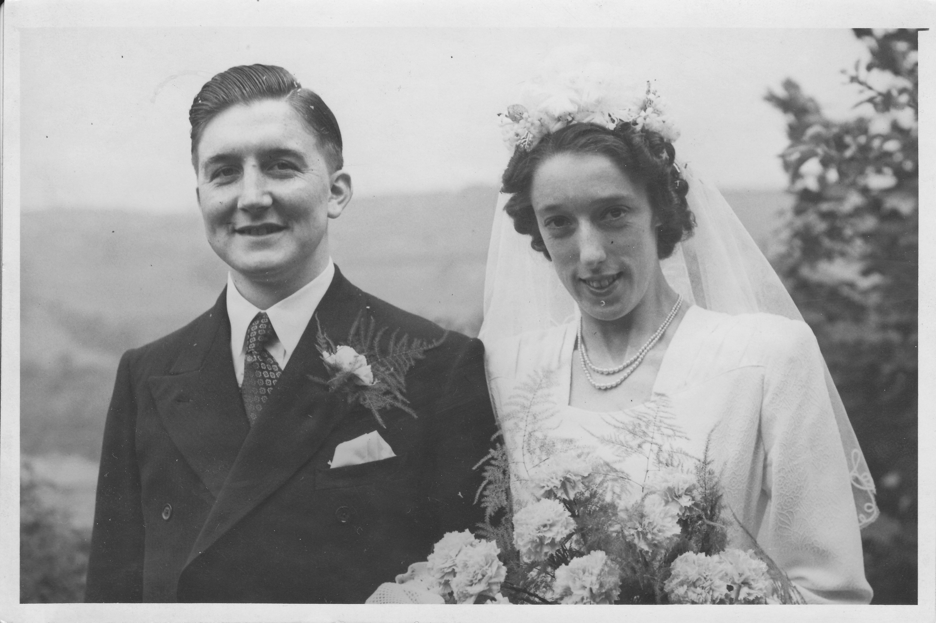

On the fourth of June 1949 it was raining in the morning. We were hoping that the weather would improve in time to have our photographs taken after the wedding. Fortunately it did, although the manse lawn was very wet. Our minister's wife Elsie found a piece of old carpet and so we were able to keep our feet reasonably dry for the photo session.

We were starting to recover from six years of war. Food and fuel were still rationed but clothing had just come off the ration before our wedding. Although we were theoretically at peace the situation was still tense. The Berlin blockade had just been lifted but supplies were still being flown in. Young men of eighteen continued to be called up for service in the armed forces.

Steam trains were still running to Clayton West and hundreds of tons of coal were still being transported up the line every week. Holiday excursions still ran occasionally. Trolley buses were still running in Huddersfield operated by the Huddersfield Passenger Transport Authority. The Metropolitan Borough of Kirklees had still to be created. Our bus requirements at that time were served by three companies. County Motors of Lepton, Yorkshire Traction Company of Barnsley and West Riding Buses of Wakefield. All buses had both a driver and a conductor. Street lighting at that time was very minimal, but it was paradise compared to the years of blackout. Incidentally 1949 was the year that Blackpool re-introduced the illuminations after a ten year gap.

The National Health Service was in its infancy and things like organ transplants and chemotherapy were a fair way off. Finding a dentist in those days was probably easier than it is today.

Coal was still in short supply which made things difficult in cold weather as most people depended on open coal fires for heating. Quite a lot of coal ovens were still being used for cooking. Central heating was limited to public buildings and a small number of large houses and was usually coke fired. Factory chimneys were also smoking as people busied themselves with spinning, weaving and various other industrial activities. The atmosphere was quite sulphurous and we did occasionally get choking smogs. Another function which the factories and collieries provided at that time was to give us a signal that it was time to get to work. They did that by means of the works "buzzer".

There was no natural gas supply, only coal gas of rather variable quality. Gas was produced locally by W. B. & G. H. Norton in Scissett. The site of the gasworks was roughly where Carpet Barn now stands. Denby Dale had its own gasworks as did Skelmanthorpe. The gas 'grid' was still to come. Morton’s shop in Scissett and Harry Ackroyd in Clayton West were still selling quite a lot of paraffin to people who had neither gas nor electricity. I believe that Clayton West station was still lit by oil lamps at this time.

Many houses had no flush toilets, just a rather draughty smelly earth closet. A chamber pot was an essential rather than a decoration in many households in those days.

Milk was delivered daily (Sundays included) by the local farmers and it was mainly transported by horse and cart. It was fresh daily and often ladled straight from the can into the customer's jug. It would be kept in the coolest place in the house as very few families possessed a fridge. Electric washing machines were also thin on the ground and automatics had still to come.

Fruit and vegetables were still seasonal - no such thing as strawberries at Christmas and certainly no ready meals. Supermarkets had still to come. The old monetary system of pounds, shillings and pence was still in use. 12 pence in a shilling, 20 shillings in a pound. The sum f 14-19-11½ would be expressed verbally as fourteen pounds, nineteen and eleven pence ha'penny. Shop assistants would total sums up mentally or with pencil and paper. There were no electronic calculators although rather bulky electro mechanical calculators were available.

The only takeaway food outlets at that time were fish and chip shops. We had two in Clayton West, Benny Hardcastle's and Bob Wright's.

Very few cars were on the road, which was as well really as there were no motorways.

Telephones also were not very plentiful and at that time they were under the control of the Post Office. All telephones were attached to the system by a bit of wire and a lot of numbers had to be called via an operator. None of those damned annoying voices telling you to press 1 for this and 2 for that.

Television was only just beginning to come up north at that time and I believe that the nearest transmitter was in Sutton Goldfield. One or two local people did buy sets and go to the expense of installing a high

dipole aerial but reception was very variable. Programmes were broadcast on one channel in black and white for only a few hours a day. The cinema was still popular and the 'Savoy' in Skelmanthorpe was well patronised with its thrice weekly programme change. There were several cinemas in Huddersfield, the most modern of these being the 'Ritz' with its theatre organ and resident organist. There were also two theatres in

Huddersfield. The National Anthem which at that time was God save the KING was still played at the end of theatre and cinema performances and most people remained standing whilst it was being played. During the winter months at that time Scissett Baths would become a dance hall when a sprung floor was laid over the pool area. It was a very popular venue for all ages.

There was still at least one policeman in each village and a sergeant was based at the Police Station in Crown Street in Scissett.

The mail was mainly carried by rail at that time. One of our postmen would collect the first incoming mail from the 6 o'clock train in the morning. The first outgoing mail would leave on the 1 o'clock train and the last would leave at half past six. The only transport between railway station and post office was the postman's bike. I do not think the mail was any slower in those days and there was no junk mail.

There were no debit and credit cards and no cash dispensers.

Ladies had nylon stockings but no tights and 'the pill' had not yet been introduced.

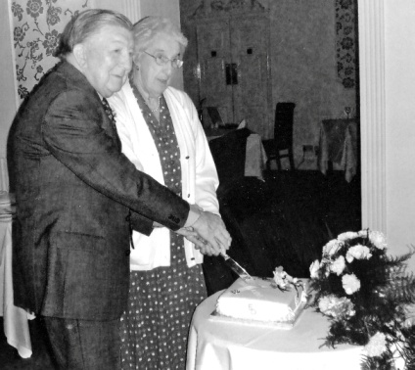The computer age had yet to begin. Newspapers were very much slimmer in those days and illustrations were much coarser in appearance and only in black and white. Our own local Huddersfield District Chronicle was still being printed in Clayton West.

Some words were used differently. We did things rather than 'stuff'. Gay meant light hearted excitement, bright and brilliant in colour. We had `moments' rather than 'moments in time'.

We have lived through years of rapid progress and looking back 60 years those days seem very austere. I do not think we thought that way at the time and we survived.



ALL THAT REALLY MATTERS – contributed by Audrey Coultas

All that really matters is the way  
in which we live,

The way we face our troubles

And the happiness we give.

The way we deal with others  
whom we contact on life's way,

The way we work, the things we think  
and the sort of prayers we pray.

All that really matters is our  
attitude of mind,

The way we meet life's rough and smooth  
and the setbacks that we find.

The way we try to right the wrong  
and the way we check despair

The way we use our talents

and the things for which we care.

All that really matters is the  
character we build,

The way we shape its glory by the  
missions we've fulfilled.

The rays we cast through goodness  
across the ways we've trod,

These are the things that matter to  
ourselves as well as God.

Thanks to all the contributors to this edition of LINK.

Contributions are always welcome and for the Autumn 2010 edition of this magazine need to be with Rev. Nick by

Sunday 15th August, please.

**REGULAR ACTIVITIES IN OUR CHURCHES**

**Clayton West**

Sunday Worship every week at 3.00 pm. Communion is included in the service on the 1st first Sunday of each month

Saturday Coffee Morning on the 4th Saturday each month 10.00am

**Trinity (Barnsley)**

Sunday Worship every week at 10.30 am. Communion is included in the service on the 3rd third Sunday of each month

Tuesday Bible Study at 7.30 pm

Wednesday Age-Well (*over 50s club*) every week 10.30am-1.00pm

Trinity Players every week at 7.30pm

Thursday Trinity Tots (*carers & toddlers*) 10.00am – 12.00noon

**West Melton**

Sunday Worship on the 1st (*inc. WHIZZ KIDS*) and 4th Sundays at 10.30am and on the 2nd & 3rd Sundays at 3.00pm. Communion is included in the service on the 3rd Sunday of each month

Monday Sisterhood every week at 2.30pm

Wednesday Little Stars (carers & tots) 9.30am every week *(in term time)*

Praying Hands (*prayer group*) 7.30pm – 8.30pm on the 2nd Wednesday of each month

Fellowship evening (*varied programme*) 7.30pm on the 4th Wednesday of each month

Friday Children’s Fun Night 6.30pm – 8.00pm (1st & 3rd Fridays *in term time*)

Saturday Men’s Breakfast at 8.00am on the 3rd Saturday each month