LINK

The magazine of the Barnsley Group Pastorate

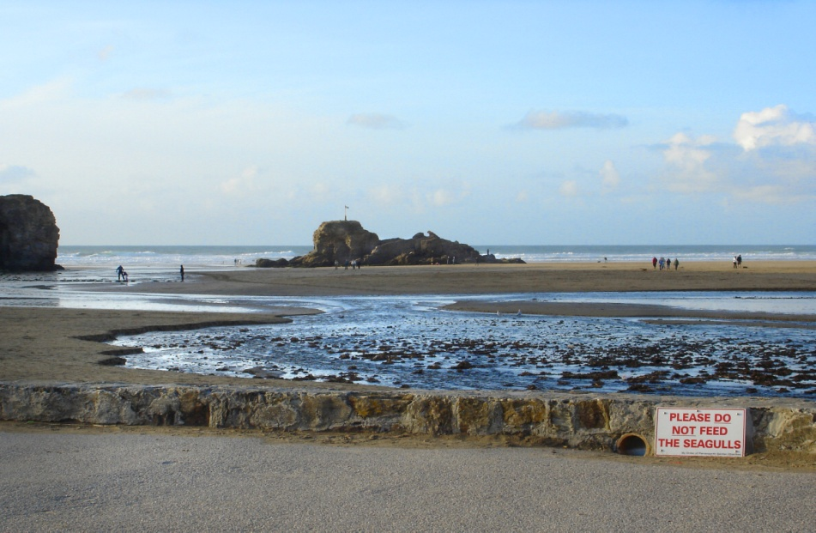

**SUMMER 2011**  

Plumbing and

heating engineers

Tel: 01709 873518

[info@paskellplumbing.co.uk](mailto:info@paskellplumbing.co.uk)



**Druids Sheffield**

**Friendly Society**

Plans for Healthcare – Tax Exempt Savings

Sickness and Death Benefits

Endowments – Insurance I.S.A.

Leaflets on all plans available from:-

Dove House, Brampton Road,

Wath-Upon-Dearne, S63 6BE

Tel: 01709 876409

Fax: 01709 878045

Email: deuidssheffield.friendly@virgin.net

www.druidsfriendly.co.uk

Established 1858. Authorised in the United Kingdom under the Friendly Societies Act 1992. Reg. No. 795f

Druids Sheffield Friendly Society is regulated by the

13307

_________________________

**Simon T. Anderson**

Funeral Director

23 Dodworth Road, Barnsley.

**(01226) 733119**

*24 HOUR SERVICE*

AN INDEPENDENT FUNERAL SERVICE

*Professional and friendly advice on all aspects of the funeral service*

Financial Services Authority

___________________________________________________



Andrew P. Lockwood

**MinstChP. CCM(Sheffield)**

**CHIROPODIST**

**All Foot Ailments Treated**

CORNS – CALLOUSES (Hard Skin) – VERRUCAE – ATHLETE’S FOOT etc.

**Home Visits – Prompt Attention**

**Tel: 01484 687632**

**Mobile: 07971355078**

Dear friends

In the summertime when the weather is high you can stretch right up and touch the sky. When the weather’s fine… we do as we please, we go fishing or go swimming in the sea…We’re always happy… (*Mungo Jerry*)

Summertime brings joy to life… (*The A-Teens*)

Summertime and the living is easy… (*DuBose Heyward– recorded by various artists*)

And I love to live so pleasantly. Live this life of luxury. Lazing on a sunny afternoon in the summertime… (*The Kinks*)

Let’s steal away in the noonday sun. It’s time for a summertime dream. Birds in all creation will be twitterin’ in the trees and down below’s a pond I know. You can swim in it if you please… (*Gordon Lightfoot*)

Get up in the morning. Check out the weather. If it looks like sun  
I get my things together… And head for the beach… (*Eric Carmen*)

Summer, summer, summertime, time to sit back and unwind… (*Will Smith*)

This is a song about Summertime (Cool summer yeah cool summer)   
May it never end, may it never end… (*Janet Jackson*)

It’s a lazy afternoon summertime, as I recline, lay back and relax, let the sun shine …(*Roots*)

We're all going on a summer holiday no more working for a week or two. Fun and laughter on our summer holiday, no more worries for me or you… (*Cliff Richard*)

I wonder how many of you started to sing those songs in your head (or even out loud!) as you read the words?

They all imply that summer is a nice time to relax, forget about

your worries, be happy and simply having a good time.

I love listening to ‘Summer Songs’ on the car radio – they have the ‘feel-good’ factor don’t they, they put a smile on your face, the sun is shining and life is good – what a mantra!

Yet as Christians we should be like that all year round. Jesus gives us the *‘feel-good’* factor. His love for us gives us the *‘feel-good’* factor. His forgiveness gives us the *‘feel-good’* factor. His grace gives us the *‘feel-good’* factor. He cares about us whatever the weather. He is not a *‘fine-weather saviour’,* he is an *‘all-weather saviour’.* Jesus will give you an inner happiness all day, every day, if you let him into your life even when you are lazing on a sunny afternoon in the summertime.

Have a glorious summer and may God continue to bless you.

Your friend and minister



*(Cover photo - Perranporth Beach, Cornwall)*

**Sunday School Days – Here we are again**

by Joyce Jones

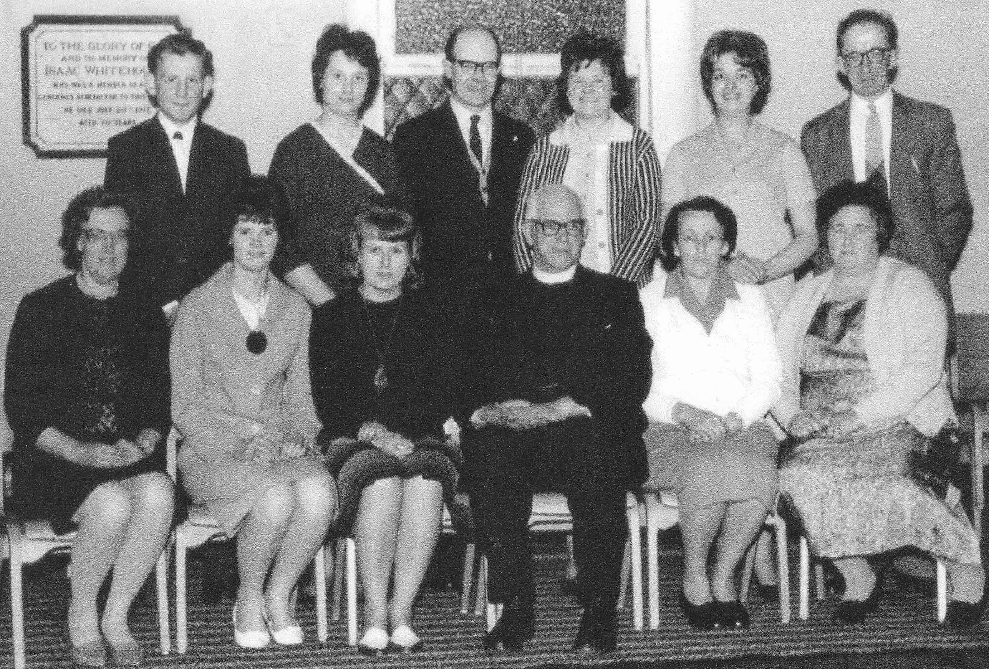

I thought you might like to see the Sunday school teachers of yesteryear this photo was taken probably in 1961 or there about, it shows our then minister the Rev Robert Robson, a well loved Newcastle man. He started the Friday night film show which ran for years, all black and white films, all silent with Popeye and Felix the cat, all remembered by my age group, be there early next week we said, so we were there to get the front seat or sit in a favourite place. It was 3d or about 2p as we are now with our decimal coins. The photo was taken by Mr. Short of Wombwell a local photographer he called us the Queen’s chapel as he took the photos of our Sunday school Queens for a few years, more about that later. This photo was taken after the prize giving. The back row L to R is Keith Binney, Pat Smith - now King, Harold Neil, Margaret Kirkham - now Smith, Josie Peace - now Binks and George Paskell. In the front row, L to R, are Dorothy Lindley, Ann Paskell - now Peace Ann Kay, the Rev Robson, Mrs. Copeland and Mrs. Daisy Paskell .These were really great days. Mrs. Lindley also played the organ in church as did Mr. Paskell when Mr. Stanger retired to live in East Yorkshire.

Once again HAPPY DAYS.

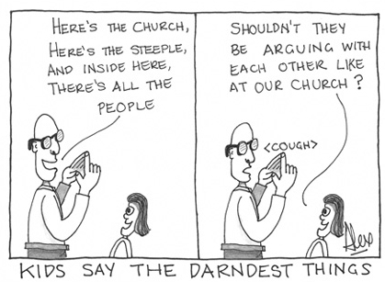



*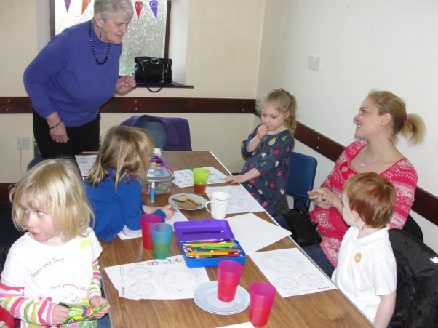On 2nd March West Melton URC held a BIG BREW afternoon to raise money for and awareness of Traidcraft. The organiser, Helen Owen, writes:*

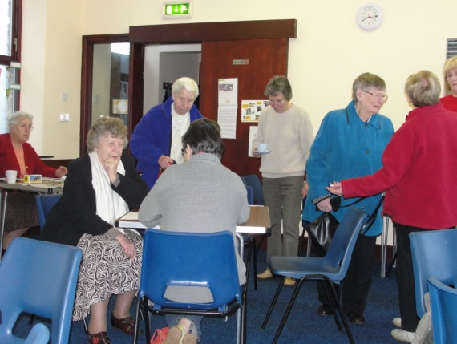I have just received a letter from Paul Chandler, Traidcraft's Chief Exec. in which he thanks me for my support during the past year. My total purchases for the year April 2010 to March 2011 were £695.59.

He also speaks of how impressed he has been at the number of Big Brews and other events which were held during Fairtrade Fortnight around the country.

In addition he refers to generous donations to Traidcraft's charity arm, Traidcraft Exchange, and quotes the sum of £277,716.16 which was the total donated by Fair Traders and retailers passing on surpluses from their stalls, shops or fundraising events. The proceeds of our Big Brew were sent to Traidcraft Exchange so we have made a contribution, albeit rather small, to that sum.

Clearly none of all this would have been possible without the support and generosity of all my customers, their families and friends. To quote Paul Chandler "So as well as my thanks directly to you, please pass on our gratitude to all those partners, children, friends and customers who have supported you in making all this possible. You really have made a difference!" Finally, the letter states that together the 6000 registered Fair Traders achieved £6.9 million of sales and the 363 shops achieved £1.74 million of sales for. Traidcraft's producers.

West Melton’s Green Tips Corner

**Number 4 – How to control blackfly.**

Here is a green tip for gardeners--grow garlic near broad beans and borage to (almost prevent) blackfly. Works near other plants which are prone to blackfly. [](http://www.google.co.uk/imgres?imgurl=http://blogs.crocus.co.uk/kitchengarden/files/2010/07/blackfly3.jpg&imgrefurl=http://blogs.crocus.co.uk/kitchengarden/2010/07/03/rogues-gallery-blackfly/&usg=__H2DIfw03m29xIAvPOvb5EeMaPpQ=&h=528&w=704&sz=134&hl=en&start=13&zoom=1&tbnid=bcluGx8DnlCDgM:&tbnh=105&tbnw=140&ei=Qp3KTaTzC4_n-ga_hdW0Aw&prev=/search?q=blackfly+and+broad+beans&hl=en&sa=G&biw=1600&bih=818&gbv=2&tbm=isch&itbs=1)

Or you can make a ‘HOT’ spray. Put a whole garlic bulb through a garlic press and let it sit in a glass jar with a tablespoon of vegetable oil. Add a dessertspoonful of Fairy liquid (other dishwashing liquids are available!), a dash or two of hot pepper sauce (Tabasco) and 7 cups of water in a spray bottle. Spray to your heart’s content safe in the knowledge that you will only harm those pesky aphids.

**AT THE EASTER HOLIDAY CLUB IN CLAYTON WEST…**

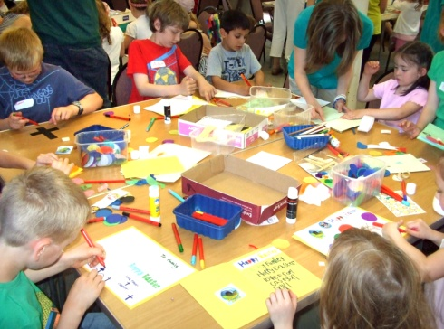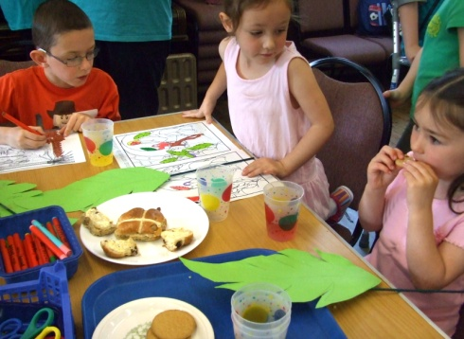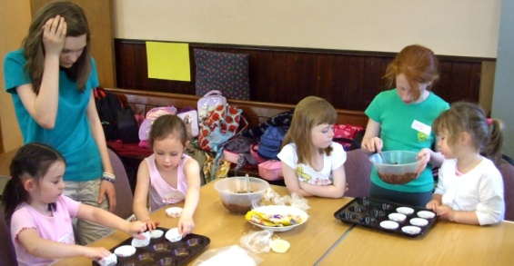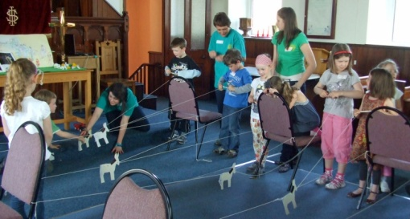we started the day with Palm Sunday, waving our palm leaves as we walked around the Church. Everyone had a go at the donkey race and enjoyed the other games. We heard the Easter story, ate Hot Cross buns, made chocolate krispies and an Easter card; a busy day!

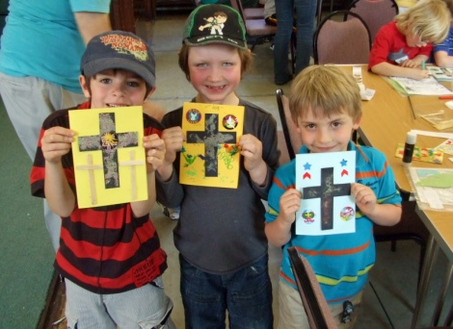The day finished with everyone upstairs in church for a final prayer and songs. Lots of parents and carers came to join with us which was a lovely end to a fantastic day.

During a recent stay at the Windermere Centre I came across this article in the magazine of Carver URC. (http://carver.urc.org.uk)

It certainly resonated with me and probably will do with you too. If you have memories of events like this please write them down and give them it me for a future edition of the LINK. Thanks. *Nick.*

**Prize Giving** by George Wray

One of the great days in the Sunday school calendar was the annual prize giving. Prizes were given for regular punctual attendance and good conduct. Scholars obtaining full marks, that is to say one hundred and four marks in the year, received a book to the value of three shillings and sixpence, a second prize necessitated the scholar to attend ninety four times per annum to earn a book worth half a crown. First prize winners were allowed to be absent two Sundays in the year for holidays. Methodists could be very generous.

Morning Sunday school started at nine thirty, at ten thirty the scholars trooped under strict supervision from the Sunday school via a dark corridor at the side of the organ into the gallery of the Chapel. Like Colditz there was little chance of escape. The service in the chapel lasted till twelve noon. The afternoon Sunday school started at two, this frustrated the devil who, as we were constantly reminded, "soon found work for idle hands."

In the afternoon school we sat on wooden forms in classes, the superintendent sat on the stage behind an oak table piled high with the books to be given out as prizes. At his side sat the Sunday school secretary and the august person who was appointed to present the prizes. This could be a Sunday school teacher or respected member of the church. They did not need to be as august a person as the one who opened the sale of work who needed to be a mill manager or a councillor as they were expected to put their hands in their pockets. The superintendent would ring a large brass bell and there would be absolute silence as he walked slowly in front of the table. He then glanced to the boys’ side of the room, his eyes like machine guns, then he glanced towards the girls’ side and almost smiled. He liked girls! Then he announced the first hymn, then prayed in a special voice, a good, generous prayer calling a blessing on King, Queen and Empire, those who worked on the mission fields, those placed in government over us and all set in authority, doctors, nurses and so on and on. Sometimes he took a step nearer to the edge of the platform but always managed to end his supplications before he fell off the edge. Then another hymn and the lesson and the notices would be read out before he announced, "will the teachers please mark the registers and collect the missionary money."

The pennies for the missionary fund were entered. A member of the class was detailed to walk to the end of the room and place the money and registers on the table where the missionary secretary attended to his awesome responsibility with the aid of a Black Swan fountain pen. While this took place the whole school talked quietly knowing the superintendent would overlook such levity on prize giving Sunday. On ordinary Sundays he would glare, ring the bell, shout like a regimental sergeant major or even sit down and look all round the room till all talking ceased, then say dramatically, "All right, you'll all wait till I'm ready to continue, you'll all be kept in till after three." He only did this occasionally as repetition might have led to some form of mutiny, with men and women of all ages in the school. England was an authoritarian country before the Second World War.

When the children returned to their classes the superintendent invited the teachers to lead their classes into the centre of the room, "quietly" He might even smile his superior smile as opposed to the one he reserved for his equals and those with more money, then it became obsequious and toadyish. He let his gaze rest on the pile of books on the table a few moments before introducing the presenter, "who needs no introduction." However they always got one, male or female, their achievements and accomplishments trumpeted and exaggerated beyond all recognition. The presenter would rise slowly to his feet, head bowed in mock embarrassment and say a few words about the school and its traditions.

After a few anecdotes and testimony to the value of Sunday school attendance, he would start to present the prizes, beginning with the youngest class on the girls' side. The Sunday school secretary produced a list from his pocket and read the first name. The recipient would rise to her feet and walk up on to the platform to receive her prize. The presenter would shake her hand and say a few private words of congratulations. If the book was a religious book or of an ‘improving’ nature he held it up cover first to show the school. Pilgrim's Progress was always good for a commendation. Some books, especially if they were tales of adventure or the sea were held up with a condescending smile for all to see, as proof of the school's tolerance of choice, But, looking back, it was improving books of saints and missionaries that got the applause and I well remember children going back to their seats, grasping their prizes, head down and red faced, in a warm cloud of self congratulation and sanctity. I also know a lady who deliberately picked her prize with a lurid cover. There's always one!

**WORDSEARCH – Parables of Jesus – can you find all 14?**

|  |  |  |  |  |  |  |  |  |  |  |  |  |  |  |
| --- | --- | --- | --- | --- | --- | --- | --- | --- | --- | --- | --- | --- | --- | --- |
| E | X | C | W | B | U | U | T | T | R | C | Z | S | W | H |
| E | Z | E | O | C | N | N | E | W | E | A | M | T | B | I |
| R | W | F | P | J | J | M | N | O | W | S | E | I | M | T |
| T | Y | G | M | Q | U | E | V | D | O | U | T | L | X | O |
| G | O | X | N | Z | S | R | I | E | S | S | D | D | L | E |
| I | S | E | R | A | T | C | R | B | D | E | R | R | G | R |
| F | T | Y | R | W | S | I | G | T | O | J | A | B | O | U |
| T | A | U | I | Y | T | F | I | O | Z | E | G | E | D | S |
| W | L | O | C | P | E | U | N | R | P | H | N | H | L | A |
| O | E | I | H | Q | W | L | S | S | M | P | E | A | O | E |
| S | N | E | F | U | A | Z | L | F | X | P | T | P | V | R |
| O | T | F | O | A | R | E | E | Z | A | B | M | P | E | T |
| N | S | A | O | K | D | P | F | Q | U | I | O | Y | Y | D |
| S | B | E | L | O | S | T | S | O | N | B | T | O | O | I |
| G | O | O | D | S | A | M | A | R | I | T | A | N | U | H |

Two Debtors - Good Samaritan - Rich Fool - Lost Son - Fig Tree - Unjust Steward - Tares - Hid Treasure - Pearl - Drag Net - Two Sons - Ten Virgins – Talents - Sower



Matthew 13: 1 - 23

Quiet Days in Yorkshire Synod

25 June 10.30am – 4.00pm

Intake URC, Ardeen Road, DONCASTER, DN2 5EU

Leader: Heather Skidmore. Phone: 01777 838634

email: [hskid@btinternet.com](mailto:hskid@btinternet.com)

**********

2 July 10am – 3pm

Bishop Burton Methodist Church (near BEVERLEY)

Leader: Sister Jo McGuigan, Canoness of St. Augustine

To book a place please phone Jim Sharp on 01482 868383

**********

2 July 10.30am – 4.00pm

Selby URC, New Lane, SELBY, YO8 4QB

Leader: Janet Lawrence. Phone 01757 700268

email: [janet.lawrence5@hotmail.com](mailto:janet.lawrence5@hotmail.com)

**********

2 July 10.30am – 4.00pm

Wadsley URC, Carlton Road, SHEFFIELD, S6 1WR

Leaders: Elizabeth Aizlewood. Phone 0114 2341308

email: [elizabeth.aizlewood@live.co.uk](mailto:elizabeth.aizlewood@live.co.uk)

Rev. Nick Percival. Phone 01226 771277

email: [revnickp@yahoo.co.uk](mailto:revnickp@yahoo.co.uk)

**********

Tea/Coffee will be provided at all venues. Please bring your own lunch.

No need to book – except for the day at Bishop Burton Methodist Church.

**I encourage you all to go to one of these Quiet Days – you will be very welcome and will be refreshed. *Nick***

**West Melton Sisterhood – The end of an era.**

By Margaret Marchant

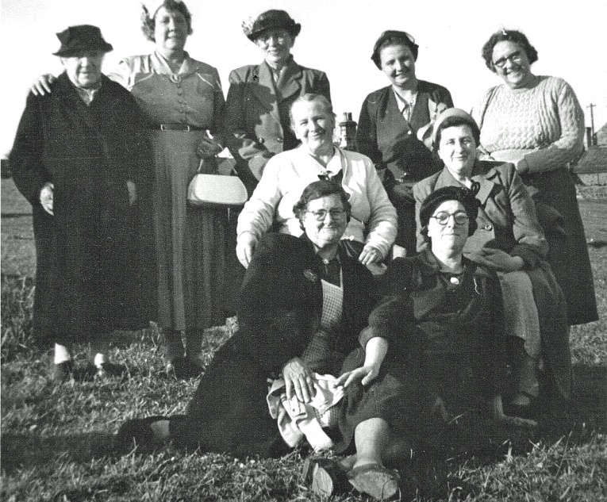After some fifty years or more, it is with sadness that I write to say that the Sisterhood at the United Reformed Church West Melton has now ceased to meet.

Over the past few years our numbers have declined, due to members passing away, or are unable to attend due to ill health.

On looking at an old record book, when the Sisterhood began, there was quite a few ladies attending, at least forty between 1956 and into the 1970’s, unfortunately as they have passed on their places have not been filled with new members.

During the years I chaired the meetings, we tried to keep up with past traditions e.g. our Annual Sisterhood Anniversaries in our own church, visiting other local churches to help them celebrate their Ladies’ Anniversaries, we celebrated our member’s birthdays by going out for lunch, then back to our own church and rounding the afternoon off by having a game of bingo, we provided stalls for various functions at church, such as spring fayres, garden parties, coffee mornings and the autumn fayre.

At Christmas we would have a Christmas lunch in the community hall and end the afternoon by singing a few of our favourite carols, we also went on outings visiting friends and places of interest.

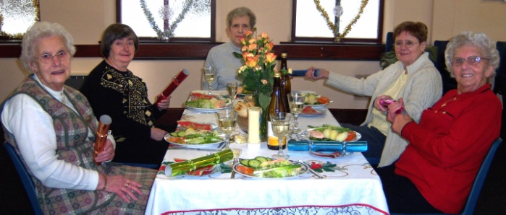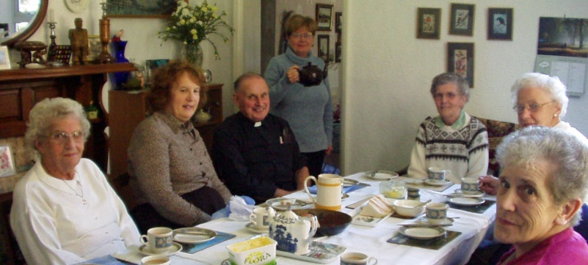Before I close I would like to say how proud I was to take over as leader of the meetings for the past few years, as my mother Mrs Martha Copeland , had held the same position many years ago.

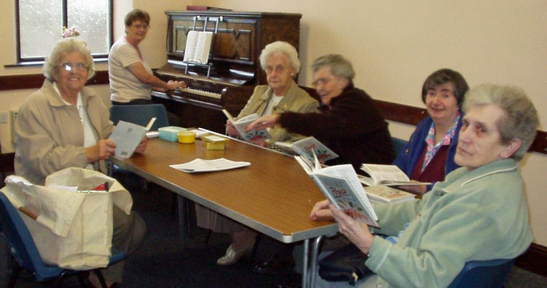So all that remains for me to say, is a big thank you for all your support we have received down the years from everyone.

Thank You.

God Bless

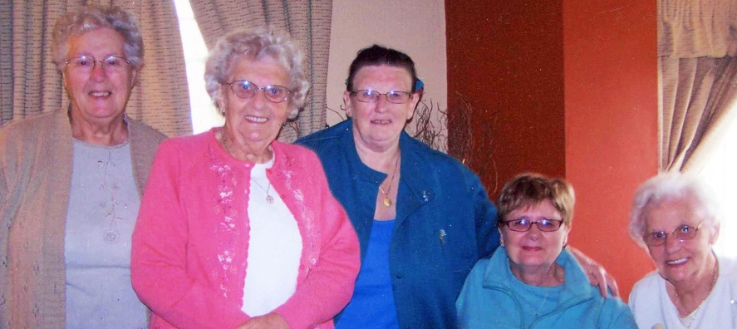

**Summer Pudding – A Recipe**

*Enough for 6-8 people*

**INGREDIENTS**

About 1 ½lb/675g of raspberries, redcurrants and blackcurrants

4oz/115g caster sugar

2 tbsp crème de cassis or good quality blackcurrant cordial (optional)

1 small, day-old loaf of white bread

Two days before you want to eat the pudding, strip the currants from their stems and put them in a bowl with the raspberries. Toss them with the sugar, cover and leave to stand overnight.

By the next day, the fruit will be sitting in its own syrup. Tip the contents of the bowl into a pan and bring to simmering point. ≤ Cook gently for two minutes, then leave to cool. Add the crème de cassis or cordial, if you are using it.

Slice the bread thinly and cut off the crusts. Cut a circle of bread to fit the base of a 1 ½-pint/800ml pudding basin. Dip one side into the juices in the pan and put it in the bowl, dipped side down.

Cut the rest of the bread into triangles and, dipping each piece first in the juices in the pan, arrange snugly around the sides of the bowl. Fill in any gaps with more bread, saving enough slices to cover the top of the bowl.

Pour half the fruit and juices into the bowl, then top with a layer of bread. Pour the rest of the fruit and juices in, then finish with more bread.

Cover with cling film, and put a small plate on top (one slightly smaller than the circumference of the bowl). Weigh it down with some heavy jars, and put in the fridge overnight (or for up to two days).

To serve, run a knife around the inside of the bowl and invert on to a plate.

🕈 🕈 🕈

**West Melton’s ECO GARDEN – work in progress**

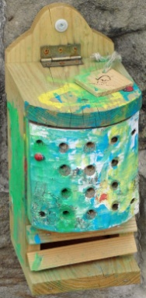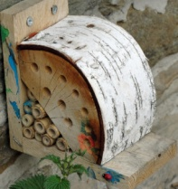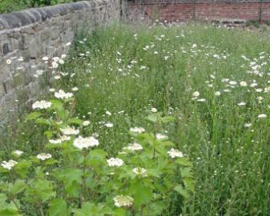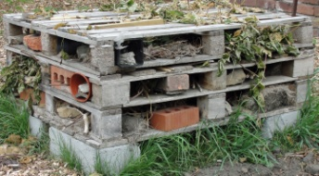A wildlife friendly garden is being created with the help of everyone at the church. The children enjoyed painting the bird and bug boxes.

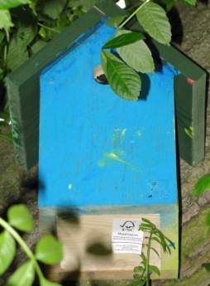



These faith teas are getting out of hand!



Just let me know who was here first and I will get the paperwork started!

*Copyright Gospel Communications International, Inc -* [*www.reverendfun.com*](http://www.reverendfun.com)

**News from around the world**

**Syrian Christians threatened: join anti-government uprising or leave -** [www.barnabasfund.org](https://netcommunity.barnabasfund.org/page.redir?target=http%3a%2f%2fwww.barnabasfund.org&srcid=2046&srctid=1&erid=2316527)

As demonstrations against the Syrian government intensify, Christians are coming under increasing pressure to join the uprising - or leave.

|  |
| --- |
| [St-Sarkis-Armenian-Apostolic-Church_email.jpg](https://netcommunity.barnabasfund.org/page.redir?target=http://www.flickr.com/photos/26085795@N02/4729814797/in/photostream/&srcid=2046&srctid=1&erid=2316527) |
| Syrian churches have received threatening letters calling them to join demonstrations |

In one Christian village outside the southern city of Deraa a home came under fire by a group of masked men on motorbikes, while Muslim residents in the village of Hala have issued an ultimatum to their Christian neighbours either to join the demonstrations against President Bashar al-Assad's regime or to leave. Their demands are making life extremely difficult for the Christians, who have closed their shops and are considering what course of action to take. Churches have also received threatening letters.

Barnabas Fund is one of the very few Christian agencies working to assist the Christians in Syria, and has done so for many years. They are in particular need of humanitarian help now, with food prices rocketing as the country's economy is affected by the unrest.

Christians have largely stayed away from the protests, having generally been safe and well-treated by the secular Baathist government, which has allowed them a considerable amount of religious freedom. They are fearful of what may replace it as Islamists attempt to hijack the demonstrations, which were originally concerned with political and economic change.

Muslims have been rallied by prominent Islamists in the region in support of the demonstrations. Abu Muhammad al-Maqdisi, mentor of the late Abu Musab al-Zarqawi, who led al-Qaeda fighters in Iraq, said:

Just as the fall of the regime is necessary for someone calling for democracy, it is also necessary for someone calling for application of sharia.

**Christians "first victims" of Arab revolutions**

In a letter to Western leaders, a senior Syrian church leader appealed for them to "Ask the Heads of State of Arab countries to work for real development... But don't encourage revolutions". He said:

The situation has deteriorated into organised crime, robbery, fear, terror being spread, rumours of threats to churches... Fundamentalist groups are threatening citizens and wanting to create ‘Islamic Emirates'... Christians especially are very fragile in the face of crises and bloody revolutions! Christians will be the first victims of these revolutions, especially in Syria. A new wave of emigration will follow immediately.

Some fear that for Christians a post-Assad Syria could deteriorate like post-Saddam Hussein Iraq. Saddam, like Assad, restrained the influence of militant Islamists, but after his fall they were free to wreak havoc on the Christian community; hundreds of thousands of Christians were consequently forced to flee the violence. Many of them went to Syria, which has a long-standing history of welcoming Christian refugees, but the current unrest is [driving some back to their dangerous homeland](https://netcommunity.barnabasfund.org/page.redir?target=http%3a%2f%2fwww.barnabasfund.org%2fDesperate-Christian-refugees-return-to-Iraq-can-you-help-us-feed-them.html&srcid=2046&srctid=1&erid=2316527).

Christians comprise around 10 per cent of the Syrian population. They are able to worship and practise their faith largely without interference, although evangelism among Muslims is strongly discouraged and conversion from Islam to Christianity is forbidden by law. It seems highly unlikely that regime change would benefit the Syrian Church.

Dr Patrick Sookhdeo, International Director of Barnabas Fund, said: Syria has been a beacon of freedom and security for Christians in a largely hostile Arab world. If they are now forced to leave the country, where will they go? The entire region is rocked by instability, and as Islamist groups seek to capitalise on the political unrest to advance their own agenda, the future of Christianity in that part of the world looks increasingly uncertain.

**ZIMBABWE from the URC’s Commitment for Life programme** [*www.cforl.org.uk*](http://www.cforl.org.uk)

Representatives of the United Reformed Church have expressed their anger and concern at the news of the violent disruption of an ecumenical prayer service for peace at a church in Harare by Zimbabwean police earlier this month.

Their comments are based on the press statement from the Zimbabwe Christian Alliance (full copy below) which describes a vicious attack by Zimbabwe armed riot police on a Harare congregation of approximately 600 people. The brutal actions of the police caused serious injury to many – and 14 people were arrested and taken to Harare central police station where they were charged with “causing public violence” and held for two days.

Commenting on this, Simon Loveitt, public issues spokesperson for the United Reformed Church, said: “This brutal attack on people gathered to pray for peace represents a new level of oppression and violence in the long litany of human rights violations by the Zimbabwe Republic Police. It now appears that even places of worship can no longer be considered as sacred or safe spaces – and this raises serious concerns about the fundamental human rights of freedom of thought, conscience and belief in Zimbabwe.

“The greatest irony is that people praying for peace were charged with “causing public violence” while the only violence was from those who are charged with the protection of citizens from the very acts they perpetrated; this resonates with the message of Holy Week on which we are currently reflecting,” added Mr Loveitt.

Mr Frank Kantor, the URC’s secretary for church & society, and a South African national, personally knows many of the victims of this recent violence and says: “Although I have a strong and personal connection to the Christian community in Zimbabwe, I believe that these atrocities are something all Christians should be concerned about. It is our prophetic mandate to speak out against injustice and oppression in whatever form – and I am proud that the United Reformed Church is prepared to publically stand in solidarity with our brothers and sisters in Christ.”  
Mr Kantor concludes: “…we appeal to all Christians to remember the on-going suffering and distress of our brothers and sisters in Zimbabwe in their prayers.

**REGULAR ACTIVITIES IN OUR CHURCHES**

|  |
| --- |
|  |
|  |

**Clayton West**

Sunday Worship every week at 3.00 pm. Communion is included in the service on the 1st first Sunday of each month

Saturday Coffee Morning on the 4th Saturday each month 10.00am

**Trinity (Barnsley)**

Sunday Worship every week at 10.30 am. Communion is included in the service on the 3rd third Sunday of each month

Tuesday Bible Study at 7.30 pm

Wednesday Age-Well (*over 50s club*) every week 10.30am-1.00pm

Trinity Players every week at 7.30pm

Thursday Trinity Tots (*carers & toddlers*) 10.00am – 12.00noon

**West Melton**

Sunday Worship on the 1st (*inc. WHIZZ KIDS*) and 4th Sundays at 10.30am and on the 2nd & 3rd Sundays at 3.00pm. Communion is included in the service on the 3rd Sunday of each month

Wednesday Little Stars 9.30am every week *(in term time)*

Praying Hands (*prayer group*) 7.30pm – 8.30pm on the 2nd Wednesday of each month

Fellowship evening (*varied programme*) 7.30pm on the 4th Wednesday of each month

Friday Children’s Fun Night 6.30pm – 8.00pm (1st & 3rd Fridays *in term time*)

Saturday Men’s Breakfast at 8.00am on the 3rd Saturday each month

**Group Minister: Group Treasurer:**

Rev. Nick Percival BA Mr. John Paskell

19 Longdale Croft 1 Giles Avenue

Barnsley, S71 2QT Wath on Dearne

Tel: 01226 771277 Rotherham, S63 6SG

Mobile: 07986668032 Tel: 01709 879224

Email: [revnickp@yahoo.co.uk](mailto:revnickp@yahoo.co.uk) Email: [john@paskellplumbing.co.uk](mailto:john@paskellplumbing.co.uk)

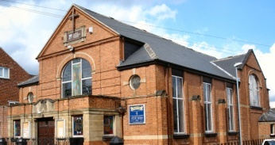 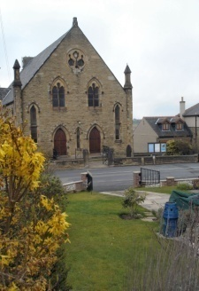 

Trinity Clayton West West Melton,

Farrar Street Church Lane Melton High Street

Barnsley Clayton West Wath on Dearne

S70 6BS Huddersfield HD8 9LY Rotherham S63 6RG

**Church Secretaries:**

TRINITY: Mrs. Fiona Weighton-Smith, 18 Normans Way, Sandal, Wakefield, WF2 6SS Tel: 01924 253010

Email: [isabelsmith655@talktalk.net](mailto:isabelsmith655@talktalk.net)

CLAYTON WEST: Mrs. Betty James, Winter Hill Farm, Bank End

Lane, High Hoyland, Barnsley, S75 4BB

Tel: 01226 382820

WEST MELTON: Mr. John Paskell. *(As above)*

**www.urcbarnsleygroup.co.uk**