LINK

The magazine of the Barnsley Group Pastorate



**Winter 2010** 

Plumbing and

heating engineers

Tel: 017090873518

[info@paskellplumbing.co.uk](mailto:info@paskellplumbing.co.uk)



**Druids Sheffield**

**Friendly Society**

Plans for Healthcare – Tax Exempt Savings

Sickness and Death Benefits

Endowments – Insurance I.S.A.

Leaflets on all plans available from:-

Dove House, Brampton Road,

Wath-Upon-Dearne, S63 6BE

Tel: 01709 876409

Fax: 01709 878045

Email: deuidssheffield.friendly@virgin.net

www.druidsfriendly.co.uk

Established 1858. Authorised in the United Kingdom under the Friendly Societies Act 1992. Reg. No. 795f

Druids Sheffield Friendly Society is regulated by the

13307

_________________________

**Simon T. Anderson**

Funeral Director

23 Dodworth Road, Barnsley.

**(01226) 733119**

*24 HOUR SERVICE*

AN INDEPENDENT FUNERAL SERVICE

*Professional and friendly advice on all aspects of the funeral service*

Financial Services Authority

___________________________________________________



Andrew P. Lockwood

**MinstChP. CCM(Sheffield)**

**CHIROPODIST**

**All Foot Ailments Treated**

CORNS – CALLOUSES (Hard Skin) – VERRUCAE – ATHLETE’S FOOT etc.

**Home Visits – Prompt Attention**

**Tel: 01484 687632**

**Mobile: 07971355078**

Dear friends

First, the answer to the riddle in the Autumn *LINK.*

*Q. What does this represent?  
To possess ocular receptors in the posterior portion*

*of a cephalic protuberance.*

A. Have eyes in the back of one's head!

# Something to think about.

I wonder what Christmas means to a mother who has lost her husband, who must take care of 3 or 4 children, working every day, never quite getting everything done, never making ends meet? What does Christmas mean to her?  
  
I wonder what Christmas means to a man in Zimbabwe, 80 years old, living in a hut, who knows nothing of shopping malls or Christmas trees? What does Christmas mean to him?  
  
I wonder what it means to little Korean children with smudges on their cheeks, & sparkling eyes that look up in wonder as you walk past? What does Christmas mean to them?  
  
I wonder what it means to missionaries who are half a world away from families & friends, who are sacrificing so much to take the precious gospel message to others who have never heard? What does it mean to them?  
  
I’m sure that it means different things to different people.  
  
To shop keepers it is the busiest time of the year. Stores stay open longer, & hire extra people to accommodate all the shoppers. It means more profit, hopefully enough profit to see them through lean times ahead.  
  
For some employees it means a Christmas bonus, a little more money in their pockets to do things that they want to do.  
  
For many teenagers & adults it is a time of fun & parties. For children it is a time of impatience, with time seeming to pass so slowly, as they wait for Christmas morning.  
  
But sometimes I get the feeling that we are like the people who decided to throw a party to honour a very special friend. They sent out invitations, decorated the hall, & had caterers supply the best quality food. All the people came together at the designated time, but to their surprise, the guest of honour was not there.  
Finally, they made the embarrassing discovery that no one had ever invited the guest of honour.

I wonder if that happens at Christmas time? Do we go through all the decorating, & buying presents, & preparing elaborate meals, but somehow forget whose birthday it really is?  
  
One family tried to overcome that by putting an extra place at their Christmas table for Jesus, & calling Christmas, "His birthday party." When one of their daughters was asked if she got everything she wanted for Christmas, she answered by saying, "No, but then it’s not my birthday."  
  
It isn’t our birthday, is it? It’s the Lord’s birthday & it’s a time to remember His birth & what it is supposed to mean to us.

I hope you all have a joyful Christmas and a peaceful New Year. May God continue to bless you.



✞

**A QUIZ FOR CHRISTMAS** (Answers on page 15)

How much do you really know about Christmas?

Our culture has influenced our understanding of the story of the birth of Jesus. A lot of misconceptions have arisen due to this. The more difficult questions help clarify the difference between the original Bible story and modern ideas.

1 How did Joseph and Mary get to Bethlehem?

2 A manger is a…?

3 Which animals does the Bible say were housed in the stable?

4 What sign were the shepherds told to look for by the angel?

5 What is frankincense?

6 What is myrrh?

7 How many wise men came to see Jesus?

8 What does "wise men" most likely refer to?

9 Where did the wise men meet Jesus?

10 Who told Joseph and Mary to go to Bethlehem?

11 According to the Bible, where did the little drummer boy meet Jesus?

12 In which gospel/s do we find the story of Jesus’ birth

13 Why did the child Jesus go to Egypt?

14 December 25th has been celebrated as Christmas since the Bible was written. True or False?



### Prayer requested for Sudan

The World Evangelical Alliance is asking Christians across the globe to pray for Sudan on 5 December, regarding a referendum on 9 January. The troubled African country’s church leaders are pleading for concerted prayer for peace. The referendum was a condition laid down in the 2005 Comprehensive Peace Agreement that ended the long-running civil war. It is thought that the mainly Christian south of the nation will vote for separation from the mostly Muslim north, but this might reignite war, especially since the government is not guaranteeing the safety of Christians who decide to move south. The WEA Secretary General says: ‘Now is the time for a new future that will bring peace, wholeness, dignity, freedom of belief and freedom from extreme poverty. The people of Sudan deserve nothing less.’

Source: Christian Today (10/11) www.christiantoday.com

**TRINITY TOTS**

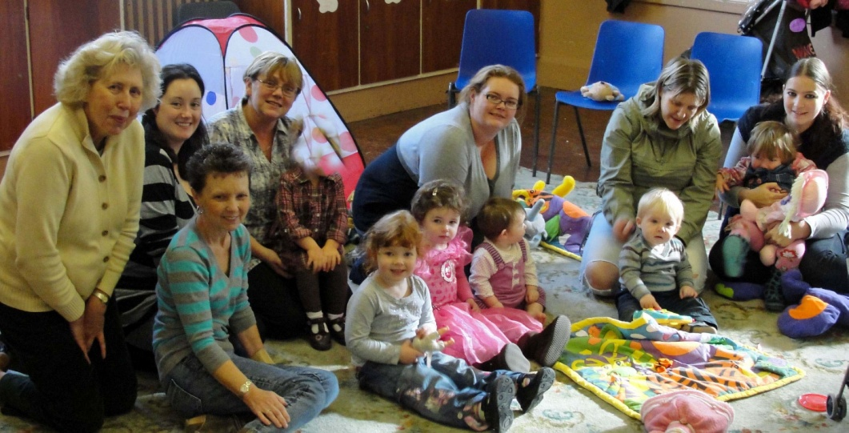

**Thoughts on Coming on a Thursday**



Carol: “Play group is such fun. We come to meet everyone”.

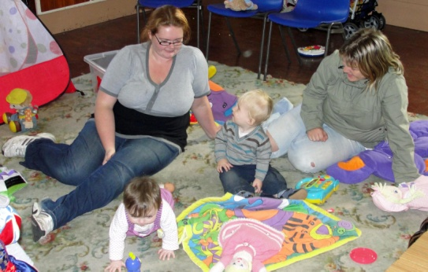

.

Linda: “Kids can be as loud as they want, running around having fun, while we relax and have a chat”.

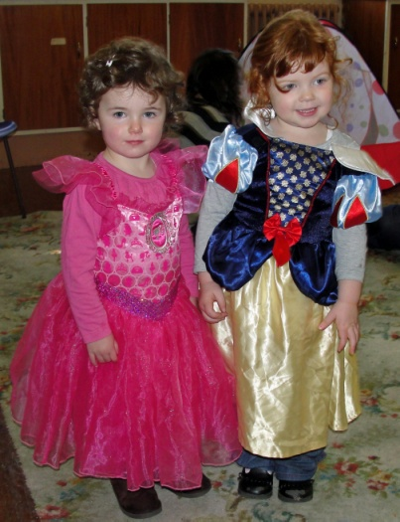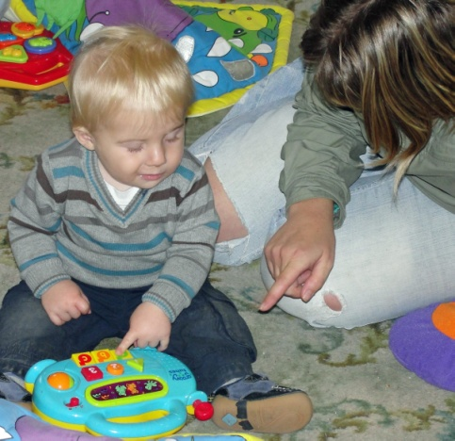

Sinead: “We smile and laugh. We sing and dance. We love to play and make a mess”.

**Trinity Tots meet in the hall every Thursday from 10.00am till 12 noon.**

**Carrot Cake**

**by Jayne Bryant**

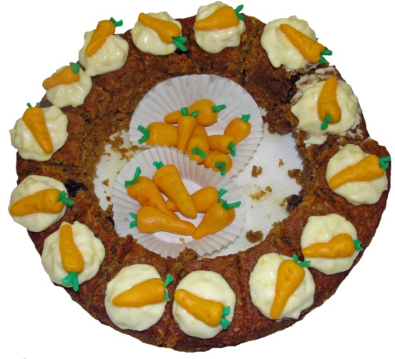

Ingredients

*250g/9oz Wholemeal plain flour*

*25g/1oz baking powder*

*1½ teaspoons ground cinnamon*

*125g/4 ½ oz desiccated coconut*

*5 medium eggs*

*250g/9oz muscovado sugar*

*185ml/6 ½ fl oz vegetable oil*

*500g/1il 2oz grated carrots*

*125g/4 ½ raisins*

*Marzipan and orange and green colouring*

Cheese frosting

*125g/4 ½ cream cheese*

*375g/13oz icing sugar*

*250g/9oz unsalted butter*

*capful vanilla essence*

*10inch/ 25cm deep springform tin*

*Oven 180 C/ Gas mark 4*

Preheat oven. Prepare tin and line base with baking parchment.

Sift flour, baking powder and cinnamon into bowl and add coconut stirring together to stop clumping.

In another bowl whisk together the eggs, sugar, vanilla and oil until pale and doubled in volume.

Gently fold in the dry ingredients with care to keep the volume, finally fold in the carrots and raisins.

Spoon into prepared tin and bake in centre of oven for 40mins or until a skewer inserted comes out clean. Leave to cool in tin.

Meanwhile, to make the frosting simply beat the ingredients together until pale and fluffy.

To make the carrots for decoration use a cocktail stick to add the orange colouring to the marzipan a little at a time, kneading it in to achieve a carrot colour. Take small amounts and roll in the palm of the hand to form a conical shape, mark with a knife or the cocktail stick to give the impression of a carrot. Repeat the colouring process again with a small amount of marzipan and green colouring this time for the tops of the carrots. Take a small amount of the green and roll a thin long shape, cut into strips placing them on top of the carrots, then using a knife press in the middle which will make them stand up to look like the leaves.

When cool turn out the cake. You can use a serrated knife to cut cake into layers and then sandwich them together with the frosting, finishing off by coating the top of the cake with more frosting and completing with the marzipan carrots as decoration.

**Trinity Players - Pardon Me Prime Minister**

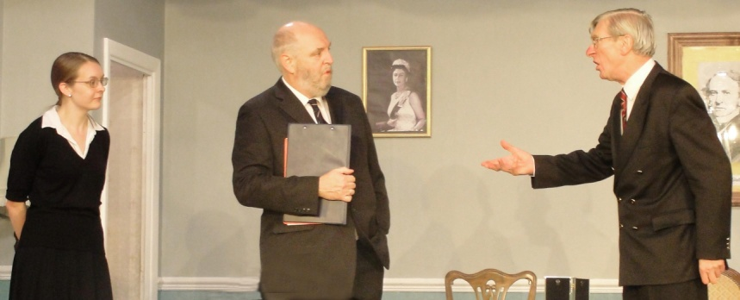

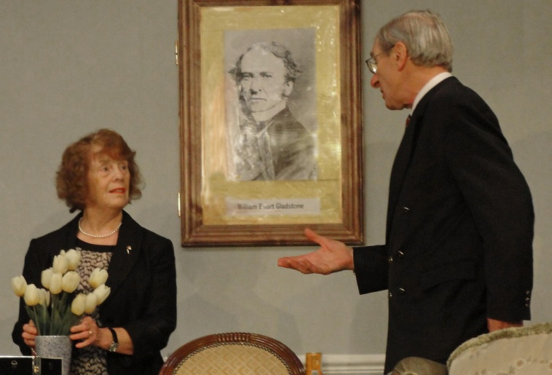**In October Trinity Players put on a very accomplished and successful production of this hilarious farce, written by Edward Taylor and John Graham.**

**The situations in the play were handled confidently by all the cast members. The sight of our very own Barbara Parkinson in her underwear is a memory which will stay with many for a long time to come! If you missed it then you missed a really good night out.**

**Coming soon – *CINDERELLA***



A traditional pantomime for all the family.

Come and see Rev Nick as you have never seen him before!

**Only 7 performances.**

Friday January 14 at 7.15pm

Saturday January 15 at 3.00pm

Saturday January 15 at 7.15pm

Sunday January 16 at 4.00pm

Friday January 21 at 7.15pm

Saturday January 22 at 3.00pm

Saturday January 22 at 7.15pm

Prices: Adults £6.00; Concessions £5

To book: By phone 07760 735953

E-mail [boxoffice@trinityplayersbarnsley.com](mailto:boxoffice@trinityplayersbarnsley.com)

Online [www.trinityplayersbarnsley.com](http://www.trinityplayersbarnsley.com) and follow the link.

**A picture for you to colour**

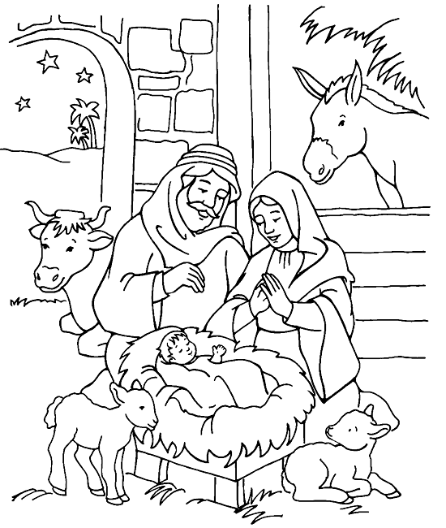

**Word Search Puzzle**

*from www.geocities.com/lectionarypuzzles.*

*Words in a straight line in all directions.*

**G N I T S A L R E V E**

**L U F R E D N O W U G**

**R O F H A I A S I H I**

**E A U T H O R I T Y V**

**S E C A E P R I N C E**

**T B S Y T H G I M H N**

**S R E D L U O H S I U**

**R O L E S N U O C L P**

**D E M A N D N G O D O**

**N R O B R E H T A F N**

**(Isaiah 9:6) For a child has been born for us, a son given to us; authority rests upon his shoulders; and he is named Wonderful Counselor, Mighty God, Everlasting Father, Prince of Peace.**

**Word List**

**EVERLASTING WONDERFUL SHOULDERS COUNSELOR AUTHORITY PRINCE MIGHTY ISAIAH FATHER RESTS PEACE NAMED GIVEN CHILD UPON BORN BEEN SON HIS HAS GOD FOR AND US TO**

**'Gold Wrapping Paper'** *submitted by Barbara and Clive Parkinson*

The story goes that some time ago a mother punished her five year old daughter for wasting a roll of expensive gold wrapping paper. Money was tight and she became even more upset when the child used the gold paper to decorate a box to put under the Christmas tree.

Nevertheless, the little girl brought the gift box to her mother the next morning and then said, 'This is for you, Momma.'

The mother was embarrassed by her earlier overreaction, but her anger flared again when she opened the box and found it was empty. She spoke to her daughter in a harsh manner. 'Don't you know, young lady, when you give someone a present there's supposed to be something inside the package?'

She had tears in her eyes and said, 'Oh, Momma, it's not empty! I blew kisses into it until it was full.'

The mother was crushed. She fell on her knees and put her arms around her little girl, and she begged her forgiveness for her thoughtless anger.

An accident took the life of the child only a short time later, and it is told that the mother kept that gold box by her bed for all the years of her life.

Whenever she was discouraged or faced difficult problems she would open the box and take out an imaginary kiss and remember the love of the child who had put it there.

In a very real sense, each of us, as human beings, have been given a Golden Box filled with unconditional love and kisses from our children, family, friends . There is no more precious possession anyone could hold.



**Quiz Answers**

1. We don’t know. The Bible doesn’t say.
2. A feeding trough. It comes from the Greek word that means ‘to eat’.
3. The Bible doesn’t say.
4. They were not told to look for a sign. (See Luke 2:12)
5. A valuable incense made from the sap of a tree.
6. A valuable spice sometimes used in burials.
7. No one knows, but more than one. Some suppose that there were three since there were three gifts, but that is just a guess.
8. Star Gazers. Star gazers could often navigate, predict the times for best planting, knew maths, astronomy and calendar systems. They were very important in agricultural societies.
9. In a house. (See Matthew 2:11)
10. Caesar Augustus. (See Luke 2:1, 4)
11. Nowhere. The story of a drummer boy meeting Jesus is not in the Bible.
12. Matthew and Luke.
13. Joseph was told in a dream to do it. (See Matthew 2:13)
14. False. Although the Bible talks about the birth of Jesus, it never uses the word ‘Christmas’. As far as we know, the earliest Christians didn’t even celebrate Christmas. Later, several different dates were observed by Christians but it wasn’t until about the 4th century that December 25th became the common day of celebration in the western church. The simple fact is that no one really knows when Jesus was born.

**Photographs at our lunch after the group service.**

**Clayton West - 24 October 2010.**

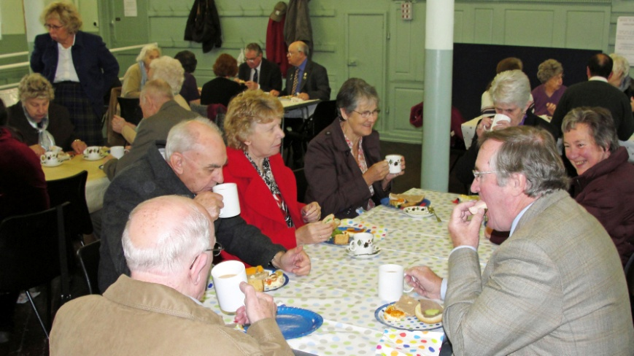 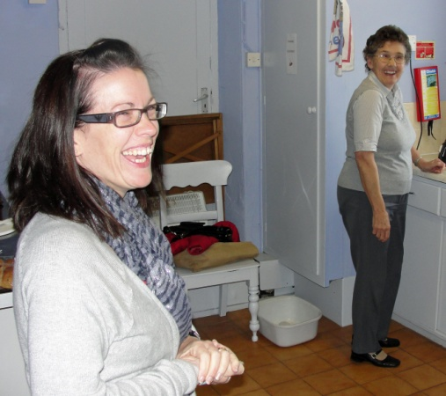

 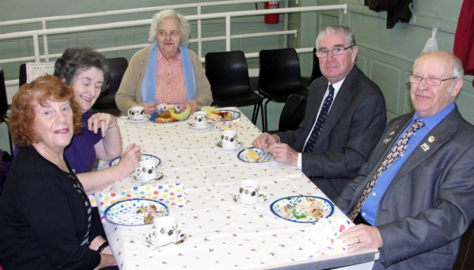

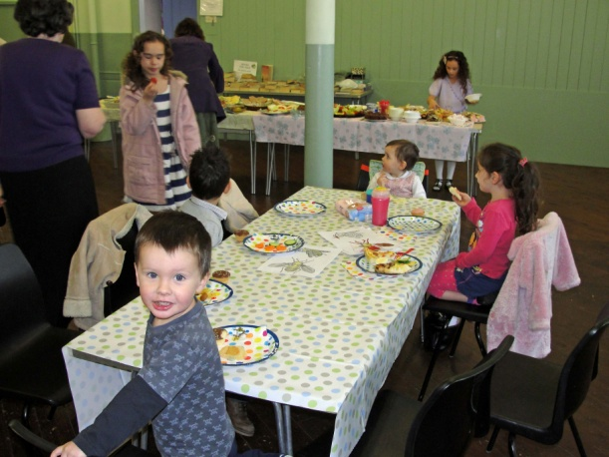

Trouble at the Table – A true story from my cruise in October 2010 *by Norma Pugh*



The eight people at the table, on P & O’s Artemis, were getting on well, Edgar the waiter was serving the evening meal.

The first course went smoothly, the second was served when the man sitting beside me suddenly uttered *"This* is absurd. This is not what I ordered," with an angry look at Edgar and with his hand a dismissive wave he ordered the meal to be taken back to Chef in the kitchen

justas if Edgar was his slave!

"Don't be angryat me Sir, I only bring, I do not Cook”, and Edgar hurriedaway upset and hurt.

The head waiter arrived – Sir, I do not understand - I am assured that the meal you ordered is before you. What is not right?

Thisnot the meal I ordered – a misrepresentation of facts has occurred - for I ordered King Prawns – and what arrived was shrimps – the menu is flawed.

The waiter, very politely, apologised on chef’s behalf and gave the man themenu to choose something else but he just guffawed.

His wife said "Please dear don't make a fuss, it is all very embarrassing - if not for you - think of me - think of the rest of us."

Not one crumb passed the man's lips and he stalked away from the table leaving his wife trying to apologise to Edgar as much as she was able.

Edgarrepeated again and again "I only bring I do not cook, I did not deserve that angry look".

After the mealI turned to Edgar - "You are not to blame - the man was the loser- he did not play the game.

He hasgone away hungry and for his next meal he has a long wait".

A huge grin lit up his faceas Edgar said "Madam thank you I certainly like the idea of that".

**Filling shoeboxes at West Melton**

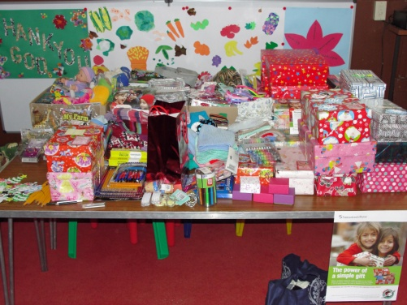 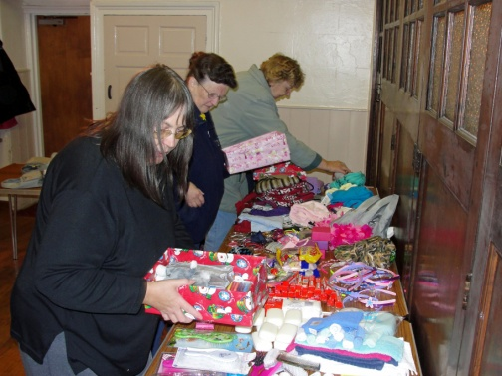

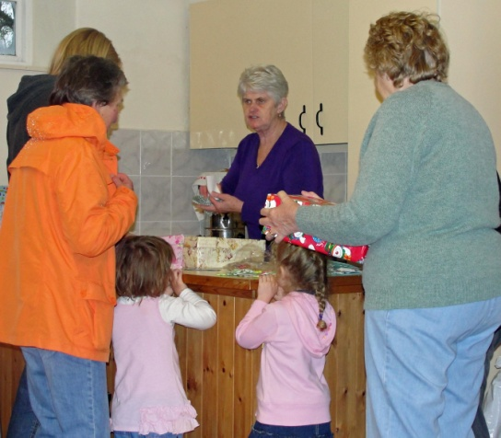 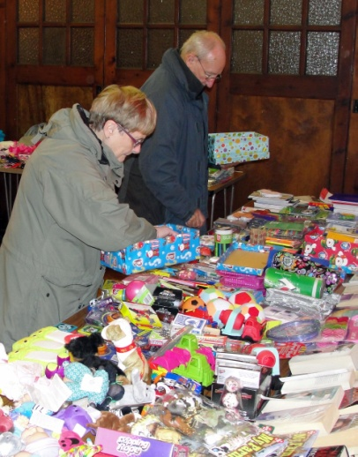



**NEWS FROM AROUND THE WORLD**



**Iraqi Christians living in fear after further attacks**

"If we stay, they will kill us."

Archbishop Athanasius Toma Dawod, a senior Iraqi church leader.

Christians in Iraq are living in a state of constant fear after a series of co-ordinated blasts targeting Christian neighbourhoods followed a bloody siege at a Baghdad church.

At least four people were killed and around 25 injured early yesterday morning when roadside bombs and mortar shells targeted homes and a church in six districts across central Baghdad – all of them areas that are predominantly Christian. The attacks came ten days after a hostage siege at a church in the Iraqi capital left more than 50 people dead. An interior ministry source told Reuters, "These operations, which targeted Christians, came as a continuation of the attack that targeted the church."

Two days after the church siege, the Islamic State of Iraq – an Al-Qaeda front group that claimed responsibility for the attack – threatened further violence, saying that [Christians everywhere were "legitimate targets."](https://netcommunity.barnabasfund.org/page.redir?target=%2fChristians-everywhere-legitimate-targets-Al-Qaeda.html&srcid=938&srctid=1&erid=1054436)

**"Genocide" warning**

A Baghdad church leader said that Iraqi Christians were "panicked" and did not know what to do. Archbishop Athanasius Toma Dawod, a senior Iraqi church leader in London, warned of a pending "genocide" and urged Christians to flee the country, while a senior cleric in Baghdad called for them to stay and bear witness to the faith, adding, "But people are human, and we can't stop them leaving."

Hundreds of thousands of Iraqi Christians have already been driven from their homeland over the last 20 years because of attacks by Muslim extremists. The exodus is expected to accelerate in light of the latest outbreak of violence.

**Please Pray**

* For all who have lost loved ones in the attacks and that the Lord will grant peace to those who are anxious about further violence.
* That Iraqi Christians will find comfort, hope and strength in the Lord at this time.
* For wisdom and guidance for Christian families in Iraq as they consider whether or not to stay in their homeland.
* That the new Iraqi government, reportedly formed just yesterday after eight months of deadlock, will be strong and stable. Pray that it will exercise its authority over this escalating security crisis.

🕈

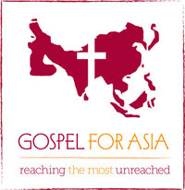

Sixteen Years Later: Amazing Growth

When Shriram Tamang, a Gospel for Asia-supported leader in Nepal, hiked through a rugged, remote and largely unreached area of his country in 1993, he could not have known that 16 years later he would return—and witness massive changes in the spiritual landscape of this place.

In 1993, Shriram and his fellow pastor, Jaigath Shrestha, sent a GFA-supported missionary named Shyam Giri to serve in this area. They appointed Shyam to minister in a district where only a few believers lived—but no churches existed. After sending Shyam to his new assignment, Shriram and Jaigath hiked to the top of a mountain in the area and asked God to make His name known in the region.

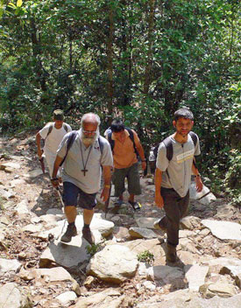

"Father, we thank You, for You called us to preach the Good News, to

make disciples and to establish the Church," they prayed. "In that manner, we now begin our task, and ask You to give us many labourers so that many churches may spring up in this mountainous region. Lord, hear our prayers. In Jesus' name, Amen."

After this, they hiked to several other villages in this rugged area, interceding for God to move and sharing the Gospel with people along the way. After almost a month, they returned home.

*Many places in Nepal can only be accessed on foot. Shriram, left, knows this well. He and Jaigath hiked in this part of the country for almost a month in 1993.*

Now, in 2010, Shriram can say God definitely answered their prayers uttered during that long-ago, month-long missionary journey. In just two districts, 24 GFA-supported pastors and missionaries serve 19 congregations.

On June 5, Shriram returned to the mountainous region with another leader, Dagan Thapa. They held a meeting to encourage and teach missionaries there—some of whom walked three days to get to the event.

Not only did the Lord grow His Church in the district where Shriram and Jaigath placed Shyam, but fellowships sprouted up in other areas also. In the city where Shriram and Dagan held the meeting, Gospel for Asia-supported leaders had been praying God would provide land for them to build a church, and the Lord provided a perfect place.

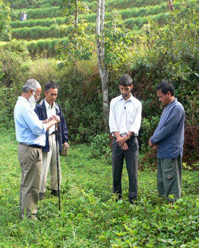

The leaders look forward to constructing a church on the land, which lies near a highway for easy access.

Overall, God did amazing things in this area of Nepal. Sixteen years after his first journey there, Shriram got to witness the massive growth that occurred through radio broadcasts, Gospel-literature distribution, Bridge of Hope centres and new fellowships. A place that once deterred missions work because of its forbidding terrain now resonates with the sounds of believers worshiping. Please pray for continued growth in this area as more and more hear the Gospel message.

*Shriram and other pastors prayed over the land for a new church building.*

**🕭 🕭 🕭 🕭 🕭**

Thanks to all the contributors to this edition of LINK.

Contributions are always welcome and for the Spring 2011 edition of this magazine need to be with Rev. Nick by

Sunday 6th February, please.

**REGULAR ACTIVITIES IN OUR CHURCHES**

**Clayton West**

Sunday Worship every week at 3.00 pm. Communion is included in the service on the 1st first Sunday of each month

Saturday Coffee Morning on the 4th Saturday each month 10.00am

**Trinity (Barnsley)**

Sunday Worship every week at 10.30 am. Communion is included in the service on the 3rd third Sunday of each month

Tuesday Bible Study at 7.30 pm

Wednesday Age-Well (*over 50s club*) every week 10.30am-1.00pm

Trinity Players every week at 7.30pm

Thursday Trinity Tots (*carers & toddlers*) 10.00am – 12.00noon

**West Melton**

Sunday Worship on the 1st (*inc. WHIZZ KIDS*) and 4th Sundays at 10.30am and on the 2nd & 3rd Sundays at 3.00pm. Communion is included in the service on the 3rd Sunday of each month

Monday Sisterhood every week at 2.30pm

Wednesday Parents and Tots 9.30am every week *(in term time)*

Praying Hands (*prayer group*) 7.30pm – 8.30pm on the 2nd Wednesday of each month

Fellowship evening (*varied programme*) 7.30pm on the 4th Wednesday of each month

Friday Children’s Fun Night 6.30pm – 8.00pm (1st & 3rd Fridays *in term time*)

Saturday Men’s Breakfast at 8.00am on the 3rd Saturday each month

**Group Minister: Group Treasurer:**

Rev. Nick Percival BA Mr. John Paskell

19 Longdale Croft 1 Giles Avenue

Barnsley, S71 2QT Wath on Dearne

Tel: 01226 771277 Rotherham, S63 6SG

Mobile: 07986668032 Tel: 01709 879224

Email: [revnickp@yahoo.co.uk](mailto:revnickp@yahoo.co.uk) Email: [john@paskellplumbing.co.uk](mailto:john@paskellplumbing.co.uk)

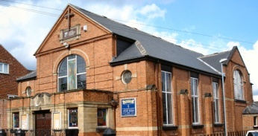 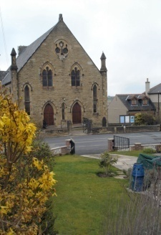 

Trinity Clayton West West Melton,

Farrar Street Church Lane Melton High Street

Barnsley Clayton West Wath on Dearne

S70 6BS Huddersfield HD8 9LY Rotherham S63 6RG

**Church Secretaries:**

TRINITY: Mrs. Fiona Weighton-Smith, 18 Normans Way, Sandal, Wakefield, WF2 6SS Tel: 01924 253010

Email: [isabelsmith655@btinternet.com](mailto:isabelsmith655@btinternet.com)

CLAYTON WEST: Mrs. Betty James, Winter Hill Farm, Bank End

Lane, High Hoyland, Barnsley, S75 4BB

Tel: 01226 382820

WEST MELTON: Mr. John Paskell. *(As above)*

**www.urcbarnsleygroup.org.uk**