LINK

The magazine of the Barnsley Group Pastorate

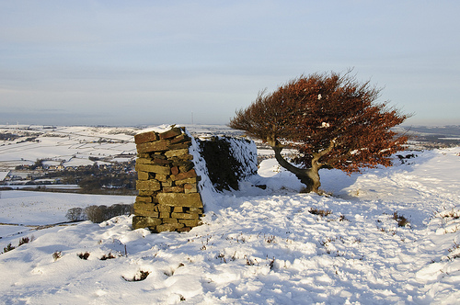

**WINTER 2011**  

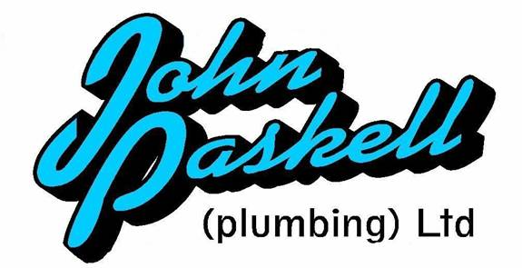Plumbing and

heating engineers

Tel: 01709 873518

[info@paskellplumbing.co.uk](mailto:info@paskellplumbing.co.uk)



**Druids Sheffield**

**Friendly Society**

Plans for Healthcare – Tax Exempt Savings

Sickness and Death Benefits

Endowments – Insurance I.S.A.

Leaflets on all plans available from:-

Dove House, Brampton Road,

Wath-Upon-Dearne, S63 6BE

Tel: 01709 876409

Fax: 01709 878045

Email: deuidssheffield.friendly@virgin.net

www.druidsfriendly.co.uk

Established 1858. Authorised in the United Kingdom under the Friendly Societies Act 1992. Reg. No. 795f

Druids Sheffield Friendly Society is regulated by the

13307

_________________________

**Simon T. Anderson**

Funeral Director

23 Dodworth Road, Barnsley.

**(01226) 733119**

*24 HOUR SERVICE*

AN INDEPENDENT FUNERAL SERVICE

*Professional and friendly advice on all aspects of the funeral service*

Financial Services Authority

___________________________________________________



Andrew P. Lockwood

**MinstChP. CCM(Sheffield)**

**CHIROPODIST**

**All Foot Ailments Treated**

CORNS – CALLOUSES (Hard Skin) – VERRUCAE – ATHLETE’S FOOT etc.

**Home Visits – Prompt Attention**

**Tel: 01484 687632**

**Mobile: 07971355078**

Dear friends

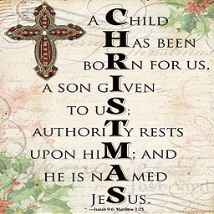As we enter Advent we begin to think about the birth of our Saviour. We also hear the familiar story of Christmas, some of it based upon words in the bible and some of it based on non-biblical tradition. Discussion about what really happened will take place in many house and bible study groups. Was Mary a ‘virgin’ in today’s understanding of that word? Was there a census when Jesus was born? Did Mary travel on a donkey? Was Jesus born in a stable, or in a cave or even in a room in a house which would be used for animals in the cold winter months? Did the ‘wise men’ arrive twelve days after the birth or was it many months later?

Does any of that really matter? Should we not simply focus our attention on John 1: 14 which says; *“The Word became flesh and made his dwelling among us. We have seen his glory, the glory of the One and Only, who came from the Father, full of grace and truth.”* That verse is central to our faith. Without it we have nothing. No miracles, no teachings, no crucifixion and no resurrection!

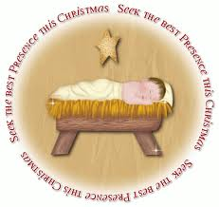

Celebrate Christmas. Celebrate the birth of Jesus, our Saviour who came into the world to forgive our sins and make eternal life available for each and everyone of us. As you celebrate on Christmas Day, pause for a while and give thanks to God for Jesus and all that he has done for you.

Come on and celebrate!

His gift of love we will celebrate - the Son of God, who loved us - and gave us life.



May God continue to bless you.

Your friend and minister



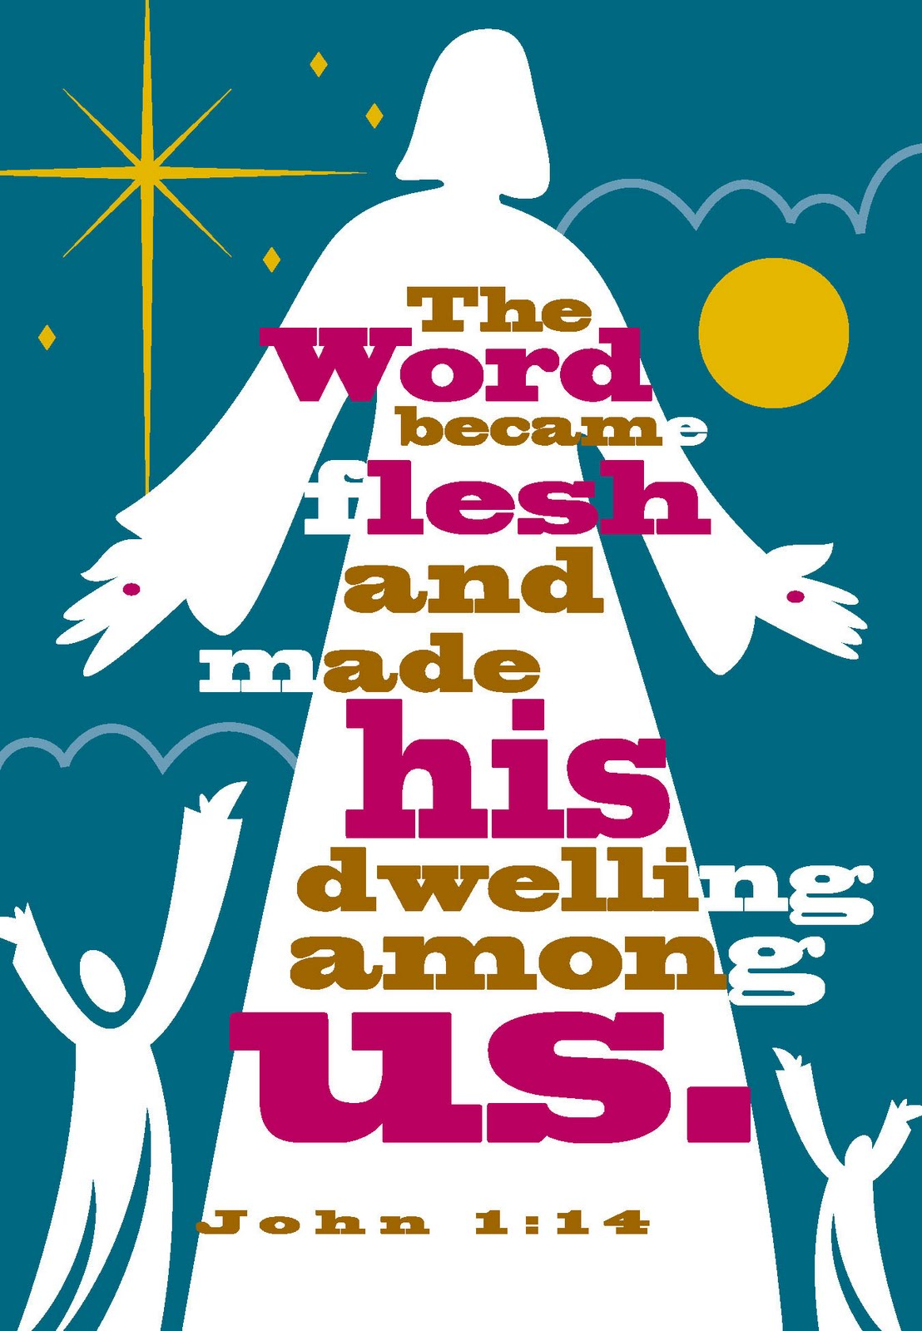

**A REPORT ON A COURSE I ATTENDED**

**IN SEPTEMBER 2011**

**AT WESTMINSTER COLLEGE, CAMBRIDGE**

By Clive Parkinson

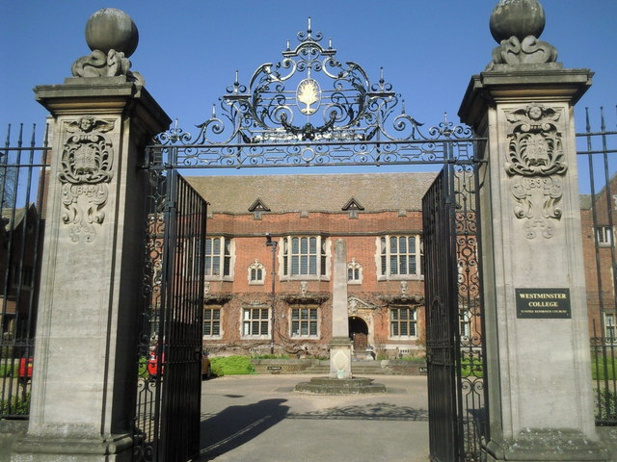

The overall theme of the course was, “Identity, Human, Christian, Reformed, U.R.C.

After parking I was on my way to reception in the college when I passed a group waiting for transport, who had just finished the course, this always makes people smug, whatever their age! I was greeted by “You must be the new kid!” I replied, “Yes I’m the new kid on the block!”

I was warmly greeted by the office staff, shown around and then taken to my room.

After refreshments there was a short introduction to the course.

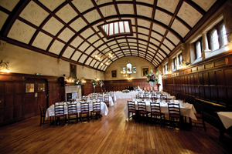After the evening meal we had the first session, it was entitled “ Made in the image of God,” a study of the first 4 chapters of Genesis. Evenings ended in prayer at 9 o’clock, mornings began with prayer at 9 -15 in the college chapel.

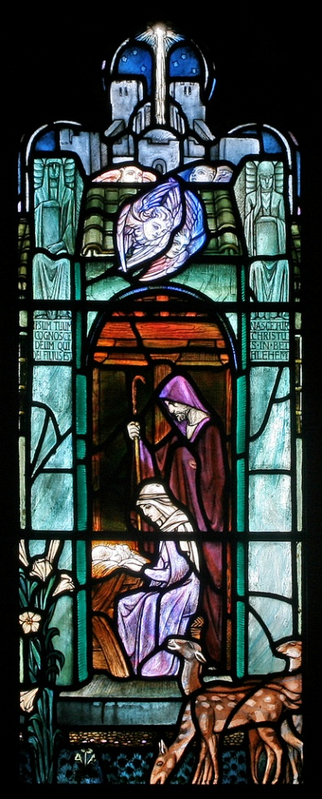During the course, we covered material about being reformed, being united, looking at some of the “Founding Fathers” of the reformed movement, Luther, Calvin, Swingli, Knox, Schleiermacher, Barth and Moltman, the latter now in his eighties.

The key to being reformed is the” Westminster Confession” a statement of faith. But it is also a tradition that is always open to change and new insights.

There was a session on “being united “, about our history from the reformation to the present.

There were sessions on baptism and identity and being human, and study of David in the Bible.

There was a session on art, how artists see humanity, including classical and modern paintings of the nativity and crucifixion.

And a final session on “following Jesus, discipleship and identity.”

The course was concluded by a service of Holy Communion on the Friday Afternoon.

I felt better informed about the U.R.C. as it had an emphasis on identity. I questioned the fact that however we perceive our identity, we need others to recognize our identity as a church. I took evidence to show, that both in a recent book from Hodder and Stoughton, a list of denominations and faiths did not include the U.R.C. also an information sheet extracted from the internet with the title “what are the U.K. denominations ?” nor did that include the U.R.C. But the lecturer at that session had an

agenda which he adhered to. He listened but did not respond to the fact that many many people do not know who we are and what we stand for.

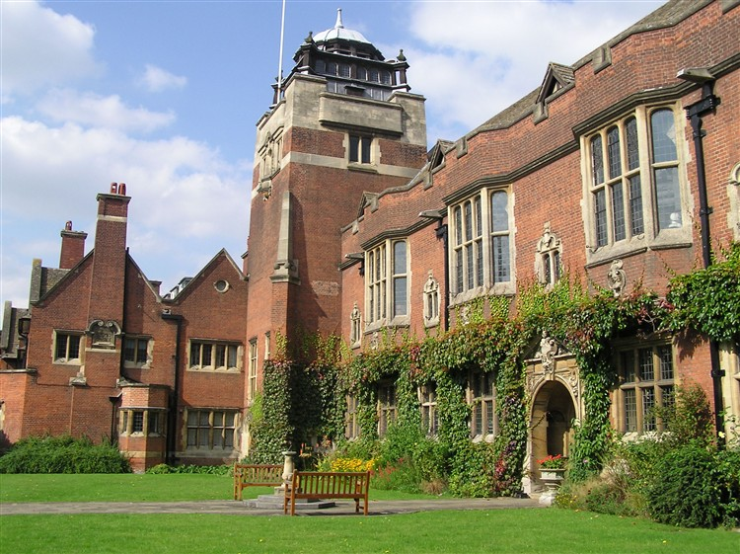An interesting fact I discovered from the course was that there are 75 million members of reformed churches in the world, and there are 73 million Anglicans worldwide.

In 2012, we shall be celebrating 350 years of nonconformism, we were excluded from the C of E in 1662. Also we celebrate 40 years of the U.R.C. and in 2012 we shall be expressing our regrets together with the C.of E. at the divisions of the past, and our mutual recognition of one another as churches who belong to the one church of Jesus Christ.

**Norma's September stay in Hospital.**

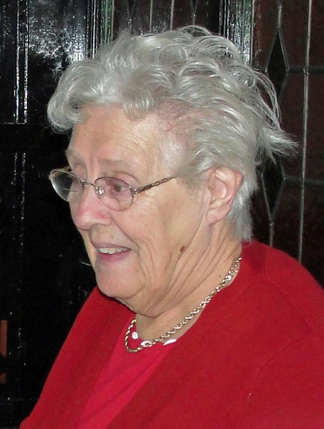"What am I doing here?" I said

I never gave it a thought

that I would finish up the day in a hospital bed.

It all started with a pain in my leg, the calf of which was sore and red.

Down to medical centre I did go, expecting after pills and lotions,

To home I would return, I was not to know

This was not in Doctor's plan.

A hospital appointment was made for blood test and a scan.

"Now if you please Miss Pugh, no time to go home, you may have DVT."

(This is deep vein thrombosis)

Oh what has happened to poor (not so little) me?

In the hospital, blood I gave

The scan until Monday they would save.

"Can I go home?" "No" was the reply,

"over the weekend you must stay"

so I was taken up to Ward A.

Antibiotics I received, in hand, arm and tummy

Then more blood was taken — O Yummy Yummy!

On Tuesday morn I had my scan, if OK,

I could on the morn to my own home return.

This was not to be, for a clot in the vein (lower leg) was found,

So Norma was not homeward bound.

Back to bed for another few days,

(feels like I'll be here for years)

Warfarin tablets, I must take

It's Rat Poison you know, so of the dosage, there must be no mistake.

After sleepless nights with the comings and goings

Patients shouting. patients wandering,

Security called for a man to settle

The wandering ones keep staff on their mettle!

Beds to change. new patients to see,

each nurse doing three jobs at once, I'm glad it's not me!

I was pleased when Friday came to be told if this

last blood sample was good,

I was free. I would be able to go home Saturday.

And Guess What —IT WAS AND I DID.

Thank you to all for your prayers, get well cards and good wishes,

it was much appreciated.

*Norma Pugh.*

WEST MELTON’S GREEN TIPS CORNER

**No 6 - Limescale Removal** by Helen Owen

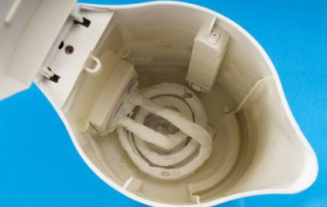For kettles-add a mixture of half water and half white vinegar to cover the element or base and leave overnight. Remove any odour by boiling some fresh water in the kettle a few times. Result. A lime-free kettle which works more efficiently.  
For shower heads-to remove limescale and gunge from the shower head soak it in lemon juice or vinegar overnight. Either remove the head and soak it in a jug or soak a rag and wrap the head in it covered by a plastic bag secured with an elastic band.  
Of course if you have very soft water you may never or very rarely need to perform these tasks!

**Did you see the**

**TRINITY PLAYERS’ production of**

**Lord Arthur Savile’s Crime?**

18 – 22 October 2011

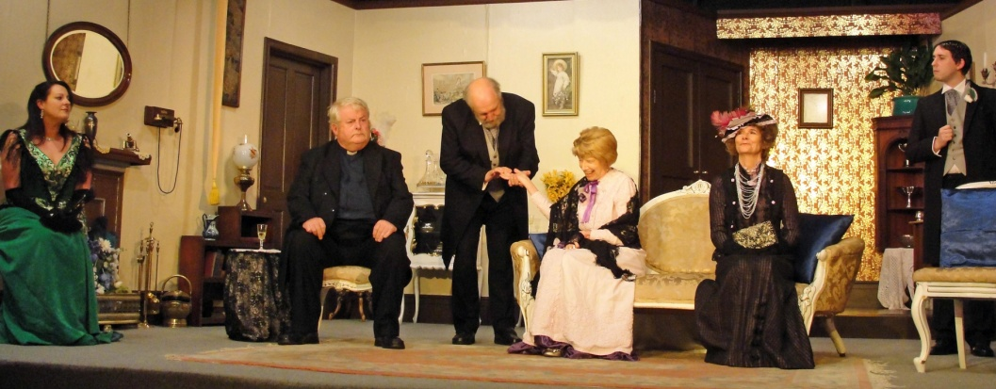

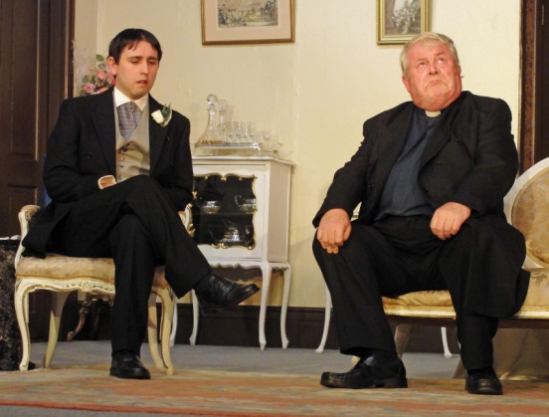This production has been acclaimed by some as Trinity Players’ best ever production. It must also be able to lay claim to having their best set, ever. The production was slick and extremely well acted. The set dressing and costumes were perfectly in keeping with the period in which it was set. The play, by Constance Cox, based on a short story by Oscar Wilde is almost a laugh a minute.

Lord Arthur Savile (*Michael Cutts*) is a well-bred gentleman who is ‘not overburdened with brains’. His engagement to the lovely Sybil Merton (*Lucy Jepson*) looks like eternal happiness – but all this changes when his prospective mother in law, Lady Julia Merton *Christine Mulrooney*), insists he has his palm read by Mr Podgers (*Bob Willerton*), a well-respected cheiromantist who predicts that Lord Arthur will commit a murder at some time. To prevent his future wife from having to bow her head in shame for him, Arthur feels duty-bound to get the dirty deed over and done with before the marriage and sets about choosing his victim, and their method of disposal. 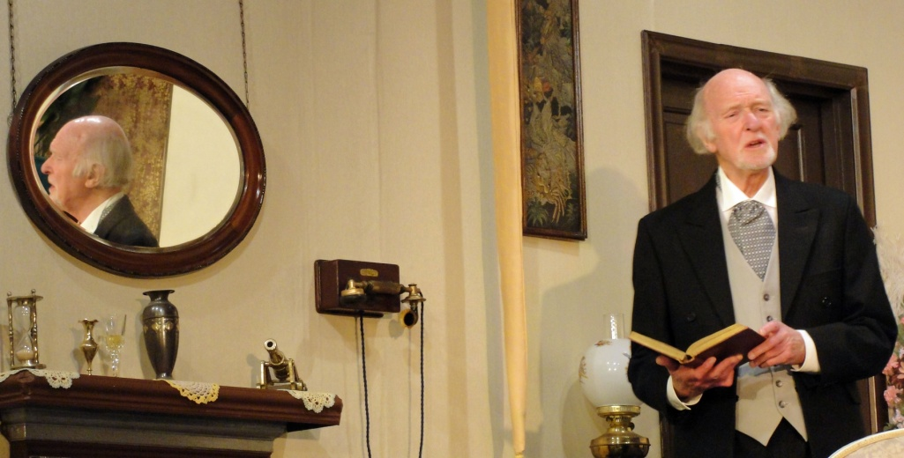

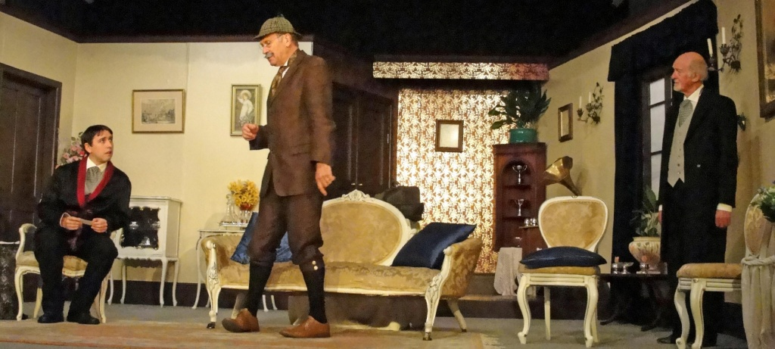He enlists the help of his faithful butler, Baines (*Bill Moss*), and decides to poison his great aunt. While planning this murder, a strange character appears offering his help. His name is Herr Winkelkopf (*Phil Johnson)* and he professes to be ‘President of the Royal Society of Anarchists’. Suffice to say, things go drastically awry with the first murder attempt, so another victim is selected, and another! Things then go from bad to worse, until an important revelation about the identity of Mr Podgers puts an end to the whole fiasco…or does it?

**Coming Soon… Rev Nick is the GENIE in The Trinity Players’ traditional pantomime**



**Friday (6.30pm), Saturday (1pm & 4pm)**

**and Sunday (3pm)**

**13th, 14th & 15th January 2012**

**Friday (6.30pm) and Saturday (1pm & 4pm)**

**20th and 21st January 2012**

*(Performance times to be confirmed)*

To book phone 07760 735953 or

Email: BoxOffice@TrinityPlayersBarnsley.com