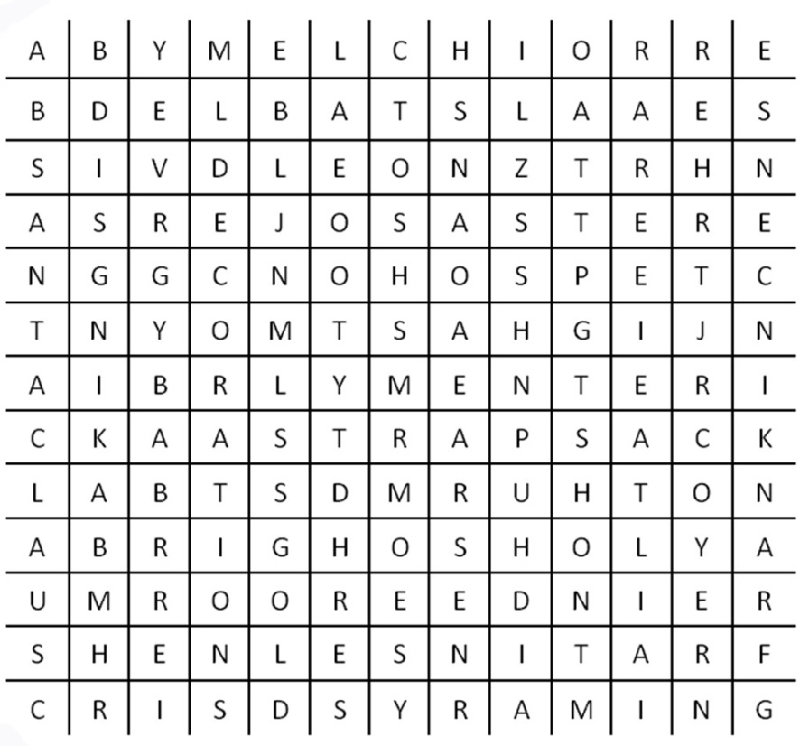
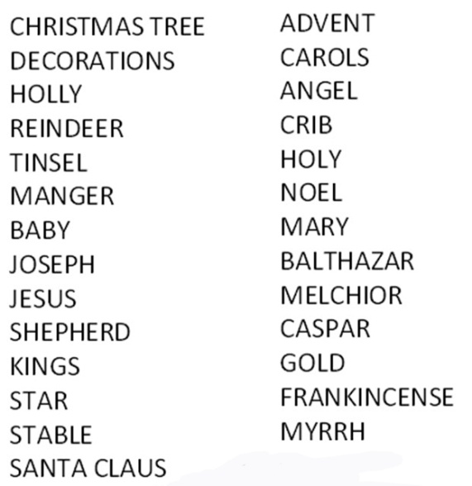
Getting to know you - Mary Gibson
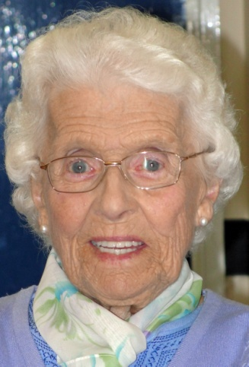
Mary, a long serving member of the Farrar Street congregation and Trinity Age-Well, celebrated her 90th Birthday on October 19 this year when she was guest of honour at a luncheon attended by her family and close friends at Ardsley House.
A couple of days earlier she was presented with a special edition of a glossy magazine packed with stories and images from her life produced in the style of one of her favourite magazines.
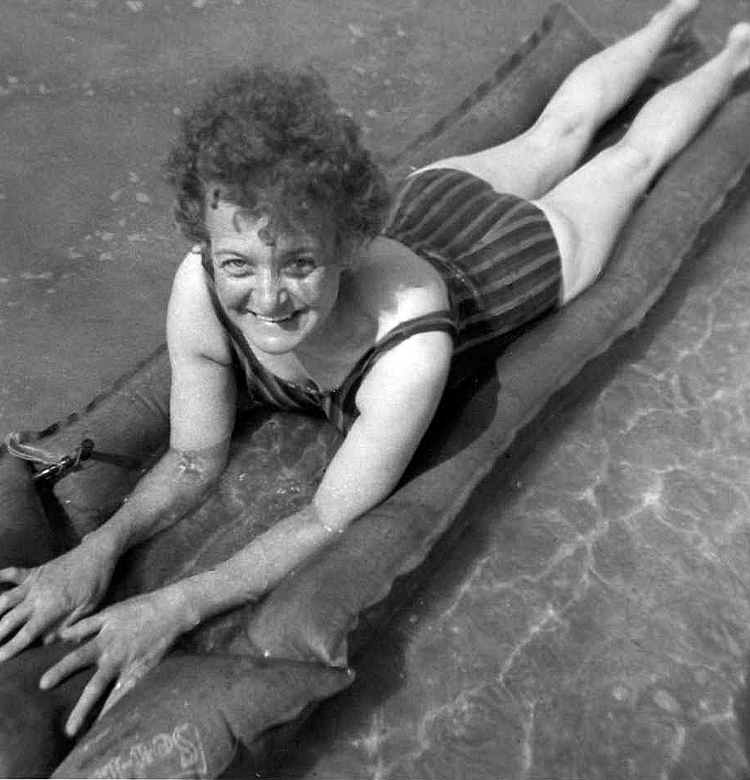
Mary was born Mary Agnes Lee in Barnsley in 1921. Her parents Herbert and Catherine Agnes Lee lived in Carlton Road. They were “in business”. Catherine had two footwear shops in the town centre and Herbert made leather goods from their next home in Vaughan Road - the street of just four houses just off Vernon Way in Gawber.
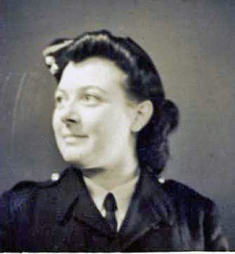
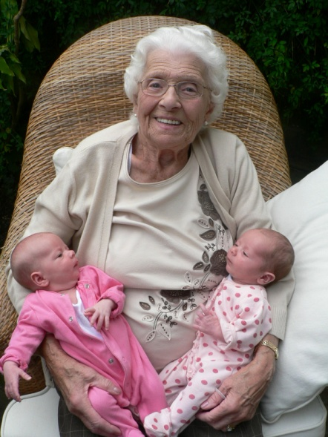
She has always had strong links to Burton-on-Trent which is where her husband Donald, who she married in 1943, hailed from. He was also a member of the congregation until his death in 1995. It was in the Staffordshire village of Branston, famous for its pickle, that Mary and Don’s son Bryan was born in 1945 and where the family lived for a time in a small cottage. They later moved to Leeds, then ‘home’ to Barnsley, where they lived in Queens Drive and then for many years in Summer Street. Their daughter Janet was born at Pindar Oats Maternity home in 1948.
Mary had three brothers. Albert was in the Royal Air Force and killed during in Second World War. John (known as Jack) was in the Navy and later took up a series of jobs as a pearl diver, steelworker and finally as a shopkeeper. He would turn up out of the blue, captivate everyone then disappear for years on end. Only a search of the official records revealed that he had died in London without any of his relatives in Barnsley knowing. Her other brother, Leonard, who until he retired worked for Barnsley Markets Department, still lives in Gawber with his wife Jean.
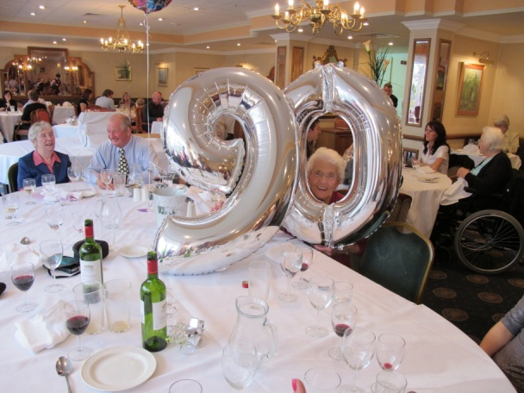
Both of Mary’s parents came from large families, so that she has many more distant and ‘long lost’ relatives in and around South Yorkshire. She recently became a great grandmother when Bryan’s daughter, Kara, gave birth to twin girls in Epsom in Surrey. Needless to say this event features in the magazine about Mary and her life along with a host of stories and pictures of the younger generation.
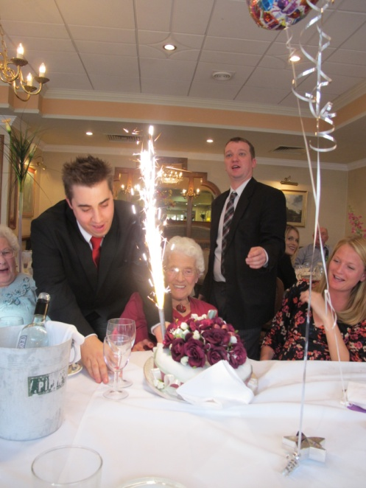
Bryan went to the now demolished St. Marys Boys School in Churchfields, then Barnsley Grammar School. He became a barrister before moving into publishing, which explains how it was possible to produce Mary’s unique 90th Birthday memoir and make it look as if it came from the shelves of W H Smith. Janet (now Janet Horbury) went to St Matthew’s Infants School in Blackburn Lane and then to the “new” mixed-sex Broadway Grammar School. She worked in the Probate Registry in Wakefield before becoming a phlebotomist – someone who takes blood samples – at Barnsley District Hospital. She lives in Gawber with husband David. Both are retired. David has an allotment off Pogmoor Lane so that Mary always gets plenty of fresh, organic produce to keep her fit and healthy!
Mary’s diet is particularly important because she is a celiac, which means that she must avoid wheat and watch what else she eats. You need only pick up a packet of something in the supermarket and read the ingredients to discover how few everyday products are gluten-free. Fortunately, nowadays, there are an increasing number of special foods for people with this condition.
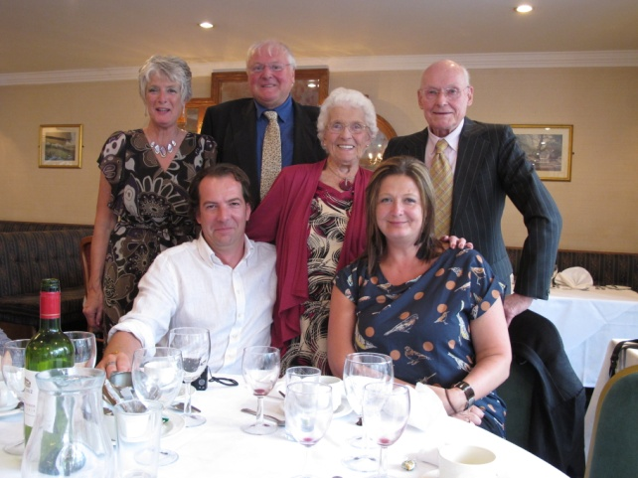
As a young women Mary helped out in the family business then worked for the Fire Service in Barnsley on the switchboard before moving to Edinburgh to be with Don during the war following their marriage. There she took a clerical job with the local authority after turning down a chance to host “Workers Playtime”, playing records to employees in factories to keep them entertained – because all the knobs and switches looked so complicated! The time the family spent in Leeds in the mid-1940s was triggered by her parents moving there to open a shop selling kosher food to members of the local Jewish community. Mary and Don gave up quite a lot to go and help out. But things went wrong when her mother Catherine, the driving force, died suddenly, and her father decided to give up the business and return to Barnsley. Don then took a job with Yorkshire Traction, and because work was hard to come by at that time started out at the bottom as a bus conductor simply to get ‘a foot in the door’. He later became an inspector and in the end was often in charge of bus services across the Barnsley area as well as the scheduling of long-distance coach trips.
Unfortunately, Don suffered a stroke which caused him to retire early, although he made a comeback, learning to walk again and eventually driving an adapted car. This experience is what caused him, Mary and her late friend Marjery to set up Barnsley Stroke Club in order to help other people facing the same life-changing problems. This club still flourishes and is highly regarded by the hospital authorities.
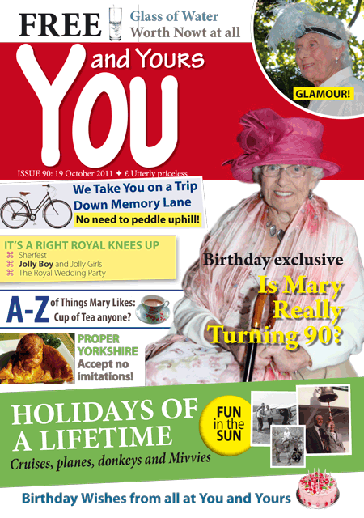
One hobby which they pursued together was crown green bowling as members of Huddersfield Road Bowling Club, where Mary became Ladies Champion in 1988. She still attends the club as a non-playing member and on her 90th birthday became an honorary member.
Right from the 1950s, Mary and Don spent as much time as they could enjoying life at weekends and on holidays. When the children were young they were enthusiastic campers and later they had a caravan on a site near Mablethorpe in Lincolnshire. To celebrate their silver and ruby weddings they went on cruises on the SS Black Watch and SS Canberra (the boat that became a troopship during the Falklands War). Their 20th anniversary they celebrated by taking a joy ride in a monoplane!
Mary has lived in Kingstone for the last 20 years, close enough for regular walks in Locke Park, which she greatly enjoys – although a trip to Cawthorne Park and Cannon Hall is something that she also likes when she is feeling a little bit more energetic. Her energy is in fact legendary and she is famous for “gadding about” whenever she can, as well as events at Trinity United Reformed Church attending the Sheffield Road Bapist Church Luncheon Club and going on every outing available to her. She regularly visits Bryan in Hampshire for a month in the summer and normally returns refreshed after her enforced relaxation away from all the distractions at home!
She has always been the creative type and this has rubbed-off on her descendants. She still knits and recently made shawls for each of her twin great granddaughters and she routinely makes her own greetings cards and similar personalised items. And she is a good cook too, even if this is something that she does less of these days. One of the stories in the magazine about Mary’s life tells of a trip to the Dorset Annual Fair when she politely interrupted the celebrity chef during a cookery demonstration to tell him, “That’s not how you make Yorkshire Pudding!”
No doubt there are many other people with such stories to tell and everyone is allowed a degree of nostalgia when they reach the grand old age of 90. But it is perhaps unusual for this to appear in a glossy magazine – covering such things as Mary’s life, garden, travels, homes, family, special interests and her involvement with the church. She will almost certainly be coming to Trinity United Reformed Church with a copy of it tucked in her handbag so some of her many friends there may get to read the rest of her life story.

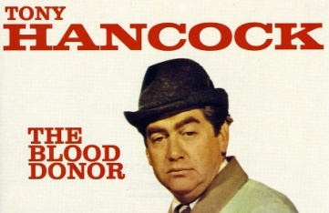
As we think about giving gifts at this time of year, why not join up to give a gift of helping someone to live. By becoming a blood donor you can make a difference, blood stocks are low due to colds and flu and new donors are always needed.
Either log on to www.blood.co.uk or telephone on 0300 123 23 23 to find out where and when sessions are being held. If you already donate, thank you, if not please think about it. It does not hurt and it does not take long, by the time you read this I will have given my 56th donation. Sue Wadsworth
TRINITY’S BIBLE STUDY AND PRAYER GROUP
by Clive Parkinson

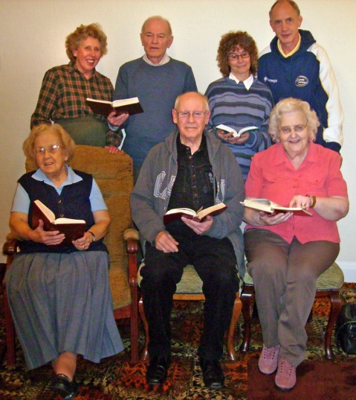
Currently we have nine regular members and we meet on Tuesday evenings every week with breaks at Easter, August and Christmas.
Normally we meet at Mrs. Marie Rapson’s house, except for Lent, when our numbers increase and we meet in the church lounge.
Since we began in 2007, we have completed four York courses during Lent. The rest of the time we have studied St. Luke’s and St. John’s Gospel, The Books of Acts, Psalms and Proverbs.
Currently we are studying St Matthew’s Gospel and Ecclesiastes.
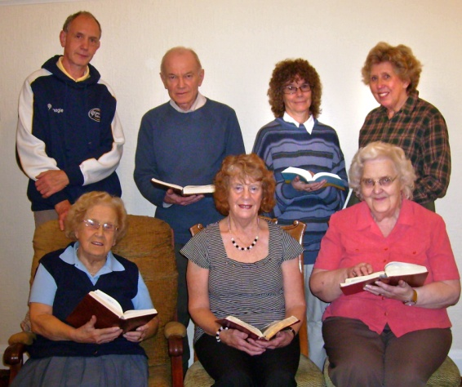
Each meeting begins with a poem, a reading, an article about a Christian, or it may be some personal experience.
The opening is done by members in turn on a voluntary basis followed by prayers for those who are ill, bereaved, persecuted or for victims of disaster.
During the evening we have a short break for refreshments.
We thank Marie for her hospitality and for refreshments especially for the homemade date and walnut cake and fruit cake.
Bible Lands Sponsored Children
West Melton URC sponsor two children through Bible Lands (http://www.biblelands.org.uk/index.html)

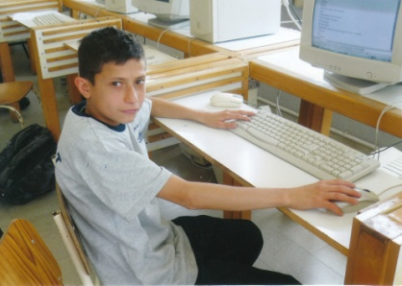
In this magazine we would like to introduce you to Wassim. We have been sponsoring him now for some time. Below is a recent letter to us from Wassim keeping us updated on his progress. Next month we will tell you about the other child we sponsor.

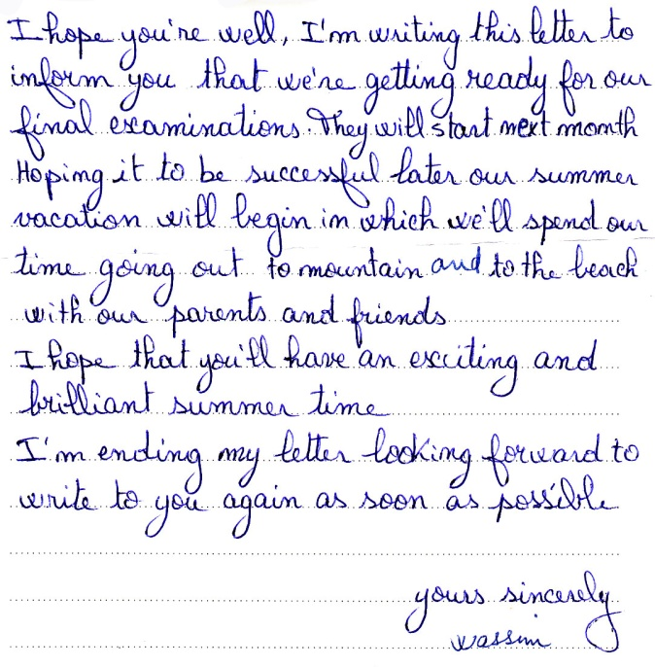
Thank you to everyone who has contributed to this magazine. Items for the Spring 2012 LINK need to be with me by Sunday 12th February, please. Thanks, Nick.
REGULAR ACTIVITIES IN OUR CHURCHES
Clayton West

Sunday Worship every week at 3.00 pm. Communion is included in the service on the 1st first Sunday of each month
Saturday Coffee Morning on the 4th Saturday each month 10.00am

Trinity (Barnsley)

Sunday Worship every week at 10.30 am. Communion is included in the service on the 3rd third Sunday of each month
Tuesday Bible Study at 7.30 pm
Wednesday Age-Well (over 50s club) every week 10.30am-1.00pm
Trinity Players every week at 7.30pm
Thursday Trinity Tots (carers & toddlers) 10.00am – 12.00noon

West Melton

Sunday Worship on the 1st (inc. WHIZZ KIDS) and 4th Sundays at 10.30am and on the 2nd & 3rd Sundays at 3.00pm. Communion is included in the service on the 3rd Sunday of each month
Wednesday Little Stars 9.30am every week (in term time)
Praying Hands (prayer group) 7.30pm – 8.30pm on the 2nd Wednesday of each month
Fellowship evening (varied programme) 7.30pm on the 4th Wednesday of each month
Saturday Men’s Breakfast at 8.00am on the 3rd Saturday each month

Group Minister: Group Treasurer:
Rev. Nick Percival BA Mr. John Paskell
19 Longdale Croft 1 Giles Avenue
Barnsley, S71 2QT Wath on Dearne
Tel: 01226 771277 Rotherham, S63 6SG
Mobile: 07986668032 Tel: 01709 879224
Email: revnickp@yahoo.co.uk Email: john@paskellplumbing.co.uk

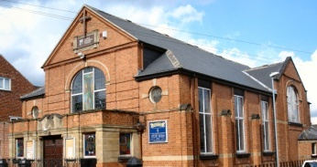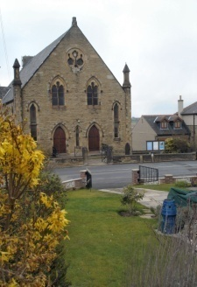
Trinity Clayton West West Melton,
Farrar Street Church Lane Melton High Street
Barnsley Clayton West Wath on Dearne
S70 6BS Huddersfield HD8 9LY Rotherham S63 6RG

Church Secretaries:

TRINITY: Mrs. Fiona Weighton-Smith, 18 Normans Way, Sandal, Wakefield, WF2 6SS Tel: 01924 253010
Email: isabelsmith655@talktalk.net

CLAYTON WEST: Mrs. Betty James, Winter Hill Farm, Bank End
Lane, High Hoyland, Barnsley, S75 4BB
Tel: 01226 382820

WEST MELTON: Mr. John Paskell. (As above)

www.urcbarnsleygroup.co.uk

