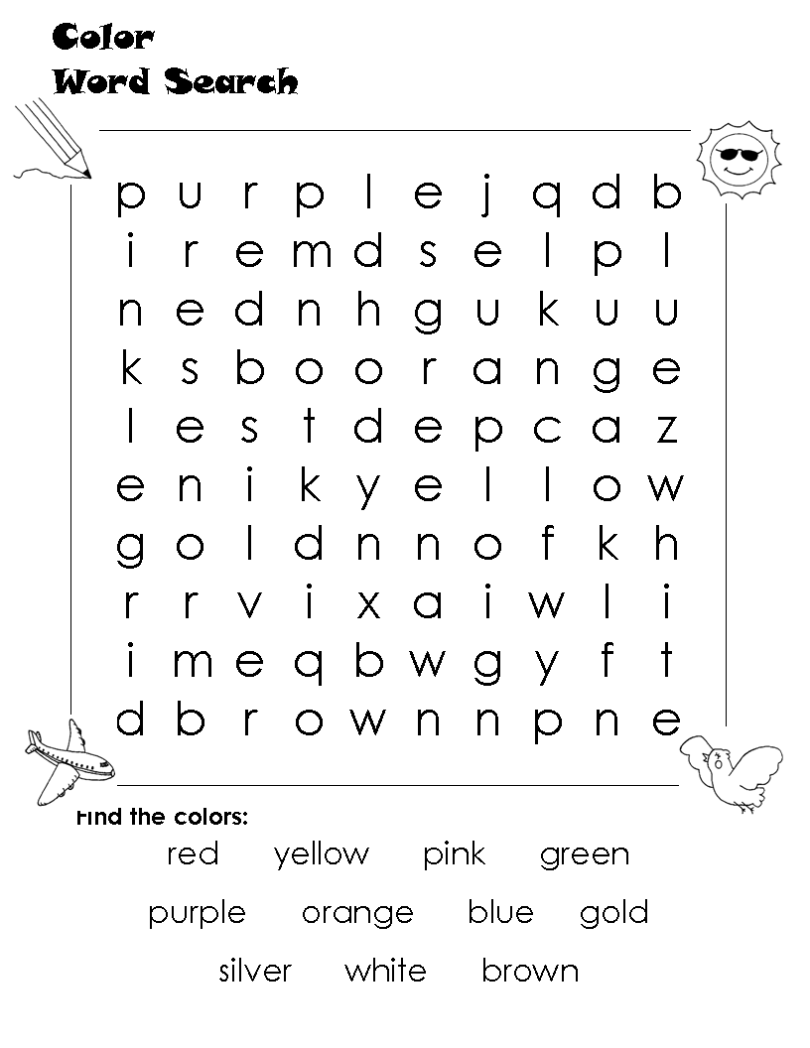

Rayaan - West Melton’s Sponsored Child
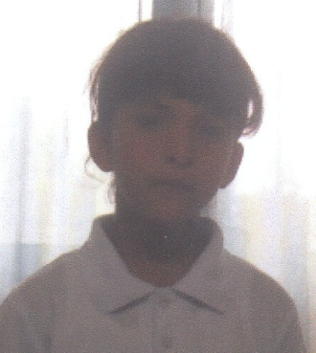

Firstly my apologies for the poor quality of the photo of Rayaan. It is the only one we have at the moment. Rayann is sponsored through Bible Lands (www.biblelands.org.uk). Her date of birth is 27/7/04. Rayaan comes from a poor Muslim family living in the Jerusalem area.

Her father is employed but due to the economic and political situation in the area his wage is low and sporadic and he finds it a struggle to support his wife and five children. Rayaan has one sister and three brothers.

Rayaan and two of her brothers, Ahmed and Sanad, are visually impaired and they all attend the Helen Keller Centre as day students (See next page).

Rayaan enjoys good general health; she is an energetic and talkative little girl who is progressing well in the kindergarten section of the school. She is fond of listening to music, drawing and playing with toys and dolls.

The Hellen Keller Centre in Jerusalem (www.helenkellerschool.org)

A boarding school for visually impaired children located in East Jerusalem. It took over most of the blind pupils from former 'Al-Shurooq School' which moved to Beit Jala/ West Bank in 1995. The partner's programme focuses on pre- and elementary school programmes. Pupils from Jerusalem use the school as a day care centre. The Helen Keller School endeavours to integrate blind children into regular schools and has a strong network with other local service providers.

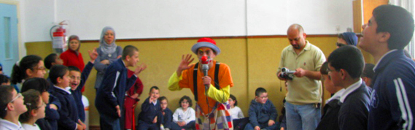
As a recognised registered school for special education services for visually impaired children and adolescents up to 21 years of age, according to the requisites and regulations of the Ministry of Education and of Social Welfare.
It offers educational services, vocational training with an emphasis on life skills and therapeutic support especially for visually impaired young people with developmental delay and borderline to mild intelligence disability.

Thank you to everyone who has contributed to this magazine. Items for the Autumn 2012 LINK need to be with me by Sunday 12th August, please. Thanks, Nick.
Look Who’s Talking by Derek Benfield
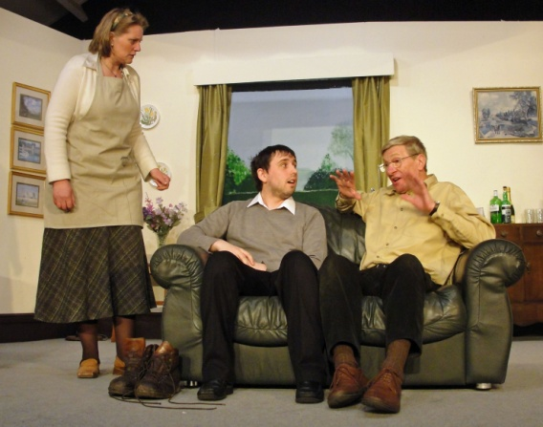
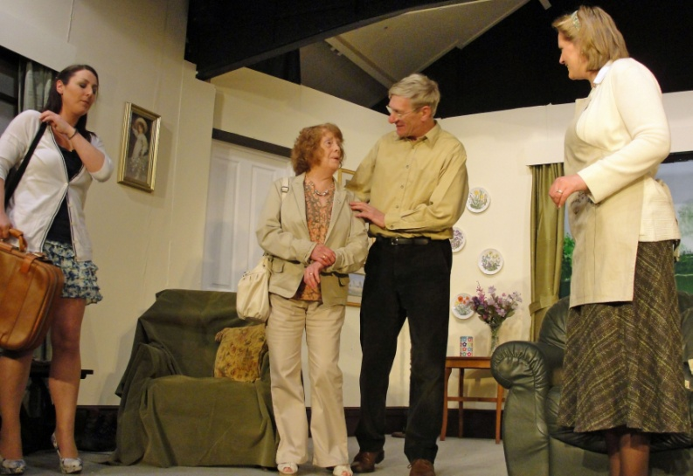
This two-act play by Derek Benfield, performed in the church hall from 16 -19 May, deals with the trials and tribulations of deceit and misunderstanding within marriage. Sheila and Andrew are settling down to a normal relaxed Sunday-Andrew is digging in the garden; Sheila is preparing lunch while waiting for their old friend, Jane, to join them, when two unexpected visitors wander into this idyllic country scene with disturbing and riotous results. Sheila and Andrew begin to weave a web of lies and half-truths to hide their own possible infidelities, unaware that the other is doing the same. This leads to a complicated and hilarious series of misunderstandings and mistaken identities.
Cast
SHEILA: Alison Beresford
BRIAN: Michael Cutts
ANDREW: Edmund Bell
CAROLE: Esther Dyson
JANE: Barbara Parkinson
BUTTERNUT AND CARAMELIZED ONION GALETTE

And now for pudding…!
News from around the world

Tree Crashes Into Church Building Strong winds and heavy rainstorms destroyed three church buildings on May 16.
The winds in one village of Assam, India, uprooted a nearby tree and sent it crashing on the church, severely damaging the roof and the back walls. “The believers are very discouraged, and some of them cried bitterly when they realized they do not have a place to sit and worship,” said a Gospel For Asia field correspondent. Pastor Ahilan leads the church congregation and also felt the sting of being without a church building, tearing up as he explained his sadness over the destruction. Many believers lost their homes in the storm, as well. In Tripura, India, two temporary church buildings are beyond repair because of heavy rainstorms. The two churches, made up of 11 families, now worship together in one house. Pastors Pravar and Anil serve as lead pastors in these churches. “The believers are very discouraged and worried,” said a correspondent. Both of these churches are new. One was created in 2010 with the hard work and collective effort of the body of believers. The other was built in 2011.
Please pray:
- The Lord will provide the resources to rebuild these churches soon.
- The believers, along with their pastors Ahilan, Pravar and Anil, will not despair over the destruction but remain steady in their faith.
- The fellowships will not face any hindrances in continuing their worship services.
- Those who lost their homes during the storm will be able to rebuild their houses soon.
http://www.gfauk.org
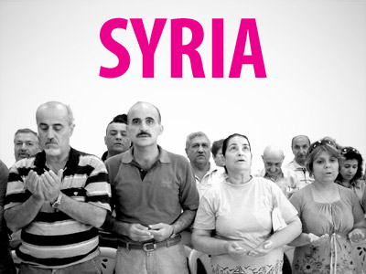
Ten Christian families were expelled from their village in Syria by armed militants as jihadists hijack the anti-government uprising and wreak havoc across the country.
The group seized control of Qastal al-Burg village, which is around 30 miles northwest of Hama, on 10 May. They ordered the ten Christian families who live there to leave empty-handed and took over their homes. The militants also occupied the village church, turning it into their command control centre.
A Barnabas Fund partner in Syria, with whom we are working to help Christians affected by the crisis, said that despite the UN’s peace-building efforts, armed groups have increased their activities. They have taken control of a number of Christian suburbs in Homs, establishing their own police centres and monitoring peoples’ movements. Churches have been damaged and, as the economy grinds to a halt, many people have not been paid for months or are without work altogether. Christians have been forced to flee, leaving their homes and possessions behind.
http://www.barnabasfund.org
REGULAR ACTIVITIES IN OUR CHURCHES
Clayton West
Sunday Worship every week at 3.00 pm. Communion is included in the service on the 1st first Sunday of each month
Friday Baby and Toddler Group 9.30am – 11.30am (in term time)
Saturday Coffee Morning on the 4th Saturday each month 10.00am

Trinity (Barnsley)

Sunday Worship every week at 10.30 am. Communion is included in the service on the 3rd third Sunday of each month
Tuesday Bible Study at 7.30 pm
Wednesday Age-Well (over 50s club) every week 10.30am-1.00pm
Trinity Players every week at 7.30pm
Thursday Trinity Tots (carers & toddlers) 10.00am – 12.00noon

West Melton

Sunday Worship on the 1st (inc. WHIZZ KIDS) and 4th Sundays at 10.30am and on the 2nd & 3rd Sundays at 3.00pm. Communion is included in the service on the 3rd Sunday of each month
Wednesday Little Stars 9.30am every week (in term time)
Praying Hands (prayer group) 7.30pm – 8.30pm on the 2nd Wednesday of each month
Fellowship evening (varied programme) 7.30pm on the 4th Wednesday of each month
Saturday Men’s Breakfast at 8.00am on the 3rd Saturday each month

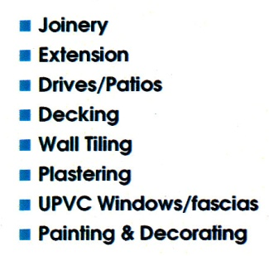

___________________________
___________________________

Group Minister: Group Treasurer:
Rev. Nick Percival BA Mr. John Paskell
19 Longdale Croft 1 Giles Avenue
Barnsley, S71 2QT Wath on Dearne
Tel: 01226 771277 Rotherham, S63 6SG
Mobile: 07986668032 Tel: 01709 879224
Email: revnickp@yahoo.co.uk Email: john@paskellplumbing.co.uk

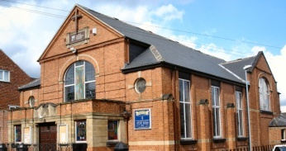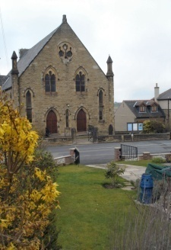
Trinity Clayton West West Melton,
Farrar Street Church Lane Melton High Street
Barnsley Clayton West Wath on Dearne
S70 6BS Huddersfield HD8 9LY Rotherham S63 6RG

Church Secretaries:

TRINITY: Mrs. Fiona Weighton-Smith, 18 Normans Way, Sandal, Wakefield, WF2 6SS Tel: 01924 253010
Email: isabelsmith655@talktalk.net

CLAYTON WEST: Mrs. Betty James, Winter Hill Farm, Bank End
Lane, High Hoyland, Barnsley, S75 4BB
Tel: 01226 382820

WEST MELTON: Mr. John Paskell. (As above)

www.urcbarnsleygroup.co.uk

