****

**The shepherd went to see the baby Jesus**

Thanks to everyone who has contributed to this magazine. Items for the Spring 2013 edition need to be with Nick by Sunday 10th February, please**.**

**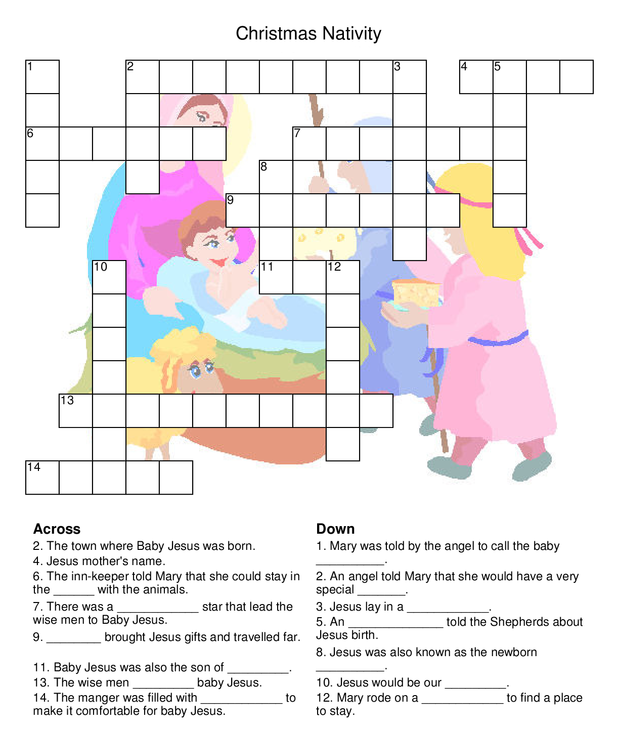LAST TANGO IN WHITBY**

****

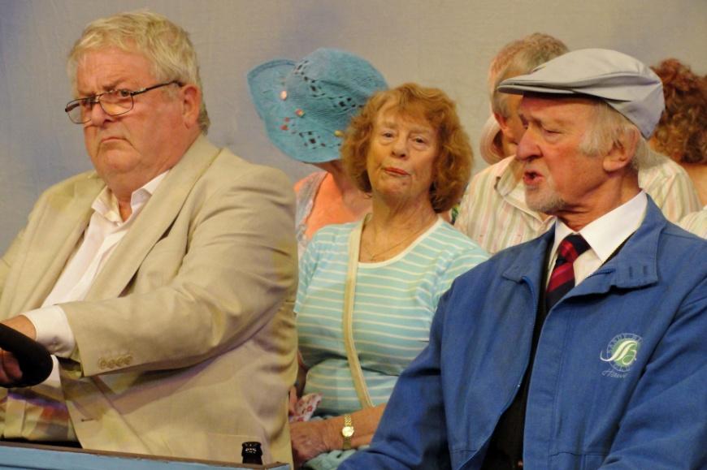The Trinity Players last production was Mike Harding’s play *Last Tango in Whitby.* It was performed at the Lamproom in Barnsley from 31st October to 3rd November. It is a bitter-sweet comedy set in 1990.

The old 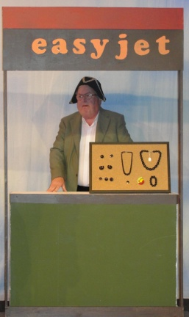town team are making their way to Whitby for the annual dancing holiday – but this year Arthur is missing so Pat is alone. Will she find happiness in the whirl of tangos and “touch-ups” or does fate have something else in store?

The sets for the seventeen scenes were ingeniously designed and the ensemble performed to the high standard we have come to expect of Trinity Players.

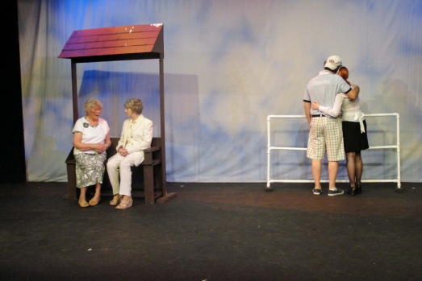I lost count of the number of costume changes that had to be made and I was surprised that they did not cause any of the cast to miss their entrances!

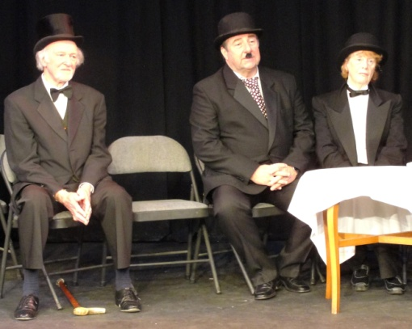The play is a lot of fun but also has its poignant moments. As for the dance routines! I have heard a rumour that they are all going to audition for the next series of Strictly Come Dancing!

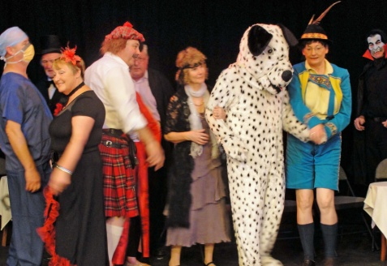The talent contest in Act 2 was a joy to behold with a rather overgrown ‘dog’ putting in a fine performance. (Britain’s Got Talent next for him?)

On the next page are some more photos from this excellent production.

**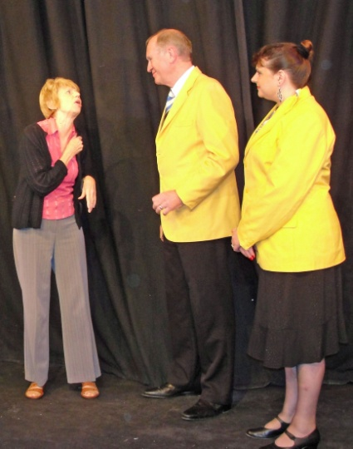 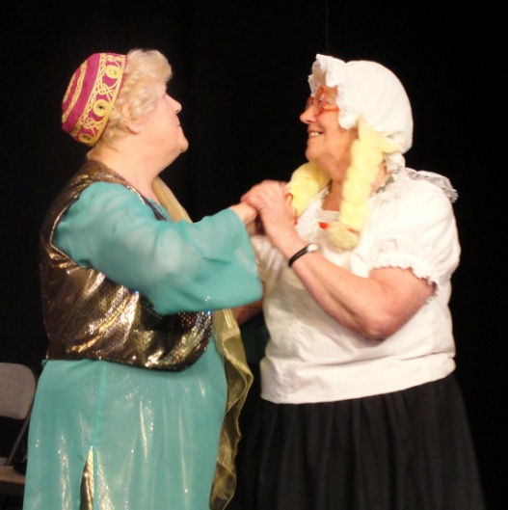**

**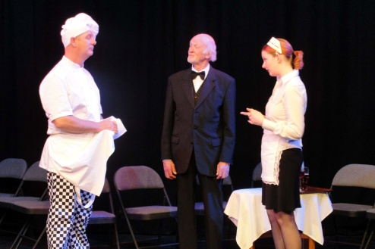 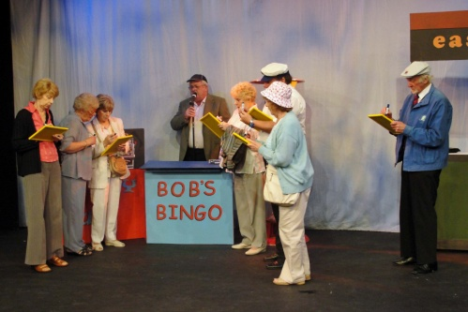**

**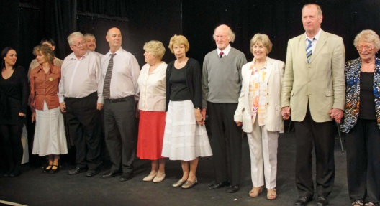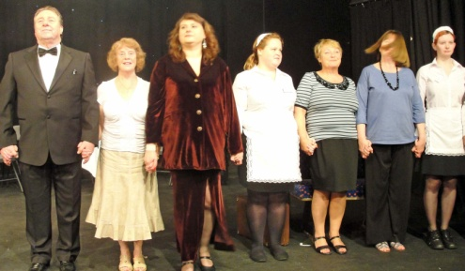**

COMING NEXT: DICK WHITTINGTON. FEBRUARY 8,9 & 15,16 – 2013

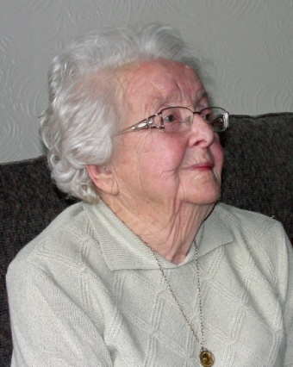Getting to know you – Beatrice Squires

On 25th September Beattie celebrated her ninetieth birthday.

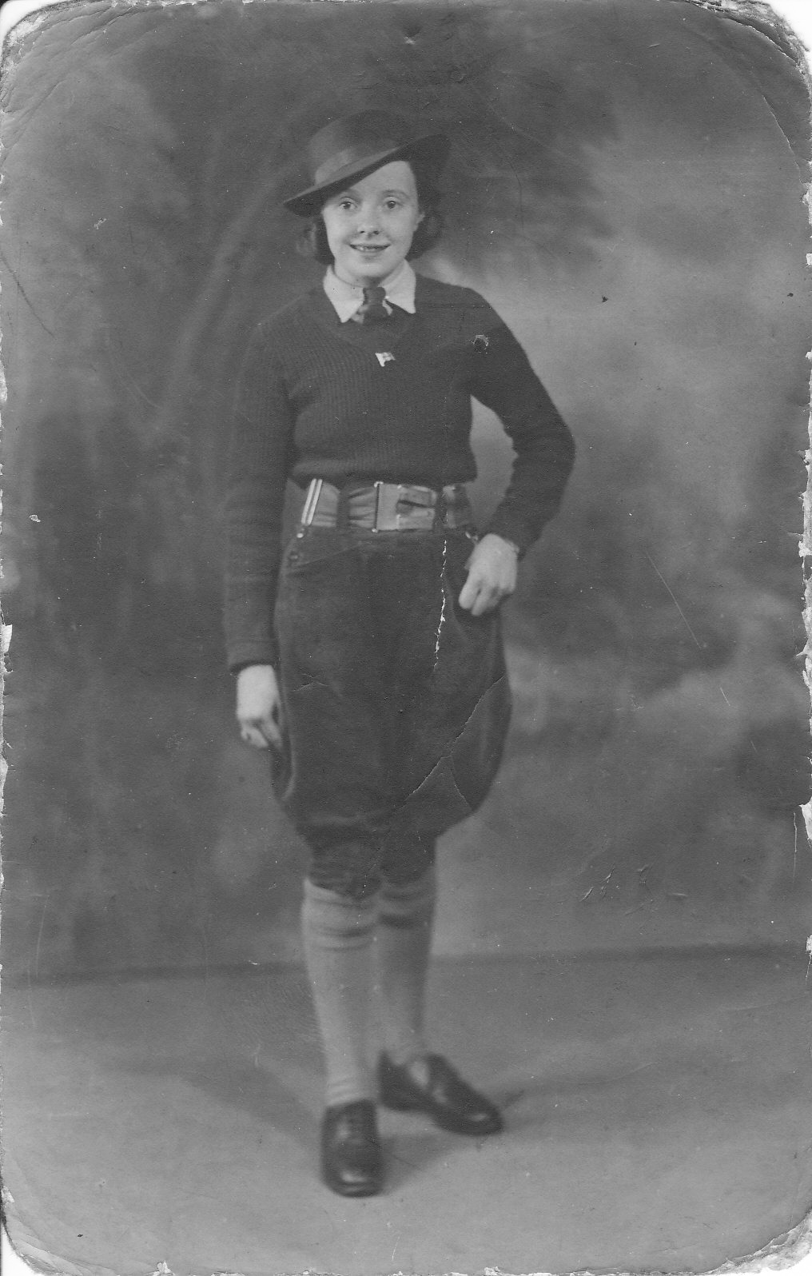Beattie started her church life in the Methodist Church. When her family moved to Mottram Street her new next door neighbours took her to their church, Regent Street Congregational Church. Beattie played a full part in the life of the church. She taught in the Sunday School and played the piano for the children. It was at this church that she met her husband to be, Felix.

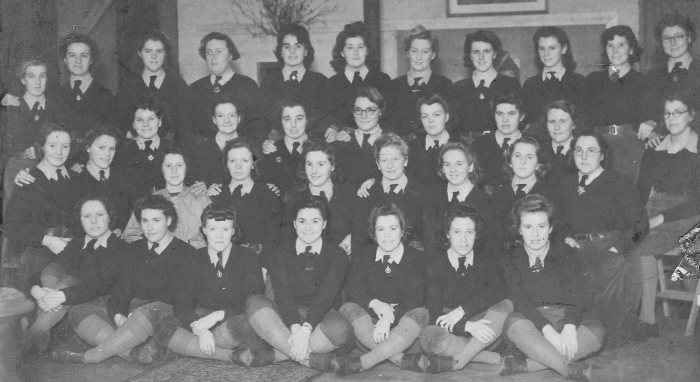Beattie got a job at the Co-op grocery shop in Farrar Street which was managed by Felix’s father. Beattie left the Co-op in 1942 when she joined the Land Army. She was sent to a hostel in Doncaster which she shared with thirty nine other girls. Much of their work was at 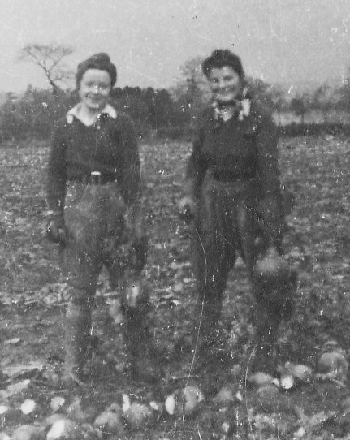Cawthorne Park. During this time Beattie was taught to drive, in three days!, So, apart from working in the fields and feeding the pigs she would also drive the tractor to cut the corn at harvest time.

Looking smart in her Land Army uniform

Beattie is on the far left of the middle row

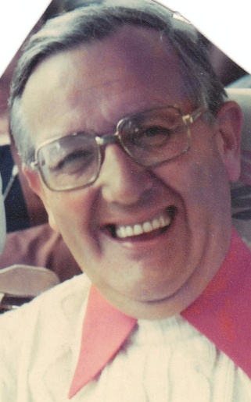The last two years of Beattie’s time in the Land Army was spent at Firbeck on the farm of Mr. Nicholson – a ‘gentleman’ farmer whose daughter also worked on the farm. Beattie was well looked after and was treated as one of the family. After the harvest was safely gathered in at Firbeck they were taken to the pub for a meal but the girls were not allowed to drink alcohol!

Beattie (left) and Emma chopping turnips -Nov 1944

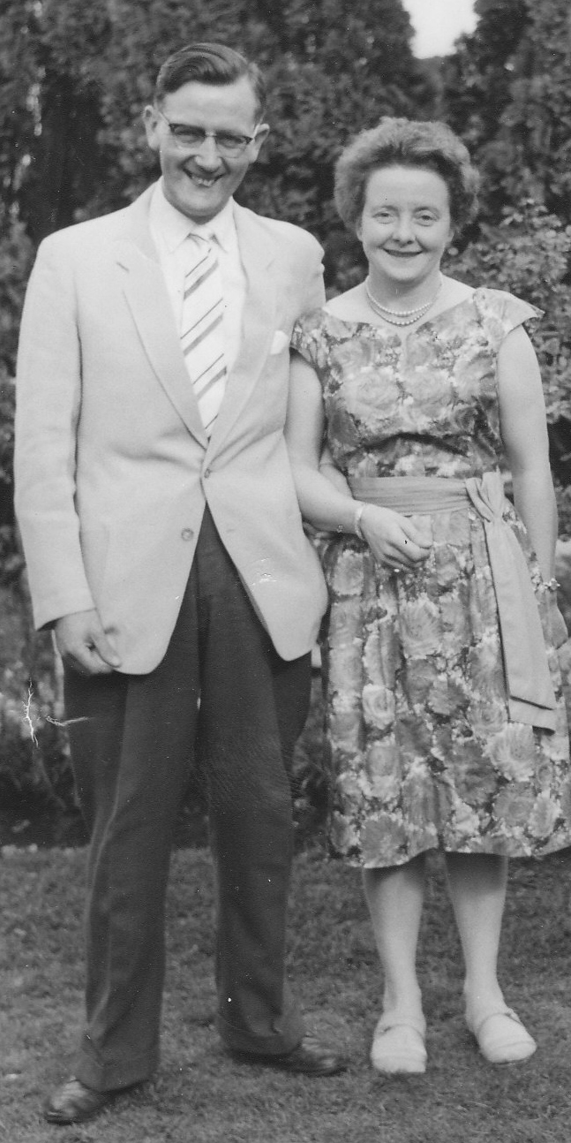

The weather played a big part in the work Beattie undertook and once, whilst she was snow shifting she was called upon to help deliver a calf. Working fairly locally, Beattie was able to return home every weekend so was able to go to church and, perhaps more importantly, see Felix.

Of her time in the Land Army Beattie said, “I found it was my college education and it taught me to live with other people. When it rained if there was no undercover farm-work we sewed mailbags”.

Beattie and Felix were married after the war in Regent Street Congregational Church where their reception was also held. Beattie and Felix’s family was completed on 14 June 1950 when Judith was born, “She is a blessing”, Beattie said. When Judith started school Beattie went to work at Atkins Butchers and later moved to the tailoring department of the Co-op where she worked on the cash desk. Beattie retired when she was fifty nine when her first grandson was born.

When Regent Street Church closed Beattie began worshipping at Trinity United Reformed Church (formerly Farrar Street Congregational Church). Once again she played a full part in the life of the church doing a lot of catering at the church, taking her turn at the day care lunch club and the annual gift day, Christmas and harvest suppers as well as singing in the choir, which she still enjoys.

**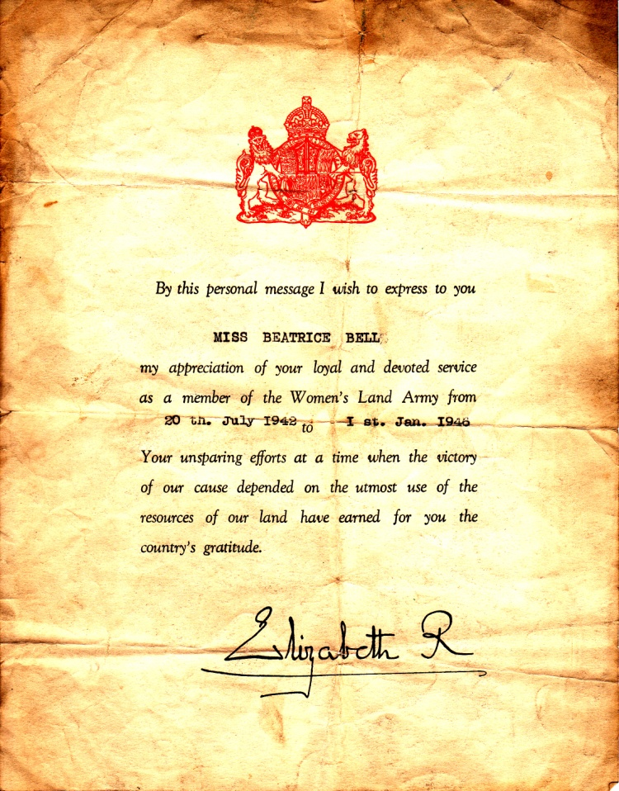**

**From the October Synod meeting.**

Many Are Called...a framework for mission and ministry across Yorkshire.

To encourage the Ministry of All true Believers, Rev David Pickering (St Andrew’s Roundhay URC in Leeds) convenor of the Synod Ministries Committee presented a new paper to Synod that took account of comments on the previous paper. He asked for churches to discuss the paper and send comments by 6 January 2013. He said the paper offered a flexible toolkit to fit with existing arrangements. Its effectiveness in helping our ministry depended “On our openness to our sense of God’s call and our own imagination,” he said. In a lively debate, representatives warned against talking about ministry instead of doing it, suggested implications for training, highlighted the ministry of music, noted that Elders (in one church at least) were called the leadership team, referred to church life reviews and called for ways to be found to avoid local ecumenical partnerships repeating similar processes to satisfying their denominations’ separate requirements.

After comments were received, a further paper would be put to Synod Council, who would decide on whether to submit it to Synod in March 2013. The paper was formally received for local churches to consider and make comments. (If you would like a copy please ask Nick or your elder)

****

**REGULAR ACTIVITIES IN OUR CHURCHES**

**Clayton West**

Sunday Worship every week at 3.00 pm. Communion is included in the service on the 1st first Sunday of each month

Friday Baby and Toddler Group 1.15pm – 3.15pm *(in term time)*

Saturday Coffee Morning on the 4th Saturday each month 10.00am

**Trinity (Barnsley)**

Sunday Worship every week at 10.30 am. Communion is included in the service on the 3rd third Sunday of each month

Tuesday Bible Study at 7.30 pm

Wednesday Age-Well (*over 50s club*) every week 10.30am-1.00pm

Trinity Players every week at 7.30pm

Thursday Trinity Tots (*carers & toddlers*) 10.00am – 12.00noon

**West Melton**

Sunday Worship on the 1st (*inc. WHIZZ KIDS*) and 4th Sundays at 10.30am and on the 2nd & 3rd Sundays at 3.00pm. Communion is included in the service on the 3rd Sunday of each month

Wednesday Little Stars 9.30am every week *(in term time)*

Praying Hands (*prayer group*) 7.30pm – 8.30pm on the 2nd Wednesday of each month

Fellowship evening (*varied programme*) 7.30pm on the 4th Wednesday of each month

Saturday Men’s Breakfast at 8.00am on the 3rd Saturday each month







C:\Users\Nick\Desktop\2012_05_23\AD TEXT 4.jpg

C:\Users\Nick\Desktop\2012_05_23\AD TEXT 5.jpg

\_\_\_\_\_\_\_\_\_\_\_\_\_\_\_\_\_\_\_\_\_\_\_\_\_\_\_





\_\_\_\_\_\_\_\_\_\_\_\_\_\_\_\_\_\_\_\_\_\_\_\_\_\_\_



**Group Minister: Group Treasurer:**

Rev. Nick Percival BA Mr. John Paskell

19 Longdale Croft 1 Giles Avenue

Barnsley, S71 2QT Wath on Dearne

Tel: 01226 771277 Rotherham, S63 6SG

Mobile: 07986668032 Tel: 01709 879224

Email: [revnickp@yahoo.co.uk](mailto:revnickp@yahoo.co.uk) Email: [john@paskellplumbing.co.uk](mailto:john@paskellplumbing.co.uk)

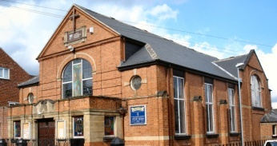 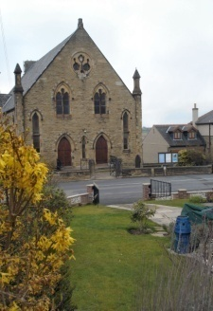 

Trinity Clayton West West Melton,

Farrar Street Church Lane Melton High Street

Barnsley Clayton West Wath on Dearne

S70 6BS Huddersfield HD8 9LY Rotherham S63 6RG

**Church Secretaries:**

TRINITY: Mrs. Fiona Weighton-Smith, 18 Normans Way, Sandal, Wakefield, WF2 6SS Tel: 01924 253010

Email: [isabelsmith655@talktalk.net](mailto:isabelsmith655@talktalk.net)

CLAYTON WEST: Mrs. Betty James, Winter Hill Farm, Bank End

Lane, High Hoyland, Barnsley, S75 4BB

Tel: 01226 382820

WEST MELTON: Mr. John Paskell. *(As above)*

**www.urcbarnsleygroup.co.uk**