LINK

The magazine of the Barnsley Group Pastorate

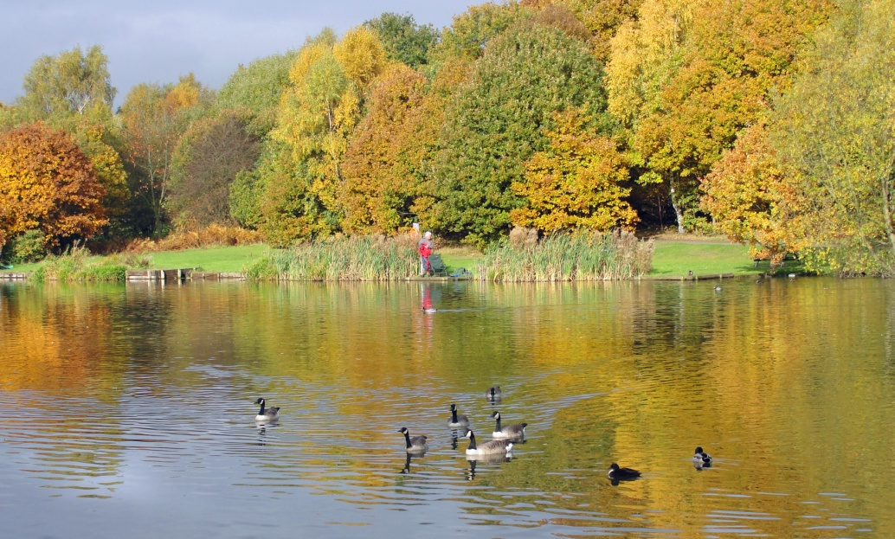

**AUTUMN 2011**  

Plumbing and

heating engineers

Tel: 01709 873518

[info@paskellplumbing.co.uk](mailto:info@paskellplumbing.co.uk)



**Druids Sheffield**

**Friendly Society**

Plans for Healthcare – Tax Exempt Savings

Sickness and Death Benefits

Endowments – Insurance I.S.A.

Leaflets on all plans available from:-

Dove House, Brampton Road,

Wath-Upon-Dearne, S63 6BE

Tel: 01709 876409

Fax: 01709 878045

Email: deuidssheffield.friendly@virgin.net

www.druidsfriendly.co.uk

Established 1858. Authorised in the United Kingdom under the Friendly Societies Act 1992. Reg. No. 795f

Druids Sheffield Friendly Society is regulated by the

13307

_________________________

**Simon T. Anderson**

Funeral Director

23 Dodworth Road, Barnsley.

**(01226) 733119**

*24 HOUR SERVICE*

AN INDEPENDENT FUNERAL SERVICE

*Professional and friendly advice on all aspects of the funeral service*

Financial Services Authority

___________________________________________________



Andrew P. Lockwood

**MinstChP. CCM(Sheffield)**

**CHIROPODIST**

**All Foot Ailments Treated**

CORNS – CALLOUSES (Hard Skin) – VERRUCAE – ATHLETE’S FOOT etc.

**Home Visits – Prompt Attention**

**Tel: 01484 687632**

**Mobile: 07971355078**

Dear friends

I am currently reading the book *COMEBACK CHURCHES*

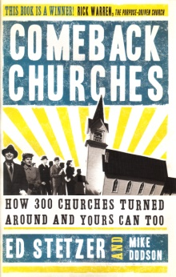 by Ed Stetzer and Mike Dobson.

The blurb says, “Perhaps you’ve noticed: large church buildings that were filled in the 1950s and 60s now hold a fraction of their capacity…Overall, our churches are stagnant, in need of a return to healthy evangelistic growth”. Amongst other things, the book challenges us to identify what sort of church we are. It suggests thirteen possibilities for our consideration. Which, I wonder, fits closest to our churches?

1. ***Institutionalized Church*:** Do we simply function as an institution. Do we focus on the way we do things? Have we lost sight of the purpose for which the church was created?
2. ***Voluntary Association Church:***Do we operate using democratic principles rather than New Testament principles? When one group of people in the church seeks to make a positive change does another group begin to whine, complain and gossip against the change? Are compromises then made so that nothing really changes? If so, this book suggests that we will not change until our value system is changed.
3. ***Unintentional Church:***Do we mean well and have good intentions but never ‘do’ what we ‘hope to do’ Do we think disciple will be produced by carrying on as we are?
4. ***“Us four and no more” Church:***Do we think that we will loose our close fellowship if more people come to us? Do we want a family feel when this means keeping a group small enough to relate like family?
5. ***“We can’t compete” Church:***Have we simply given up, like a family run shop next to a new supermarket? Have we decided we simply can’t compete and so have stopped trying?
6. ***“Decently and in order” Church:***Do we have a high regard for process but lack passion? Do we run everything by the book, which, unfortunately, is not the Bible? Do we think all is well as long as everything is discussed in minute detail and approved by the relevant meeting, or have we forgotten that the business of the church was given by our Lord in the Great Commission and the Great Commandment?
7. ***“Square peg in a round hole” Church:*** Do we select people for leadership and service, not by their gifts or passions, but because “We’ve got to fill this position – who haven’t we asked yet?” People are all in their place, but is it the right place to help their church and those around them?
8. ***“Time-Warp” church:***Have we preserved not just the doctrine of the faith, but the positions, practices and appearances of years gone by? Do we expect others to adapt and accept what we’ve grown comfortable doing and give no thought to change how we do things? Is it good enough for me so it should be good enough for them!?
9. ***“Tidy” Church:***Do we take pride in ourpremises and get annoyed if youth or messy children begin to come? Would we view this ‘new growth’ as a threat and try to contain growth in this direction?
10. ***“My way or the highway” Church:***Do a number of our members know how things ought to be, and are vocal, maybe even vociferous, in expressing it? Do we like a certain type of music? Do we say, “it’s always too hot (or too cold) in here” or “I liked it better when the notices were earlier in the service (or later)” Are we not satisfied until things are done ‘our way’?
11. ***“Chaplaincy” Church:***Do we want a ‘chaplain’ rather than a leader? Do we have an employer/employee relationship with the chaplain (minister)? Do we expect the ‘chaplain’ to do everything, after all he/she is the one who has been to theological college?
12. ***The “Company” Church:***Do we focus too much on what is handed down to us by our denomination trying to apply them rather than concentrating on the needs of our community?
13. ***“Play it safe” Church:***Do we have faith that God will provide? If we don’t then do we not hinder ministry and evangelism rather than enable it? Do we want to protect what we have, placing as much money on deposit as we can but making no plans to reach others for Christ?

Plenty of food for thought there! If you would like to borrow the book please tell me.

If you wish to buy a copy it is published by: B & H Publishing Group, Nashville. The ISBN number is 0805445366.

May God continue to bless you.

Your friend and minister



*(Cover photo – Dearne Valley Park – Barnsley)*

**Memoirs of a Cruise Ship Holiday** by Margaret Swallow

The holiday started off well enough! We were picked up in Wath and taken directly to the ship!! No lugging cases, no transferring from Victoria Coach Station (an horrendous place!!) en route to Dover, wonderful!

The intrepid duo (my friend and I!), full of anticipation, were checked in and directed to our cabin! It was in a good spot, deck six and amidships--great! Then we opened the door--the cabin was small and I mean small!!!!! The bed had to be split, by six inches to accommodate two ladies! The bottom of the bed had a 12 inch clearance to the cabin wall. My friend always has much more luggage than me--her case would not fit under the bed, so for 13 nights we had to stride over it--not good in rough weather!! Flattening ourselves against the wall and avoiding banging our heads on the protruding TV and squeezing ourselves into the shower cubicle, we managed to survive without injury!

The ship could well be described as a floating old people’s home -80% of passengers were well over 80 with varying disabilities. It was quite amazing to see the skills used to follow the movement of the boat with their zimmers as it lurched from side to side on leaving Lisbon Harbour. Have Camera will travel (me!) was not so skilled! My sea legs were definitely not seaworthy as we left Lisbon! With camera in right hand and hanging on to the ship’s door with the other, I attracted the attention of a crew member who assisted me in my hour of need and stopped me being blown overboard! Luckily for you, both me and my camera were saved!!

Days at sea were really exciting! There were planned activities!!! Carpet Bowls and a library filled with the after lunch snoozers before the race for afternoon tea !!!! The Church service on Sunday was inspirational and attended by 30 people out of a total of 900 passengers—a sign of the times!!! After the excitement of days at sea we were excited to reach our first port of call, which was on a Sunday--nothing opened--everything closes on Sundays!!!

All in all, an experience not to be missed--or repeated!

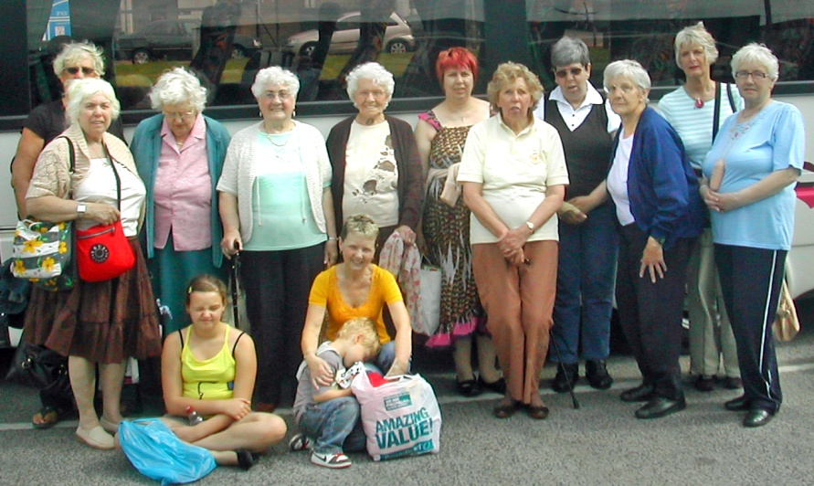**The Day We Went To Cleethorpes** by Trinity Age-well and the Tots

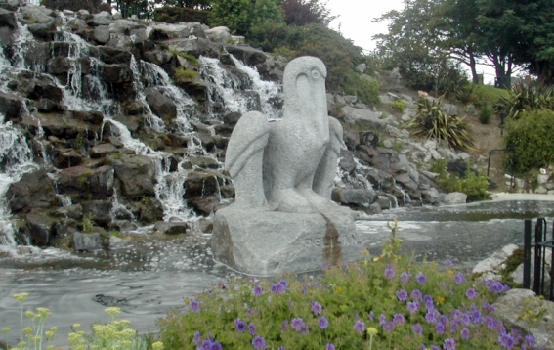The weather was kind. We had asked for sun as we had had last year in Scarborough. Not quite the Mediterranean blue but still plenty of sun.

We walked along the prom and enjoyed the fresh air, also finding a lovely place for lunch.

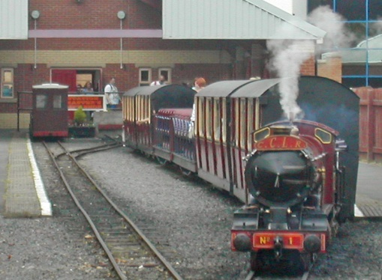There was a land train that went for the pier along the prom to the south and the park. This had a boating lake, where a group of men were sailing model boats, which were remote controlled. Children were enjoying the paddling pool.

Jean and Una took the opportunity to meet up with a cousin they rarely see. A lovely chance to catch up on family news. Una was grateful to the coach driver who’d agreed to carry her mobility scooter. He was most surprised at how small and portable it was.

Val her daughter Tracy, Alice and granddaughter Alisha all had a lovely day

Visited a small market. Walked on the pier, while Alisha looked for shells on the beach and found pools to dabble in. We had an amusing time in the café where we had our lunch. The table was all shiny looking , but the plates and cups all stuck to them and when we picked up the serviettes there was a tearing sound as though they’d been Velcro-ed.

Joshua and his nana made straight for the beach, where Josh made a sandcastle and lots of sand-pies. Nana and I played crazy golf and also went on the land train.

A most enjoyable day, weather kind, good company and a store of happy memories to take home. Yes we enjoyed Cleethorpes.

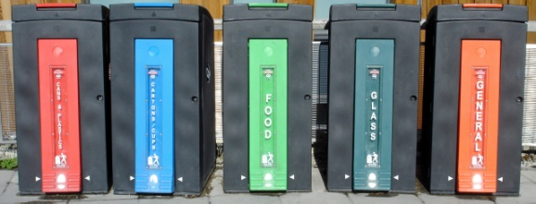WEST MELTON’S GREEN TIPS CORNER

**No. 5 – Recycling**  by Helen Owen

Mobile phones can be recycled by a number of charities including Christain Aid which receives £4 for each phone it recycles.  
Used printer cartridges and toners can also be recycled by Christian Aid and other charities, although there are some which cannot be accepted, notably Epson cartridges.  
I am willing to arrange each of the above if anyone wants to let me have their old phones and cartridges.  
Old spectacles can be taken to most opticians for recycling.  
Unwanted items of all descriptions can be recycled via the internet either for a selling price or given away free.  
I can provide web site info. if required and am willing to put other peoples items onto these sites (as long as I'm not inundated!)

**Getting to know you – Cecil Auckland writes:**

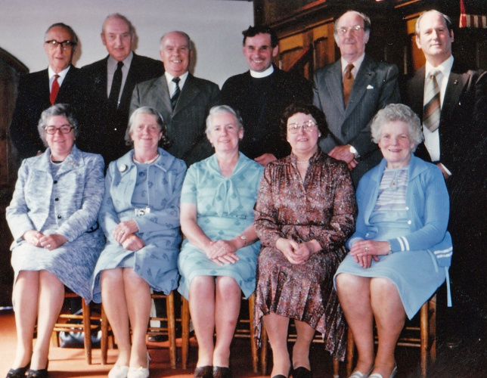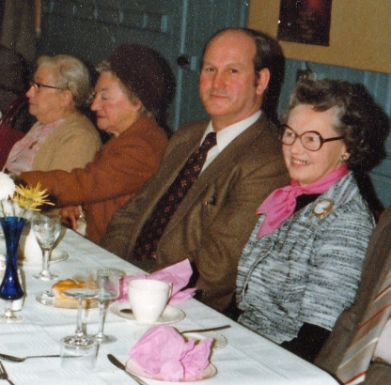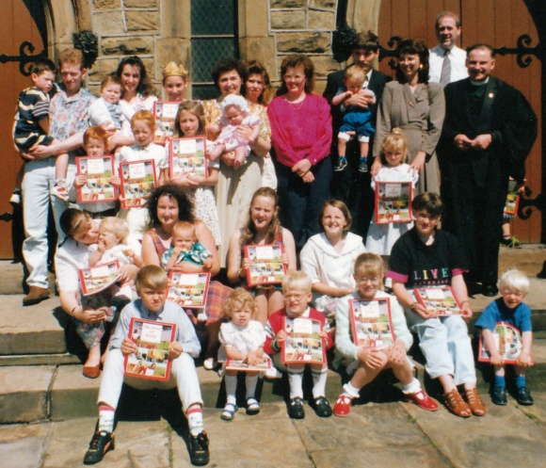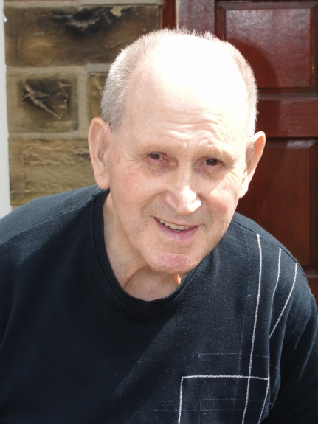As I approach my ninetieth birthday (26 July 2011) I was asked to look back over my many years connected to the church at Clayton West. I remember my first visit in the forties on Anniversary Sunday when the church was so full we had to sit on benches in the aisles.

In the late forties, after the war, I became treasurer of the church, a position I held for nearly fifty years. Throughout the fifties and sixties the church was a pivotal part of village life. As well as being treasurer and an elder, myself and my wife were also involved with the Sunday School which was very well attended. We were also members of the excellent church choir.

The church had a very busy calendar year. The anniversary weekend was a main event. There was also the crowning of the Sunday School queen, harvest festival, summer fête and other social events. We had a drama group which produced plays and put on pantomimes at Christmas.

I enjoyed my time as treasurer, it never seemed a chore, and also the social life of the church. However, one thing I certainly don’t miss are those early mornings going down to the church to light the boiler!

✞ ✞ ✞ ✞ ✞

**WATH - THE QUEEN OF VILLAGES**

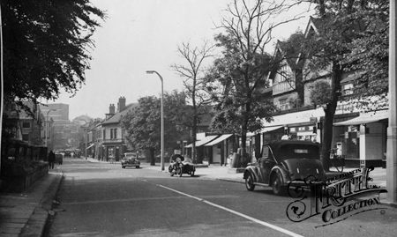

Do walk with me down Barnsley Road. `What's that peculiar whiff?'

It's coming from the skin yard, so do not stay to sniff.

The scent we find on West Street is sickly-sweet and queer,

it assures us that at Whitworths they are busy brewing beer.

We will not go up Warehouse Lane if you take my advice,

the odours from the slaughterhouse are never very nice.

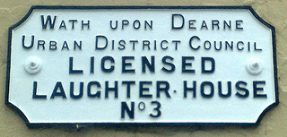

Instead we go along Moor Road and hear the rhythmic thump

of the thing that softens water for the locos on the Hump.

Here at the Recreation Ground the bench needs several wipes,

or when we rise we will find our dress has zebra stripes.

The air down here is very thick and smuts pour down like rain

from the smoke of many engines and the ovens at Wath Main.

There's a burnt smell from the malt kilns as up Station Road we pass

and now we're almost overcome by Wath and Thurnscoe Gas.

Were we to turn up Sandygate the aspect's much more sunny,

and several stately mansions prove that where there's muck

there's money.

But once we get past Dunford House our lungs can scarcely cope

with the dreadful reek of oil and grease where

Stanleys make their soap.

And then behind the greasy smell something quite unpleasant lurks,

I think the wind is blowing from off the sewage works.

Now there's a change of atmosphere — that means we can't be far,

from Manvers with its special blend of sulphur, smoke and tar.

The gardeners believe these fumes will keep the

mildew from their roses,

but visitors to our dear Wath deplore the insult to their noses.

A stranger said 'I have known some smells from fact'ries,

drains and tillages,

but never a pang that was half as strong as that in the

Queen of Villages!

By MIRIAM SMITH (1992) On Wath in the early 20th century

Harvest Festival Word Search

.

|  |  |  |  |  |  |  |  |  |  |  |  |  |  |  |
| --- | --- | --- | --- | --- | --- | --- | --- | --- | --- | --- | --- | --- | --- | --- |
| D | N | R | Q | L | F | N | B | X | D | R | L | W | Y | O |
| S | L | D | M | T | S | O | G | S | A | B | S | V | Y | G |
| N | E | M | G | S | N | I | X | T | I | Y | K | N | B | B |
| O | I | J | E | E | O | T | L | S | D | T | O | G | L | U |
| I | G | R | E | V | I | A | L | F | M | I | R | O | U | D |
| T | N | P | R | R | S | R | O | A | T | A | A | Y | H | L |
| A | I | U | I | A | I | O | E | A | V | H | Y | M | N | S |
| T | V | R | N | H | V | C | G | L | B | I | A | U | D | B |
| I | I | J | O | P | O | E | A | M | X | T | T | N | B | D |
| C | G | H | S | O | R | D | Q | S | S | H | R | S | K | M |
| E | O | Y | Y | G | P | R | O | G | R | A | M | M | E | S |
| R | H | P | N | N | K | U | S | D | S | T | I | U | R | F |
| X | S | O | V | E | G | E | T | A | B | L | E | S | N | G |
| S | C | H | I | L | D | R | E | N | G | B | X | D | G | Z |
| D | D | H | B | A | N | A | N | A | S | P | V | L | I | B |

ALMS, ALTAR, BANANAS, CHILDREN, CONGREGATION  
DECORATION, FESTIVAL, FRUITS, GIVING, HARVEST, HYMNS, POOR, PROGRAMME, PROVISIONS, RECITATIONS  
THANKS, VEGETABLES, YAMS.



**Seren House promotes healthy family life**

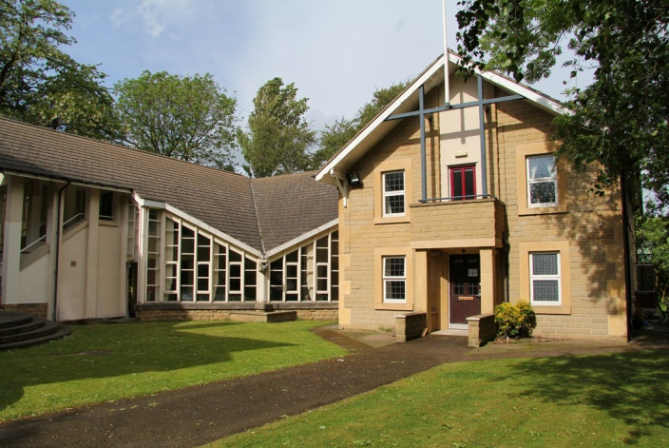

In the face of ongoing debates regarding the nation’s moral standards Seren House opens its doors to women with children under the age of 5 providing a life changing programme for those wanting to overcome addiction and break the cycle of offending behaviour.

Seren House is a Christian Women and Children’s Therapeutic Community based in Rotherham that provides a safe, nurturing and caring environment for mother and children. The 24 week programme is diverse, challenging and tailor made to meet each individual’s needs and incorporates the experience and skills of the award winning Kickstart Community Programme from Sheffield.

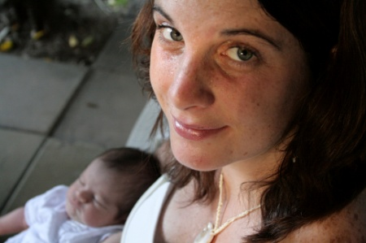Kirsty Allan, Registered Manager comments “We believe in encouraging mothers to develop their relationship with their children, empowering and enabling them to change, whilst supporting them to establish a stable loving family life.”

If you are interested in knowing more about Seren House please don’t hesitate to contact us, or if you would like to get involved there are various ways of doing so; several volunteer opportunities available, as an addition to or as an alternative there is facility of supporting the project financially.

Please contact the office for more information.

Tel: 01709 760055   
Email: info@serenhouse.co.uk or helen.barrios@serenhouse.co.uk

Web: www.serenhouse.co.uk

**Two simple recipes for Autumn**

**Glazed Carrots**

2 pounds baby carrots, 1 teaspoon salt 2oz butter, 2 tablespoons sugar, 1/2 teaspoon ground nutmeg

In a large saucepan over medium heat, in 1 inch of boiling water heat carrots and 1/2 teaspoon salt to boiling. Reduce heat to low; cover and simmer 20-25 minutes or until tender-crisp; drain. Add butter, sugar, nutmeg and 1/2 teaspoon salt. Return mixture to heat and cook, stirring constantly, until carrots are glazed.

**Poached Pears**

6 firm Conference pears, 1 litre cranberry and raspberry juice 175g (6oz) caster sugar, 1 cinnamon stick, Few strips peeled orange rind

Peel the pears, leaving the stalks on. Remove the core from the base of each with the tip of a potato peeler or melon baller. Place the pears in a pan and pour over the juice. Add the sugar, cinnamon stick and orange rind. Heat gently until the sugar has dissolved, then simmer for 20-25 mins until the pears are tender. Turn the pears occasionally in the liquid to ensure that they're evenly cooked. Remove the pears from the syrup and place in a serving bowl. Boil the liquid for 5-10 mins until syrupy. Strain the hot syrup over the pears, discarding the cinnamon and orange peel. Serve the pears warm with a spoonful of yogurt. Alternatively, leave them to cool completely then chill in the fridge for 3-4 hrs before serving. Add a few raspberries or blackberries to the syrup to add colour.

**Photos of recent events**

West Melton’s BBQ – 24 June

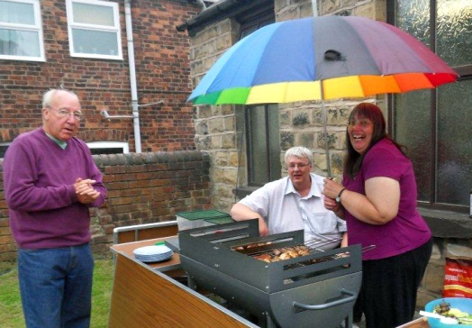 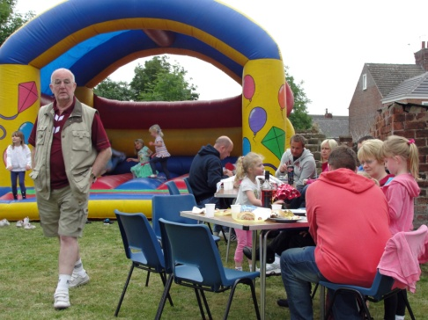

Fiona’s ‘At Home’ – 25 June

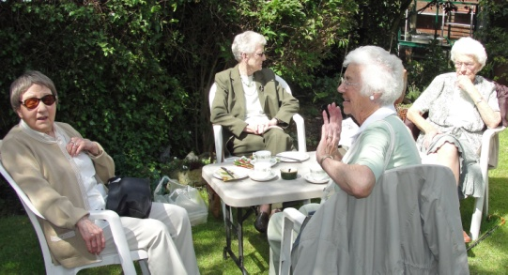 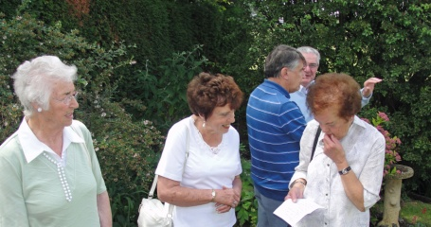

Clayton West’s Strawberry Fayre – 23 July

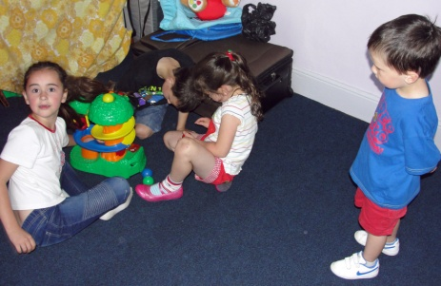 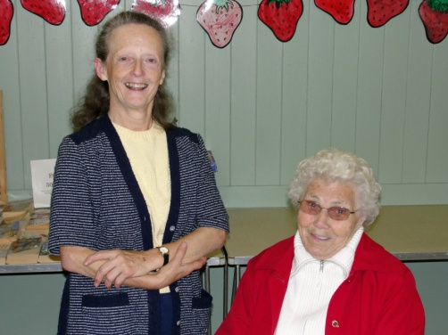



*Copyright Gospel Communications International, Inc –* [*www.reverendfun.com*](http://www.reverendfun.com)

**COUNT YOUR JOYS** submitted by Ann Fox

Instead of your woes; count your friends.

Instead of your foes; count your courage.

Instead of your fears; count your laughs.

Instead of your tears; count your health.

Instead of your wealth; count on God...

Instead of yourself.

**Clayton West Summer Holiday Club 9 – 12 August**

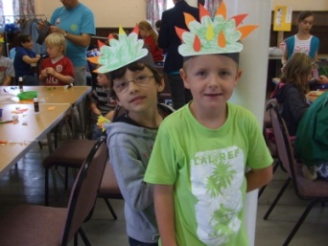 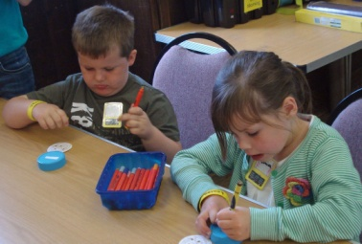

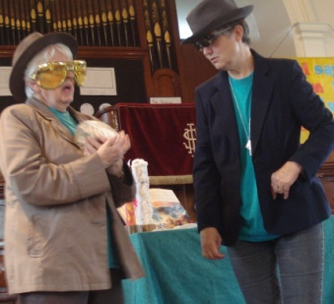 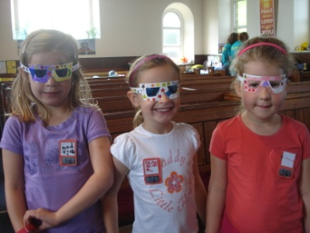

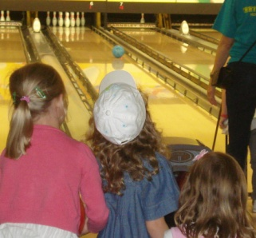 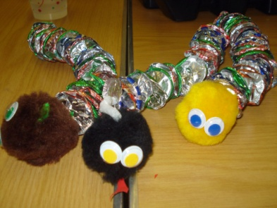

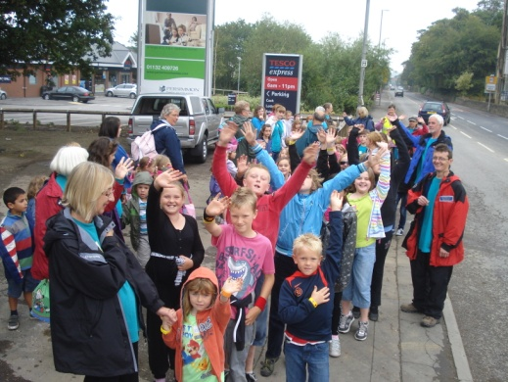 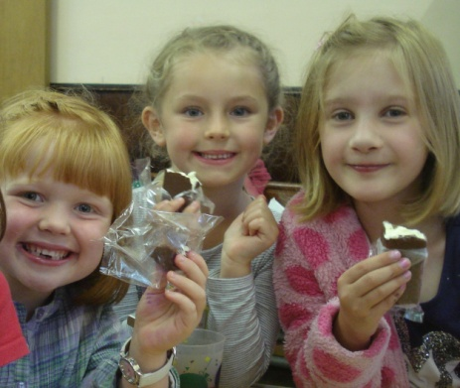

***126 people were at Holiday Club for some or all of the week ...81 children, 10 teenage helpers and 35 adults. On most days there were about 68 children, so what did we do?***

The children enjoyed activities linked to the theme of Secret Agents alongside hearing Bible Stories about events in the life of Moses, how he was rescued and how God used him to rescue the Israelites from slavery in Egypt.

Each day we met Agent X and Agent Y who brought clues about the Bible story. We did secret writing, made disguises and gadget watches and kept fit with our Agents workout. Our first story about Moses was when he was rescued from the river, this is when we used the lids from the coffee jars we asked you to save. A picture to colour was glued onto the card, holes were punched, then placed back into the lid with some small balls, covered with cling film and then you had to try and get the balls into the holes!

On day 2 our story was God speaking to Moses from the burning bush. God promised Moses he would look after him and the Israelites.

On day 3 we heard how God sent plagues to Egypt as he was unhappy with Pharaoh and wanted him to let the Israelites go. We used the 1,400 foil milk bottle tops you had saved for us !

Day 4 was the story of God helping Moses and the Israelites escape from Egypt through the Red Sea.

Each day there was a trip, these were a Mini Beast Safari in Cliffe Woods with Denby Dale Parish Countryside Officer, dance and games with Energise, Bowling at Barnsley Bowl and a party and talent show. Choc ices on the Friday afternoon and the Sunday morning service rounded off a very happy week.

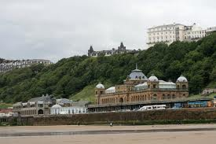**Yorkshire Assembly** by Mary Reynard

On Wednesday 1st June I attended the Yorkshire Assembly held at the Spa, Scarborough, a very attractive and comfortable venue. The meeting was very ably chaired by the convenor, Mrs. Pauline Mewis. After a very warm welcome Revd. Jason McCullagh of St. Andrew’s URC, Scarborough, led morning devotions. Revd. Kevin Watson, Moderator of Yorkshire Synod, was our first speaker and, as usual, he talked, joked and preached about his subject – the use of words – pointing out how many meanings have changed and can be misinterpreted. We have to be careful how we communicate with others as language has changed so much in recent times, e.g. computer jokes – “Jesus saves”, Chips are not fries. Listening, caring and showing love is the heart of Jesus and should be ours. We need to show joy which can be interpreted as J = Jesus first: O = others second: Y = yourself last. He closed with a riddle, “What preceded God? Is greater than God? More evil than the devil? All the poorest people have it. All wealthy people need it. If you eat it you will die! ANSWER – NOTHING. We had some wonderful hymns and because men are now encouraged to attend the singing was great.

In the afternoon Councillor John Blackburn, Mayor of Scarborough, and his wife gave a civic welcome but I must confess that two friends and I missed it as we decided in the lunch hour to have a ride on an open-top bus which went along the prom at a very leisurely pace. We just managed to creep back into the Spa before the guest speaker began. Dr. Paul Whittaker OBE, who is the artistic director and founder of the charity Music and the Deaf, was our afternoon speaker. Some of you who have heard Paul speak will realise what a super afternoon we had. He started by playing a CD, *Love Changes Everything* and signing (not singing) the words, a very moving experience for us all. He told us how, from the age of five, he had wanted to play the piano. Being deaf from birth it was not easy to find a teacher to take him on but eventually his mother succeeded. When he was twelve he was playing the organ in Wakefield Cathedral, an amazing achievement for any boy. Recently he has been made a Lay Cannon there. He persevered in his chosen career, gaining a music degree at Oxford University, a post-graduate diploma from the Royal Northern College of Music and an honorary Doctorate of Letters from Huddersfield University. In 2007 he received an OBE for services to music, very well deserved. Paul wanted to pass on his love of music to other deaf children in schools but was told there was no music tuition available, so he formed his charity. Along with a group of dedicated people, Paul has taught deaf children the joy of music and encouraged them to play in an orchestra together. His dream is to eventually form a National Deaf Orchestra and we hope and pray he will succeed. ‘Sing Up’ is another very successful section of the charity and deaf children are discovering they have a voice and can join in choral singing. Obviously they can not hear the music so have to be taught by visual and physical means. He demonstrated this by doing a clapping sequence asking us to repeat it. We were split into two groups, clapping different rhythms. If he gave only three claps we were not to respond. Quite a few of us got caught out and we could hear! Paul ‘hears’ his music by reading the manuscripts and he had a lady signer there with him for when others spoke to him. He finished his talk by signing another of his favourite songs, “We can be Kind” a beautiful song sung by Nancy LaMott (pictured right). Paul’s talk was hilarious and inspiring and this last song brought us back to what we had heard from Kevin Watson that morning.

We closed the Assembly by singing, “Christ for the World we Sing” We came away feeling challenged and uplifted. The meeting is for everyone so look out for the date next summer. I can promise you an enjoyable time.

Thank you to everyone who has contributed to this magazine. Items for the Winter 2011 LINK need to be with me by Sunday 6th November, please. Thanks, Nick.

**REGULAR ACTIVITIES IN OUR CHURCHES**

|  |
| --- |
|  |
|  |

**Clayton West**

Sunday Worship every week at 3.00 pm. Communion is included in the service on the 1st first Sunday of each month

Saturday Coffee Morning on the 4th Saturday each month 10.00am

**Trinity (Barnsley)**

Sunday Worship every week at 10.30 am. Communion is included in the service on the 3rd third Sunday of each month

Tuesday Bible Study at 7.30 pm

Wednesday Age-Well (*over 50s club*) every week 10.30am-1.00pm

Trinity Players every week at 7.30pm

Thursday Trinity Tots (*carers & toddlers*) 10.00am – 12.00noon

**West Melton**

Sunday Worship on the 1st (*inc. WHIZZ KIDS*) and 4th Sundays at 10.30am and on the 2nd & 3rd Sundays at 3.00pm. Communion is included in the service on the 3rd Sunday of each month

Wednesday Little Stars 9.30am every week *(in term time)*

Praying Hands (*prayer group*) 7.30pm – 8.30pm on the 2nd Wednesday of each month

Fellowship evening (*varied programme*) 7.30pm on the 4th Wednesday of each month

Saturday Men’s Breakfast at 8.00am on the 3rd Saturday each month

**Group Minister: Group Treasurer:**

Rev. Nick Percival BA Mr. John Paskell

19 Longdale Croft 1 Giles Avenue

Barnsley, S71 2QT Wath on Dearne

Tel: 01226 771277 Rotherham, S63 6SG

Mobile: 07986668032 Tel: 01709 879224

Email: [revnickp@yahoo.co.uk](mailto:revnickp@yahoo.co.uk) Email: [john@paskellplumbing.co.uk](mailto:john@paskellplumbing.co.uk)

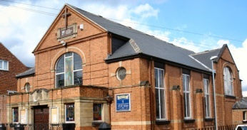 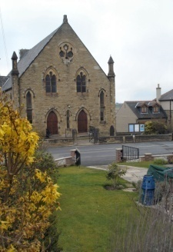 

Trinity Clayton West West Melton,

Farrar Street Church Lane Melton High Street

Barnsley Clayton West Wath on Dearne

S70 6BS Huddersfield HD8 9LY Rotherham S63 6RG

**Church Secretaries:**

TRINITY: Mrs. Fiona Weighton-Smith, 18 Normans Way, Sandal, Wakefield, WF2 6SS Tel: 01924 253010

Email: [isabelsmith655@talktalk.net](mailto:isabelsmith655@talktalk.net)

CLAYTON WEST: Mrs. Betty James, Winter Hill Farm, Bank End

Lane, High Hoyland, Barnsley, S75 4BB

Tel: 01226 382820

WEST MELTON: Mr. John Paskell. *(As above)*

**www.urcbarnsleygroup.co.uk**