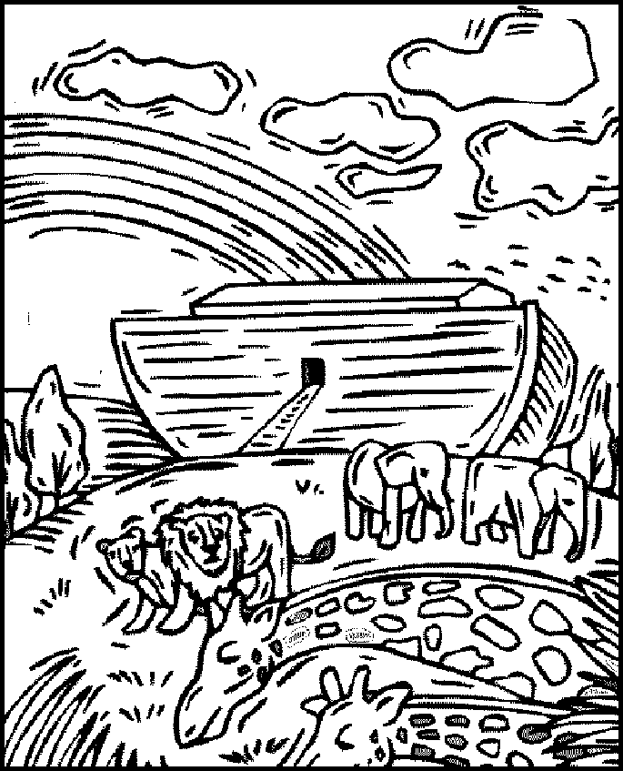
Genesis 8:17

Noah’s Animals – A wordsearch puzzle for you. 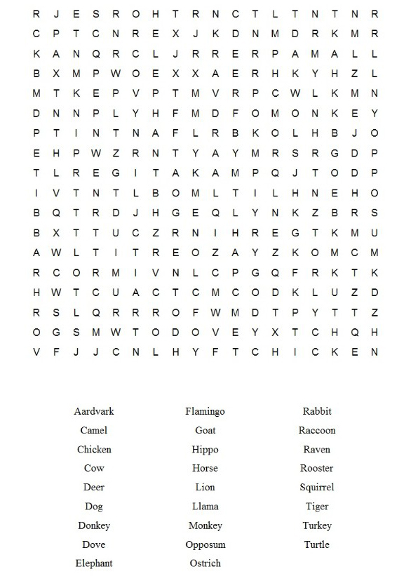
Emley Show – 4th August – Visited By Rev. Nick Percival
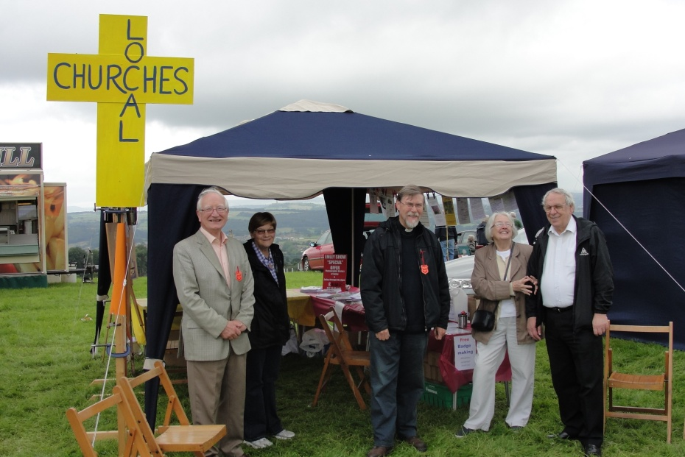
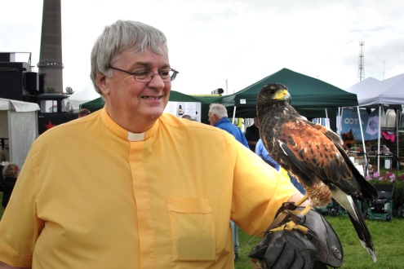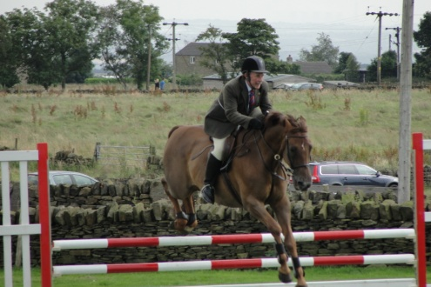
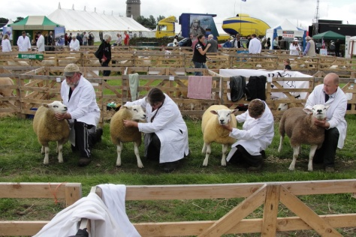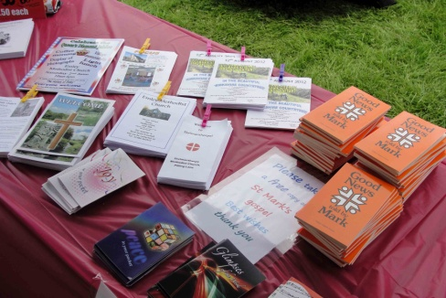
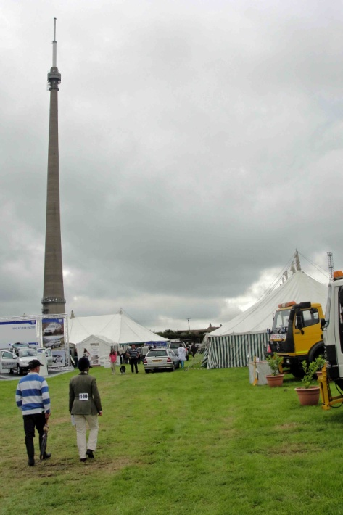
This was my first visit to the Emley Show. It was a really good experience. Local churches from in and around Clayton West get together to provide a stand at the show. Information about the churches is available to visitors, as well as free copies of Mark’s Gospel. There was also badge making equipment and children, young and old, were invited to make a badge. The stand is a really useful witness by the local churches.
As a ‘townie’ I had never experienced a country show before and was pleasantly surprised as to what was on offer. The photograph of me shows me holding a Harris Hawk which was part of the stand for the Wise Owl Bird of Prey Display. Wayne and Katrina Auty take their birds on school visits and birthday parties amongst other events. (More details can be found on their website www.birdofpreydisplay.co.uk)
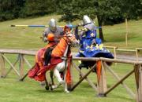
This year’s attractions included: Punch and Judy, Ferret Racing, Vintage Tractors, Mini Zoo, Children’s and teens funfair rides, Skelmanthorpe United Junior Football Club, Emley Brass Band, Horses, cattle, goats, poultry, rabbits, dogs, cage birds, dry stone walling, craft marquee and food hall and Knights of the Damned Jousting show. Next year the show is on Saturday 3rd August. Why not pay it a visit. You will have a great day out. For more information visit: www.emleyshow.com
Thank you to everyone who has contributed to this magazine. Items for the Winter 2012 LINK need to be with me by Sunday 11th November, please. Thanks, Nick.
PRAYING HANDS at West Melton
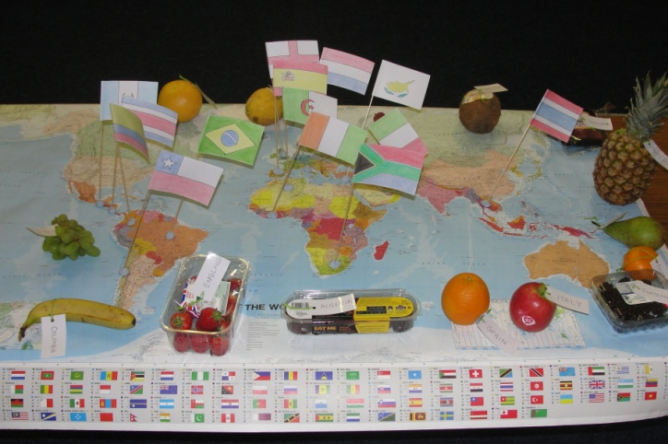
Praying Hands is a prayer group which meets at the church on the second Tuesday of each month. It starts at 7.30pm and lasts for about half an hour after which a further time of fellowship is enjoyed over a cup of tea or coffee.
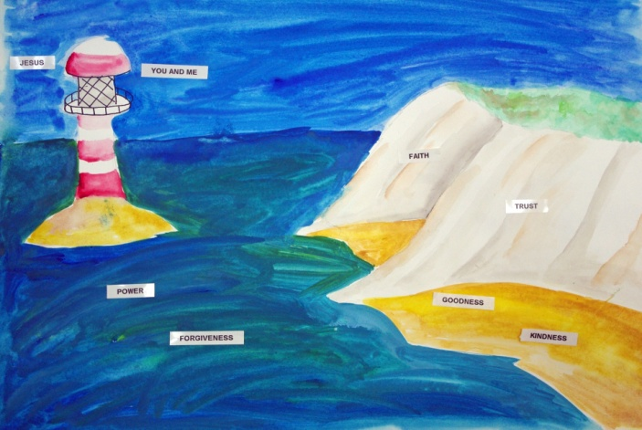
Each month the prayer session is led by a different person. This ensures a variety of styles. Our photos show two of our recent ‘themes’. In one we looked at different fruits and where they came from in the world. We prayed for the countries in which the fruit was grown. Another the theme was the seaside when various aspects of God’s love were explored.
Some weeks we use candles and some quiet relaxing meditative music. We have also had soft toys as a way of leading us into prayer. variety, as it is said, is the spice of life. At every Praying Hands meeting there is time for us to pray for any concerns we have or any people whom God has placed on our hearts at that time. It is a very friendly and non-threatening group and I would encourage those who have never been to come along one evening. I promise you don’t have to say anything, you are more than welcome to pray in anyway you feel is appropriate and comfortable for you.
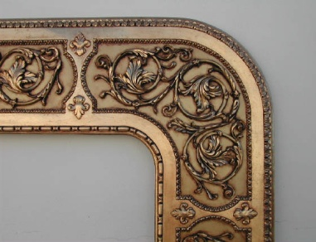
Antique Corner
Back again, after great demand.
Love John and Tinker Les and their beloveds have not visited many antique fairs, as nowadays there are not as many, but they are always on the look out for bargains and visit local antique centres. Love John’s missus decided she wanted a small square pine old country kitchen table for their back conservatory, so the search was on. Tinker Les in his eye ‘oles trying to spend Love John’s brass, going to the extreme of suggesting buying a purpose made new table at an arm and leg price.
An Antique Corner!
However, Love John found a suitable table at a local antique centre, lovely solid table with better legs then Love John’s, but the price tag stated NT which we all know means no trade or simply no discount for cash, but the purchase was made as the price was ok for Love John. So now Love John and better half sit in back conservatory supping coffee, watching the garden birds (odd pigeon).
Happy hunting.
Baked raspberry cheesecake
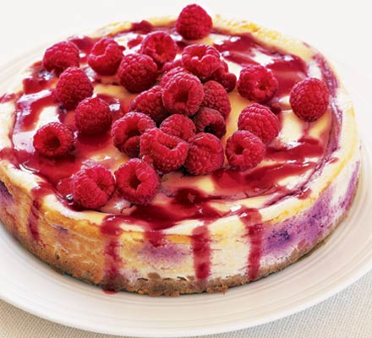
Ingredients:
8 digestive biscuits,
50g butter (melted),
600g cream cheese,
2tbsp plain flour,
175g caster sugar,
vanilla extract,
2 eggs, plus 1 yolk,
142ml pot soured cream,
300g raspberries,
icing sugar.

Method

Heat the oven to 180C/fan 160C/gas 4. Crush 8 digestive biscuits in a food processor (or put in a plastic bag and bash with a rolling pin). Mix with 50g melted butter. Press into a 20cm springform tin and bake for 5 minutes, then cool.

Beat 600g cream cheese with 2 tbsp flour, 175g caster sugar,a few drops of vanilla extract, 2 eggs, 1 yolk and a 142ml pot of soured cream until light and fluffy. Stir in 150g raspberries and pour into the tin. Bake for 40 minutes and then check, it should be set but slightly wobbly in the centre. Leave in the tin to cool.

Using the remaining 150g raspberries, keep a few for the top and put the rest in a pan with 1 tbsp icing sugar. Heat until juicy and then squash with a fork. Push through a sieve. Serve the cheescake with the raspberry sauce and raspberries.
A disturbing news report
Cancer and HIV patients have been told to buy bottles of ordinary blackcurrent squash and olive oil for £14 by a church claiming the blessed goods are a 'miracle cure' for their illnesses.
The Victorious Pentecostal Assembly (VPA) sells the over-inflated goods with the claim that once blessed by a pastor they can cure a host of serious health conditions.
Undercover reporters found members of the VPA congregation in Manchester were told that if a terminally-ill person drank a mixture of the specially blessed litre of squash and 500ml bottle of olive oil, which were being sold at double their real value, their ailments would disappear.
A church leader who identified himself as Pastor Mbenga also claimed to have previously cured diabetes and a brain tumour using the concoction.
He said the mixture would 'do what no man can do' through divine intervention and guaranteed the cancer would be cured.
'God will take over with divine intervention and the cancer will disappear,' Pastor Mbenga told the reporters from Manchester Evening News.
The church’s founder, Pastor Alex Omokudu, who lives in a £1.8million mansion in Hornchurch, Essex, has also regularly appeared in television adverts claiming, 'doctors do not have the answer - we have got the answer. We have got the answer to healing'.
The products sell in several supermarkets for less than £6.
Now a cancer charity has warned the practice is deliberately targeting the vulnerable and could stop patients from seeking proper medical treatment.
Read more: http://www.dailymail.co.uk/news/article-2185953/Church-slammed-selling-blackcurrant-cordial-olive-oil-drink-miracle-cure-cancer-HIV.html#ixzz23bpA8bfu (Read more, Daily Mail, 9/8)
REGULAR ACTIVITIES IN OUR CHURCHES
Clayton West
Sunday Worship every week at 3.00 pm. Communion is included in the service on the 1st first Sunday of each month
Friday Baby and Toddler Group 1.15pm – 3.15pm (in term time)
Saturday Coffee Morning on the 4th Saturday each month 10.00am

Trinity (Barnsley)

Sunday Worship every week at 10.30 am. Communion is included in the service on the 3rd third Sunday of each month
Tuesday Bible Study at 7.30 pm
Wednesday Age-Well (over 50s club) every week 10.30am-1.00pm
Trinity Players every week at 7.30pm
Thursday Trinity Tots (carers & toddlers) 10.00am – 12.00noon

West Melton

Sunday Worship on the 1st (inc. WHIZZ KIDS) and 4th Sundays at 10.30am and on the 2nd & 3rd Sundays at 3.00pm. Communion is included in the service on the 3rd Sunday of each month
Wednesday Little Stars 9.30am every week (in term time)
Praying Hands (prayer group) 7.30pm – 8.30pm on the 2nd Wednesday of each month
Fellowship evening (varied programme) 7.30pm on the 4th Wednesday of each month
Saturday Men’s Breakfast at 8.00am on the 3rd Saturday each month

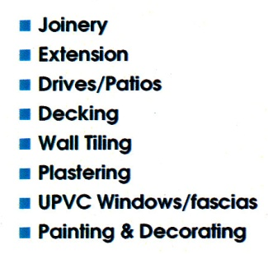

___________________________
___________________________

Group Minister: Group Treasurer:
Rev. Nick Percival BA Mr. John Paskell
19 Longdale Croft 1 Giles Avenue
Barnsley, S71 2QT Wath on Dearne
Tel: 01226 771277 Rotherham, S63 6SG
Mobile: 07986668032 Tel: 01709 879224
Email: revnickp@yahoo.co.uk Email: john@paskellplumbing.co.uk

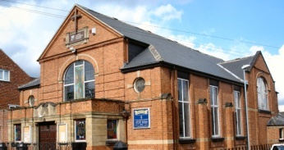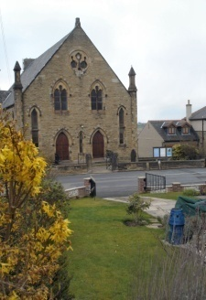
Trinity Clayton West West Melton,
Farrar Street Church Lane Melton High Street
Barnsley Clayton West Wath on Dearne
S70 6BS Huddersfield HD8 9LY Rotherham S63 6RG

Church Secretaries:

TRINITY: Mrs. Fiona Weighton-Smith, 18 Normans Way, Sandal, Wakefield, WF2 6SS Tel: 01924 253010
Email: isabelsmith655@talktalk.net

CLAYTON WEST: Mrs. Betty James, Winter Hill Farm, Bank End
Lane, High Hoyland, Barnsley, S75 4BB
Tel: 01226 382820

WEST MELTON: Mr. John Paskell. (As above)

www.urcbarnsleygroup.co.uk

