LINK

The magazine of the Barnsley Group Pastorate



**AUTUMN 2010**  

Plumbing and

heating engineers

Tel: 017090873518

[info@paskellplumbing.co.uk](mailto:info@paskellplumbing.co.uk)



**Druids Sheffield**

**Friendly Society**

Plans for Healthcare – Tax Exempt Savings

Sickness and Death Benefits

Endowments – Insurance I.S.A.

Leaflets on all plans available from:-

Dove House, Brampton Road,

Wath-Upon-Dearne, S63 6BE

Tel: 01709 876409

Fax: 01709 878045

Email: deuidssheffield.friendly@virgin.net

www.druidsfriendly.co.uk

Established 1858. Authorised in the United Kingdom under the Friendly Societies Act 1992. Reg. No. 795f

Druids Sheffield Friendly Society is regulated by the

13307

_________________________

**Simon T. Anderson**

Funeral Director

23 Dodworth Road, Barnsley.

**(01226) 733119**

*24 HOUR SERVICE*

AN INDEPENDENT FUNERAL SERVICE

*Professional and friendly advice on all aspects of the funeral service*

Financial Services Authority

___________________________________________________



Andrew P. Lockwood

**MinstChP. CCM(Sheffield)**

**CHIROPODIST**

**All Foot Ailments Treated**

CORNS – CALLOUSES (Hard Skin) – VERRUCAE – ATHLETE’S FOOT etc.

**Home Visits – Prompt Attention**

**Tel: 01484 687632**

**Mobile: 07971355078**

Dear friends

First the answer to the riddle in the Summer LINK.

# *Where will you find roads without cars, forests without trees and cities without houses?*

# On a map!

✞

# Something to think about.

“Don’t be ridiculous!” Saul replied. “There’s no way you can fight this Philistine and possibly win! You’re only a boy, and he’s been a man of war since his youth.” [*1 Samuel 17:33*](http://biblegateway.com/bible?version=51&passage=1+Samuel+17%3A33)

The context of this account should be fairly familiar to us: the Israelites and the Philistines are at war and the Philistines’ champion (Goliath) has been challenging the Israelite army to fight him.  David hears these challenges, is furious that “the armies of the living God” are being defied and offers to fight Goliath. Verse 33 is Saul’s reply to David.

It is interesting to note the two different attitudes to youth: Saul obviously thinks that David’s youth will make victory impossible while David does not seem to think this has any relevance what-so-ever!

I think this passage is both a warning and a challenge; a warning that we must not limit God by supposing certain things will stand in the way of His plans (in this case, youth) and a challenge to be so certain of God’s sovereignty that we consider there to be no limiting factors (even when the odds seem very much against us).

David is a wonderful example of youth in terms of age but maturity in terms of spiritual attitude!  He is angry that Israel is being defied, and by implication God (something that none of the other Israelites seem to have considered), and so sure of God’s power and protection (verse 37) that he offers to fight Goliath.

Are we unashamedly bold for God in the same way?  Do we consider nothing to be impossible for Him and consequently step forward in confidence despite situations that look impossible?

✞

**THE RIDDLE**

What does this represent?  
To possess ocular receptors in the posterior portion  
of a cephalic protuberance. (*answer in the Winter LINK*)

# May God continue to bless you.

# Your friend and minister,

 *Cover photo: Sunset on Lindisfarne*

Thanks to all the contributors to this edition of LINK.

Contributions are always welcome and for the Winter 2010 edition of this magazine need to be with Rev. Nick by

Sunday 14th November, please.



by Margery Forsyth

Keith and I enjoyed a wonderful holiday in May this year when we spent a few days at Lake Garda followed by a visit to the famous Oberammergau Passion Play. It has been performed every ten years since the 17th Century as a thank you to God for sparing the village from the ‘Black Death’. There are performances on five days each week and there are102 performances between May and October. 2010 is the 41st production. The presentation includes a cast of over 2000 actors, musicians and stage technicians who have to be either natives or long term residents of Oberammergau. The actors are all amateurs. This year, one of the Mary Magdalenes works as a flight attendant and one Jesus is a psychologist. There are two actors for each of the main characters but the Chorus and townspeople, including children, are involved in every performance. We felt sorry for the performers who had to stand in blazing sunshine in heavy robes, though they have to do the same when it rains! There were also animals. A donkey, of course, and sheep and goats, pigeons expelled from the Temple, camels and horses. These were also well rehearsed as they all behaved themselves!

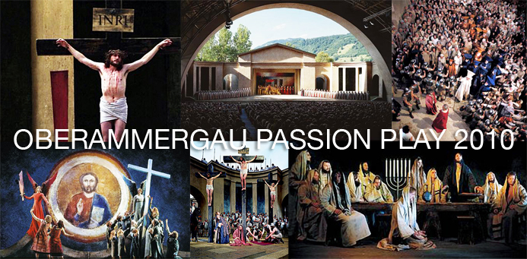

The townspeople spend two years in preparation for the event. Not only do they design and make costumes and scenery they also have to obey a local government ‘Hair Decree’ which requires the men to grow their hair and stop shaving from Ash Wednesday the year before the Play (2009).

The theatre holds almost 5000 of an audience. It was refurbished for the 2000 performances with new seats and under floor heating, though we didn’t need this as we experienced very hot weather when we were there. The stage is in the open air and the Bavarian Alps can be seen in the background.

The organisation must also take years of preparation. We had booked with our tour company in 2008. Everyone can only stay for two nights in Oberammergau or neighbouring villages and towns. All our arrangements were under the organisation of the Oberammergau authorities.

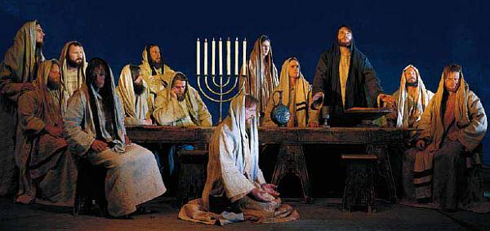

We had an A4 sheet of vouchers including ones for our hotel which we exchanged for our dinner that night and our accommodation for two nights. The hotel gave us our tickets for the Play and a Textbook to allow us to follow the German libretto and text. We also had vouchers for lunch and dinner in a hotel in Oberammergau.

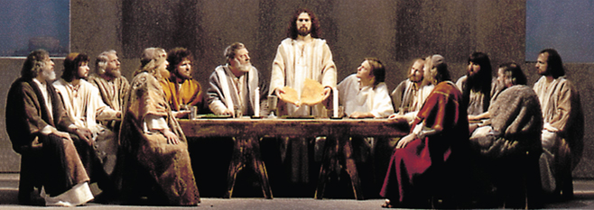

We stayed in Murnau, about 20 minutes away. On the day of the play, mid morning, we set off for the short ride into Oberammergau. The first stop was the hotel for lunch then a wander through the town to the Passionstheater for the afternoon performance. This began at 2.30pm and lasted till 5.00pm. It was easy to follow the text and yet see all the action. There is a mixture of ‘Living Images’ or tableau from the Old Testament and the story of Christ’s last week in Jerusalem. Each act begins with a spoken Prologue followed by narration by a Chorus and four soloists before the scene is acted out. Dinner in the same hotel then back for the evening session which began at 8.00pm. We could only follow our books till darkness fell but as we knew the story so well that didn’t matter. It was still warm (18º C) when the Play ended at 11.00pm.

It is difficult to list all our impressions of the Play but the Lord’s Supper and the Crucifixion were probably the highlights. Watching the Disciples prepare the Table and the Lord’s Prayer constructed line by line by them were very moving and will give a new significance to Communion for us. From the scene in which Judas hanged himself, and it really looked as though he did, to Jesus being nailed to the Cross and finally a lightning storm (due to the hot weather) at the appropriate moment made The Crucifixion surreal. Few audiences will experience this, I am sure.

We bought a book of pictures from this year’s production which is a wonderful reminder of the Play but it can never portray the emotion and awe of being there in person.

✞ ✞ ✞

**CHRISTMAS FRUIT CAKE**

Christmas will soon be here. So now is the time to start thinking about baking your Christmas cake. Here is the perfect recipe.

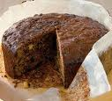

Ingredients

1 cup of water; 2 cups of dried fruit; 1 cup of brown sugar; 1 cup of caster sugar; 1 tsp of salt; 8oz of mixed nuts; 4 large eggs; 1tsp of Baking Soda; Juice of 1 lemon; 1 bottle of malt whisky.

Method

Sample the whisky to check for quality.

Take a large bowl. Check the whisky again. To be sure it si of the highest quality, pour one level cup and drink. Repeat.

Turn on the electric moxer, beat one cup of butter in a large fluffy bowl. Add one tsp of sugar and beat again.

Make sure the whisky is still OK. Cry another tup.

Turn of the mixerer. Break two eggs and add to the bowl and chuck in the dried fruit. Mix on the turner.

If the dried fruit gets stuck in the beaterers, pry it loose with a drewscriver. Sample the whisky for tonsisticity.

Next two cups of salt, or something. Who cares!

Check thwe whisky.

Now sift the lemon juice and strain your nuts.

Add one table.

Spoon – of sugar or something – whatever you can find. Grease the oven. Turn the cake tin to 350 degrees.

Don’t forget to beat off the turner. Throw the bowl out of the window.

Check the whisky again and go to bed.

ZZZZZZZZZZZZZZzzzzzzzzzzzzzzzzhic!

**Chocolate – by Mary Reynard**

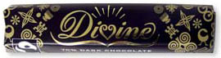

Chocolate comes in various types

Like white and dark, or milk,

But the one which suits my taste buds best

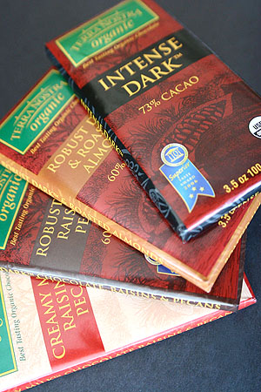Is dark, and smooth as silk.

It is supposed to make you fit;

An aphrodisiac - they say.

Should give you lots of energy

To help you work and play.

A pleasure to enjoy each day

When searching for this vigour,

But then, if eaten to excess

Could spoil my sylph-like figure!

**DAYS GONE BY AGAIN by Joyce Jones**

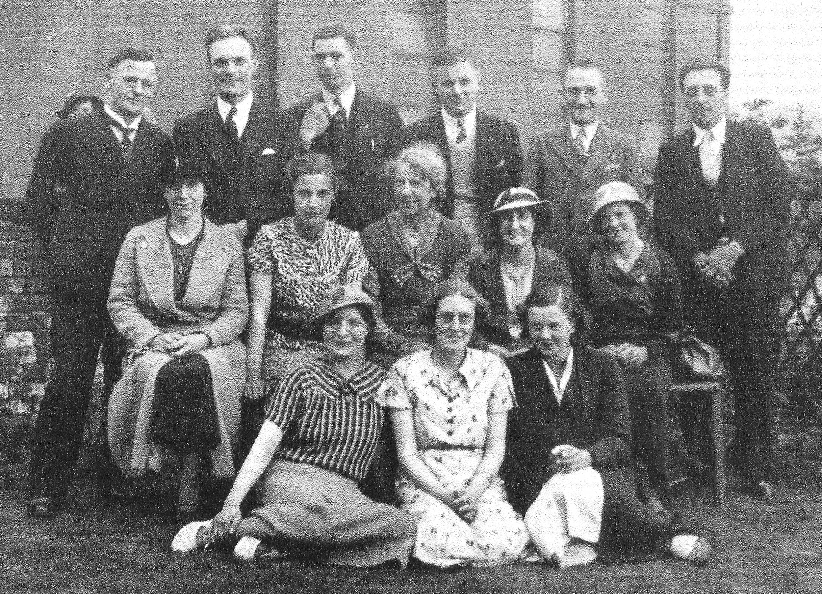

This photo shows the young people of the church in probably the 1930's Front row L to R. Miss Elsie Lightly, Miss Dorothy Paskell, Mrs Edna Stanger [don't know her single name]. [Mrs Elsie Frost,] [Mrs Dorothy Lindley] was also organist at West Melton.  
Middle Row L to R 2nd Miss Lilian Barlow, 4th Miss Ellis,Miss May Duke, the other two ladies I don't know. Miss Duke was cousin to Elsie and never married. Back row L to R, I think this is Mr Eric Stanger, Married to Edna , he was organist here at West Melton. 3rd is Mr Bernard Frost 5th and 6th are Mr Arthur Fearns , and Mr William Jones [Billy]

Miss Lightly married Mr Bernard Frost in 1944 and he became Minister at Kimberworth Rd Congregational Church in the late 1950's. Rev Frost was my uncle. Mr Fearns was a Superintendant in the Sunday school when I was about 9 or 10 and in church up to his death. I am sure that Mrs Ellis can tell us more about the people and the time. Our church has been a meeting place for young people who have gone on to marry their church friends. George and Pauline Kay and myself and Bryan, it has seen marriages between girls and boys who came to Sunday school and left due to work, but came back to be married in our church. Margaret and Brian Marchant to name one couple who did.

## Word Search Puzzle

**(Luke 10:30-35)**

##### *from www.geocities.com/lectionarypuzzles Words are in a straight line in all directions*

### T O O K W E W J T H G U O R B Y S P H F J U I K H E I A S G N I V A H I A I E D T U I R N L W R W W I L L T T E S E H L L U T F E O E D T D A Y N C U G U I E S O E N A W B E A P W E N S A L K C A W L T D H N B A K H X A T D A E O L O L I Y A W S O N E T H H N M W M E U N O R T S G I R N A C E A I I E M N U I I E Y N L S S E S N B N S H K D I S D V A I J V I B P W U A E E H S Z A B E P L E D D M E H T M E A F R O M A R E E R R E O N O O P U T R P L A C E R V I E F R D V E T S E I R P R K E M A C P W E E R N W O D E P P I R T S R H L I D A G N I V A E L T T R E H T O I N C D E R U O P Y A W A S D N A H E E G A V E T I V E L O N G N I O G D Y

Jesus replied, "A man was going down from Jerusalem to Jericho, and fell into the hands of robbers, who stripped him, beat him, and went away, leaving him half dead. Now by chance a priest was going down that road; and when he saw him, he passed by on the other side. So likewise a Levite, when he came to the place and saw him, passed by on the other side. But a Samaritan while traveling came near him; and when he saw him, he was moved with pity. He went to him and bandaged his wounds, having poured oil and wine on them. Then he put him on his own animal, brought him to an inn, and took care of him. The next day he took out two denarii, gave them to the innkeeper, and said, 'Take care of him; and when I come back, I will repay you whatever more you spend.' (NRSV)  
  
**Word List**  
  
TRAVELING SAMARITAN JERUSALEM INNKEEPER WHATEVER STRIPPED LIKEWISE BANDAGED ROBBERS REPLIED LEAVING JERICHO DENARII BROUGHT WOUNDS PRIEST POURED PASSED LEVITE HAVING CHANCE ANIMAL WHILE SPEND REPAY PLACE OTHER MOVED JESUS HANDS GOING WITH WINE WILL WHEN WENT TOOK THEN THEM THAT TAKE SIDE SAID ROAD PITY NRSV NEXT NEAR MORE LUKE INTO HALF GAVE FROM FELL DOWN DEAD COME CARE CAME BEAT BACK AWAY YOU WHO TWO SAW PUT OUT OIL NOW MAN HIS HIM DAY BUT SO OF BY

✞

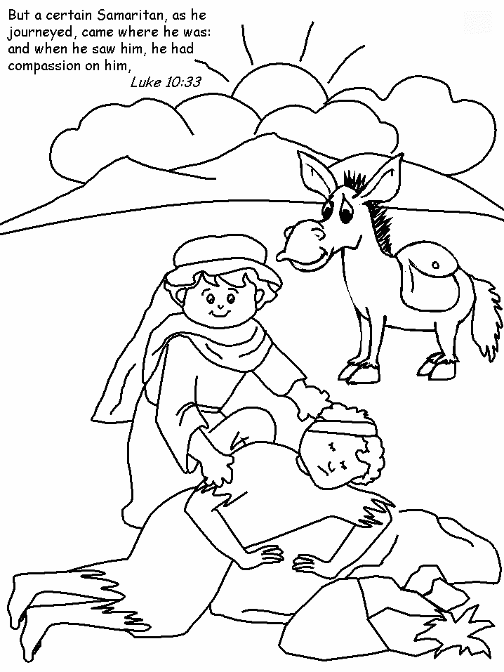



Pardon Me, Prime Minister" is a farce in its truest form with the action taking place in an office at Ten Downing Street.  
  
The Prime Minister and the Chancellor are preparing a severely puritanical Budget, taxing Gambling, Night Clubs and even Bingo Halls out of existence. On the eventful afternoon before its presentation however, shocks are in store for both of them.

**Yorkshire Synod of the United Reformed Church**

**Mission Enabling Group Update August 2010**

**Pat Evans is Calling ALL Fair Trade Churches Again**

**Dear Friends**,

After the last MEG meeting, Anne Parker sent out the MEG hotline and in it asked for confirmation that churches who were Fairtrade Churches be sent to me.

**I have only had 17 replies** and I know there are many more churches than that which are Trading Fairly!! Thank you to those who did reply. If you didn’t reply

**AND YOUR CHURCH IS A FAIR TRADE CHURCH PLEASE CAN YOU TAKE A MOMENT TO CONFIRM THIS TO ME ON** [pat.evans39@tiscali.co.uk](mailto:pat.evans39@tiscali.co.uk)

**so that I can do a proper tally.**

**VISION2020**

**Now that Vision2020 has been accepted by the General Assembly,** National Mission Committee is considering the next step to implement it, in 2011 and beyond. *They are looking for new ideas to support the development of Vision2020 at local, Synod and in particular at Assembly level?* This may be ideas for new projects, programmes and resources, and/or for particular priorities with reference to the 10 themes. If you have any thoughts please let me have your ideas **by Wednesday 5th September** at the very latest, so that they can be included in a paper for the Mission Committee meeting. *(My e-mail address is at foot of next column)*

**URC RETREATS GROUP**

*(****From Rev. Nick Percival)***

**WINDERMERE** **EVENTS 2011**

**1) "National"** **Retreat (perhaps for "first-timers") 21-24 April 2011** (Easter Weekend). This is to be jointly organised by the Windermere Centre and the Retreats Group.

**2) Consultation on Spiritual Direction. 23-26 May 2011**.Again this will be jointly organised by the centre and the retreats group.

More information will be available later.

**QUIET DAY**

**We are planning a "National" Quiet Day - for the whole of the URC on 2nd July 2011.**

I would like to organise something Synod wide or locally (e.g. Mission and Care Groups) if facilitators can be found.

**Please contact Nick**

**for more information. E-mail:** [**revnickp@yahoo.co.uk**](mailto:revnickp@yahoo.co.uk)

Following each Mission Enabling Group meeting - ‘We want YOU to know what we do!’ compiled by Anne Parker – [**yorksynodmeg@btinternet.com**](mailto:annebarry526@btinternet.com). PLEASE USE THIS EMAIL ADDRESS TO CONTACT US – WE ARE WAITING TO HEAR!

West Melton’s Green Tips Corner

**Number 2 – Olive Oil**

**Shining Solution for Stainless Steel** – Some of the chemical solutions used for shining stainless steel are effective but they may have abrasive formulations. They can definitely shine steel but in the long run, the metal becomes dull and even corroded. If you substitute olive oil (not extra virgin) for those chemical compounds, the stainless steel item will get the same sheen without the long term [side effects.](http://lifehackery.com/2008/08/20/home-6/" \t "undefined)

[http://konac.kontera.com/javascript/lib/imgs/grey_loader.gif](http://lifehackery.com/2008/08/20/home-6/" \t "undefined)

**The hymn and the praise chorus**

AN OLD farmer went to the city one weekend, and attend­ed a big city church. He came home and his wife asked him how it was.

"Well," said the farmer, it was good. They did some­thing a bit different, though. They sang praise choruses instead of hymns."

"Praise choruses?" said his wife. "What are those?"

"Oh, they're all right. They're sort of like hymns, only different," replied the farmer.

"Well... how are they different?" asked his wife.

"Well, it's like this," answered the farmer. "If I were to say to you: 'Martha, the cows are in the corn', that would be a hymn.

If, on the other hand, I was to say to you: 'Martha, Martha, Martha, Oh Martha, MARTHA, MARTHA, the cows, the big cows, the brown cows, the black cows, the white cows, the black and white cows, the COWS, COWS, COWS are in the corn, are in the corn, are in the corn, are in the corn' ... that would be a praise chorus."

**Evangelism — OUR way forward!**

*This article was written by Rev Peter Clarkson for his congregation at Wigton Moor, Leeds.*

***It is very relevant for us as well.***

As a local church we now have a strategy for evangelism. We can all influence and win others for Christ, and together we can see our church steadily grow in numbers. This is what OUR focus on evangelism is all about. We are developing a strategy that consists of 4 elements. Think of a fork with 4 prongs — 1) Friendship 2) Prayer 3) Conversation 4) Invitation.

**Friendship**

A large proportion of people who are Christians and who are committed to a local church are in that position because they have been strongly influenced and impressed by a Christian friend, or by the friendliness of a local church, or by both! Evangelism through friendship and friendliness must be our starting point and something we take extremely seriously. We should value friendship and nurture friendships with Christians and non Christians alike, and be ready to give of ourselves in order to build and keep friendships.

**Remember: Proverbs 17 v17**

**Prayer**

It is true that many people become Christians because of a Christian friend or through discovering a caring, welcoming, friendly church **but** nearly all these people will also have been **prayed for** by others over a period of time. Therefore, to be disciplined in prayer for those who we hope will become Christians is vital. We must pray for them, and if the opportunities arise, we must be ready and willing to pray **with them.** Praying for and with friends is a big challenge, but one we can meet if we trust our heavenly Father. Use prayers of blessing whenever possible.

**Remember: Numbers 6 v 24-26**

**Pray — "The Lord bless you and keep you; the Lord make his face shine upon you and be gracious to you; the Lord turn his face toward you and give you peace."**

**Conversation**

We all have many conversations each week with a whole variety of people including various friends. How many of these conversations could develop into opportunities to share the gospel? Is it not possible to bring "spiritual topics" into more of our chats with people? Are we alert to the doors of opportunity that God opens through ordinary every day conversations like the one Jesus had with the woman at the well? Most evangelism is done through conversation rather than traditional proclamation.

**Remember: Colossians 4 v 5-6.**

**Invitation**

Conversations can lead to invitations! Jesus' method of evangelism was often "invitational". He invited folk to "Come and see", "Come and drink", "Come and taste", "Come and receive", "Come and live" etc ... His disciples copied him and invited their neighbours and friends and new contacts to "Come and meet Jesus — the Messiah, the Saviour." In our conversations and through our prayers and prayerful listening to God,

we will be guided to invite others to come and experience Jesus in our worship and among our church community, to come and meet him whatever we are doing.

**Remember: John 1 v 41-42 and 45-46.**

This strategy will be more fruitful if **a significant number of people in our church really try to consistently implement it.** I have no doubt that our church could double in size if a sufficient number of people put into practice the above! May the Lord of the harvest be with us!

**Are YOU more serious than God?**

Do this revealing quiz and find out whether you are taking holiness just a mite too far ...

I A visiting minister begins his sermon with a joke. The punchline has a mild swear word in it. Do you…

a) leap into the air and call down a thunderbolt?

b) tut as loudly as you can?

c) smile sweetly and enjoy the joke?

d) snort with laughter and nudge the old lady next to you?

2 During communion, a toddler escapes from the crèche and runs in shouting for a potty.

Do you…

a) Grab the child by the collar and hiss: “ssshh, you'll offend God” into his ear?

b) Stop chewing until the child has been taken away.?

c) Get up and help the child to the toilet?

d) Stand up and shout “me, tool”?

3 You are praying aloud, when someone by a microphone burps by accident and everyone laughs. Do you...

a) Say: “Excuse me Lord while my errant sister repents of her sin” and wait?

b) Carry on praying but say “Amen” as quickly as possible?

c) Wait for the laughter to die down and continue?

d) Run to the microphone, say: “I've got something to share, too” and then do your best fake burp?

4 At a guest service, a woman in a very short skirt and skimpy top walks in and sits next to you. Do You...

a) Open your Bible at a highlighted verse about iniquity and share it with her?

b) Move away quickly and sit some­where else?

c) Introduce yourself and make sure she has a notice sheet and Bible?

d) Undress to your underwear so she doesn't feel so bad?

5 Your church is doing door-to-door" evangelism. At the first house, a man opens the door.

Do you ...

a) Wave your Bible in his face and shout: “Fire and Brimstone for you, my boy”?

b) Smile ingratiatingly and say: “Are you saved, brother, because if not…” and leave an ominous pause?

c) Ask him if he has a minute to talk to you about faith?

d) Peer into his living room and say: “Oh, you're watching Neighbours. Can I come in?”?

6 At your new house group, the choice of drinks is “red or white wine, or a hot drink if you prefer”. Do you ...

a) Pull out a whip and overturn the coffee table?

b) Say “cocoa, please” in clipped, disapproving tones?

c) Ask for tea because you prefer it to alcohol?

d) Drink directly from the bottle during prayers?

**How did you do?**

**All 'a' answers**

You are much more serious than God. In fact, God is wondering which version of the Bible you read. Take a long holiday and read some of the parables. Jesus had a wicked sense of humour and you could do with some of it. Now.

**All ‘b’ answers**

You are definitely more serious than God, but there is hope. If your best friend answered all "a's", find a new friend. You are mixing with the wrong people. Read some Adrian Plass and try and see who you identify with. Then ask for prayer.

**All ‘c’ answers**

Your reactions are similar to God's. You are probably up to date with your Bible reading notes and pray regularly, but you also know how to have fun and stay non-judgmental when people make mistakes.

**All ‘d’ answers**

You are nowhere near as serious as God. In fact, you are so non-serious, it's serious. Is your Bible extremely dusty? Do you prefer to watch dodgy late-night comedy to being at house-group? God has a sense of humour, but not quite to the extent of yours. Make an appointment to see your minister immediately.

✞

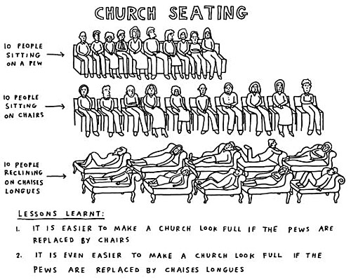

**Our website can now be accessed by using the original address. www.urcbarnsleygroup.org.uk**

**REGULAR ACTIVITIES IN OUR CHURCHES**

**Clayton West**

Sunday Worship every week at 3.00 pm. Communion is included in the service on the 1st first Sunday of each month

Saturday Coffee Morning on the 4th Saturday each month 10.00am

**Trinity (Barnsley)**

Sunday Worship every week at 10.30 am. Communion is included in the service on the 3rd third Sunday of each month

Tuesday Bible Study at 7.30 pm

Wednesday Age-Well (*over 50s club*) every week 10.30am-1.00pm

Trinity Players every week at 7.30pm

Thursday Trinity Tots (*carers & toddlers*) 10.00am – 12.00noon

**West Melton**

Sunday Worship on the 1st (*inc. WHIZZ KIDS*) and 4th Sundays at 10.30am and on the 2nd & 3rd Sundays at 3.00pm. Communion is included in the service on the 3rd Sunday of each month

Monday Sisterhood every week at 2.30pm

Wednesday Little Stars (carers & tots) 9.30am every week *(in term time)*

Praying Hands (*prayer group*) 7.30pm – 8.30pm on the 2nd Wednesday of each month

Fellowship evening (*varied programme*) 7.30pm on the 4th Wednesday of each month

Friday Children’s Fun Night 6.30pm – 8.00pm (1st & 3rd Fridays *in term time*)

Saturday Men’s Breakfast at 8.00am on the 3rd Saturday each month

**Group Minister: Group Treasurer:**

Rev. Nick Percival BA Mr. John Paskell

19 Longdale Croft 1 Giles Avenue

Barnsley, S71 2QT Wath on Dearne

Tel: 01226 771277 Rotherham, S63 6SG

Mobile: 07986668032 Tel: 01709 879224

Email: [revnickp@yahoo.co.uk](mailto:revnickp@yahoo.co.uk) Email: [john@paskellplumbing.co.uk](mailto:john@paskellplumbing.co.uk)

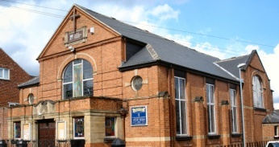 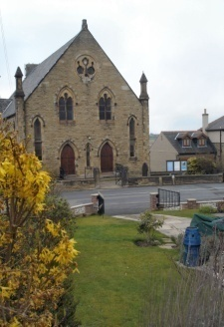 

Trinity Clayton West West Melton,

Farrar Street Church Lane Melton High Street

Barnsley Clayton West Wath on Dearne

S70 6BS Huddersfield HD8 9LY Rotherham S63 6RG

**Church Secretaries:**

TRINITY: Mrs. Fiona Weighton-Smith, 18 Normans Way, Sandal, Wakefield, WF2 6SS Tel: 01924 253010

Email: [isabelsmith655@talktalk.net](mailto:isabelsmith655@talktalk.net)

CLAYTON WEST: Mrs. Betty James, Winter Hill Farm, Bank End

& group secretary. Lane, High Hoyland, Barnsley, S75 4BB

Tel: 01226 382820

WEST MELTON: Mr. John Paskell. *(As above)*

**www.urcbarnsleygroup.org.uk**