My Early Life! by Margaret Swallow

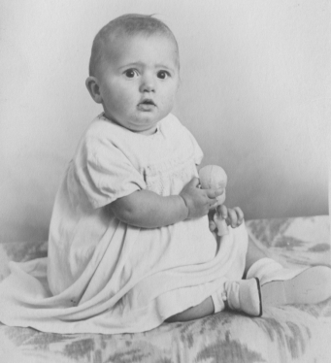
On the 21st January 1939, Europe was on the brink of war and descending into chaos.!! To add to this chaos a baby girl was born to Fred and Edith Swallow of 188 Melton High Street West Melton, right next door to The Congregational Chapel, and christened Margaret Rose! The house where we lived was tiny! No hot water, an outside loo and no electricity, that was linked up from the Church in 1955! My sister Irene was born in November 1944.We were as different as chalk and cheese! Constantly falling out and giving my mother grief!! Our hands have met but not our hearts, she used to say!

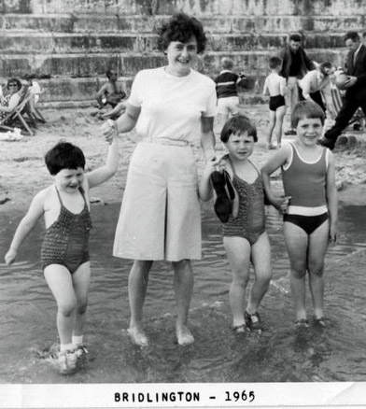
My father was a miner. He had a brilliant brain, teaching himself mathematics and was a talented artist. He made little of his life however, often the worse for drink and he smoked heavily but was a gentle sole and I loved him dearly. He passed on his love of history and literature to me, but I never inherited his artistic talent. He died in 1970 of liver cancer at the age of 62.
My mother was the strong one, working hard to try to make ends meet with little money, taking in washing and cleaning and preparing meals from nothing during the war. She came from a family with strong religious principles. She was feisty and never afraid to speak her mind! She would tackle anyone who threatened her family. She had a beautiful singing voice and loved her hymn singing, and it was from her I inherited my love of music, which is still a very important part of my life!
Church too was an important part of our lives. Mother would lift us over the wall to send us off to Sunday School, which was always full. The church was our social life and many met their future partners there.

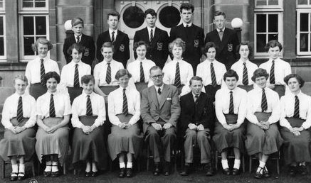
At the age of 13, I passed a transfer examination to Wath Grammar School--an excellent school and my Dad was immensely proud of me. I loved school--could not get enough of it! I went to Matlock Teacher training College, but failed my training. I was devastated I felt I had let my father and myself down. My confidence took a big knock and stayed with me for years!

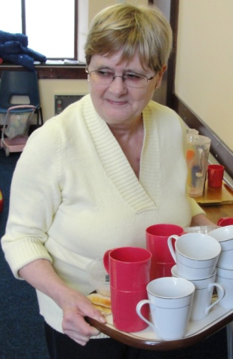
After this I went to work in children’s homes in Leeds and Cheshire. I lost touch with church life during this period because we lived and worked on the job with only ½ day off per week whilst all of my peer group were growing up and getting married. They were very happy times though and I loved working with the children.
From 1977 I worked until my retirement in 1999 at Mexborough Social Services. I loved my job and this was a very happy period for me.
Sadly I never met any one who I wanted to share my life with, but have always been content with my own company. My faith is an important part of my life and it saddens me to see the falling numbers in spite of the hard work we all put in .
So not a lot to tell about my life story--but I am happy doing what I do. I have had a happy working life and made some very good friends along the way. I am completely disorganised and scatterbrained, but then everyone knows that!
WORDSEARCH - The Resurrection of Jesus
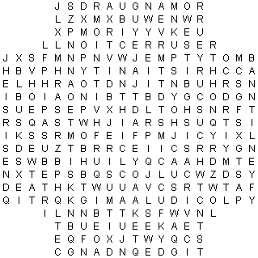
Burial  Christianity  Cross  Crucifixion  Death | Earthquake  EmptyTomb  Eyewitnesses  Gospels  HeisRisen | HistoricalFact  JesusChrist  Prophecy  Resurrection  RomanGuards | Salvation  Stone  Substitute  ThirdDay

INSTRUCTIONS: Look for the words on the list. Circle them. Words may be hidden horizontally, vertically, diagonally, forwards, or backwards. (Solution p. 17)

Jesus praying in the Garden of Gethsemane.
A picture for you to colour.

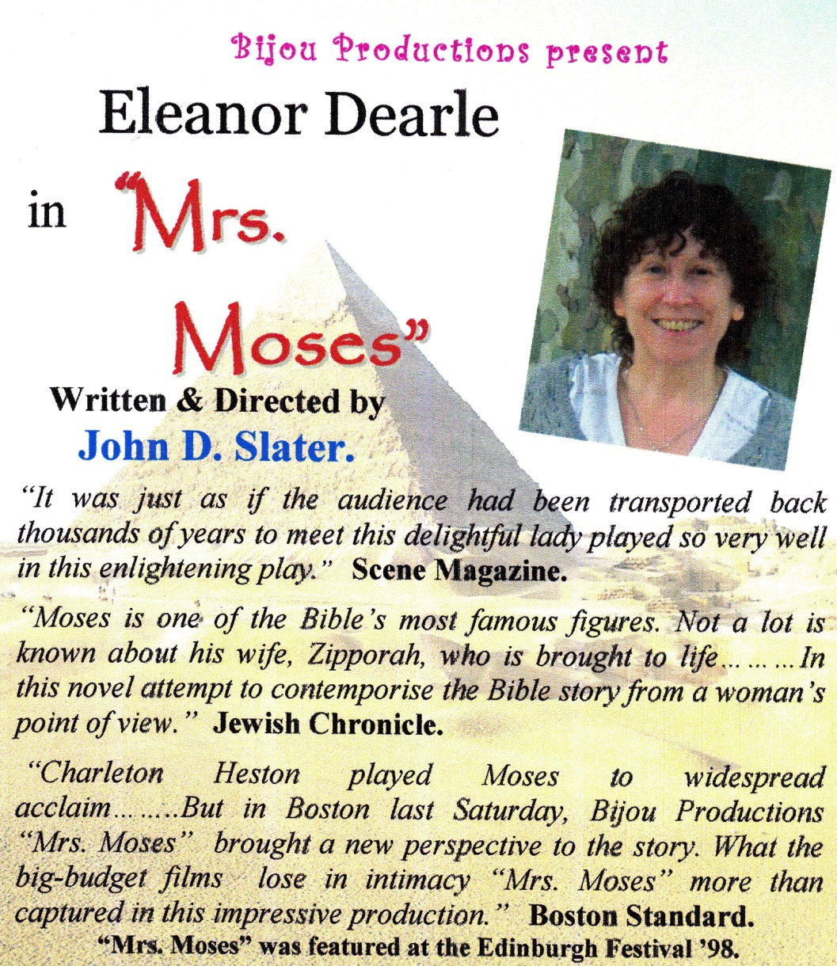

Mrs. Moses is going to be performed at WEST MELTON URC on Saturday 26 March and at TRINITY URC on Saturday 16 April. Both shows will start at 7.30pm. Tickets are £5 each and can be obtained from Rev Nick( contact details on back cover) or can be purchased on the door. Please try and support this production,
it promises to be a good night out.

Getting to know you – Frank Wensley

Frank was born in 1921 and on 13th February he celebrated his ninetieth birthday.
Frank’s parents moved to Barnsley when his father was posted to the area in the police force.
Frank attended Blackburn Lane and St. Mary’s schools. He left school at fourteen and started work as an errand boy at the Co-op Tailoring department. He later became an assistant in the hat department. When he was at the Co-op he became involved with sporting activities and whilst he was learning to play tennis he met Eve whom he later married.
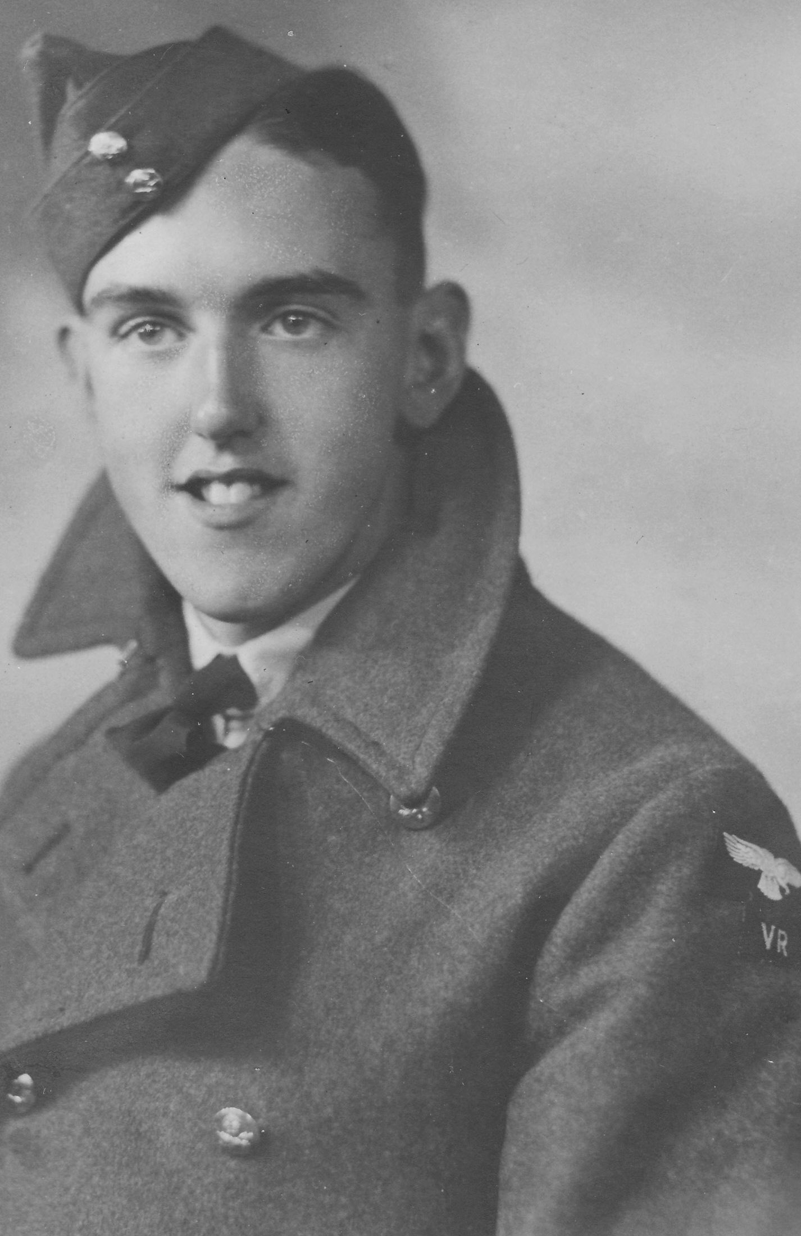
When the war started he joined the LDV (which properly stood for Local Defence Volunteers, Frank told me it also stood for Look, Duck and Vanish!). Later he joined the R.A.F in the 757 squadron.
In 1942, when on leave, Frank and Eve got married.
Frank was demobbed in 1946 and returned to the Co-op. Frank and Eve’s two children, Paul and Diane, were born in 1947 and 1948 just eighteen months apart.
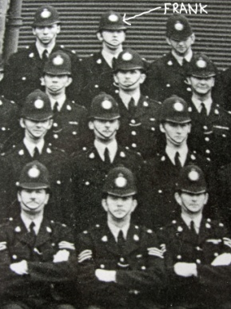
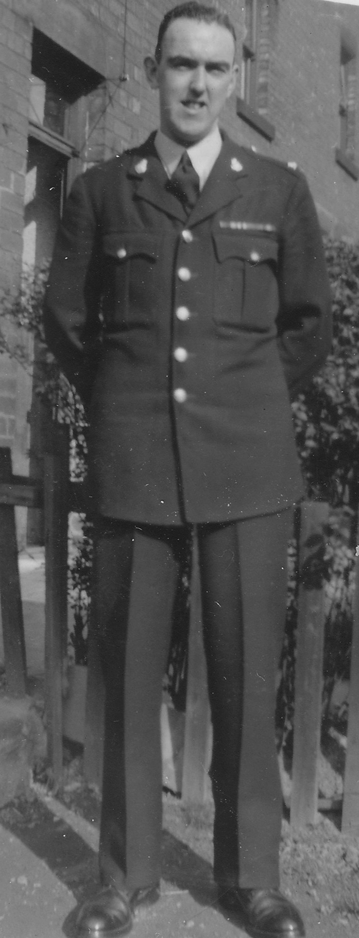
Frank followed in his father’s footsteps and joined the Police in 1950. A life long ambition, but, unfortunately, he had to retire from the force in 1957 because of severe arthritis. He not only lost his job but they also had to leave the police house in which they lived. Frank went to work for the coal board for a short while and then worked for the Wades Group ending up working in Wakefield.
He retired in 1986.

Frank had always been interested in music and had had some piano lessons when he was a young lad. He joined the White Rose Organ Society, bought an electronic organ and is still actively involved with the society serving as its treasurer. Frank is also responsible for booking all the visiting organists.

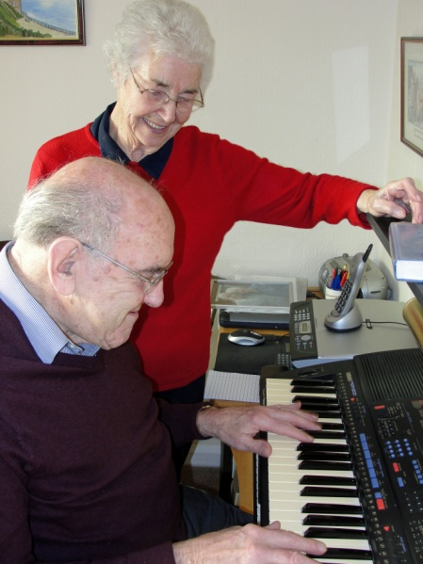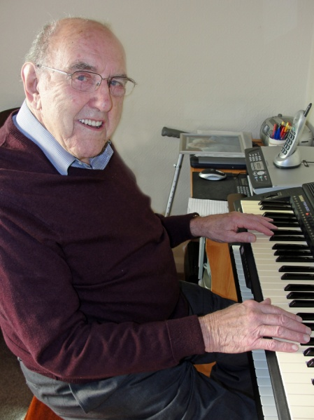

Solution to the wordsearch on page 12.

Thanks to all the contributors to this edition of LINK.
Contributions are always welcome and for the Summer 2011 edition of this magazine need to be with Rev. Nick by
Sunday 15th May, please.

West Melton’s LITTLE STARS (Tots group)
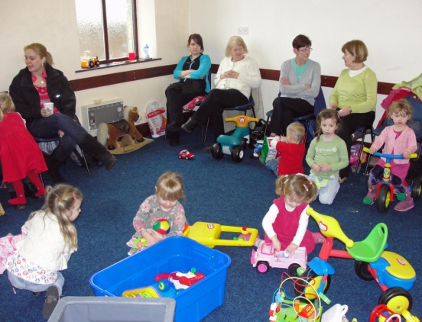
The Little Stars meet every Wednesday morning (during term time) in the community hall at the church. The group is very popular and currently has a waiting list. If you would like more information please contact Ann Peace on (01709) 875691.

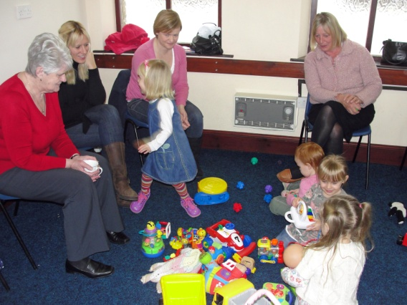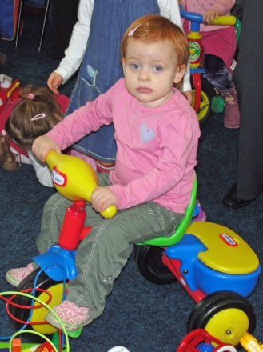

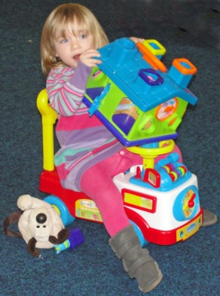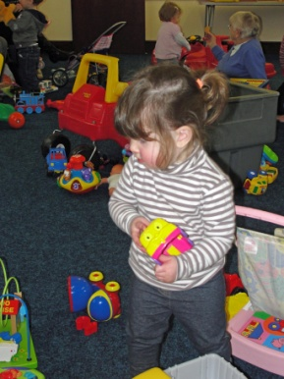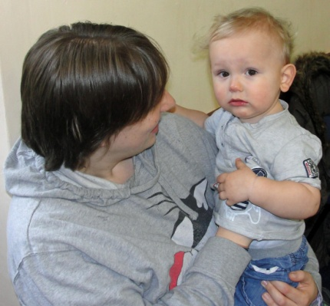

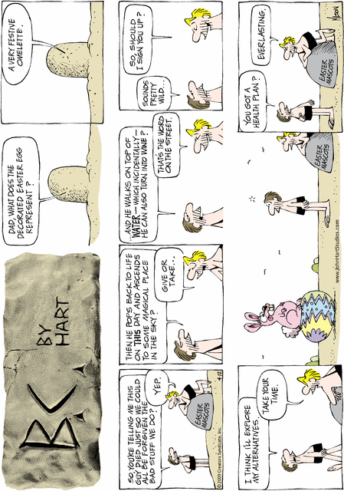
My Choir by Watt Clark

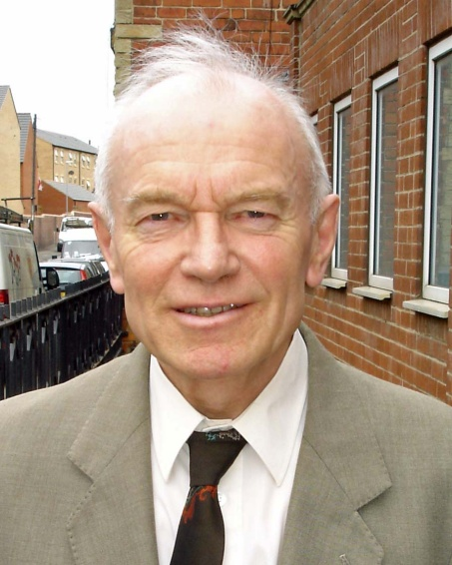
I am a member of the Barnsley Male Voice Choir. The choir meets at Gilroyd for practice or rehearsal on Thursday every week.
As you know, choirs are often led by a conductor or choirmaster, our choir master is John Pearson and he has led our choir at Gilroyd for about a year.
There are fifteen men in our choir and we sing wide range of songs in harmony.

As we are a Mail voice choir the music we use is set for T.T.B.B. Which stands for Tenor, Tenor, Bass, Bass. This means we have two different harmonies for tenors and basses which give a very rich choral sound.

We sing at a church service every week and we are available for weddings and other celebrations.
My favourite piece is “Cavalry of the Steppes” and we often sing this.

As you know Choirs can sing with or without instrumental accompaniment. Singing without accompaniment is called a cappella singing.

For rehearsals we have piano or organ accompaniment and sometimes a guitar. Other times the choir rehearses unaccompanied.

If you would like to know more about the choir please contact John Pearson at Gilroyd Social Club, Saville Road , Dodworth , Barnsley, S75 3PX Phone: 01226 206800

News from home and abroad

PAKISTAN GOVERNMENT “NOT AMENDING BLASPHEMY LAW”
Pakistan’s prime minister has told religious leaders that the government has no plans to amend the country’s controversial “blasphemy law”, amid further violence against Christians. Yousuf Raza Gilani’s statement on Tuesday (18 January) followed a brutal attack on two Christian women, a mother and daughter, who were falsely accused by a Muslim relative of insulting Muhammad in a domestic dispute. The pair were so severely beaten that they lost consciousness, and they were publicly humiliated in a parade around their neighbourhood in east Lahore. There have been calls to amend the blasphemy law, which is often used against Christians and other non-Muslims, since Christian mother-of-five Aasia Bibi was sentenced to death last November. This has triggered widespread protests by Muslim groups and the assassination of Salman Taseer, governor of Pakistan’s Punjab province, who supported Aasia and proposals to reform the blasphemy law. Mr Gilani said at the Ulema and Mashaikh Conference 2011 that religious leaders must not have any fear that the present government would do anything contrary to Islam or its teachings. He said that they were “not amending the blasphemy law” but warned that they were “not in favour of misuse of the law either”.
A private member’s bill seeking an end to the death penalty for blasphemy was submitted to the National Assembly Secretariat by former information minister Sherry Rehman last November. She said the blasphemy laws had become a source of victimisation and persecution of the country’s minorities. The blasphemy law is often exploited to settle personal scores and grudges, with Christians and other non-Muslims particularly vulnerable to malicious, false accusation – as seen in the case of Aasia Bibi and the attack on the two women in Lahore. A senior police officer said that the latter incident was “a domestic issue” and the blasphemy accusation was unfair..
It was the result of an ongoing personal dispute between a Christian woman, S.C., and her Muslim sister-in-law. The latter accused S.C. and her Christian mother of insulting Muhammad following a row, sparking action from local Muslim extremists.
People accused of blasphemy in Pakistan are often subjected to attack by Muslims seeking retribution for the perceived dishonour to their religion. Last month, an imam offered a 500,000 rupee (£3,800) reward to anyone who killed Aasia Bibi if the court fails to hang her.

CHARITY CONDEMNS GROWING GAP BETWEEN RICH AND POOR
Church leaders are supporting a campaign by Church Action on Poverty (CAP) to reduce the gap between the UK’s richest and poorest citizens. Eight Christian leaders, including those from the Methodist Church, Baptist Union and United Reformed Church, joined MPs and representatives of the charity in signing and delivering a letter to 10 Downing Street. The church signatories committed their denominations to spending the next three years working to close the poverty gap and persuading the government to play its part. Over a fifth of Britons still live below the poverty line. The campaign coincides with Poverty and Homelessness Action Week (30 January–6 February). CAP is encouraging religious groups to count rough sleepers, as it is believed that government records fail to reflect the true number of homeless.
Sources: Methodist Recorder (3/2); Ekklesia (31/1)

REGULAR ACTIVITIES IN OUR CHURCHES

Clayton West

Sunday Worship every week at 3.00 pm. Communion is included in the service on the 1st first Sunday of each month
Saturday Coffee Morning on the 4th Saturday each month 10.00am

Trinity (Barnsley)

Sunday Worship every week at 10.30 am. Communion is included in the service on the 3rd third Sunday of each month
Tuesday Bible Study at 7.30 pm
Wednesday Age-Well (over 50s club) every week 10.30am-1.00pm
Trinity Players every week at 7.30pm
Thursday Trinity Tots (carers & toddlers) 10.00am – 12.00noon

West Melton

Sunday Worship on the 1st (inc. WHIZZ KIDS) and 4th Sundays at 10.30am and on the 2nd & 3rd Sundays at 3.00pm. Communion is included in the service on the 3rd Sunday of each month
Monday Sisterhood every week at 2.30pm
Wednesday Little Stars 9.30am every week (in term time)
Praying Hands (prayer group) 7.30pm – 8.30pm on the 2nd Wednesday of each month
Fellowship evening (varied programme) 7.30pm on the 4th Wednesday of each month
Friday Children’s Fun Night 6.30pm – 8.00pm (1st & 3rd Fridays in term time)
Saturday Men’s Breakfast at 8.00am on the 3rd Saturday each month

Group Minister: Group Treasurer:
Rev. Nick Percival BA Mr. John Paskell
19 Longdale Croft 1 Giles Avenue
Barnsley, S71 2QT Wath on Dearne
Tel: 01226 771277 Rotherham, S63 6SG
Mobile: 07986668032 Tel: 01709 879224
Email: revnickp@yahoo.co.uk Email: john@paskellplumbing.co.uk

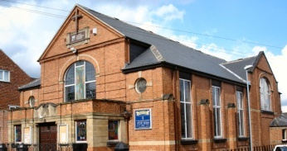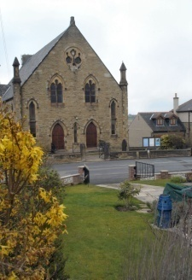
Trinity Clayton West West Melton,
Farrar Street Church Lane Melton High Street
Barnsley Clayton West Wath on Dearne
S70 6BS Huddersfield HD8 9LY Rotherham S63 6RG

Church Secretaries:

TRINITY: Mrs. Fiona Weighton-Smith, 18 Normans Way, Sandal, Wakefield, WF2 6SS Tel: 01924 253010
Email: isabelsmith655@talktalk.net

CLAYTON WEST: Mrs. Betty James, Winter Hill Farm, Bank End
Lane, High Hoyland, Barnsley, S75 4BB
Tel: 01226 382820

WEST MELTON: Mr. John Paskell. (As above)

www.urcbarnsleygroup.co.uk

