LINK

The magazine of the Barnsley Group Pastorate

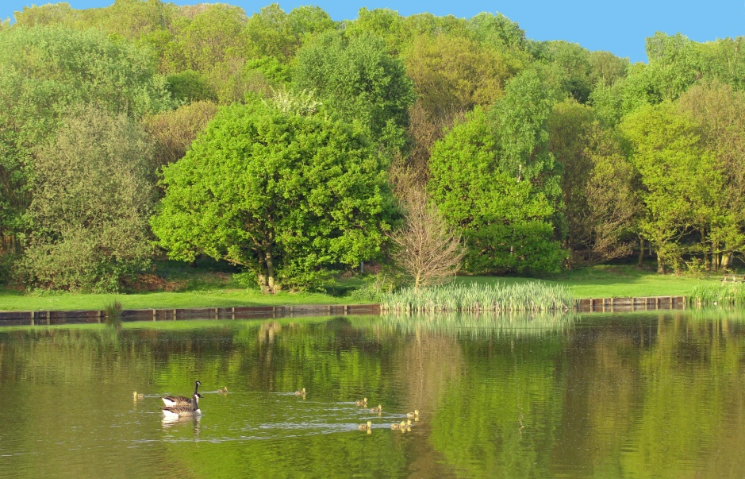

**SPRING 2012**  

Plumbing and

heating engineers

Tel: 01709 873518

[info@paskellplumbing.co.uk](mailto:info@paskellplumbing.co.uk)



**Druids Sheffield**

**Friendly Society**

Plans for Healthcare – Tax Exempt Savings

Sickness and Death Benefits

Endowments – Insurance I.S.A.

Leaflets on all plans available from:-

Dove House, Brampton Road,

Wath-Upon-Dearne, S63 6BE

Tel: 01709 876409

Fax: 01709 878045

Email: deuidssheffield.friendly@virgin.net

www.druidsfriendly.co.uk

Established 1858. Authorised in the United Kingdom under the Friendly Societies Act 1992. Reg. No. 795f

Druids Sheffield Friendly Society is regulated by the

13307

_________________________

**Simon T. Anderson**

Funeral Director

23 Dodworth Road, Barnsley.

**(01226) 733119**

*24 HOUR SERVICE*

AN INDEPENDENT FUNERAL SERVICE

*Professional and friendly advice on all aspects of the funeral service*

Financial Services Authority

___________________________________________________



Andrew P. Lockwood

**MinstChP. CCM(Sheffield)**

**CHIROPODIST**

**All Foot Ailments Treated**

CORNS – CALLOUSES (Hard Skin) – VERRUCAE – ATHLETE’S FOOT etc.

**Home Visits – Prompt Attention**

**Tel: 01484 687632**

**Mobile: 07971355078**

Dear friends

In early March I will be attending the annual Yorkshire Synod Ministers’ Retreat. One of the ways I like to spend some time when I am on retreat is by becoming more aware of God’s wonderful creation. Below is an awareness walk which is a very useful exercise to use if you wish to spend some time with God. Please try to spend an hour or so doing this walk. And enjoy doing it.

**An Awareness Walk**

This is a time to rediscover the abundance of creation around us by using the senses with which God has blessed us. This is an opportunity to delight afresh in the beauty of nature.

Try to allow at least 1 hour for the walk.

It is best to walk by yourself but if you wish to share the walk with someone else you may do so. You may find it helpful to avoid speaking about everyday concerns, instead share your 'awareness of creation' with each other.

To begin, find a SPACE alone outside. Pause to take deep breaths of the fresh air. Breathe in and reflect that God continually sustains with the breath of life.

**`Breathe in' the whole scene with eyes, ears, nose and feet.**

**Be aware of yourself in this scene.**

**FEEL your limbs, hands, fingers, feet.**

Listen to every sound near, mid-distance and far away.

Even in peaceful surroundings there is always sound - birds singing, distant traffic or voices, the rustling of leaves. Concentrate on the different sounds, block and unblock your ears and reflect on the gift of hearing. How many different sounds do you hear? Continue to be aware of noises as you start your walk.

On your walk, start to look and really **SEE** what is around. Enjoy the colours, shapes, movement, texture of flowers, plants and trees. Pause by something that catches your eye and look at its shape from different angles. Choose something small and reflect on the incredible detail and perfection of God's creation. **LOOK** at the shapes around you - the beauty and ugliness, chaos and order, light and shade, contrasts. **LOOK** at things near and far. Notice all the different greens-, Be aware of all the colours. Stop and close your eyes for a moment and try to imagine what it would be like without the gift of sight.

**TOUCH** as many things on your walk as you can. Become involved in the surroundings by touching grass, petals, stones and wood. Be aware of your hands and all that they touch and feel.

**FEEL** the ground beneath your feet - is it easy walking or difficult?

**FEEL** the weight of objects. Feel the natural and the man-made.

**COLLECT** examples of different textures (bark, leaves, stone, wood, paper, metal, plastic etc.)

**TASTE** and perhaps chew a blade of grass. Experience on your tongue the flavour of what can be seen around you. Be conscious of the different sensations of taste. Our mouths are not only for words, but to enjoy gracious gifts.

**SMELL** the countryside, water, earth, animals, food, shrubs, flowers etc. Try to find -something with a particular scent and bring it back with you.

**AT** **THE END** of your walk, sit quietly for a moment and reflect on the experience. Make a mental note of any feelings or thoughts that were important. Gather together any items you have collected as a reminder of all of God's bounty and beauty that we have within our reach. Become aware of all creation praising God. Join your praise to it in whatever way feels right and natural to you.

**Mother Julian of Norwich wrote:**

He showed me a little thing, the size of a hazelnut, in the palm of my hand, and it was as round as a ball. I looked at it with my mind's eye and I thought, 'What can this be?' And answer came,'It is all that is made.' I marvelled that it could last, for I thought it might have crumbled to nothing, it was so small.

And the answer came into my mind, 'It lasts and ever shall because God loves it.' And all things have being through love of God.

In this little thing I saw three truths.

The first is that God made it.

The second is that God loves it.

The third is that God looks after it.

What is he indeed that is maker and lover and keeper? I cannot find words to tell.

*(from Revelations of Divine Love; this translation from Enfolded in Love. Daily Readings with Julian of Notivich, ed. Robert Llewelyn, Darton, Longman and Todd 1980).*

*(With thanks to the book 'Approaches to Prayer’)*

May God continue to bless you.

Your friend and minister



WEST MELTON’S GREEN TIPS CORNER

**No 7 – Down the pan** by Helen Owen

Toilet paper-we all use it. If you haven't already, consider switching to recycled loo roll to save resources. It's less likely to contain dyes, so will be kinder to the environment too. Already using it at home? Persuade others to do the same -and what about your church toilet rolls?

Quote from a letter to the Guardian "'The Queen: 60 years on the throne'. Has she ever tried All -Bran?"



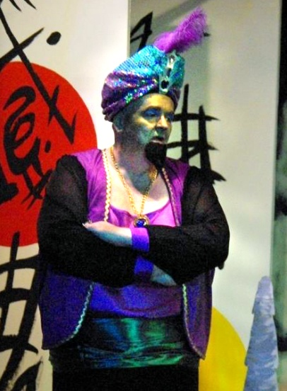 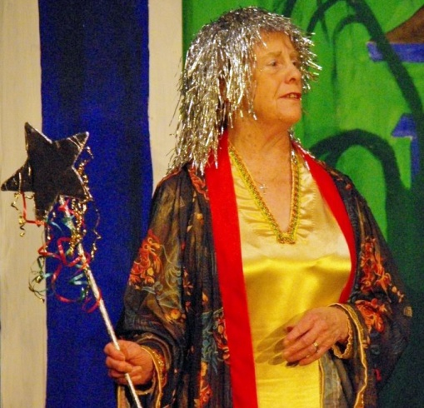



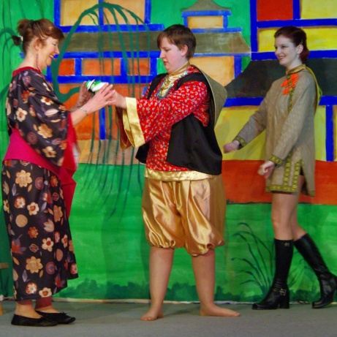Aladdin has always been my favourite pantomime. Probably because it was the first one I ever saw back in the late 50s. I was overjoyed to be able to appear in the Trinity Player’s production in January. And to play the Genie was a bonus, even if I was a grumpy one! (Type casting!)

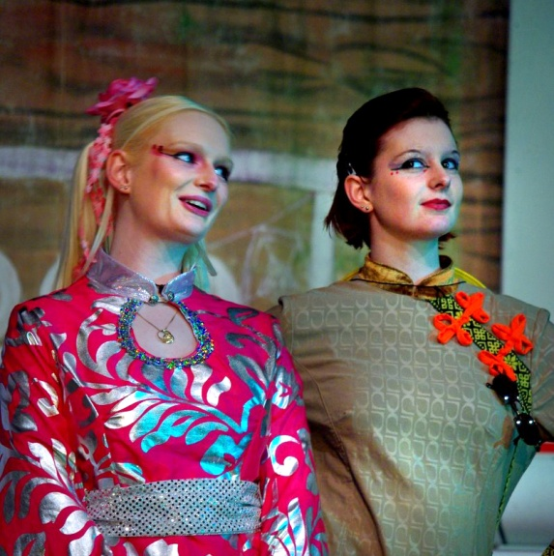The performances went very well, in fact better than that, they were excellent, even if I do say it myself. The easiest part in a panto is the acting. The real hard work goes on behind the scenes. If it wasn’t for the back stage crew we would have no sets and no props and if you came to see the show, I’m sure you would agree that it was the most colourful of our three recent pantomimes. The only downside was me singing a song. I never did manage to get all the words correct! I wonder how many people in the audience noticed? Perhaps, next year, I will persuade the director to let me sing a hymn instead!!!

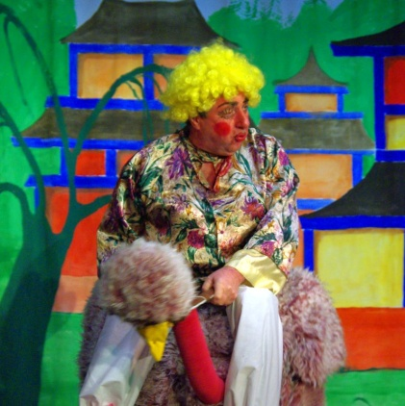 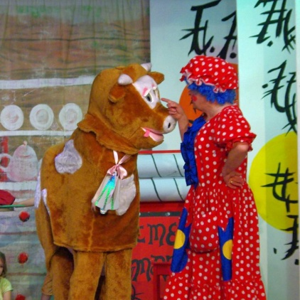

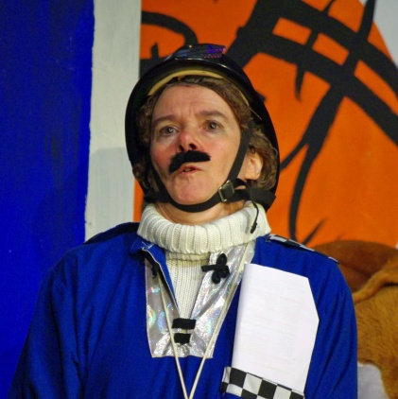 

 

Photos (except Nick and his grandchildren) by Phillip Johnson.

**John Wesley’s Rules for Singing**

Contributed by Margaret Swallow

Learn these tunes before you learn any others; afterwards learn as many as you please.

Sing them exactly as they are printed here, without altering them or mending them at all; and if you have learned to sing them otherwise, unlearn it as soon as you can.

Sing all. See that you join the congregation as frequently as you can. Let not a slight degree of weakness or weariness hinder you. If it is a cross to you, take it up, and you will find it a blessing.

Sing lustily and with good courage. Beware of singing as if you were half dead, or half asleep; but lift up your voice with strength.

Sing modestly. Do not bawl, so as to be heardabove ordistinct from the rest of the congregation, that you may not destroy the harmony; but strive to unite your voices together, so as to make one clear melodious sound.

Sing in time. Whatever the time is sung be sure to keep with it. Do not run before nor stay behind it; but attend close to the leading voices and take care not to sing too slow. This drawling way naturally steals on us all who are lazy; and it is high time to drive it out from us, and sing all our tunes just as quick as we did at first.

Above all sing spiritually. Have an eye to God in every word you sing. Aim at pleasing God more than yourself, or any other creature. In order to do this attend strictly to the sense of what you sing, and see that your heart is not carried away with the sound, but offered to God continually; so shall your

singing be such as the Lord will approve here, and reward you when he cometh in the clouds of heaven.

**A recipe for your enjoyment** by Joyce Jones

COCONUT MACAROONS – YUM YUM!

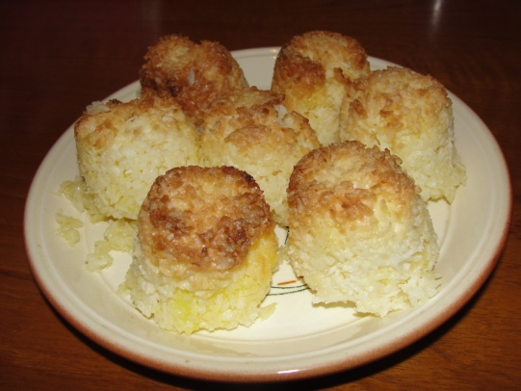

“This recipe was given to me just before I got married. It came from Mrs. Norton, a then church member, now living in Hope Valley (we all live in hope, don’t we! *Ed*.) It can also be used for tarts or a tray bake along with your favourite jam underneath.

**Ingredients:**

½lb desiccated coconut. ½lb sugar. 2 medium eggs. 2oz margarine.

**Method**

Cream the margarine with a little of the sugar until light and fluffy. Add the coconut and the rest of the sugar and continue mixing. Add the eggs and mix well. Then pack a wet egg cup with the mixture and ‘shake’ on to a baking tray. Bake in a moderate oven (180c gas mark 4) for 15 to 20 minutes until golden. Before baking you may like to top each one with ½ a glace cherry.

These macaroons are crisp on the outside and chewy on the inside (much like an Armadillo! *Ed*.)

Joyce says, “I must add that even now I am not good at making into macaroons so we have tarts or a tray bake.”

(The ones you made me for the photo were fantastic and I really enjoyed eating them. *Ed.)*

*A picture for you to colour*

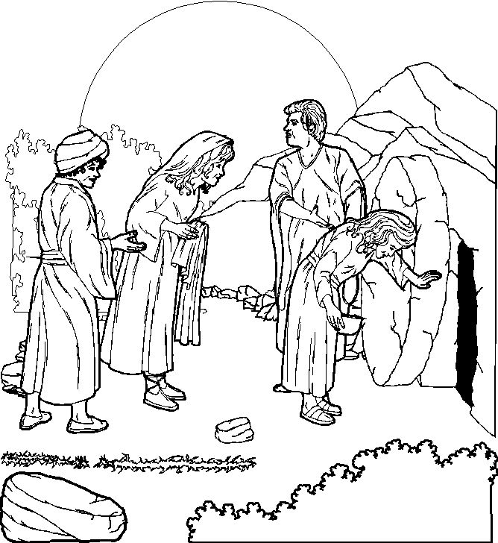

“He is not here, He is risen” (Matthew 28:6)