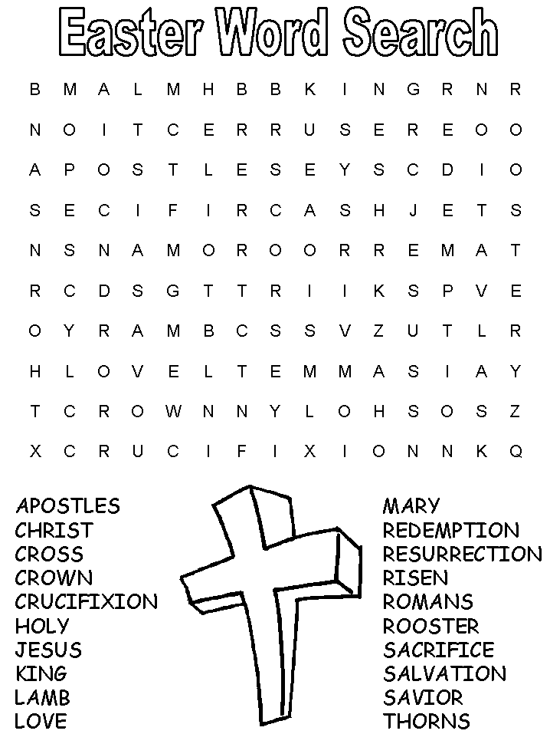

EDUCATION AND LEARNING CONFERENCE

‘SMALL ACTIONS MATTER’
December 2011 at Westminster College
by Fiona Weighton-Smith

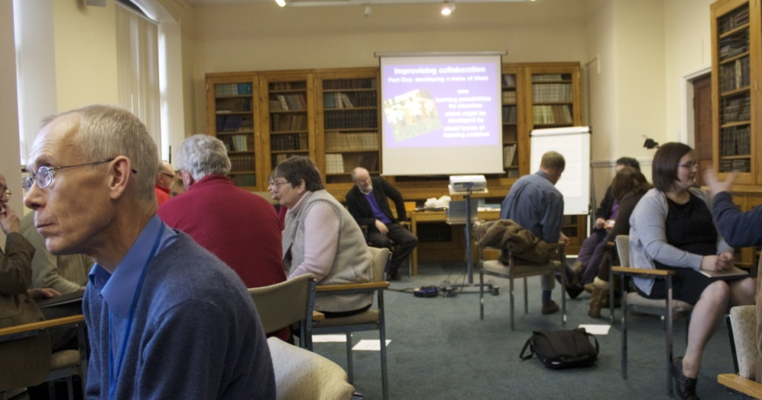
The journey down to Cambridge was good. As I arrived in plenty of time there was time to explore the town and the ‘backs’ the waterways one can punt on; in the sun the colleges looked spectacular. Back to Westminster to register and find which room I had been allocated. My room was a pleasant surprise- on the ground floor with a kitchen and bathroom almost en-suite, which made a change from having to climb 2 flights of stairs and sharing facilities. Refreshments were available when registration was done.
After opening devotions the key-note speaker, Ann Morisy, introduced the theme of the whole conference Mission through Encounter. Ann has written many books on mission her latest ‘Bothered and Bewildered’ had been sent to all attendees to be read before the conference. The book deals with the problem that society has with the conflicting thoughts that society puts out ’that there is no hope and we must find excuses to give a reason’. As a Church and as Christians we need to help people rise above these feelings ’ it is urgent that we share our faith mission to be combined with pastoral care’. Hope is not enough we have to enact it. The evening session was to explore our alternative performance when we all had a chance to discuss what had been said. Ann is an inspirational and enthusiastic speaker and
leaves one with more questions than answers.
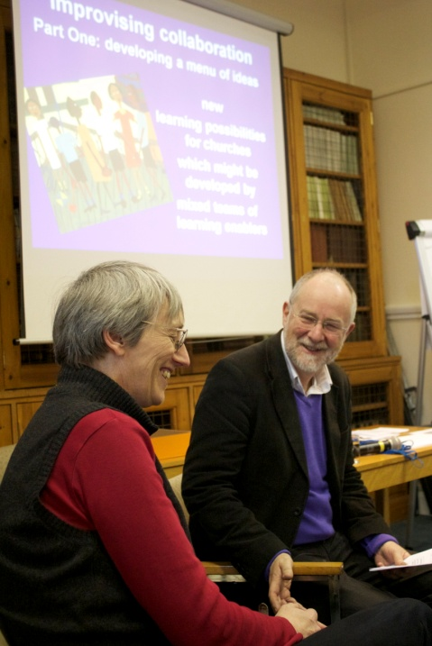
After a good night’s rest and breakfast the morning workshops started a list had been circulated before so that we could chose before coming. The workshops were based on the 10 mission Statements in Vision 2020 I had chosen Identity; Hospitality and Diversity and for the third Evangelism. In each we were asked to comment on what we thought these statements entailed. Identity was rather abstract and for me didn’t seem to answer the what the URC stood for in identity I was hoping that would have been discussed. In hospitality and diversity John Marsh who has been an Assembly Moderator. Arriving in the room we were all faced with singing Colours of Day unaccompanied
(the difficulty was keeping the tune in the other verses rather than just the first) telling a joke about some tone deaf monks did not make us feel good about our singing; but at least it broke the ice and made us relax. In the afternoon we had free time and came back for the last session at 4.30.
After dinner it was time to let our hair down for a session of drumming and other percussion instruments. This was a very enjoyable 1¾ hour. Each of us had a chance to use all the instruments learning rhythms. Daniela who took the workshop had collected the instruments from her journeys in Africa.
On day three John Campbell and Fiona Thomas took two sessions on Connected Learning in the URC.
The three days were filled with inspirational discussions which enthused us to go back to our Churches and hopefully inspire our congregations
If anyone would like to borrow Ann Morisy’s book ‘Bothered and Bewildered’ please let me know.
Getting to know you – Donald Carter
By Heidi Ryan

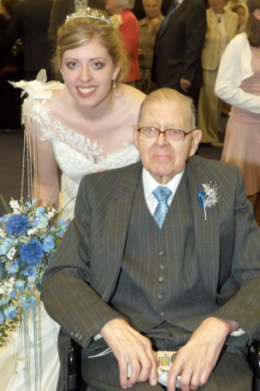
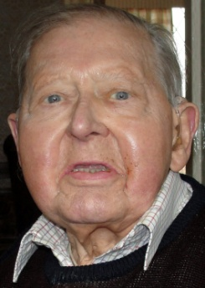
Grandad was born on Boxing Day 1921 at Emley Lodge. He grew up on Post Office Row, Clayton West with his 4 older brothers, and has lived in the village for over 80 years. He took an active part in church life for 50 years.

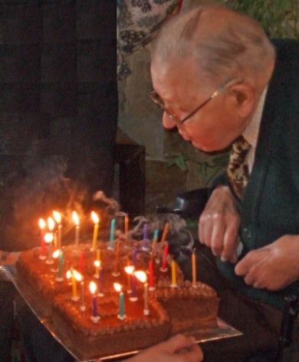
After leaving school when he was 14, he began his working life at the Band Mill at Park Mill, then moved to R.Beanland & Co. where he stayed for the next 40 years, until it closed down. His time there was interrupted when he was called up into the RAF in 1941. He served as a ground mechanic servicing Halifax bombers, for which he was awarded the oak leaf medal and
mentioned in dispatches for distinguished service.
During his time at Beanlands, Grandad met Margaret Taylor, who he married in May 1953 at what was then the Congregational Church and started attending there. As a child, he had gone to the Primitive Methodist Chapel in the village with his family.

He was a founder member of the men's society in the 50’s, and was treasurer, assistant secretary and secretary until 2003.

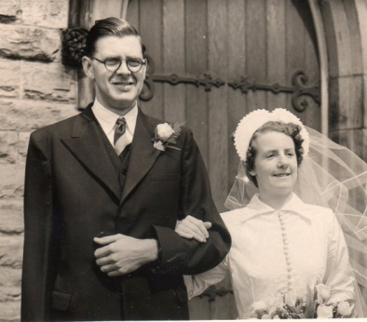
My mum, Jane, was born a few years after they married, and over the years the family grew to include dad, myself and Jonathan.

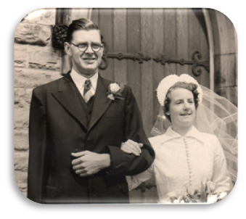
During his many years at the URC, Grandad helped with ‘general maintenance and boiler fixing’. I remember as a child regularly seeing him in his overalls, in the electric room or the boiler room, tweeking things to get them just right.

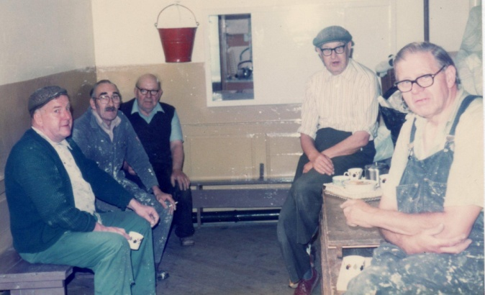
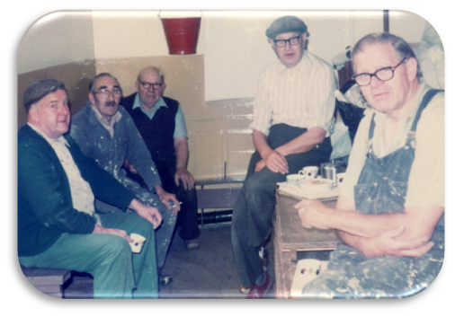
Grandad was also actively involved in the work of the Royal British Legion, responsible for the poppy collection in Clayton West, Scissett, Emley and Bretton for 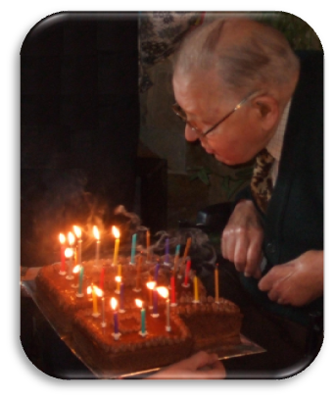50 years. Towers of poppy boxes were a common site in my grandparents front room as the time for the annual poppy appeal grew close.
Blowing out the candles
on his birthday cake
for his 90th birthday.

He and Grandma served on the committee of the village old folks treat for over 30 years.
Blowing out the candles
on his birthday cake
for his 90th birthday.
Blowing out the candles
on his birthday cake
for his 90th birthday.
Blowing out the candles
on his birthday cake
for his 90th birthday.
Blowing out the candles
on his birthday cake
for his 90th birthday.
Blowing out the candles
on his birthday cake
for his 90th birthday.
Blowing out the candles
on his birthday cake
for his 90th birthday.
Blowing out the candles
on his birthday cake
for his 90th birthday.

Grandad, and Grandma as well, were always part of our family life, celebrating milestones with us. I was really happy Grandad could attend my wedding 3 years ago and just a couple of months ago we were able to celebrate his 90th birthday with family and friends.
SOUTH AFRICA - THE RAINBOW NATION by Helen Owen
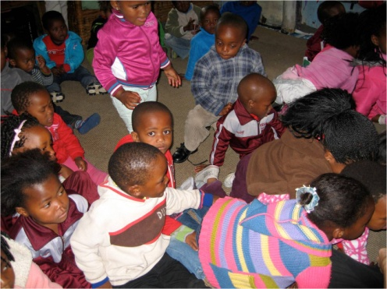
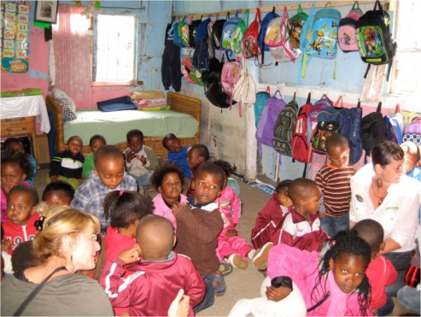
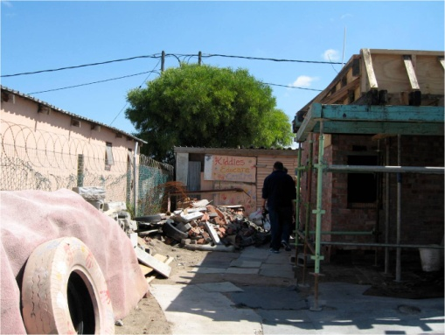
A term coined by Desmond Tutu based on God's promise to Noah after the flood, signifying a new beginning of hope, peace and reconciliation for the country after the end of Apartheid.
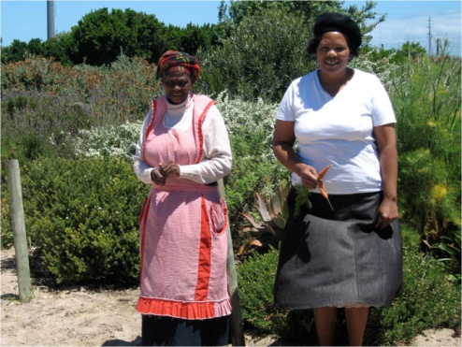
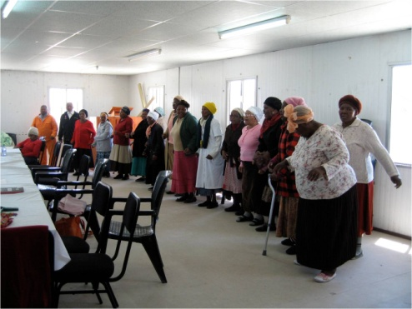
While on a trip to South Africa in November, 2011, 1 went on a tour of some projects in the Cape Town townships.
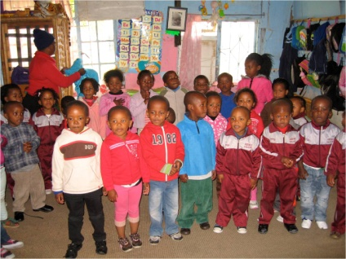
My knowledge of townships before the trip was patchy. I knew they still existed but thought they were only outside the big cities. As my friend and I drove around the Western and Eastern Cape provinces, we realised there is a township, signified by corrugated iron shacks, outside every town, always covering a huge area and a considerable distance from the town on flat sparse land frequently near the local airport.
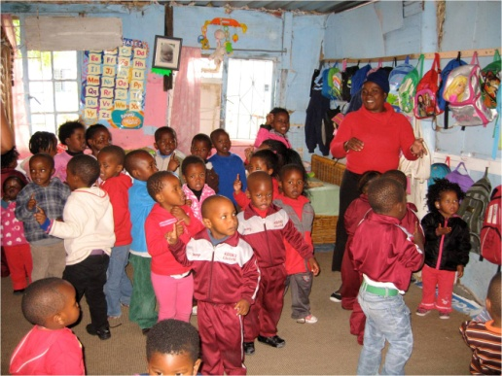
For instance, the townships on the Cape flats outside Cape Town are over an hour's drive from the city centre and industrial areas where the 40% who have jobs, work. The biggest of the many Cape Town townships, Khayelitsha is home to a million people, which gives some idea of the massive number of black South Africans who do not have adequate housing or any facilities. The townships are of course a direct result of the Apartheid laws which existed from 1913 to 1990. Cape Town Council has provided electricity to many shacks on the Cape flats and is building hundreds of brick bungalows with all facilities to replace the shacks but the waiting list is immense and unending.
Our township tour was organised by a company called Uthando (Xhosa word for `love.') which uses donations from numerous worldwide travel firms to fund over 20 projects in townships all over the south of South Africa.
The first project we visited was "Kiddies Educare Centre" in the Phillipi township, a creche and pre school day care centre for children between a few months old and 6 or 7 years old. Currently 47 children come every day from 6am to 6pm. It is run by Margret who is a truly inspiring person and a loving and committed principal of this pre school. The kids were not at all phased by the arrival of half a dozen white foreigners. In fact we all ended up on the floor with them as they peered at the photos of themselves on our cameras. Margret got them to sing the National Anthem for us before we left. It has 5 languages in it, The first verse is in Xhosa and Zulu, the second in Sethoto and then Afrikaans and finally English. The first verses were great but the kids tailed off when it got to the Afrikaans and English parts!
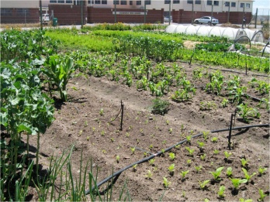
The second project was a day care centre for older people. About 25 in their 80's and 90's-2 men and the rest women. They are transported from and to their homes in the township three days a week and have their lunch while there, Another dynamic lady called "Di" runs the group and translated for us and them. They make soap blocks from old bits of used soap and package up the new blocks for sale to hotels in Cape Town. They too sang for us and very melodic it was too. They also danced for us.......and with us! The third project, in Khayelitsha, was a community garden called "Abalimi Bezekhaya" which is Xhosa meaning "Planters of the Home". They grow organic vegetables on the poorest of soils with masses of compost dug in. The produce is boxed up and sent on to schools and hospitals etc. in Cape Town. The scheme provides employment for a good number of, mainly women, from the township. The recipe book "Seed to Table" contains many of their ideas. (see recipe on the next page)
I found this tour extremely uplifting. Having seen some townships at close quarters and seeing other parts of the Western and Eastern Capes I realise not only the enormous task which lies ahead but also the massive strides that have been made over the last 20 years since Apartheid ended. South Africa is truly a Rainbow Nation.
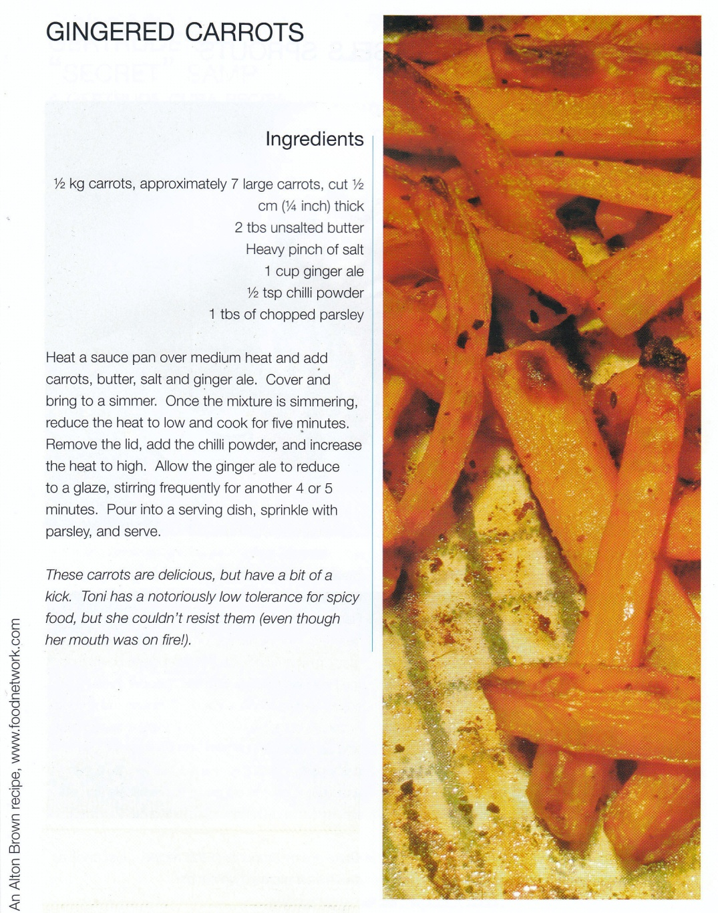

From the book “SEED TO TABLE”
A laugh to end with…..

A Leeds man walks into a High Street bank & asks for a loan. He tells the bank officer he is going to Australia on business for two weeks & needs to borrow £5,000. The bank officer tells him that the bank will need some form of security for the loan, so the Yorkshire lad hands over the keys and documents of new Ferrari parked on the street in front of the bank. He produces the Log Book & everything checks out .the loan officer agrees to accept the car as collateral for the loan.

The bank manager & its officers all enjoy a good laugh at the rough-looking Yorkshireman for using a £120,000 Ferrari as collateral against a £5000 loan. The bank manager then instructs an employee of the bank to drive the Ferrari into the bank's underground garage, where he parks it. Two weeks later, the man returns, repays the £5,000 & the interest of £15.41.

The bank officer says to the Yorkshireman, "Sir, we are very happy to have had your business and this transaction has worked out very nicely, but we are a little puzzled... while you were away, we checked you out further & found that you are a multi-millionaire. What puzzles us is, why would you bother to borrow "£5,000"?
The Yorkshireman replies: "Where else in Leeds can I park my car for two weeks for only £15.41 and expect it to be there when I return"

Ah, the mind of a true Yorkshireman ... This is why they survive

Thank you to everyone who has contributed to this magazine. Items for the Summer 2012 LINK need to be with me by Sunday 20th May, please. It will be available on Sunday 3rd June.
Thanks, Nick.
REGULAR ACTIVITIES IN OUR CHURCHES
Clayton West

Sunday Worship every week at 3.00 pm. Communion is included in the service on the 1st first Sunday of each month
Saturday Coffee Morning on the 4th Saturday each month 10.00am

Trinity (Barnsley)

Sunday Worship every week at 10.30 am. Communion is included in the service on the 3rd third Sunday of each month
Tuesday Bible Study at 7.30 pm
Wednesday Age-Well (over 50s club) every week 10.30am-1.00pm
Trinity Players every week at 7.30pm
Thursday Trinity Tots (carers & toddlers) 10.00am – 12.00noon

West Melton

Sunday Worship on the 1st (inc. WHIZZ KIDS) and 4th Sundays at 10.30am and on the 2nd & 3rd Sundays at 3.00pm. Communion is included in the service on the 3rd Sunday of each month
Wednesday Little Stars 9.30am every week (in term time)
Praying Hands (prayer group) 7.30pm – 8.30pm on the 2nd Wednesday of each month
Fellowship evening (varied programme) 7.30pm on the 4th Wednesday of each month
Friday C.A.S.C. (Christian After School Club) 3.45pm – 5.30pm
on the 3rd Friday of each month (in term time)
Saturday Men’s Breakfast at 8.00am on the 3rd Saturday each month
Group Minister: Group Treasurer:
Rev. Nick Percival BA Mr. John Paskell
19 Longdale Croft 1 Giles Avenue
Barnsley, S71 2QT Wath on Dearne
Tel: 01226 771277 Rotherham, S63 6SG
Mobile: 07986668032 Tel: 01709 879224
Email: revnickp@yahoo.co.uk Email: john@paskellplumbing.co.uk

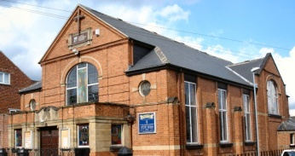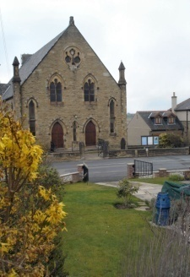
Trinity Clayton West West Melton,
Farrar Street Church Lane Melton High Street
Barnsley Clayton West Wath on Dearne
S70 6BS Huddersfield HD8 9LY Rotherham S63 6RG

Church Secretaries:

TRINITY: Mrs. Fiona Weighton-Smith, 18 Normans Way, Sandal, Wakefield, WF2 6SS Tel: 01924 253010
Email: isabelsmith655@talktalk.net

CLAYTON WEST: Mrs. Betty James, Winter Hill Farm, Bank End
Lane, High Hoyland, Barnsley, S75 4BB
Tel: 01226 382820

WEST MELTON: Mr. John Paskell. (As above)

www.urcbarnsleygroup.co.uk

