LINK

The magazine of the Barnsley Group Pastorate



**WINTER 2009** 

Dear friends

While surfing the web I came upon an interesting site (*www.soon.org.uk/christmas*) which informs the reader about Christmas. It gives information on everything you need to know about this great festival. It also provides links to other sites if you want more information on various topics.

The following paragraph caught my attention.

*Today in the West, not many people consider the religious meaning to Christmas. Most people in UK or Europe will not go to a religious church meeting, even at Christmas. It has become a busy race to spend money on presents, and get ready for the Day. In UK, our shops stay open till late Christmas Eve and often open again on Boxing Day with the cut-price 'sales'. (Not much holiday for the poor shop workers!) A visitor from another world would think that Christmas was a festival to the gods of money and shopping.*

That is a sad indictment of present day Britain. How has Christmas become like this? Do people really enjoy going to busy shops? Are people really happy to buy so much food *‘for Christmas’* much of which will find itself in a land-fill site within a couple of weeks!

Christmas should not be about spending loads of money. It should not be about shop workers having to go to work on Boxing Day because their money grabbing bosses want to grab even more money.

Christmas *(Old English root of "Cristes maesse" or Christ's Mass)* should be a simple and joyful celebration of the birth of our Lord.

Neither is it ‘Winterval’ as in Birmingham a few years ago, nor is it the following which you may have seen reported recently in the media,

**We wish you a merry Christmas (but not in Dundee)**



Christmas will not be Christmas in Dundee this year. All references to the religious holiday have been dropped from the switching-on ceremony for the city’s festive lights.

Instead of the traditional Christmas Lights switch-on, residents will be attending the “Dundee Winter Light Night”. Council officials have also decided that rather than a retelling of the Nativity story there will be a disco, a contemporary circus, a continental market and a 7ft fairy on stilts.

(Times Online 13 November 2009 - www.timesonline.co.uk/tol/news/uk/scotland/article6915061.ece)

With things like this going on how can we expect people today to know what the true story of Christmas is? There is only one way, **WE** have to tell them! A good start would be to send only ‘religious’ Christmas cards to your non-Christian friends and family – make sure that they have a relevant bible verse inside, if not then write one in before you send it or give it to them. They might even ask you for more information, what a real joy that would be as you could then invite them along to Christmas service at your church where they will truly be able to celebrate Christmas as it should be celebrated.

*****

The riddle in the Autumn Link was:

What am I?

*I drift forever with the current, down these long canals they've made. Tame, yet wild, I run elusive, multitasking to your aid. Before I came, the world was darker, colder, sometimes, rougher, true. But though I might make living easy, I'm good at killing people too.*

**Answer:** Electricity

Some Christmassy riddles for you. (answers on page 21)

1. What am I ... A glistening spike that points straight down ... A shiny blade that will not turn brown ?
2. What does Santa like to do in the garden ?
3. Why did the elf put his bed into the fire place ?
4. Why was the snowman nervous about getting married?
5. What is the most popular wine at Christmas?

*****

## I hope you all have a joyful Christmas and a peaceful New Year. May God continue to bless you.

Your friend and minister



***Items for the Spring 2010 LINK are needed by***

***Sunday 14th February, please.***

## Things NOT To Say When Hanging Tree Lights

##### Did you know that hanging lights on a Christmas tree is one of the three most stressful situations in an on-going relationship? The other two danger zones are teaching your mate to drive and wallpapering. Things NOT To Say When Hanging Tree Lights:

##### "You've got two red lights right next to each other, idiot. You're supposed to go yellow, green, red, blue -- not yellow, red, red, green, blue..."

##### "Up a little higher. You can reach it. Go on, try."

##### "What on earth do you do to these lights when you put them away every year? Tie them in knots?"

##### "Give me that."

##### "You've got the whole thing on the tree upside-down. The electric pluggee thing should be down here at the bottom, not up at the top."

##### "I don't care if you have found another two strings, I'm done!"

##### "You've just wound 'em around and around -- I thought we agreed it shouldn't look like a spiral this year?"

##### "Have you been drinking?"

##### "Where's the cat?"

##### "If you're not going to do it right, don't do it at all. Don't just throw them on, like you do the icicles. You're worse than your father."



**Christmas Eve – THOSE WERE THE DAYS – energy plus!**

By Mary Reynard

When I was fifteen and a half years old I started work at Dewsbury Public Library and quickly had to get used to working until 7pm on three days each week. This could include Christmas Eve, or it could be a Saturday, in which case I would go straight out from work.

I met Kenneth, my husband to be, at the library where he also worked as an assistant. I soon found out that he went old time dancing at the Temperance Hall in Dewsbury, where his parents played in the band. I would have met him there anyway as 3 brothers from my village had persuaded my dad to let me go to this dance in Dewsbury (the big city) instead of the local village hall. Actually it was very well organised with an M. C. and non-alcoholic refreshments, also supervised by members of the band, Kenneth’s parents.

The first time I went to the dance was in September and I was a regular by Christmas. On that Christmas Eve I was working ‘til 7 pm, so I rushed around at closing time quickly getting changed and with dance shoes in my bag, walked up to the Temperance Hall. We had a super time doing the Military 2 step, Valetta and the lancers even, to name but a few.

At my church, Gawthorpe Congregational, a group of young people, plus choir members, gathered in the primary room each Christmas Eve at 11.45 pm to go carol singing at midnight. It all sounded exciting but I was turned 14 before my dad would let me go. Anyhow, Christmas 1949 we went off to the dance and Kenneth had decided to come carol singing. So, when the dance had finished at 11 pm, along with other youngsters from my village, we set off to walk over two miles uphill (Wakefield Cutting) all the way to Gawthorpe. My dad had said to ask Kenneth in for a warm and a hot drink till I got into some warmer clothes. So off we went just round the corner to church to join the others. We sang two carols, unaccompanied, with harmonies, at various places in the village. We finished at around 2.00 am and went back to the church for a bowl of hot soup which was provided by a dedicated Sunday School teacher and deacon. Reluctantly, we then braved the chilly night to sing further afield at other homes, sometimes up lanes to farms and along unmade roads.

Singing under the starlit sky on Christmas Eve was pure magic to me. This is what it’s all about – being outside on the night Christ was born.

We carried on until around 4.00 am when we were a bit tired and we were glad to get home. Ken had to walk back to Dewsbury, his home town. My dad said that “he must be keen on you to do that”. I guess Ken had a lie in that morning, but I was up, doing my share of calling on folks with greetings and requests for contributions to funds. I came across our local Victoria Prize band playing carols around the village on Christmas Day. What I find hard to believe now is the energy we had then. Working all day, dancing all evening, walking and

singing most of the night and then out collecting next day. But then, we were very young and enthusiastic and had a good time, especially with a boyfriend along as well!

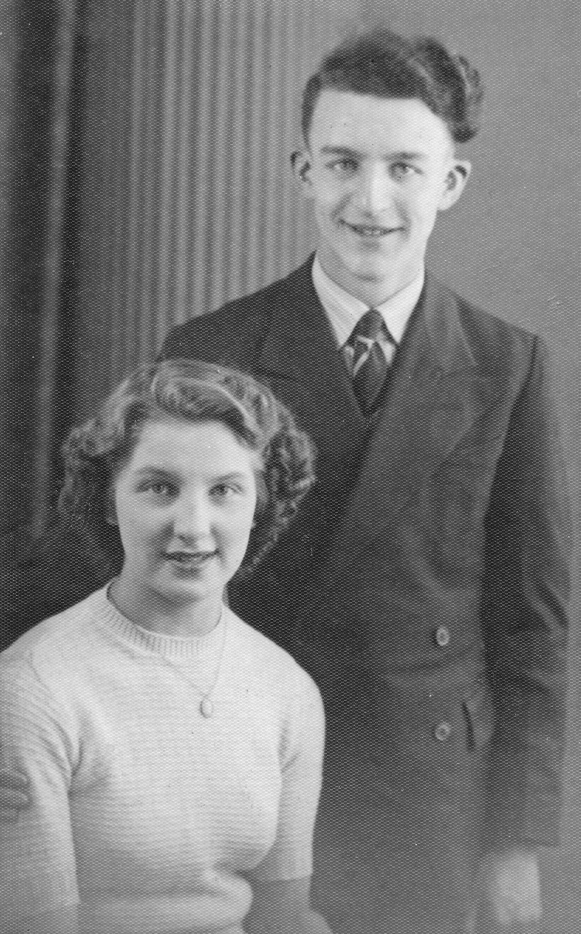

Mary and Ken in 1951

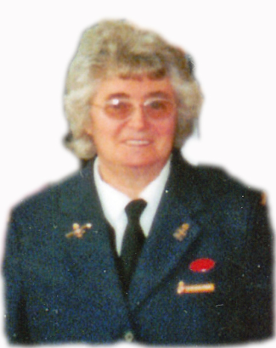Eileen Firth 1936 – 2009

It was a great sadness to us all when we heard of the death of Eileen on Monday 2nd November.

Eileen was the Girls’ Brigade captain at West Melton URC until she retired in 2003 after 45 years of faithful service. Eileen was also Treasurer of the church and only relinquished the post on October 31st.

Joyce Jones writes, *“I first new her when she came to West Melton Congregational church to take the Girls’ Brigade Company. Eileen became a good friend in later years when my girls said ‘mum, will you come and play the piano for us to sing at brigade?’ Which I did and stayed for twenty years along with Pat King, who was there before me, and Mary Cusworth. Eileen had time for the girls even when they left the company. Some had children which they brought to the Brigade which greatly pleased Eileen. It saddened us all when we heard that her illness had returned. She enriched our lives right to the end. She will not be forgotten by our church or by anyone who came into contact with her. Thank you for being our friend.”*

Her husband, Bryan said,“She’s been a good wife – brilliant”. Well Bryan, she has also been a good friend – brilliant.

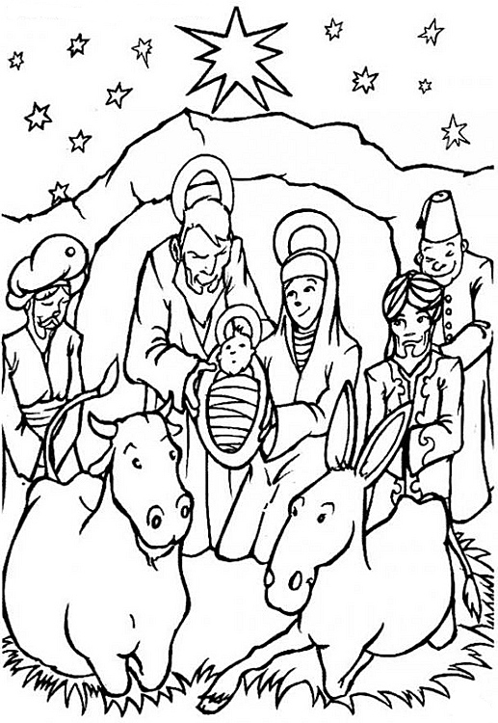

**Word Search Puzzle** from www.geocities.com/lectionarypuzzles/  
  
*Words are in a straight line in all directions*

### Y L C H I L D B U T D S W E N A F R A I D N P E O P L E W N L G I S T A E R G I D I L F M U W H O N L S L W Y E M R M F I L E A T D S E A S A G G R I I L S H P I A N O C V U D I T P H A I G A K G B A O E T V R D E Y O U H L D A Y B E D R O L Q C S E L Y I N G D J

(Luke 2:10-12) But the angel said to them, "Do not be afraid; for see--I am bringing you good news of great joy for all the people: to you is born this day in the city of David a Savior, who is the Messiah, the Lord. This will be a sign for you: you will find a child wrapped in bands of cloth and lying in a manger."

BRINGING WRAPPED MESSIAH SAVIOR(*please note – American spelling*) PEOPLE MANGER AFRAID LYING GREAT DAVID CLOTH CHILD BANDS ANGEL WILL THIS THEM SIGN SAID NEWS LUKE LORD GOOD FIND CITY BORN YOU WHO SEE NOT JOY FOR DAY BUT ALL BE

#### Christmas Themed Codeword Puzzle

A codeword puzzle with a few words connected to the festive season thrown in.

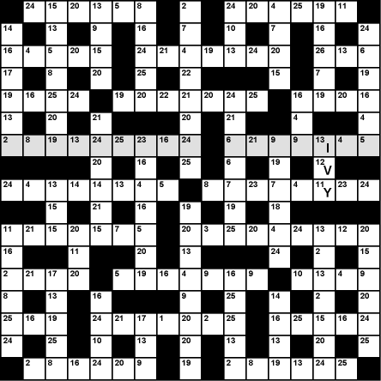

http://www.biblequizzes.org.uk/codewords/code003s_code.png

Sorry, no solution, you are on your own with this one!

WHIZZ KIDS @ WEST MELTON By Ann Peace

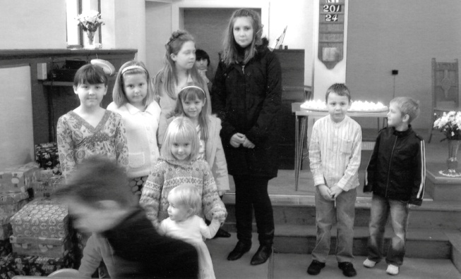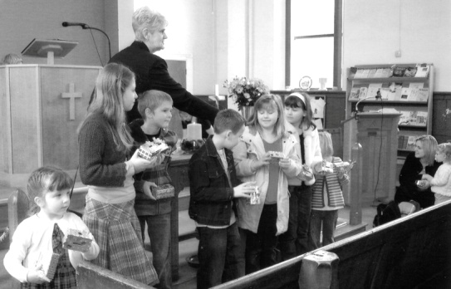Our Whizz Kids meet on the first Sunday of the month. Sometimes we stay in church for family worship and on other occasions we have bible stories and craft in the Community Hall, always returning at the end of the service, sharing with the congregation the work they have been doing. In this photo the children have made and decorated money boxes for Lent. The money they saved in lieu of chocolate, crisps, fizzy pop etc. went into the money boxes. With the help of the congregation they raised £140 which was given to the children’s chosen charity, Water Aid.

They are also involved in special services during the year including Mothering Sunday, Anniversary, Harvest (Operation Christmas Child Shoebox Appeal), Christingle and Nativity.

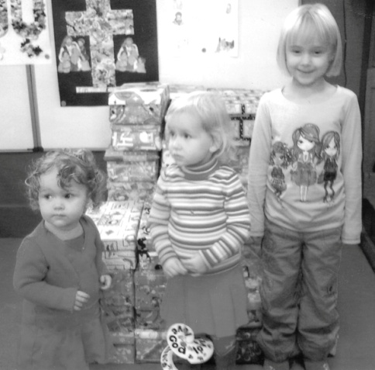We have an average of 12 children attending, aged from 1 year to 14 years old. The older children help the younger ones.

We are a happy little group and we all have a great time together. As leader I feel that the children are an essential part of our church.

* * * * *

**THE  SHORTEST  DAY** by Margaret Ingall

It's cold and dark, and on the pane

I see the glint of falling rain.

Inside the flue the north wind roars

And makes me glad I'm safe indoors.

In comfy chair, I sit so snug.

With fire in grate and cat on rug,

With cup of tea, and biscuit too

There's nothing else I need to do

But listen, by the firelight's glow,

To carols on the radio,

And gaze upon my Christmas tree

That twinkles bright for all to see.

For though the summer's far away,

I still enjoy the shortest day.



**What have we been doing in Kidz Klub**

**in Clayton West** by Jane Woodcock

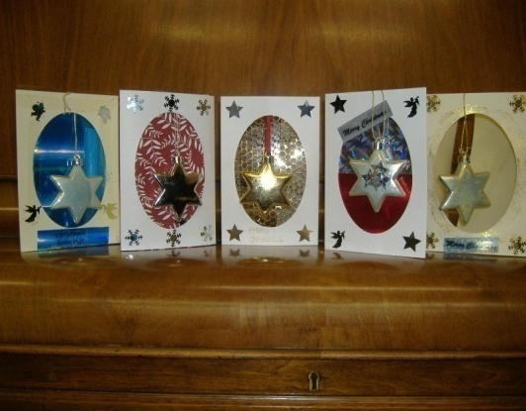Since starting back again in September we have enjoyed some craft activities; we made key ring chains using beads with letters and we have made Christmas cards.

Jeanette from the Denby Dale Centre came along to tell us about the “Time Together” Friendship Scheme. This has been set up to help improve the lives of people in the local area who are socially isolated. One aspect of this work is that volunteers visit people in their homes to spend time with them, have a cuppa and a chat. The Christmas cards we made will be taken by the volunteers when they make a visit.

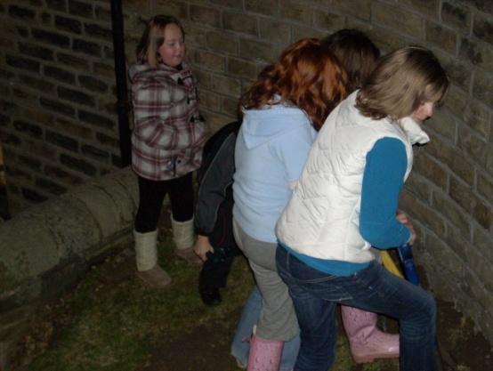

We have made (and eaten!) ‘Toasties’, played games and planted some daffodil bulbs at the Methodist Church, so look out for them in the springtime. Unfortunately when planning the programme we didn’t realise how dark it would be by 6:30pm, so we ended up trying to plant them in the dark! We finished off with hot chocolate topped with marshmallows and cream—scrumptious!

The front cover for the Churches Together Christmas card has been designed by one of the young people. Look out for the the packs of cards to deliver, they will be in the Churches on 6th December.

* * * * *

**Antique Corner** by Love John

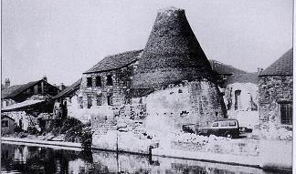Love John and Tinker Les with their beloveds have visited local antique centres.  At one Love John spotted a Daisy pattern jug, which he knows through his experience with antiques was made by Don Pottery of Swinton, (*see photo above*) but Tinker convinced him this was not the bargain Love John thought he had found.

At another centre Love John located two Rockingham plates at a very good price.  Tinker (local Rockingham expert) examined these and said they were genuine, so Love John made a purchase.



He tried to negotiate the price but was informed ‘no trade’, which means no brass off,

(I think they have lost their bargaining knack).

Tinker Les found a beret which he tried on and modelled, but it looked like a dustbin lid on a stick so he decided not to buy it.

Happy hunting.

* * * * *

**Bonfire Night** at West Melton

Once again we held a bonfire at West Melton on 5th November, not very good weather, but very well supported by people attached to the church.

Our thanks for all who contributed, supplying wood, building and tending the fire, and providing and making refreshments.

This year Rev Nick suggested we purchased large fireworks (two for £100).  They were superb and a big improvement on previous years.  The fireworks repeated very sharply, and they all thought John must have got a sweat on as he has never moved as quickly!

Fruity Christmas biscotti

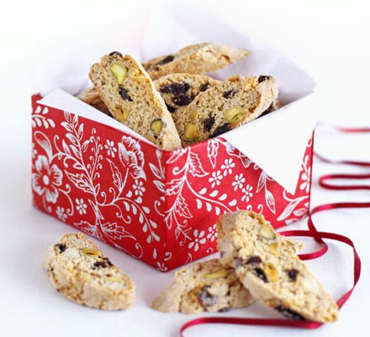Ingredients

350g plain flour , plus extra for rolling, 2 tsp [baking powder,](http://www.bbcgoodfood.com/content/knowhow/glossary/baking-powder/) 2 tsp mixed spice, 250g golden caster sugar, 3 eggs, beaten, coarsely grated zest 1 [orange,](http://www.bbcgoodfood.com/content/knowhow/glossary/orange/) 85g raisins, 85g dried or glace [cherries,](http://www.bbcgoodfood.com/content/knowhow/glossary/cherry/)

50g blanched almonds, 50g shelled unsalted pistachios.

**Method**

1. Heat oven to 180C/fan 160C/gas 4. Line 2 baking sheets with baking paper. Put the flour, baking powder, spice and sugar in a large bowl, then mix well. Stir in the eggs and zest until the mixture starts forming clumps, then bring the dough together with your hands - it will seem dry at first but keep kneading until no floury patches remain. Add the fruit and nuts, then work them in until evenly distributed.
2. Turn the dough out onto a lightly floured surface and divide into 4 pieces. With lightly floured hands, roll each piece into a sausage about 30cm long. Place 2 on each tray, well spaced apart. Bake for 25-30 mins until the dough has risen and spread and feels firm. It should still look pale. Remove from the oven, transfer to a wire rack for a few mins until cool enough to handle, then turn down the oven to 140C/fan 120C/gas 1.
3. Using a bread knife, cut into slices about 1cm thick on the diagonal, then lay the slices flat on the baking sheets. The biscuits can be cooled and frozen flat on the sheet at this point, then bagged and frozen for up to 2 months. Bake for another 15 mins (20 mins if from frozen), turn over, then bake again for another 15 mins until dry and golden. Tip onto a wire rack to cool completely, then store in an airtight tin for up to one month, or pack into boxes or cellophane bags if giving as gifts straightaway.

Harvest snaps

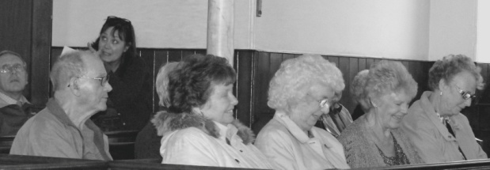 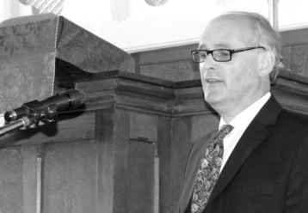

Clayton West’s Harvest Concert

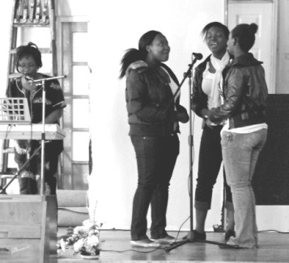 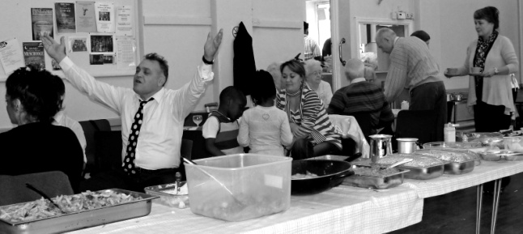

Trinity’s Harvest Lunch

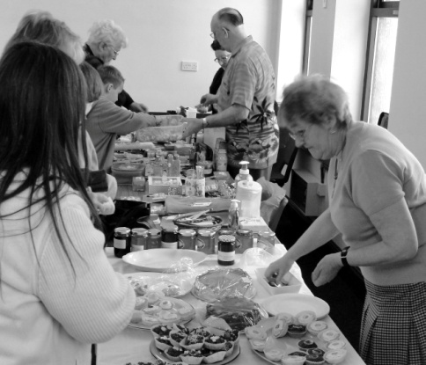 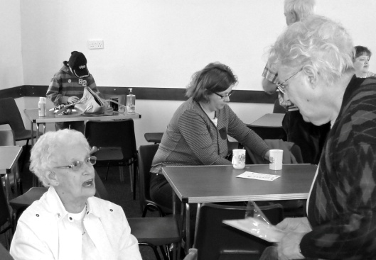

West Melton’s Harvest Coffee Morning

Meet and Eat at Clayton West

On Sunday January 24th 2010 you are invited to a special Sunday lunch to mark the Week of Prayer for Christian Unity. The venue is the Clayton West United Reformed Church, the time 12:30 p.m. - a good time, we hope, for people to come together after their morning services.

Soup and a roll will be provided to start with, and then you are invited to bring food to share. That way there's usually plenty to eat for everyone!

You are invited to stay after lunch, for a time of discussion and finally, from across our churches, we join in prayer together. Looking forward to seeing you there.



Answers to the riddles on pages 5 & 6

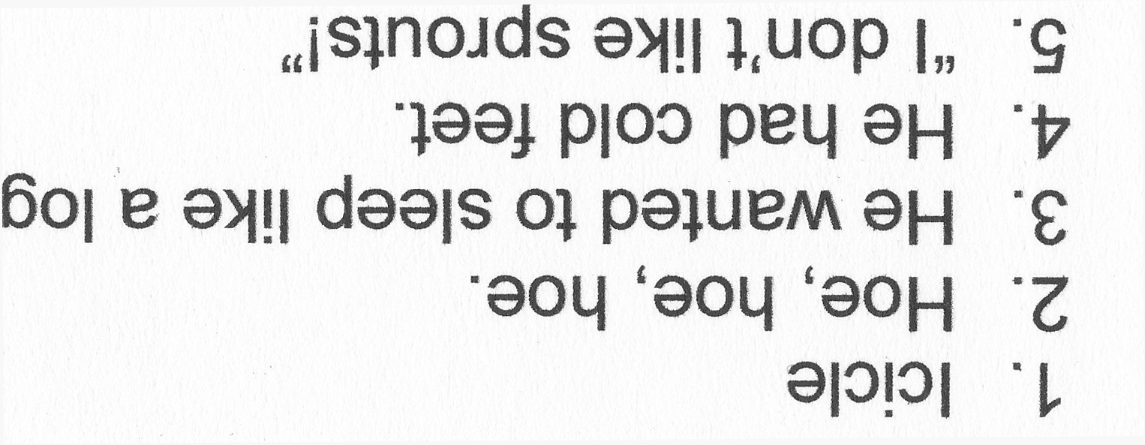

**REGULAR ACTIVITIES IN OUR CHURCHES**

**Clayton West**

Sunday Worship every week at 3.00 pm. Communion is included in the service on the 1st first Sunday of each month

Friday Men’s Society (*September-April*) Every fortnight 7.30pm

Saturday Coffee Morning on the 4th Saturday each month 10.00am

**Trinity (Barnsley)**

Sunday Worship every week at 10.30 am. Communion is included in the service on the 3rd third Sunday of each month

Tuesday Bible Study at 7.30 pm

Wednesday Age-Well (*over 50s club*) every week 10.30am-1.00pm

Trinity Players every week at 7.30pm

Thursday Trinity Tots (*carers & toddlers*) 10.00am – 12.00noon

*(term time only)*

**West Melton**

Sunday Worship on the 1st (*inc. WHIZZ KIDS*) and 4th Sundays at 10.30am and on the 2nd & 3rd Sundays at 3.00pm. Communion is included in the service on the 3rd Sunday of each month

Monday Sisterhood every week at 2.30pm

Wednesday Parents and Tots 9.30am every week *(in term time)*

Praying Hands (*prayer group*) 7.30pm – 8.30pm on the 2nd Wednesday of each month

Fellowship evening (*varied programme*) 7.30pm on the 4th Wednesday of each month

Friday Children’s Fun Night 6.30pm – 8.00pm (1st & 3rd Fridays *in term time*)

Saturday Men’s Breakfast at 8.00am on the 3rd Saturday each month